Kết quả và Code:

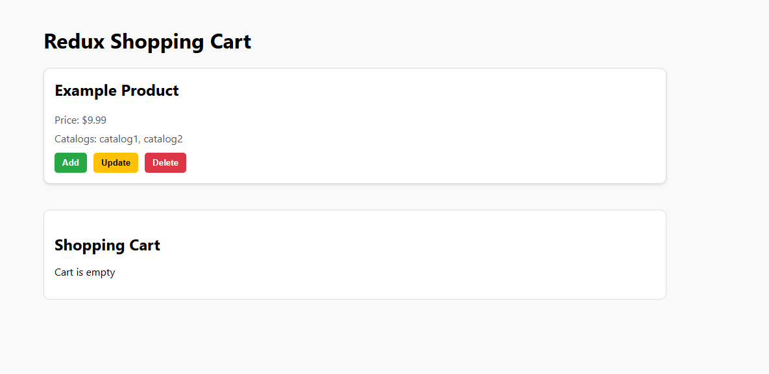

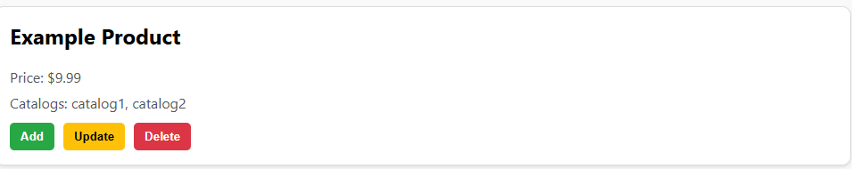

// src/components/ProductList.js

import React from "react";

import { useDispatch } from "react-redux";

import { addToCart, updateCart, deleteFromCart } from "../redux/cartSlice";

// index.js hoặc App.js

import "./styles.css";

const product = {

  id: "123456",

  name: "Example Product",

  price: 9.99,

  description: "This is an example product.",

  catalogs: ["catalog1", "catalog2"],

};

function ProductList() {

  const dispatch = useDispatch();

  const handleAdd = () => dispatch(addToCart(product));

  const handleUpdate = () =>

    dispatch(updateCart({ id: product.id, quantity: 2 }));

  const handleDelete = () => dispatch(deleteFromCart(product.id));

  return (

    <div className="product-card">

      <h2>{product.name}</h2>

      <p>Price: ${product.price}</p>

      <p>Catalogs: {product.catalogs.join(", ")}</p>

      <div className="button-group">

        <button onClick={handleAdd}>Add</button>

        <button onClick={handleUpdate}>Update</button>

        <button onClick={handleDelete}>Delete</button>

      </div>

    </div>

  );

}

export default ProductList;

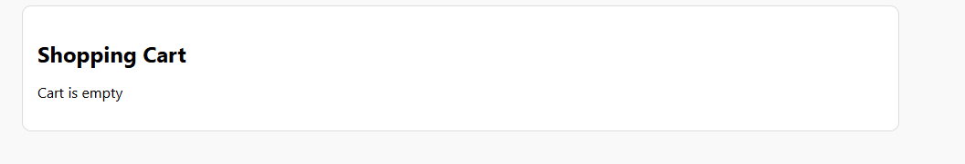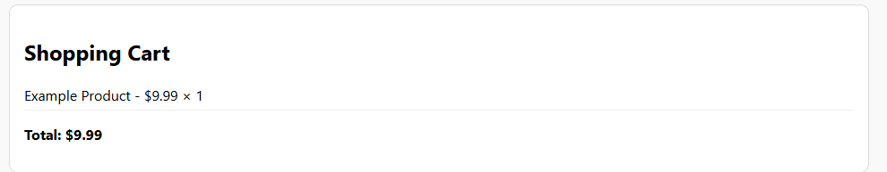

// src/App.js

import React from "react";

import ProductList from "./components/ProductList";

import Cart from "./components/Cart";

import "../src/components/styles.css"; // Import styles

function App() {

  return (

    <div className="container">

      <h1>Redux Shopping Cart</h1>

      <ProductList />

      <Cart />

    </div>

  );

}

export default App;