

**<<PROJECT NAME>>**

**Software Design Document**

– Hanoi, August 2019 –

**Table of Contents**

I. Overview 3

1. Code Packages 3

2. Database Schema 3

II. Code Designs 4

1. <Feature/Function Name1> 4

a. Class Diagram 4

b. Class Specifications 4

c. Sequence Diagram(s) 4

d. Database queries 5

2. <Feature/Function Name2> 5

III. Database Tables 5

1. <Table name 1> 5

2. <Table name 2…> 5

# I. Overview

## 1. Code Packages/Namespaces

*[Provide the package diagram for each sub-system. The content of this section including the overall package diagram, the explanation, package and class naming conventions in each package. Please see the sample and description table format below – following Java project naming convention]*

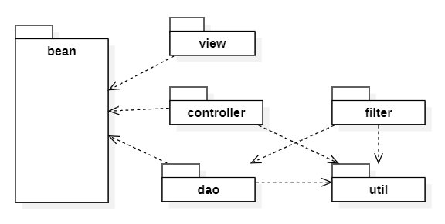

***Package descriptions & package class naming conventions***

| **No** | **Package** | **Description** |
| --- | --- | --- |
| *1* | com.dolphin.hostelmanagemnt.DAO | Each class contains methods used to retrieve data from the database by writing queries  AccountDAO.java  ContractDAO.java  HostelDAO.java  InvoiceDAO.java  LandlordDAO.java  RoomDAO.java  ServiceDAO.java  TenantDAO.java  WardDAO.java  DistrictDAO.java |
| 2 | com.dolphin.hostelmanagement.DTO | Each class corresponds to a table in the database  Account.java  Announcement.java  Contract.java  FavoriteHostel.java  Feedback.java  Hostel.java  Invoice.java  Landlord.java  Room.java  RoomResident.java  Service.java  ServiceDetail.java  Tenant.java  Ward.java  District.java |
| 3 | com.dolphin.hostelmanagement.utils | Contains connection to database or other connections.  DBUtils.java  EmailService.java  StringUtils.java |

## 2. Database Schema

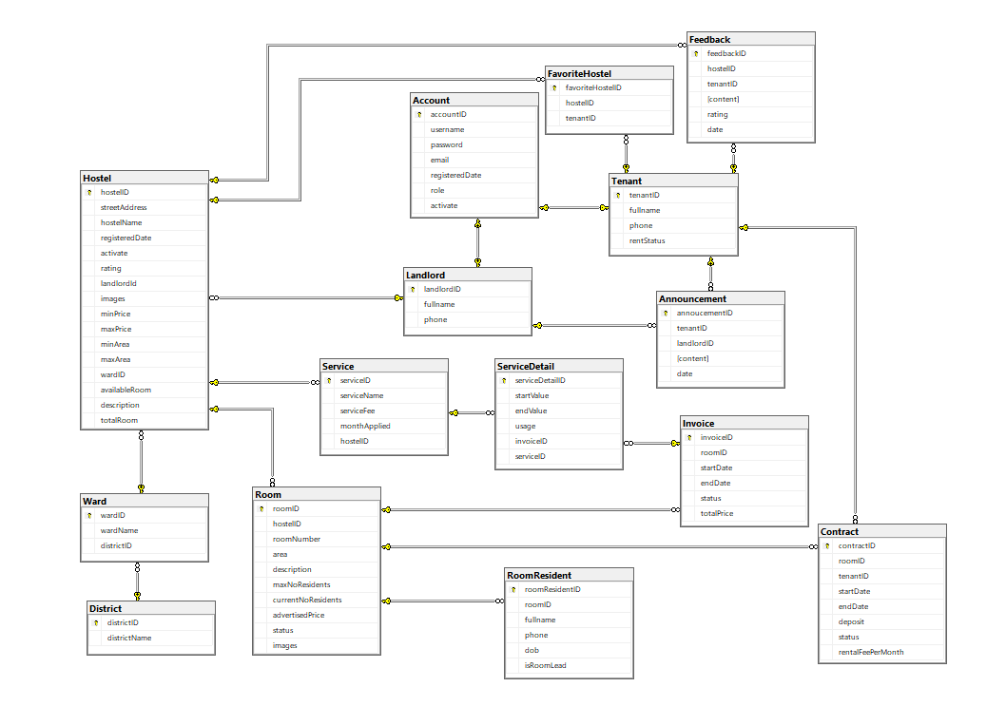

***Table descriptions & package class naming conventions are as below***

| **No** | **Table** | **Description** |
| --- | --- | --- |
| 1 | Account | Primary key: accountID  Foreign key: |
| 2 | Tenant | Primary key: TenanID  Foreign key: |
| 3 | Landlord | Primary key: LandlordID  Foreign key: |
| 4 | Hostel | Primary key: HostelID  Foreign key: landlordId, wardID |
| 5 | Room | Primary key: RoomID  Foreign key: hostelID |
| 6 | Feedback | Primary key: FeedbackID  Foreign key: hostelID, tenantID |
| 7 | Announcement | Primary key: AnnouncementID  Foreign key: tenantID, landlordID |
| 8 | Service | Primary key: ServiceID  Foreign key: hostelID |
| 9 | ServiceDetail | Primary key: ServiceDetailID  Foreign key: invoiceID, serviceID |
| 10 | RoomResident | Primary key: RoomResidentID  Foreign key: roomID |
| 11 | Contract | Primary key: ContractID  Foreign key: roomID, tenantID |
| 12 | Invoice | Primary key: InvoiceID  Foreign key: roomID |
| 13 | FavoriteHostel | Primary key: FavoriteHostelID  Foreign key: hostelID, tenantID |
| 14 | Ward | Primary key: WardID  Foreign key: districtID |
| 15 | District | Primary key: DistrictID  Foreign key: |

# II. Code Designs

## 1. <Feature/Function Name1>

*[Provide the detailed design for the function <Feature/Function Name1>. It include Class Diagram, Class Specifications, and Sequence Diagram(s)]*

### a. Class Diagram

*[This part presents the class diagram for the relevant feature]*

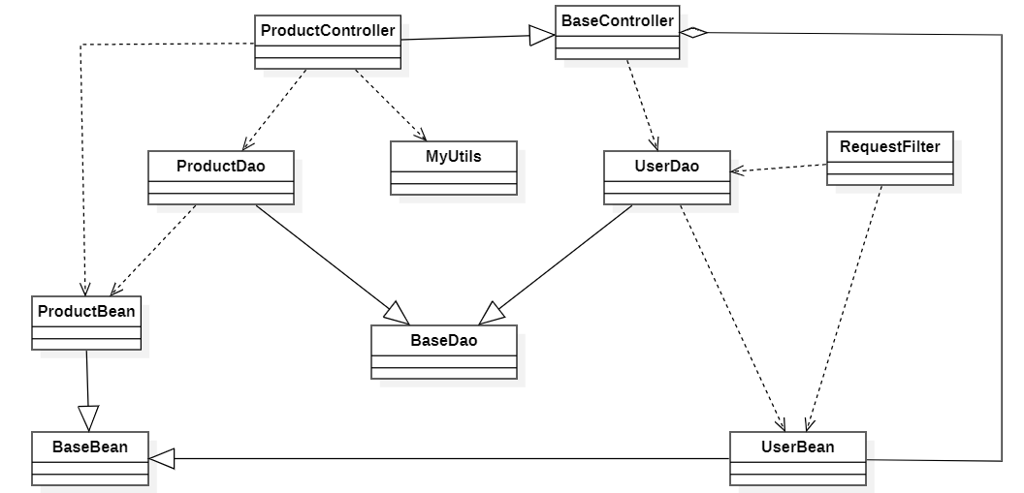

### b. Class Specifications

*[Provide the description for each class and the methods in each class, following the table format as below]*

#### XYZ Class

*[Provide the detailed description for the class methods]*

| **No** | **Method** | **Description** |
| --- | --- | --- |
| *01* | *<method name>* | *<Description of the method, including the inputs, outputs & internal method processing>* |
|  |  |  |

#### ABC Class

***Class Methods***

*[Provide the detailed description for the class methods]*

| **No** | **Method** | **Description** |
| --- | --- | --- |
| *01* | *<method name>* | *<Description of the method, including the inputs, outputs & internal method processing>* |
|  |  |  |

### c. Sequence Diagram(s)

*[Provide the sequence diagram(s) for the feature, see the sample below]*

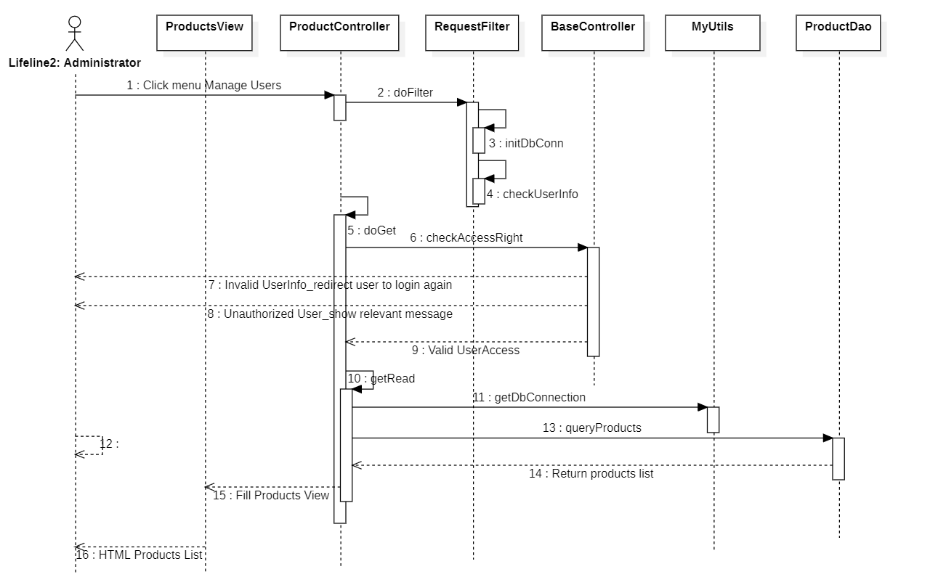

### d. Database queries

*[Provide the detailed SQL (select, insert, update...) which are used in implementing the function/screen]*

## 2. <Feature/Function Name2>

…

# III. Database Tables

## 1. Table Account

| **#** | **Field name** | **Type** | **Size** | **Unique** | **Not Null** | **PK/FK** | **Notes** |
| --- | --- | --- | --- | --- | --- | --- | --- |
| 1 | accountId | int |  | x | x | x |  |
| 2 | username | varchar(30) |  | x | x |  |  |
| 3 | password | varchar(15) |  |  | x |  |  |
| 4 | email | varchar(30) |  |  |  |  |  |
| 5 | registeredDate | Date |  |  | x |  |  |
| 6 | role | tinyint |  |  | x |  |  |
| 7 | activate | bit |  |  | x |  |  |

## 2. Table Landlord

| **#** | **Field name** | **Type** | **Size** | **Unique** | **Not Null** | **PK/FK** | **Notes** |
| --- | --- | --- | --- | --- | --- | --- | --- |
| 1 | landlordId | int |  | x | x | x |  |
| 2 | fullname | nvarchar(30) |  |  |  |  |  |
| 3 | phone | varchar(15) |  | x |  |  |  |

## 

## 3. Table Tenant

| **#** | **Field name** | **Type** | **Size** | **Unique** | **Not Null** | **PK/FK** | **Notes** |
| --- | --- | --- | --- | --- | --- | --- | --- |
| 1 | tenantId | int |  | x | x | x |  |
| 2 | fullname | nvarchar(30) |  |  |  |  |  |
| 3 | phone | varchar(10) |  | x |  |  |  |
| 4 | rentStatus | bit |  |  | x |  |  |

## 

## 4. Table Hostel

| **#** | **Field name** | **Type** | **Size** | **Unique** | **Not Null** | **PK/FK** | **Notes** |
| --- | --- | --- | --- | --- | --- | --- | --- |
| 1 | hostelId | int |  | x | x | x |  |
| 2 | streetAddress | nvarchar(30) |  |  | x |  |  |
| 3 | address | nvarchar(255) |  | x | x |  |  |
| 4 | hostelName | nvarchar(30) |  |  | x |  |  |
| 5 | totalRoom | int |  |  | x |  |  |
| 6 | registeredDate | date |  |  | x |  |  |
| 7 | activate | bit |  |  | x |  |  |
| 8 | rating | float |  |  |  |  |  |
| 9 | landlordId | int |  |  | x | x |  |
| 10 | description | nvarchar(MAX) |  |  |  |  |  |
| 11 | images | nvarchar(MAX) |  |  | x |  |  |
| 12 | minPrice | int |  |  | x |  |  |
| 13 | maxPrice | int |  |  | x |  |  |
| 14 | minArea | int |  |  | x |  |  |
| 15 | maxArea | int |  |  | x |  |  |
| 16 | wardID | int |  |  | x | x |  |

## 

## 5. Table Room

| **#** | **Field name** | **Type** | **Size** | **Unique** | **Not Null** | **PK/FK** | **Notes** |
| --- | --- | --- | --- | --- | --- | --- | --- |
| 1 | roomId | int |  | x | x | x |  |
| 2 | hostelId | int |  |  | x | x |  |
| 3 | roomNumber | nvarchar(255) |  |  | x |  |  |
| 4 | area | nvarchar(30) |  |  | x |  |  |
| 5 | description | int |  |  | x |  |  |
| 6 | maxNoResidents | int |  |  | x |  |  |
| 7 | currentNoResidents | int |  |  | x |  |  |
| 8 | advertisedPrice | int |  |  | x |  |  |
| 9 | status | int |  |  | x |  |  |
| 10 | images | varchar(255) |  |  |  |  |  |

## 

## 6. Table RoomResident

| **#** | **Field name** | **Type** | **Size** | **Unique** | **Not Null** | **PK/FK** | **Notes** |
| --- | --- | --- | --- | --- | --- | --- | --- |
| 1 | roomResidentId | int |  | x | x | x |  |
| 2 | roomId | int |  |  | x | x |  |
| 3 | fullname | nvarchar(30) |  |  | x |  |  |
| 4 | phone | char(10) |  |  | x |  |  |
| 5 | dob | date |  |  | x |  |  |
| 6 | isRoomLead | bit |  |  | x |  |  |

## 7. Table Feedback

| **#** | **Field name** | **Type** | **Size** | **Unique** | **Not Null** | **PK/FK** | **Notes** |
| --- | --- | --- | --- | --- | --- | --- | --- |
| 1 | feedbackId | int |  | x | x | x |  |
| 2 | hostelId | int |  |  | x | x |  |
| 3 | tenantId | int |  |  | x | x |  |
| 4 | content | nvarchar(MAX) |  |  | x |  |  |
| 5 | rating | tinyint |  |  | x |  |  |
| 6 | date | date |  |  | x |  |  |

## 8. Table Announcement

| **#** | **Field name** | **Type** | **Size** | **Unique** | **Not Null** | **PK/FK** | **Notes** |
| --- | --- | --- | --- | --- | --- | --- | --- |
| 1 | announcementId | int |  | x | x | x |  |
| 2 | tenantId | int |  |  | x | x |  |
| 3 | landlordId | int |  |  | x | x |  |
| 4 | content | nvarchar(MAX) |  |  | x |  |  |
| 5 | date | date |  |  | x |  |  |

## 9. Table Service

| **#** | **Field name** | **Type** | **Size** | **Unique** | **Not Null** | **PK/FK** | **Notes** |
| --- | --- | --- | --- | --- | --- | --- | --- |
| 1 | serviceId | int |  | x | x | x |  |
| 2 | serviceName | nvarchar(30) |  |  | x |  |  |
| 3 | serviceFee | int |  |  | x |  |  |
| 4 | monthApplied | date |  |  | x |  |  |
| 5 | hostelId | int |  |  | x | x |  |

## 10. Table ServiceDetail

| **#** | **Field name** | **Type** | **Size** | **Unique** | **Not Null** | **PK/FK** | **Notes** |
| --- | --- | --- | --- | --- | --- | --- | --- |
| 1 | serviceDetailId | int |  | x | x | x |  |
| 2 | startValue | real |  |  |  |  |  |
| 3 | endValue | real |  |  |  |  |  |
| 4 | usage | boolean |  |  | x |  |  |
| 5 | invoiceId | int |  |  | x | x |  |
| 6 | serviceId | int |  |  | x | x |  |

## 11. Table FavoriteHostel

| **#** | **Field name** | **Type** | **Size** | **Unique** | **Not Null** | **PK/FK** | **Notes** |
| --- | --- | --- | --- | --- | --- | --- | --- |
| 1 | favoriteHostelID | int |  | x | x | x |  |
| 2 | hostelID | int |  |  | x | x |  |
| 3 | tenantID | int |  |  | x | x |  |

## 12. Table Contract

| **#** | **Field name** | **Type** | **Size** | **Unique** | **Not Null** | **PK/FK** | **Notes** |
| --- | --- | --- | --- | --- | --- | --- | --- |
| 1 | contractID | int |  | x | x | x |  |
| 2 | roomID | int |  |  | x | x |  |
| 3 | tenantID | int |  |  | x | x |  |
| 4 | startDate | date |  |  | x |  |  |
| 5 | endDate | date |  |  |  |  |  |
| 6 | deposit | int |  |  | x |  |  |
| 7 | status | tinyint |  |  | x |  |  |
| 8 | rentalFeePerMonth | int |  |  | x |  |  |

## 13. Table Invoice

| **#** | **Field name** | **Type** | **Size** | **Unique** | **Not Null** | **PK/FK** | **Notes** |
| --- | --- | --- | --- | --- | --- | --- | --- |
| 1 | invoiceID | int |  | x | x | x |  |
| 2 | roomID | int |  |  | x | x |  |
| 3 | startDate | date |  |  | x |  |  |
| 4 | endDate | date |  |  | x |  |  |
| 5 | status | tinyint |  |  | x |  |  |
| 6 | totalPrice | int |  |  | x |  |  |

## 14. Ward

| **#** | **Field name** | **Type** | **Size** | **Unique** | **Not Null** | **PK/FK** | **Notes** |
| --- | --- | --- | --- | --- | --- | --- | --- |
| 1 | wardID | int |  | x | x | x |  |
| 2 | wardName | nvarchar(50) |  |  | x |  |  |
| 3 | districtID | int |  |  | x | x |  |

## 15. District

| **#** | **Field name** | **Type** | **Size** | **Unique** | **Not Null** | **PK/FK** | **Notes** |
| --- | --- | --- | --- | --- | --- | --- | --- |
| 1 | districtID | int |  | x | x | x |  |
| 2 | districtName | nvchar(50) |  |  | x |  |  |