

**SAKURA HOSTEL MANAGEMENT SYSTEM**

**Software Requirement Specification**

– Hanoi, April 2021 –

**Table of Contents**

I. Overview **3**

1. Introduction 3

a. Screen Flow 4

b. Screen Details 4

c. User Authorization 5

d. Non-Screen Functions 7

3. Common Requirements 7

II. Functional Requirements **9**

1. Authentication 9

a. Login by username and password 9

b. Login by email 9

2. <<Feature Name 2>> 12

# I. Overview

## 1. Introduction

The Sakura Hostel Management System aims to be a convenient place for tenants and landlords to manage their rentals. With this system, landlords will be greatly assisted with various functionalities such as tenants and hostel managements, viewing statistics of revenue and hostel usage and so on. The system provides landlords with the ability to interact with their tenants fast and conveniently, including sending and receiving requests, and posting payment information. On the other hand, tenants can quickly search for suitable rent using the smart filtering function of the system. Communication with landlords will be much more interactive through the various functions of the system including sending requests and viewing announcements.

The main users of the systems are tenants and landlords within the area of Ho Chi Minh City.

The system will be developed with Java programming language, making use of the JSP and Servlet technologies and MVC2 architecture. The system is expected to operate well on Chrome browser.

**2. System Functions**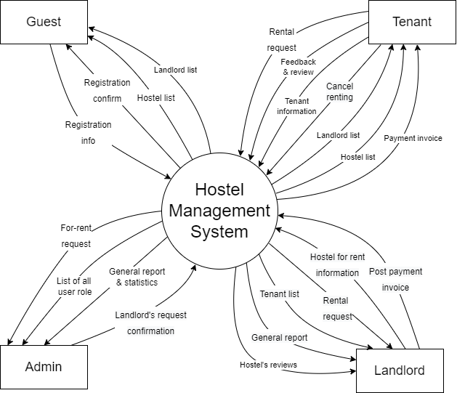

#### a. Screen Flow

#### b. Screen Details

| **#** | **Feature** | **Screen** | **Description** |
| --- | --- | --- | --- |
|  | Authorization | Login | Authenticate user to give him/her access to authorised features |
|  | Authorization | Register | A guest can register to be a tenant or landlord |
|  | Authentication | Forgot password | Send OTP via email, phone to confirm request and authentication, after that let users reset their password |
|  | Guests’ feature | Home | A guest can browse hostel list, landlord list and theirs’ detail |
|  | Manage user information | User profile | Users can view and edit their personal information |
|  | Manage user information | Change password | User can change their account password |
|  | Tenants’ feature | Tenant page | A tenant can view hostel list, landlord list / manage his rental room |
|  | Tenants’ feature | Announcement | Tenant can view announcement from admin or landlord |
|  | Tenants’ feature | Cancel renting | Tenant can send a cancel renting form to landlord |
|  | Register to rent a room | Rental registration form | Tenant are yet to rent a hostel can fill a form to rent a room |
|  | Online payment | Payment invoice | Tenant can pay monthly bill and other fee through this |
|  | Landlords’ feature | Landlord page | Landlord can see the overview information about his/her hostels and register a new one |
|  | Hostel management | Hostel list | Landlord can view a hostel list |
|  | Register a hostel for rent | Register hostel for rent form | Landlord can fill in a form to register a new hostel for rent |
|  | Hostel management | Overview | Landlord can see overview information of the hostel |
|  | Room management | Room list | Landlord can view the room list of a hostel |
|  | Manage tenants | Tenant list | Landlord can view the tenant list who stay at the hostel |
|  | Manage revenue | Revenue | Landlord can see the bill, revenue number and chart of the hostel |
|  | General report | Admin dashboard | Admin can receive and answer report from users |
|  | Landlord management | Landlord management | Admin can view a list of landlords and see their personal information and their hostel |
|  | Hostel management | Hostel management | Admin can view a list of hostels and see their information |
| 22 | Tenant management | Tenant management | Admin can view a list of tenant and see their personal information |

#### c. User Authorization

| **Screen** | **Tenant** | **Landlord** | **Admin** | **Guest** |
| --- | --- | --- | --- | --- |
| Login | X | X | X | X |
| 1. Login by username, password | X | X | X | X |
| 1. Login by gmail | X | X | X | X |
| 1. Login by facebook | X | X | X | X |
| Recover password | X | X | X |  |
| 1. Reset password | X | X | X |  |
| Register | X | X | X | X |
| 1. Fill register form | X | X | X | X |
| 1. Register with gmail | X | X | X | X |
| 1. Register with facebook | X | X | X | X |
| Home | X | X | X | X |
| 1. View hostel list with paging | X | X | X | X |
| 1. View hostel’s detail | X | X | X | X |
| 1. View landlord list with paging | X | X | X | X |
| 1. View landlord’s detail | X | X | X | X |
| 1. Bookmark hostel | X |  |  |  |
| User profile | X | X | X |  |
| 1. Change user profile | X | X | X |  |
| Change password | X | X | X |  |
| 1. Change password | X | X | X |  |
| Tenant page | X |  |  |  |
| 1. View hostel list with paging | X |  |  |  |
| 1. View hostel’s detail | X |  |  |  |
| 1. View landlord list with paging | X |  |  |  |
| 1. View landlord’s detail | X |  |  |  |
| 1. Rent a room of a hostel | X |  |  |  |
| 1. View room’s detail | X |  |  |  |
| 1. Write review of a hostel/room | X |  |  |  |
| 1. Send request/recommendation/message to landlord | X |  |  |  |
| 1. View landlord’s announcement | X |  |  |  |
| 1. Cancel renting | X |  |  |  |
| Payment invoice | X |  |  |  |
| 1. View monthly payment detail | X |  |  |  |
| 1. Pay monthly bill online | X |  |  |  |
| Rental registration form | X |  |  |  |
| 1. Fill rental form | X |  |  |  |
| 1. Upload identity papers | X |  |  |  |
| Landlord page |  | X |  |  |
| 1. View general statistics of revenue, hostels, tenants |  | X |  |  |
| Hostel list |  | X |  |  |
| 1. View hostel list with paging |  | X |  |  |
| 1. View hostel’s detail |  | X |  |  |
| 1. Edit hostel’s detail |  | X |  |  |
| 1. Activate/Deactivate a hostel |  | X |  |  |
| Overview |  | X |  |  |
| 1. View general report of a specific hostel |  | X |  |  |
| Room list |  | X |  |  |
| 1. View room list with paging |  | X |  |  |
| 1. Add a room |  | X |  |  |
| 1. Remove a room |  | X |  |  |
| 1. View room’s detail |  | X |  |  |
| 1. Edit room’s detail |  | X |  |  |
| 1. Add room’s utilities |  | X |  |  |
| 1. Edit room’s utilities |  | X |  |  |
| Tenant list |  | X |  |  |
| 1. View tenant list with paging |  | X |  |  |
| 1. Approve a rental request |  | X |  |  |
| 1. Add a tenant |  | X |  |  |
| 1. Remove a tenant |  | X |  |  |
| 1. View tenant’s detail |  | X |  |  |
| 1. Edit tenant’s information |  | X |  |  |
| 1. Send announcement to tenants |  | X |  |  |
| 1. Post payment invoice |  | X |  |  |
| Revenue |  | X |  |  |
| 1. View revenue statistics of a specific hostel |  | X |  |  |
| 1. Export report to excel file |  | X |  |  |
| Admin |  |  | X |  |
| 1. View landlord list |  |  | X |  |
| 1. Edit landlord’s information |  |  | X |  |
| 1. Activate/Deactivate a landlord account |  |  | X |  |
| 1. Approve a landlord’s request |  |  | X |  |
| 1. View hostel list |  |  | X |  |
| 1. Edit hostel’s information |  |  | X |  |
| 1. Activate/Deactivate a hostel |  |  | X |  |
| 1. View tenant list |  |  | X |  |
| 1. Edit tenant’s information |  |  | X |  |
| 1. Activate/Deactivate a tenant account |  |  | X |  |

In which:

* **Tenant:** Tenants can add, update or delete their personal information. They can make requests to rent a hostel and make payments for their rent. They can also send requests, recommendations to the landlords.
* **Landlord:** Landlords can manage the hostels they own, including adding, deleting, updating information about the hostels. They can also post payment information and see the statistics about the revenue and usage of the hostels.
* **Admin:** Admins can manage the lists of landlords, tenants and hostels. They can add, delete, modify the details related to each group of data.
* **Guest:** A guest is a non-registered user who can search for hostels based on various criteria.

#### d. Non-Screen Functions

| **#** | **Feature** | **System Function** | **Description** |
| --- | --- | --- | --- |
| 1 | Authentication | Reset password | Send new random password to user via provided email to authentication |
| 2 | Authorization | Logout |  |
| 3 | Manage landlord | Approve landlord’s request a room for rent |  |
| 4 | Email | Send mail | When customer orders, system will automatically send email verifications |
| 6 | Statistic | Export invoice, service history to pdf |  |

## 3. Common Requirements

# II. Functional Requirements

## 1. Authentication

### a. Login by username and password

* Trigger: clicking on “Sign in with password” button on homepage
* Description*:* Users sign in to the system using the existing profile
* Layout: Mock-up prototype for screen, the sample is the picture below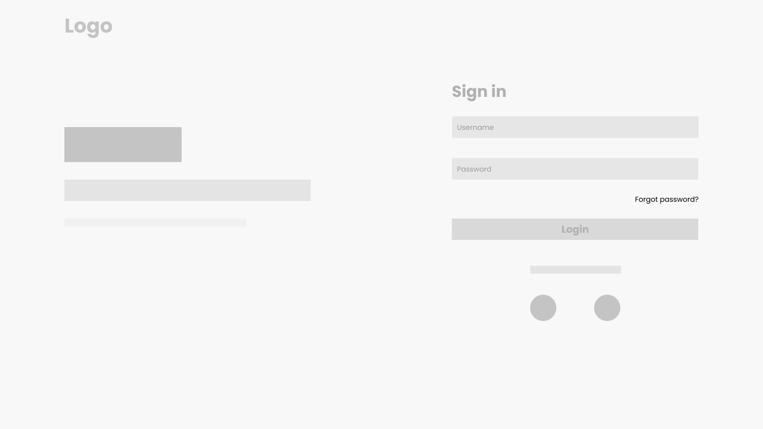
* Function details: The username and password pair is checked if they match those of an existing user in the database. If yes, the user is logged in. If not, a warning is sent to the browser.

### b. Login by email

* Trigger: clicking on “Sign in with email” button on homepage
* Description: User signs in with a connected email
* Details: The system checks if the email is registered in the database. If yes, the user is logged in. If not, a warning message is sent to the browser

**c. Login by facebook**

* Trigger: clicking on “Sign in with facebook” button on homepage
* Description: User signs in with a connected facebook account
* Details: The system checks if the facebook account is registered in the database. If yes, the user is logged in. If not, a warning message is sent to the browser.

**2. Recover password**

* Trigger: clicking on “Recover password” button
* Description: user resets their password in case they forget the current password. Users must provide a username or the email address they used to register.
* Layout:

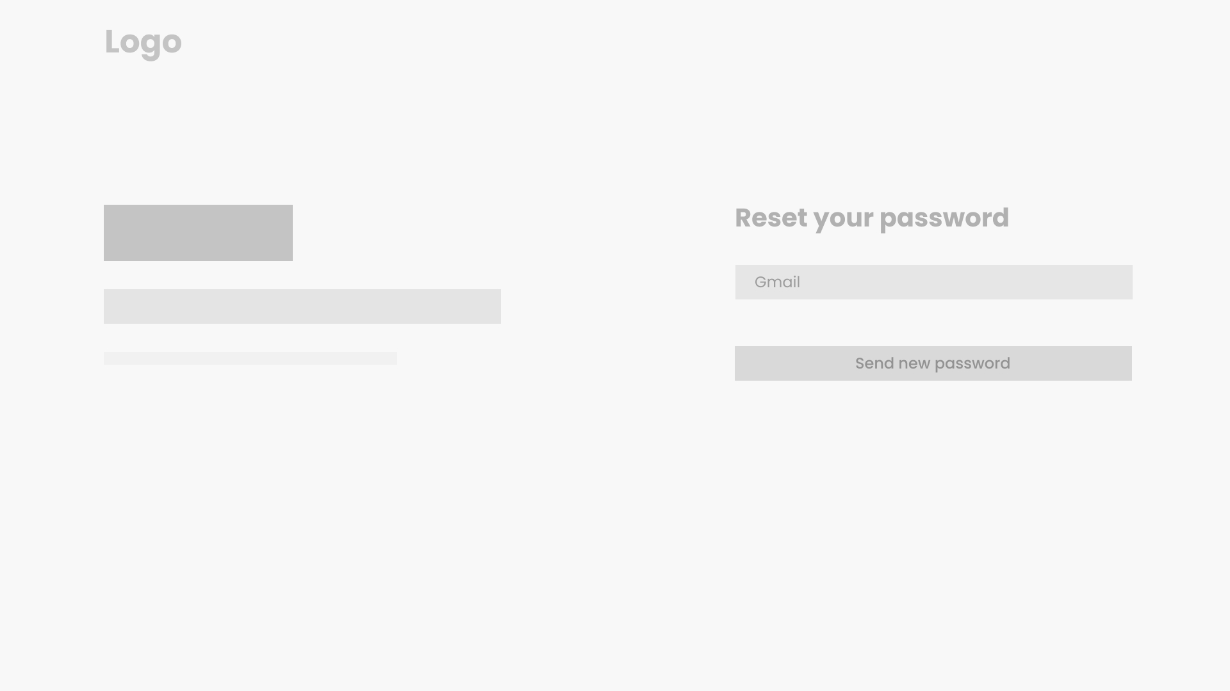

* Details: An email with a password reset link is sent to the email address used for registration. User follows the link, fill in their new password and click on the “Reset password” button

**3. Register**

1. **Fill register form**

* Trigger: Click on “Register button” button
* Description: User can register an account to login to the website using username and password
* Layout:

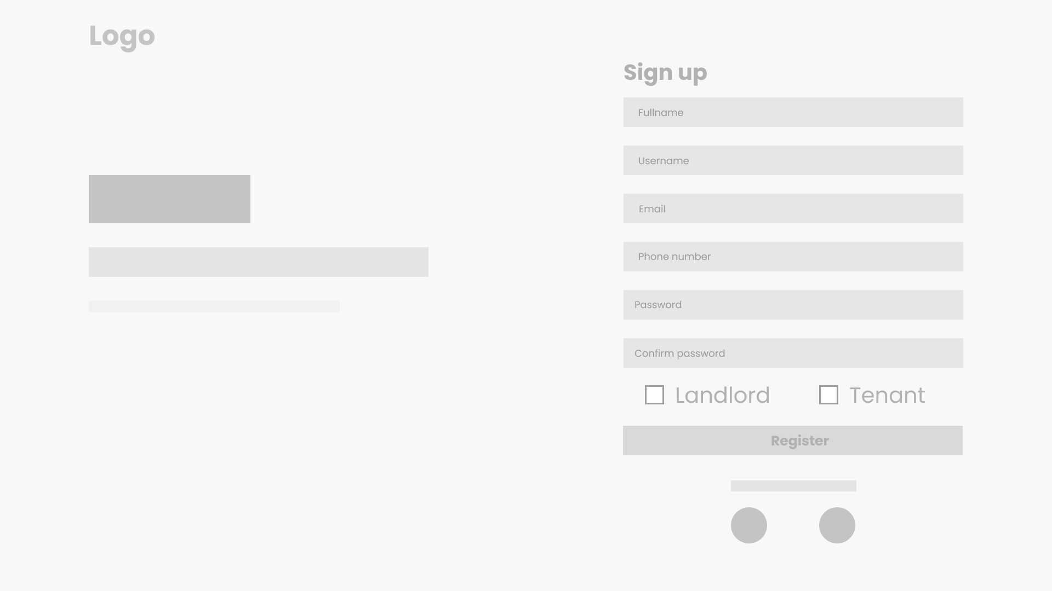

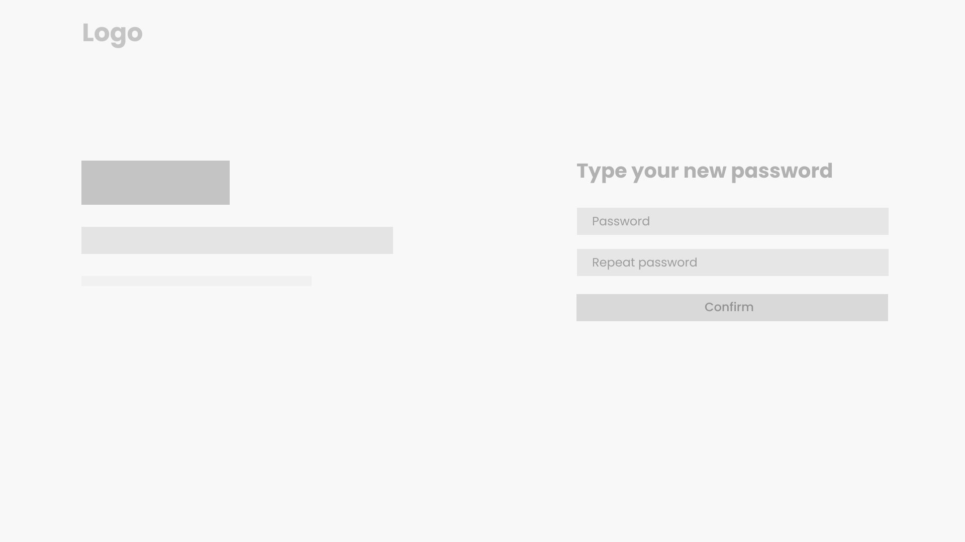

* Details: User need to fill a form that contain some basic information such as username, password, full name, email, phone number and their role as landlord or tenant

1. **Register with gmail**

* Trigger: clicking on “Register with Gmail” button
* Description:
* Details

1. **Register with facebook**

* Trigger: Click on “Register with facebook” button
* Description:

**4. Guest’s functions**

1. **View hostel list with paging**

* Trigger: When the guest visit the website
* Description: Guests can view many hostels on the website, with a fixed amount per page.
* Details: Guests can see a list of hostels in many pages, and they also can filter hostels by provinces, districts, wards, and sort by price/rating. In addition, guests can search for a hostel by name.

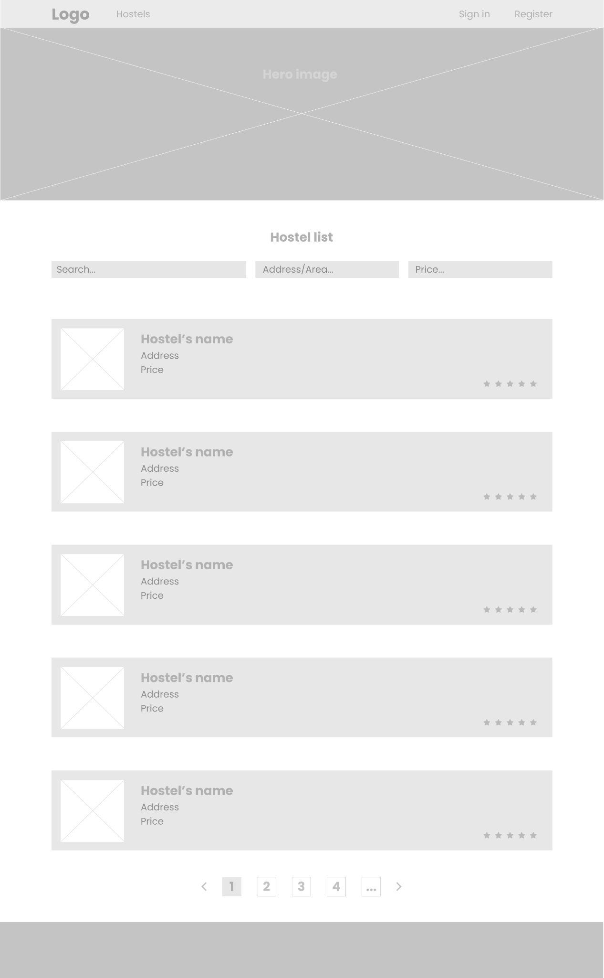

1. **View hostels’ details**

* Trigger: When the guest click a hostel in a hostel list
* Description: Users can view detailed information about the hostel as well as the hostel's landlord information.
* Details: User will see information about the hostel such as address, services, name, images, rating, room cost. They can view a list of rooms, which will have a status as available/ near available / not available, as well as policy and location of the hostel on the map. Beside, the landlord's information such as name, phone number will also be displayed too.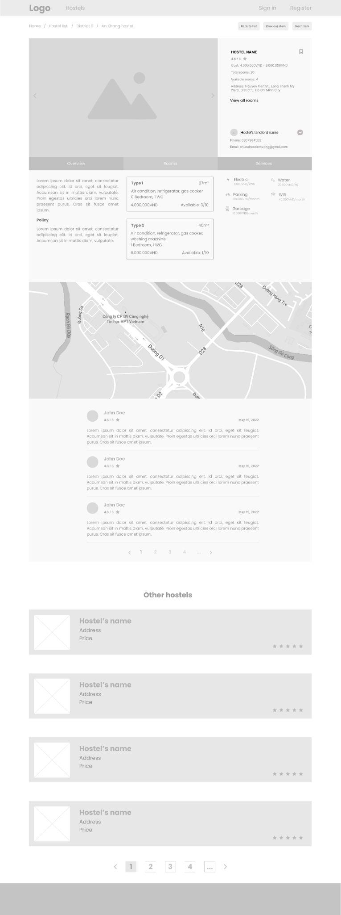



1. **View landlord list with paging**

* Trigger: When the admin clicks on the landlord list button on the navigation bar.
* Description: The website will show a list of landlords
* Details: Landlords will be shown as a list with paging, with names, status, phone number. Admin can filter the landlords by name, phone number, or sort by created date.

1. **View landlords’ details**

* Trigger: When a user clicks on a landlord in the landlord list.
* Description: Users can see detailed information about a landlord
* Details: Detailed information about the landlord is his/her name, phone number, address, facebook, email address.

**5. Change user profile**

* Trigger: When logined user clicks on the profile button on the screen, and chooses the view profile option.
* Description: Users can view their profile as well as change some of them.
* Details: Users can change information such as full name, phone number, date of birth, facebook, and save their change immediately.

**6. Change password**

* Trigger: When the user clicks on the profile button on the screen, and chooses the change password option
* Description: User can change their password
* Details: Users must enter the old password in order to change it to a new one. The new password must be confirmed twice.

**7. Tenant’s functions**

1. **View hostel list with paging**

* Trigger: When the admin clicks on the landlord list button on the navigation bar.
* Description: The website will show a list of landlords
* Details: Landlords will be shown as a list with paging, with names, status, phone number. Admin can filter the landlords by name, phone number, or sort by created date.

1. **View hostels’ details**

* Trigger: When the guest click a hostel in a hostel list
* Description: Users can view detailed information about the hostel as well as the hostel's landlord information.
* Details: User will see information about the hostel such as address, services, name, images, rating, room cost. They can view a list of rooms, which will have a status as available/ near available / not available, as well as policy and location of the hostel on the map. Beside, the landlord's information such as name, phone number will also be displayed too.

1. **View landlords’ details**

* **Trigger: When a user clicks on a landlord in the landlord list.**
* **Description: Users can see detailed information about a landlord**
* **Details: Detailed information about the landlord is his/her name, phone number, address, facebook, email address.**

1. **Rent a room of a hostel (bỏ)**
2. **View room’s detail**
3. **Write review of a hostel/room**
4. **Send request/recommendation/message to landlord**
5. **View landlord’s announcement**
6. **Cancel renting**

**8. Payment**

1. **View monthly payment detail**
2. **Pay monthly bill online**

**9. Rental registration form**

1. **Fill rental form**
2. **Upload identity papers**

**10. Statistics for landlords**

1. **View general statistics of revenue, hostels, tenants**

**11. Hostel management for landlord**

1. **View hostel list with paging**
2. **View hostel’s detail**
3. **Edit hostel’s detail**
4. **Activate/deactivate a hostel**

**12. Overview of a specific hostel**

1. **View report of a specific hostel**
2. **Edit hostel’s information**

**13. Room management for landlord**

1. **View room list with paging**
2. **Add a room**
3. **Remove a room**
4. **View room’s detail**
5. **Edit room’s detail**
6. **Add room’s utilities**
7. **Edit room’s utilities**

**14. Tenant management for landlord**

1. **View tenant list with paging**
2. **Approve a rental request**
3. **Add a tenant**
4. **Remove a tenant**
5. **View tenant’s detail**
6. **Edit tenant’s information**
7. **Send announcement to tenants**
8. **Post payment invoice**

**15. Revenue management for landlords**

1. **View revenue statistics of a specific hostel**
2. **Export export to Excel file**

**16. Admin features**

1. **View landlord list**
2. **Edit landlord’s information**
3. **Activate/Deactivate a landlord account**
4. **Approve a landlord’s request**
5. **View hostel list**
6. **Edit hostel’s information**
7. **Activate/Deactivate a hostel**
8. **View tenant list**
9. **Edit tenant’s information**
10. **Activate/Deactivate a tenant account**

## 2. <<Feature Name 2>>