TheNetNinja – Node.js and Express
To execute .js files (without including file extension):
- node <filename>

Basics

Global object
- global.setTimeOut(function, time): set execution time out
- global.setInterval(function, time): set execution interval
- __dirname: absolute path to the folder that the file resided in
- __filename: absolute path to the file

Module and require
- require(‘<file path>’): find the .js file (defined a location, normally in the same directory ./) and run it, cannot access the variables inside the file by default
- to enable access to the file, need to export the variables: module.export = variable
  - The variable can be string, num, array or even object (useful when you want to access multiple variables in the file)

The file system
Fs core module
- Read files: Fs.readFile(<relative path>, callbackFunction(err, data))
  - Relative path to file
  - Callback function to execute after the read is done
- Write files: Fs.readFile(relative path, content to write, callbackFunction(err))
  - If file does not exist, create it and write content
- Directories: fs.mkdir(relative path, callbackFunction)
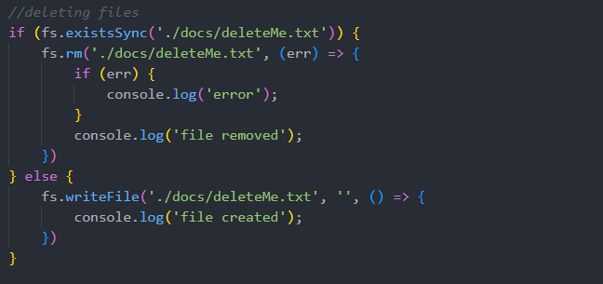

Stream and Buffer
- Stream: start using data, before it has finished loading (e.g. Youtube videos)

Server request and response
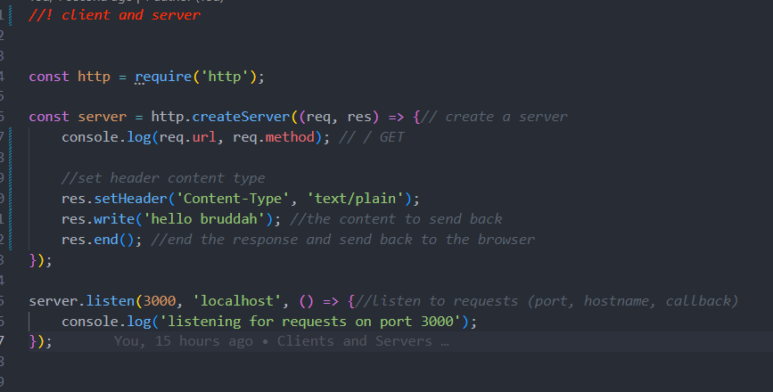
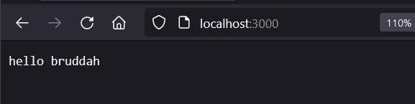
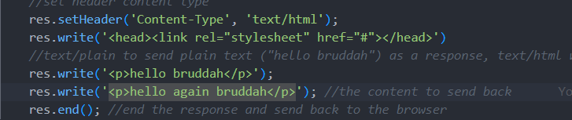

Basic Routing: route the path to the correct html page
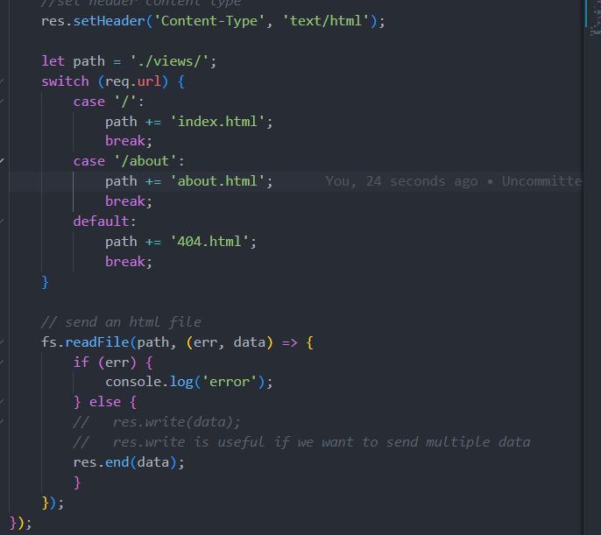

Status code
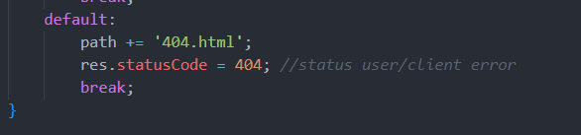

Redirect
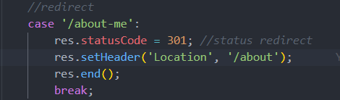

NPM
Install package globally (for every projects): npm install -g
- Nodemon
Npm init
- Package.json (manage package for the project - global)
- Package-lock.json (specifically for one project - local)
Npm -I <package>
Dependencies
- Don’t include node_modules in git: .gitignore node_modules
- Npm install to install modules again

Express Apps
Npm install express

Create express app: app.js
- Res.send(): infer type of content and status code to the browser (content type header)
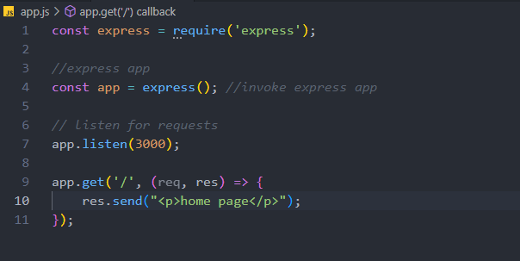
Routing and html pages
- Res.sendFile(): look for ABSOLUTE path from the computer (__dirname, ./path)
- <nav>: navigation HTML
- Res.redirect(path to file)
- App.use(): response to every requests, suitable for detecting url mismatch (404 page not found)
- App.status(): set status code

View/Template Engines – Dynamic webpages
Npm install ejs
- Res.render(): render a ejs file
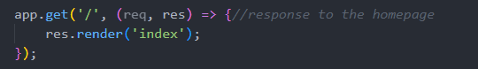

Passing data into views
- Not-so-good way
  - 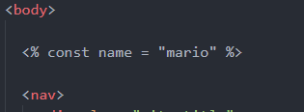 assign variables
  - output variables
- Dynamic title: another parameter into render()
  - 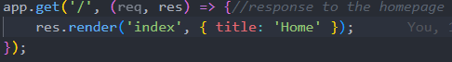
- Embedded JS code into ejs: Pass variables into ejs file and use it
  - 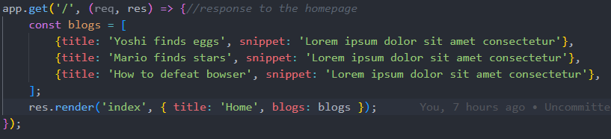
  - 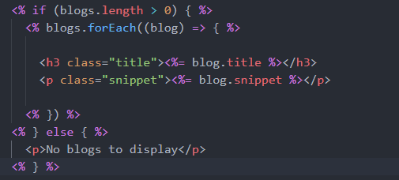
- Partial template: Inheritance of same HTML code (navigation bar e.g.) – HTML template
  - Create partial folder in views and create some files
  - “Include” those partials into ejs views
  - 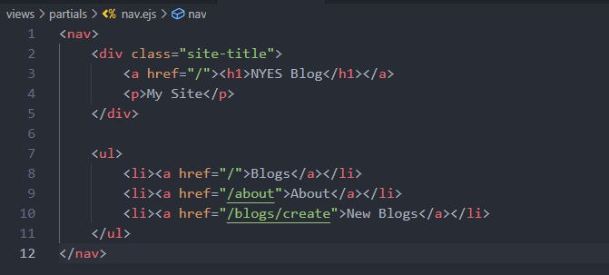
  - 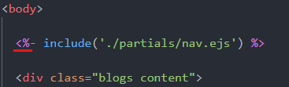
- Adding CSS

Middleware - .use()
“Code that run between getting a request and sending a response”
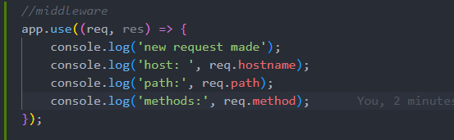
Using next()
- Tell it to move on to the next one (doesn’t send any response)
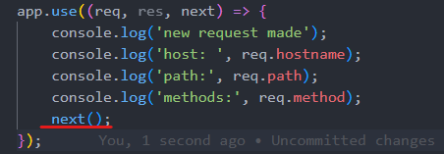

3rd party middleware: logging, security functions, etc.
- Morgan: logging middleware

Static files
- To allow access to files, should specify which file should be public
- Static middleware

MongoDB
Use mongoDB Atlas: dat09loz | PoN45CEsiNP1wodq
Connect to database:
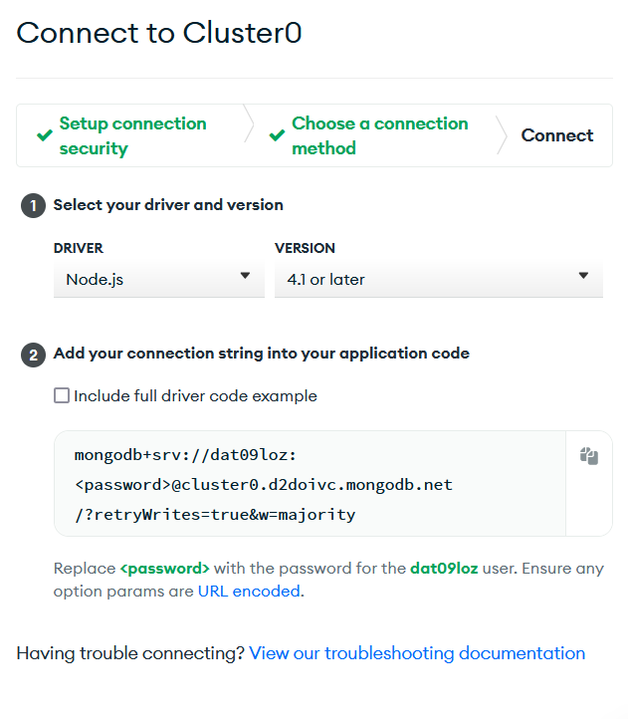
Mongoose – ODM Library (remember to specify collection name)
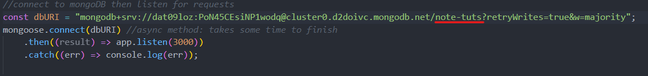
- Blog.js
Getting and saving data: Blog
- Require Blog.js
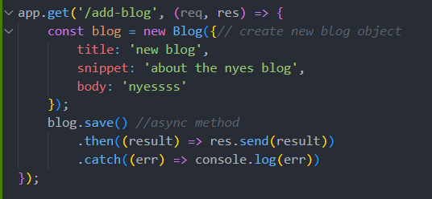
- Retrieving data
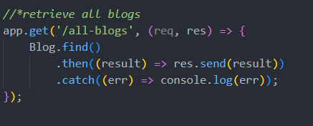

Output data in views
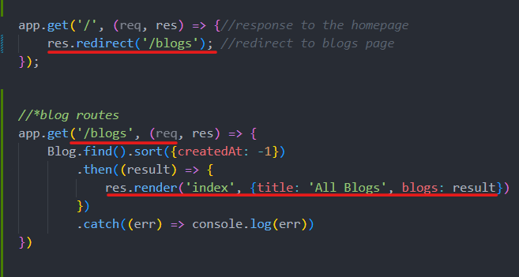

Get, post and delete request
- Get resource
- Post request to create new data
- Delete request to delete data
- Put request for update data

Post request (for creating a new blog post):
- In .ejs file: action tag for form and name tag for each input
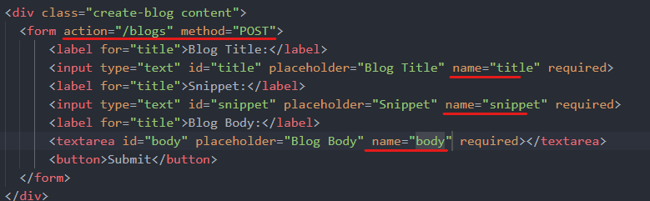
- Handle POST request on server app.js
  - Crate a middleware (process data from .ejs)
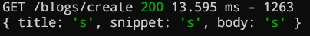
  - Create a POST req method to handle requests from /blogs
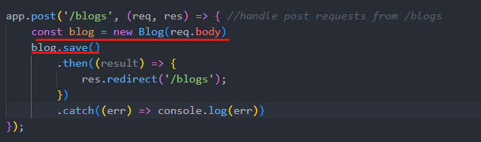

Get request (dynamic urls, for accessing each blog details in a new page)
- Surround each blog entries with its own url
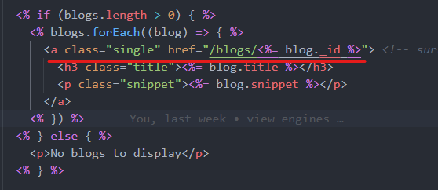
- Handle get request
  - Wrapped parameter in .get url ‘:id’ instead of ‘id’
  - Create a new ejs page to show blog details (with delete blogs function)
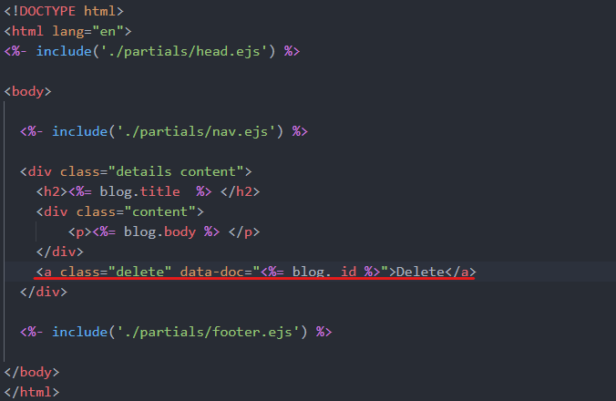
Delete request (delete each blog in their details page)
- Create a small script to handle delete – send delete request to server (details.ejs)
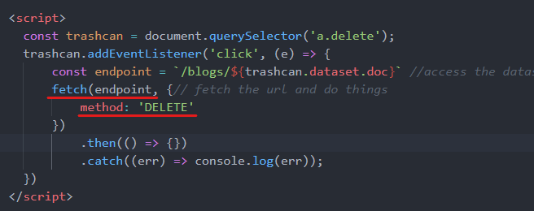
- Server delete the document based on _id, send json as response
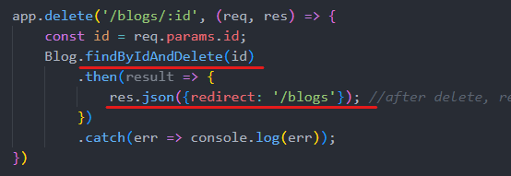
- Pass the response into JS object
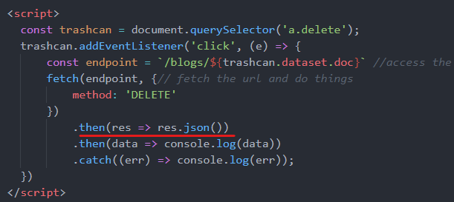
- Set the current URL to redirect property of the data object
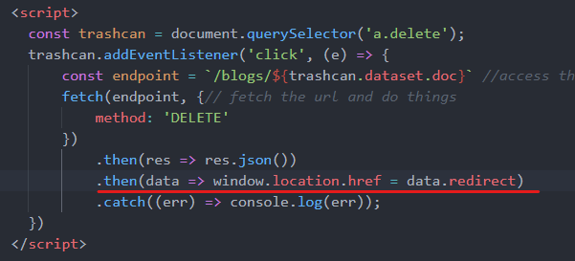

MVC
Express router – handle REST operations a lot more effective
- A new router to handle blog pages: ./routes/blogRoutes.js
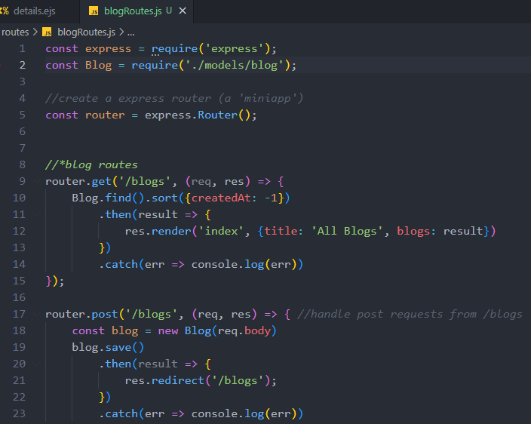
- Export routes and import the router in app.js
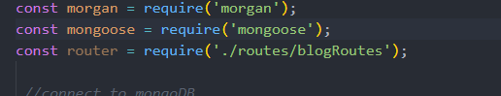
- Use the router in app.js (a middleware)
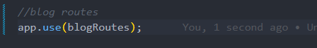
Remember to put GET request from STATIC ROUTES first (/blogs/create above /blogs/:id), or it’s not going to work
- Set /blogs to go to blogRoutes, the blogRoutes msg handler does not need to include /blogs/…. In front of it
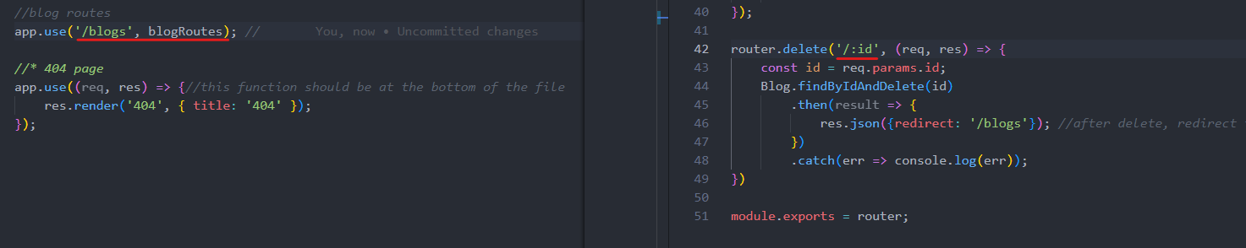

Controller (MVC approach) – blogController.js
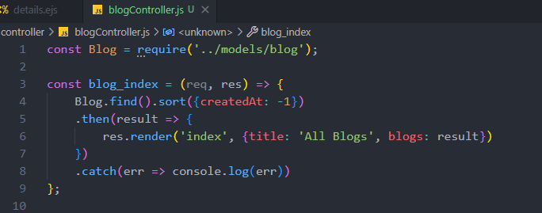
- In blogRoutes
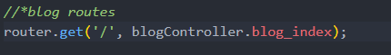
- It is good practice to store each view into different folder (blogs view in /blogs, user views in views/user, etc.)

Wrap Up
- Change the “delete” button to the trash icon
- Display 404 page when trying to find wrong blog _id
