Netninja
Repo link: https://github.com/dat09loz/react-learning

Create a React Application
Npx create-react-app <app-name>
Index.js will render the app component and inject it in the root div (in index.html)

Components and templates
Components contain templates and logic
Index.js: kickstart the application
JSX template: component always returns jsx template
ReactDOM.render()

Dynamic Values in Templates
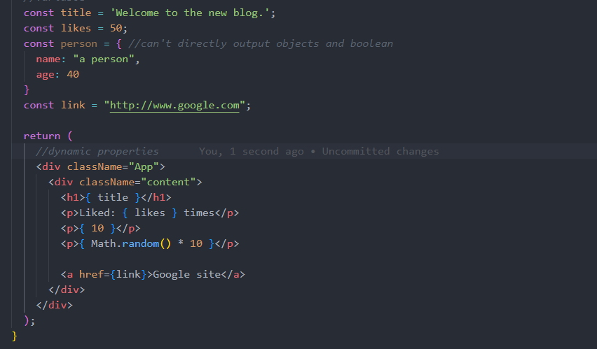

Multiple components
App.js: root component
- Nest other components to the root component
- Navbar.js
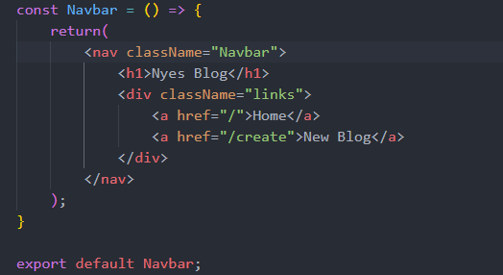
- Use it inside App.js
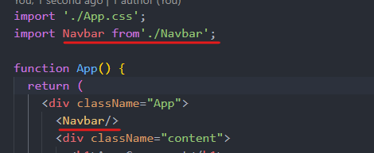

Click events
Separate function and invoke it by onClick
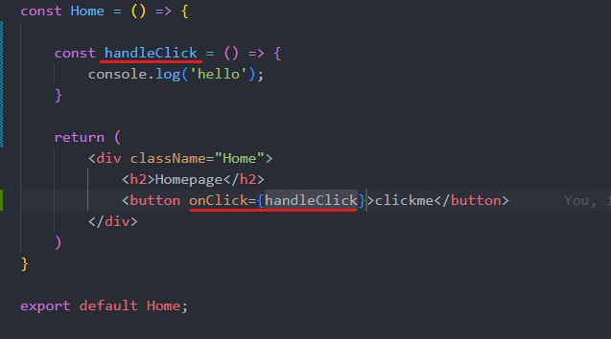
Anonymous function (pass in dynamic values) – wrapping in another function to prevent it from invoking immidiately
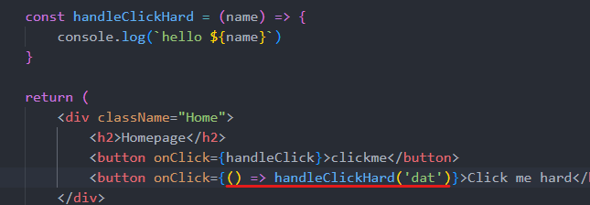
Event object (when the user do something – click a button)
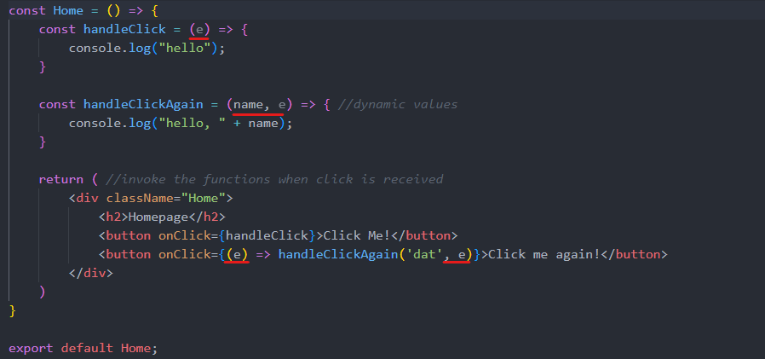

Using states
Create a “reactive” variables: a state hook useState
Use normal import if the component has a default export (export default <component>), it will return the default no matter how you call it; named export {<component>} export the specific export component name (if it allow export ofc)
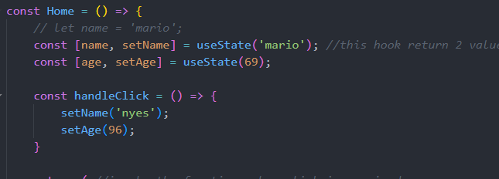
- The first argument define a variable, second one define the action that will be execute after a click

Intro to React Dev Tool
React development tools

Outputting List
Map method: cycle through the array and do something to each of them
Key property: keep track of each item of the DOM as they output it
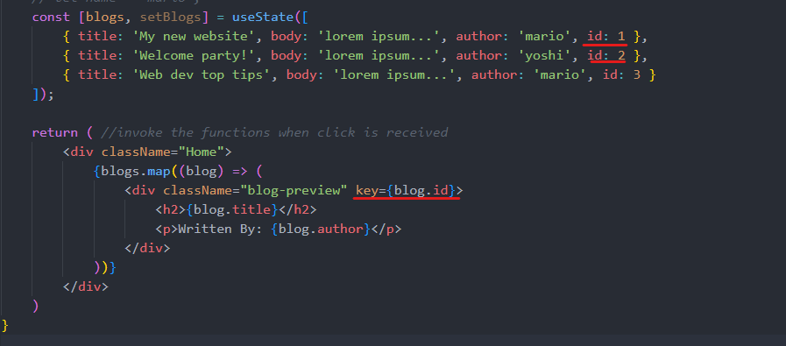

Props and Reusable Components
Props: pass data from a parent component to a child component
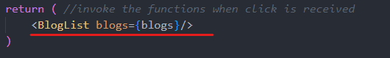home.js (parent)
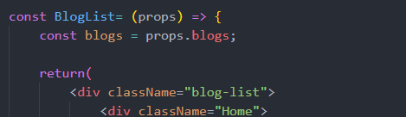BlogList.js (child)
- Multiple props
- Destructor the props directly
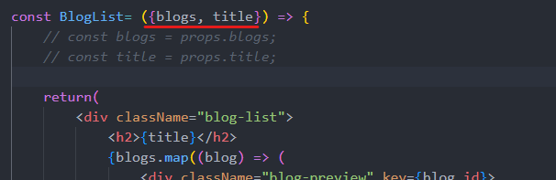

Reusing Components
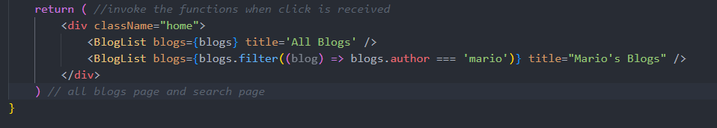

Functions as Props (handle delete)
Define the function in the parent component and pass it in as a prop
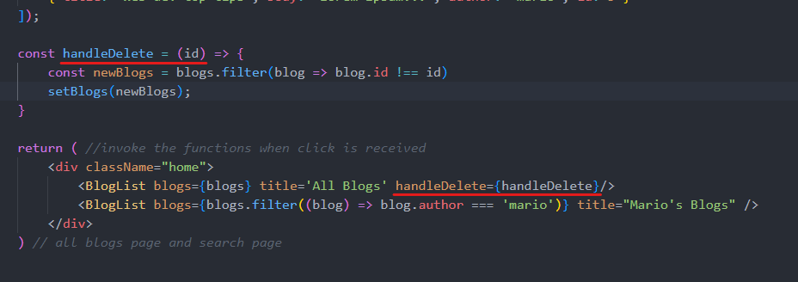
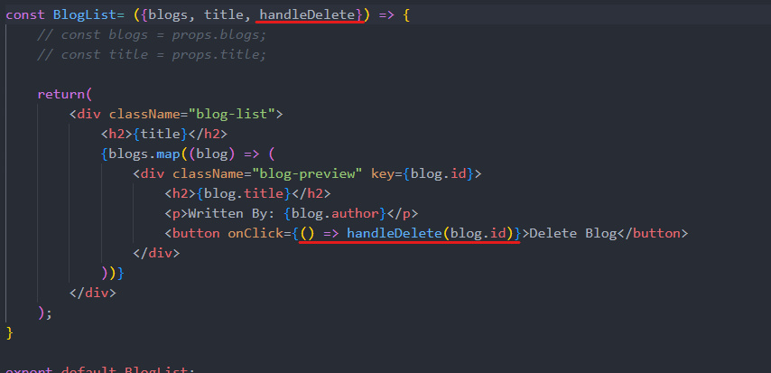

useEffect hook
run the function every render() of the component (page reload, etc.), and when the state changes (useful for fetching data for example)
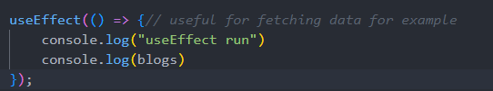
- No return values

useEffect Dependencies
e.g. when we only need it to run at certain times, not every time the state changes - -
- empty array: useEffect only run in the initial render
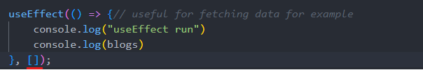
- Variable array: useEffect only run initially, and every time the variables’ state change
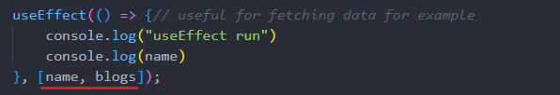

Using JSON server
Create db.json
Json-server: a fake REST API server: npx json-server –watch data/db.json –port 8000
- Watch the db.json file and host it on port 8000
Endpoints
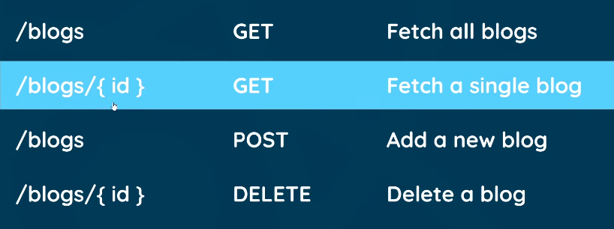

Fetching data with useEffect
Fetch().then(return js object).then(do stuff with JS object)
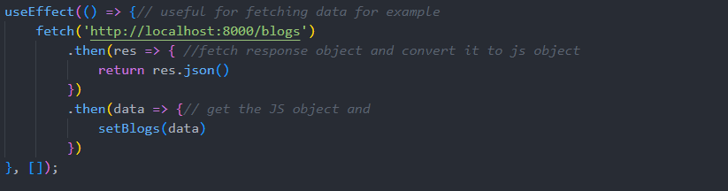

Conditional template
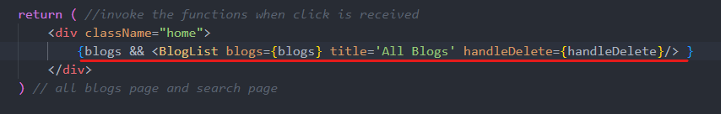
- The one on the right will be render only if the left is true

Conditional loading message
A loading screen while the data is being fetched
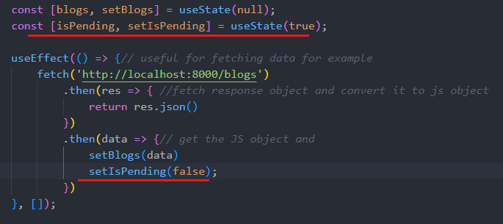
Another conditional template
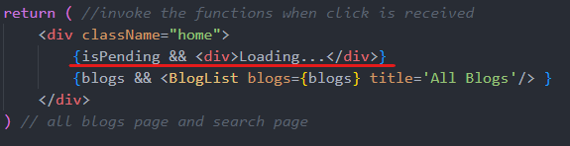

Handling errors
When the connection to the server failed: catch method
When the response is not as expected:
- res.ok method
- throw Error(<err msg>)
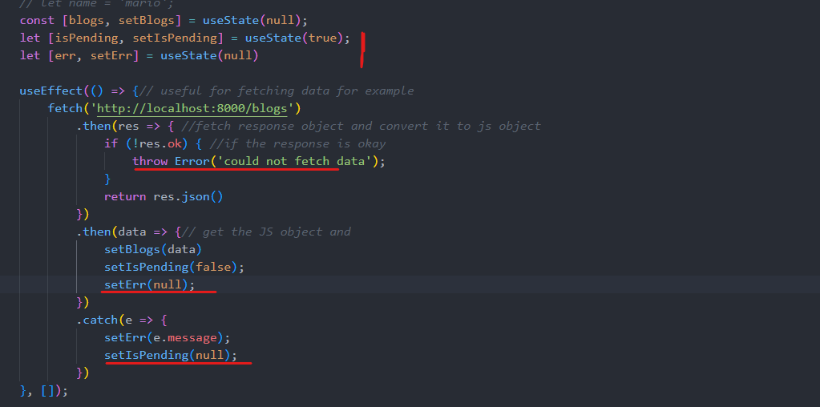

Making a custom hook
A custom useeffect we wrote above, can be used everywhere
Custom hook name starts with use: useFetch.js
useFetch return:
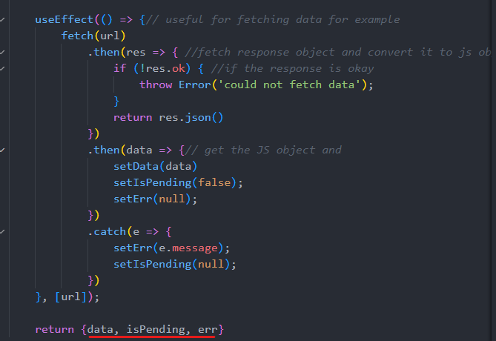
Use it in Home.js
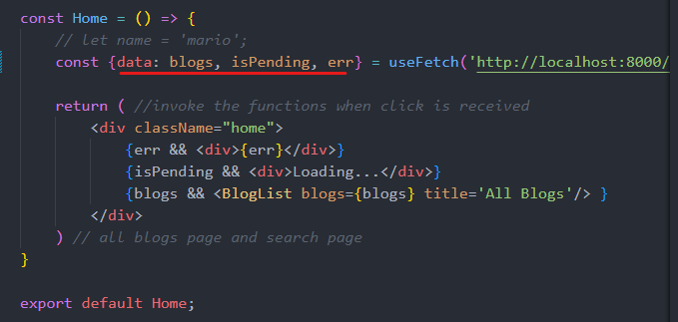

React Router
Install the package: react-router-dom
Import router package in App.js
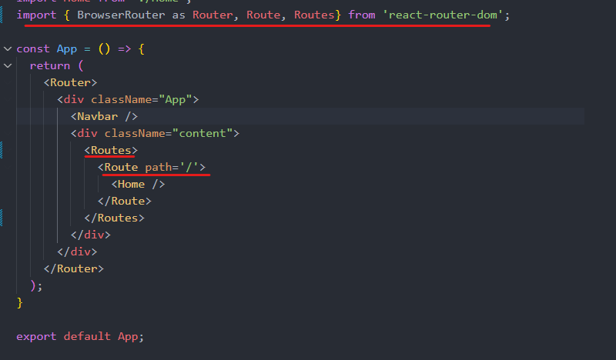
- router, routes (switch) and route
- navbar is not in the switch because it will be there in every page
- the path will show their respective page

Exact Match Route
Create a new page: Create.js and put a route in App.js
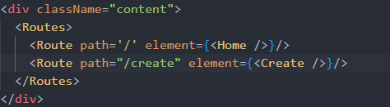

Router Links
Link component in react-router-dom: intercept requests and handle the content changes in the browser, instead of sending fresh requests (HTML request to the server every time)
- If you click “Home” in the home page, Link won’t send the request back to the server, but <a href> will send back every time you click “Home”

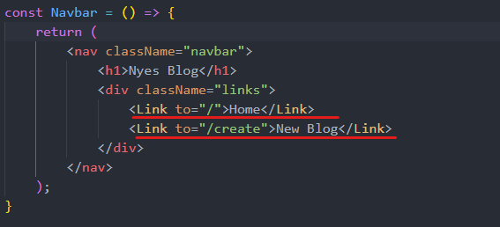

useEffect cleanup
To prevent memory leak (quickly switch to another page while the current page is still fetching data), and other stuffs
Implement an “abort controller” – use it inside useEffect function (useFetch.js)
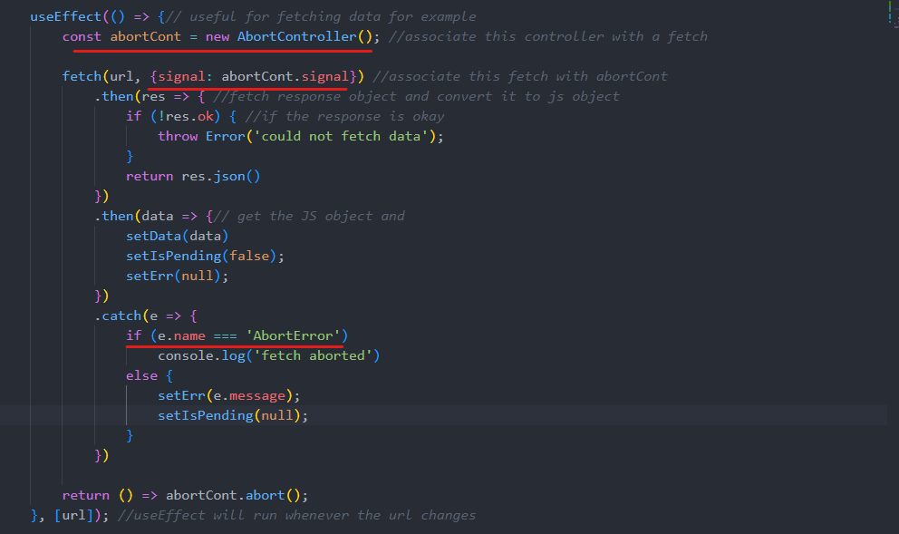

Route Parameters
Dynamic routes to the URLs (e.g. blog detail page): name it after “:”
- Use a hook to grab route parameter to the url: useParams
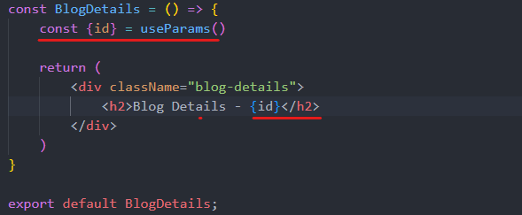
Configure the blog list (BlogList.js)
- Wrap each blog item list inside a link

Reusing Custom Hooks
Reusing the useFetch.js for fetching blog details
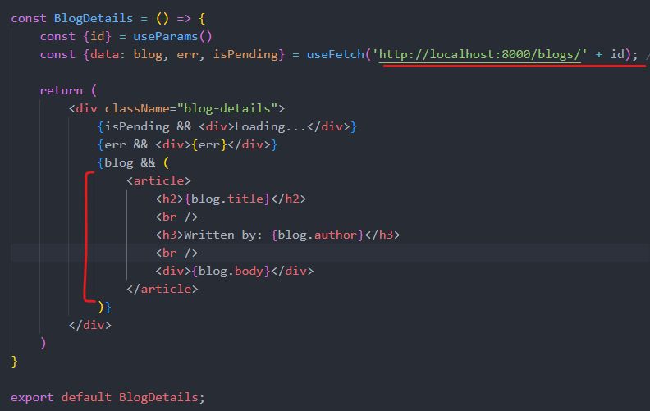
- The <article>tag specifies independent, self-contained content: foum post, blog post, news story ,…

Control inputs (forms)
Control input is implemented in input field and forms to track its value, and then store it in some type of state
Try it out in Create.js
- Create a input form

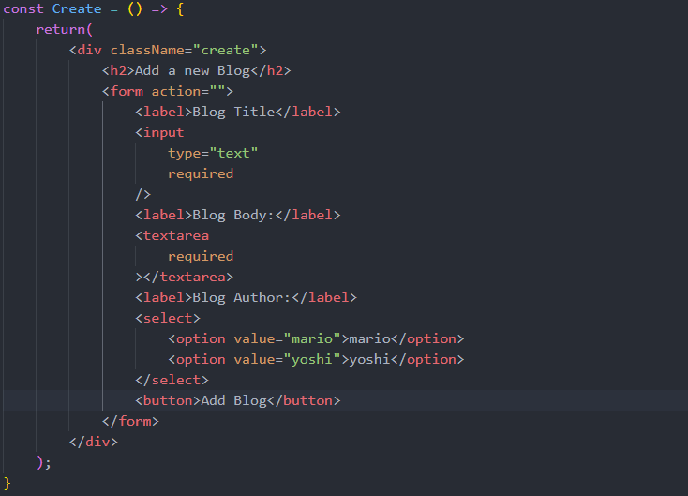
- Track input value and store it into state
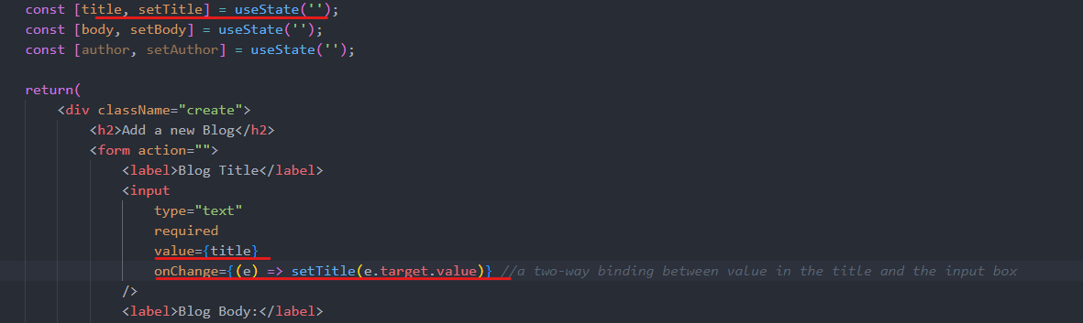
  - Assign “input” tag value to the title state
  - Whenever the input value change, it invoke the event change “e”, when it will set the title “setTitle()” to the target’s (this input tag) value
  - The same goes to body and author

Submit a form
A new function to handle submit (Create.js)
- <form onSubmit={handleSubmit}>: call the function after pressing the button
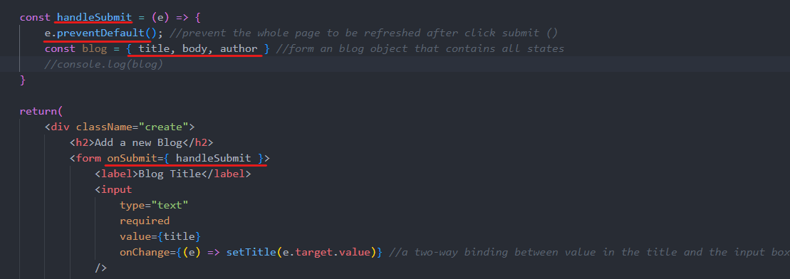
  - Event.preventDefault prevent a page from reloading after submit

Making a POST request
- A request to a server: fetch
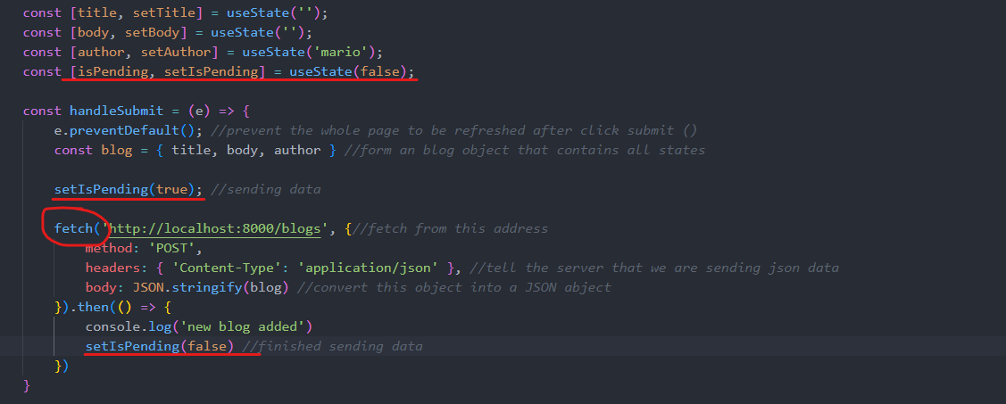
- Changing add button’s state when sending data to the server
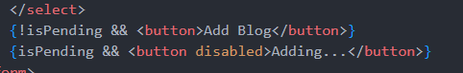

Programmatic Redirect
Send the user back to the homepage after adding a blog (Create.js)
Hook: useNavigate (router-dom v6)

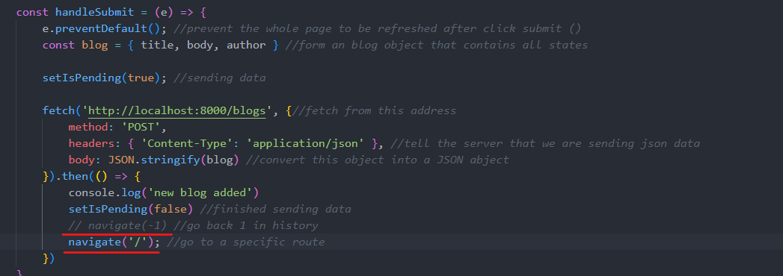

Deleting Blogs
A fetch request to the server with method DELETE (blogDetails.js)
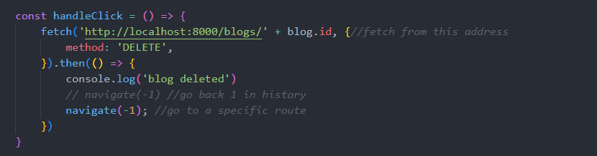

404 Page
NotFound.js
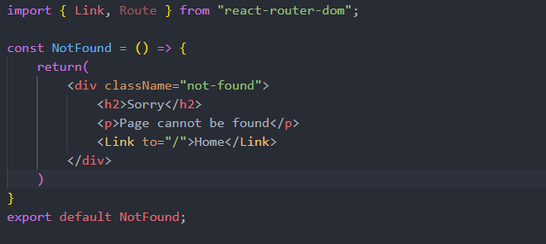
Set up a match-all route (if not match other defined routes) in App.js (should be at the very bottom of the routes list)

ReactJS Tut Official website
Components
Remember the action: the component use “state”: constructor: this.setState({prop: value})
It is good to store states in parent components

