Netninja

Repo link: <https://github.com/dat09loz/react-learning>

# Create a React Application

Npx create-react-app <app-name>

Index.js will render the app component and inject it in the root div (in index.html)

# Components and templates

Components contain templates and logic

Index.js: kickstart the application

JSX template: component always returns jsx template

ReactDOM.render()

# Dynamic Values in Templates

# Multiple components

App.js: root component

* Nest other components to the root component
* Navbar.js

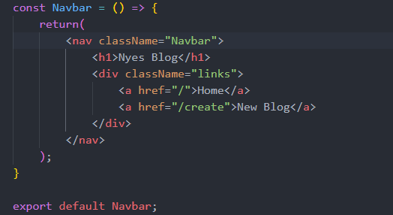

* Use it inside App.js

# Click events

Separate function and invoke it by onClick

Anonymous function (pass in dynamic values) – wrapping in another function to prevent it from invoking immidiately

Event object (when the user do something – click a button)

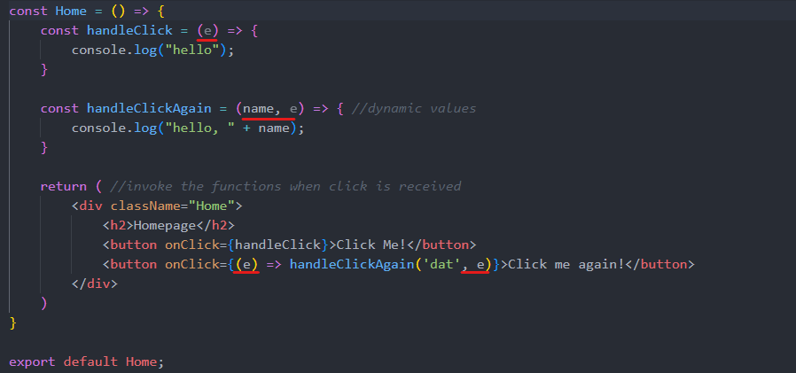

# Using states

Create a “reactive” variables: a state hook useState

Use normal import if the component has a default export (export default <component>), it will return the default no matter how you call it; named export {<component>} export the specific export component name (if it allow export ofc)

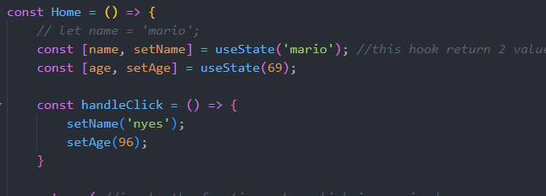

* The first argument define a variable, second one define the action that will be execute after a click

# Intro to React Dev Tool

React development tools

# Outputting List

Map method: cycle through the array and do something to each of them

Key property: keep track of each item of the DOM as they output it

# Props and Reusable Components

Props: pass data from a parent component to a child component

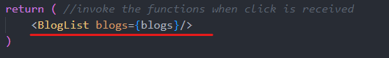home.js (parent)

BlogList.js (child)

* Multiple props 
* Destructor the props directly

# Reusing Components

# Functions as Props (handle delete)

Define the function in the parent component and pass it in as a prop

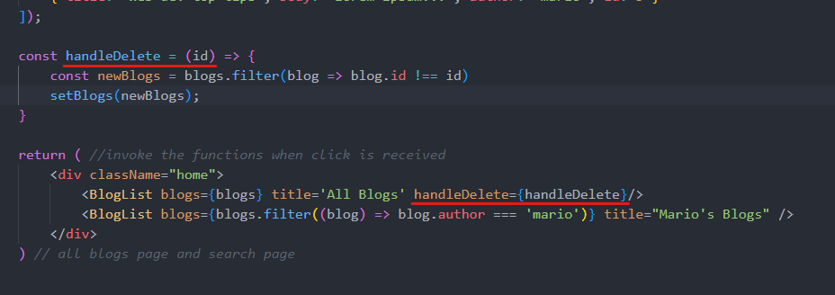

# useEffect hook

run the function every render() of the component (page reload, etc.), and when the state changes (useful for fetching data for example)

* No return values

# useEffect Dependencies

e.g. when we only need it to run at certain times, not every time the state changes - -

- empty array: useEffect only run in the initial render

* Variable array: useEffect only run initially, and every time the variables’ state change

# Using JSON server

Create db.json

Json-server: a fake REST API server: npx json-server –watch data/db.json –port 8000

* Watch the db.json file and host it on port 8000

Endpoints

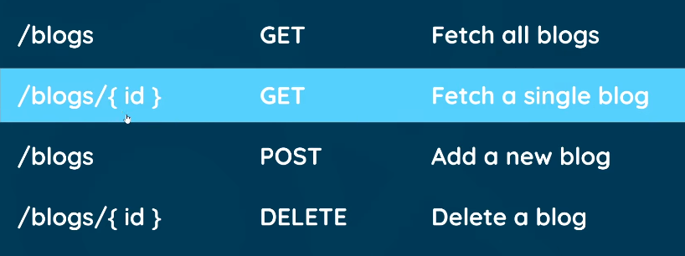

# Fetching data with useEffect

Fetch().then(return js object).then(do stuff with JS object)

Conditional template

* The one on the right will be render only if the left is true

# Conditional loading message

A loading screen while the data is being fetched

Another conditional template

# Handling errors

When the connection to the server failed: catch method

When the response is not as expected:

* res.ok method
* throw Error(<err msg>)

# Making a custom hook

A custom useeffect we wrote above, can be used everywhere

Custom hook name starts with use: useFetch.js

useFetch return:

Use it in Home.js

# React Router

Install the package: react-router-dom

Import router package in App.js

* router, routes (switch) and route
* navbar is not in the switch because it will be there in every page
* the path will show their respective page

# Exact Match Route

Create a new page: Create.js and put a route in App.js

# Router Links

Link component in react-router-dom: intercept requests and handle the content changes in the browser, instead of sending fresh requests (HTML request to the server every time)

* If you click “Home” in the home page, Link won’t send the request back to the server, but <a href> will send back every time you click “Home”

# useEffect cleanup

To prevent memory leak (quickly switch to another page while the current page is still fetching data), and other stuffs

Implement an “abort controller” – use it inside useEffect function (useFetch.js)

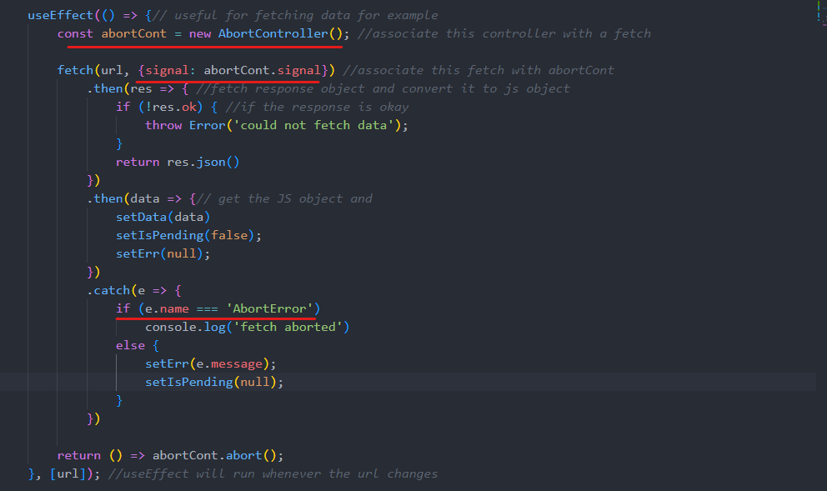

# Route Parameters

Dynamic routes to the URLs (e.g. blog detail page): name it after “:”



* Use a hook to grab route parameter to the url: useParams

Configure the blog list (BlogList.js)

* Wrap each blog item list inside a link

# Reusing Custom Hooks

Reusing the useFetch.js for fetching blog details

* The <article>tag specifies independent, self-contained content: foum post, blog post, news story ,…

# Control inputs (forms)

Control input is implemented in input field and forms to track its value, and then store it in some type of state

Try it out in Create.js

* Create a input form

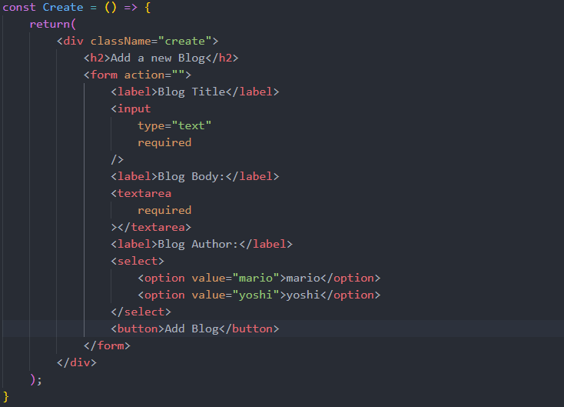

* Track input value and store it into state

* + Assign “input” tag value to the title state
  + Whenever the input value change, it invoke the event change “e”, when it will set the title “setTitle()” to the target’s (this input tag) value
  + The same goes to body and author

# Submit a form

A new function to handle submit (Create.js)

* <form onSubmit={handleSubmit}>: call the function after pressing the button

* + Event.preventDefault prevent a page from reloading after submit

# Making a POST request

* A request to a server: fetch

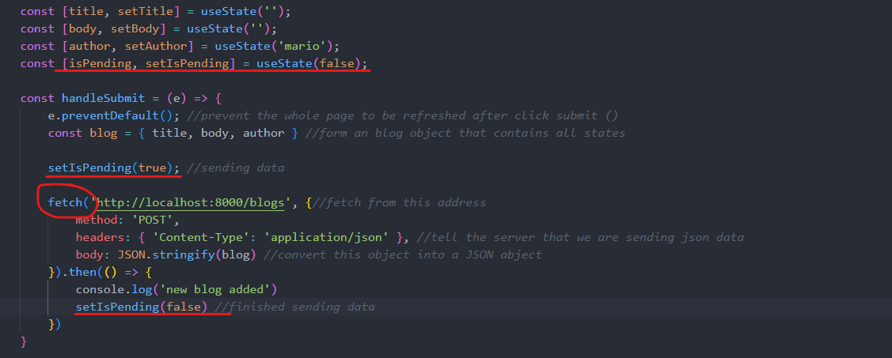

* Changing add button’s state when sending data to the server

# Programmatic Redirect

Send the user back to the homepage after adding a blog (Create.js)

Hook: useNavigate (router-dom v6)



# Deleting Blogs

A fetch request to the server with method DELETE (blogDetails.js)

# 404 Page

NotFound.js

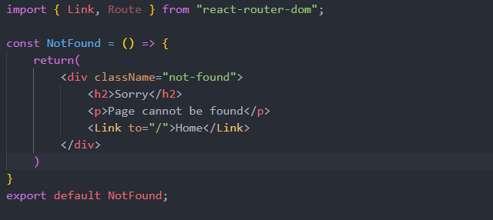

Set up a match-all route (if not match other defined routes) in App.js (should be at the very bottom of the routes list)



ReactJS Tut Official website

Components

Remember the action: the component use “state”: constructor: this.setState({prop: value})

It is good to store states in parent components