**The Evolution of Orthodontic Treatments: From Traditional Braces to Modern Solutions**

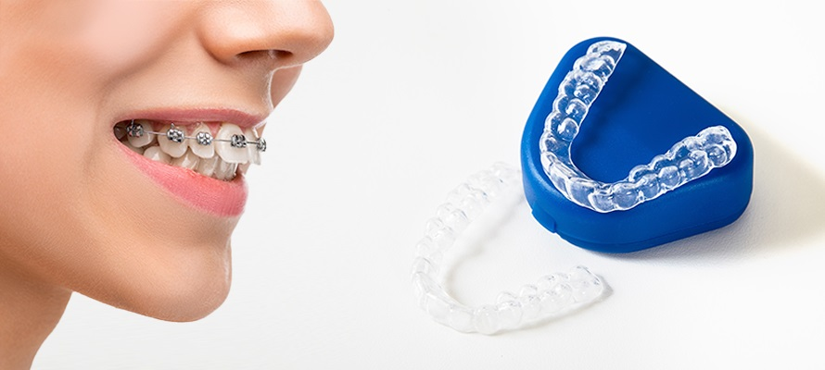

The field of orthodontics has witnessed a remarkable evolution over the years. From the early days of metal bands and wires to the latest clear aligners, the journey has been driven by a constant pursuit of more effective, comfortable, and aesthetically pleasing treatments. [Orthodontist](https://www.masterpiecesmilesbraces.com/)s, as specialized dental professionals, have been at the forefront of these advancements, transforming not just smiles but also enhancing the overall dental health and confidence of their patients.

**The Early Days of Orthodontics:**

Orthodontic treatments date back to ancient times, with evidence of dental appliances found in Egyptian mummies. However, it wasn’t until the 18th and 19th centuries that orthodontics began to resemble a scientific discipline. The introduction of metal wires in the early 1800s marked a significant leap, laying the foundation for modern orthodontic practices. These early devices were rudimentary, often uncomfortable, and not particularly aesthetic, but they opened the door to the idea of guided tooth movement.

**The Era of Traditional Metal Braces:**

For decades, traditional metal braces have been synonymous with orthodontic treatment. Comprising brackets attached to each tooth and connected by a wire, these braces apply continuous pressure to shift teeth into the desired position over time. Despite their visibility, metal braces have been highly effective in treating a wide range of dental misalignments and bite issues. Orthodontists have refined these treatments over the years, improving the materials and techniques to enhance comfort and reduce treatment time.

**Introduction of Ceramic and Lingual Braces:**

In response to the demand for less noticeable orthodontic solutions, the late 20th century saw the introduction of ceramic braces. Made from composite materials, these braces blend more seamlessly with the natural color of teeth, offering a discreet alternative to metal braces. Lingual braces, attached to the back of the teeth, provided an even more invisible option. These innovations represented a significant step in the evolution of braces, catering to the aesthetic concerns of patients, particularly adults.

**The Clear Aligner Revolution:**

The turn of the millennium brought a groundbreaking innovation in orthodontics – clear aligners. Led by brands like Invisalign, clear aligners have revolutionized orthodontic treatment, offering an almost invisible way to straighten teeth. Custom-made from clear plastic, these aligners are not only discreet but also removable, allowing for easier eating and oral hygiene. Orthodontists have embraced this technology, expanding the possibilities of orthodontic treatment to a broader range of patients.

**Technological Advancements in Orthodontics:**

Modern orthodontics is as much about technology as it is about medical science. Digital imaging and 3D printing have enabled orthodontists to create precise models of patients’ mouths, allowing for customized treatment planning. Innovations like digital scanners replace the need for traditional dental impressions, enhancing patient comfort. Furthermore, software advancements have improved the predictability of treatments, allowing orthodontists and patients to visualize potential outcomes before the treatment even begins.

**The Role of Orthodontists in the Evolution:**

[Orthodontist](https://www.masterpiecesmilesbraces.com/)s have played a pivotal role in the evolution of these treatments. Their specialized training in dental alignment and bite correction has enabled them to effectively integrate new technologies and methods into their practices. By staying abreast of the latest advancements, orthodontists ensure that they are providing the best possible care to their patients.

**The Future of Orthodontics:**

The future of orthodontics looks promising, with ongoing research and development in materials science, digital technology, and biological methods. Innovations like temporary anchorage devices (TADs) and low-friction systems are already enhancing treatment effectiveness. The potential integration of biotechnology, including the use of growth factors or gene therapy for guided tissue regeneration, could further revolutionize the field.

The evolution of orthodontic treatments reflects a remarkable journey from basic metal appliances to sophisticated, customized solutions. Today, orthodontists are equipped with a range of options to suit the specific needs and preferences of each patient. As technology continues to advance, the field of orthodontics will undoubtedly introduce even more innovative solutions, continuing to improve the oral health and smiles of patients around the world.