Assignment Title: Leveraging Artificial General Intelligence (AGI) in Healthcare
Student Name: Dat Dang Nguyen
Course: ITAI 2372
Instructor: Prof. Anna Devarakonda
A12 - Leveraging Artificial General Intelligence (AGI) in the Healthcare Industry
I. Introduction
Artificial general intelligence (AGI) is the next step in the evolution of artificial intelligence. Unlike narrow AI, which is intended to perform specialized tasks such as image recognition or language translation, AGI seeks to duplicate human-level intelligence across a broad range of cognitive activities. This includes reasoning, problem-solving, learning from minimal data, and adapting to new situations without explicit programming.
AGI has the potential to dramatically improve the healthcare business given its complexity, high data volume, and the vital requirement for accuracy. Healthcare systems worldwide face challenges such as rising costs, physician shortages, delayed diagnoses, and fragmented data systems. While contemporary AI systems have made significant advances, they remain constrained in breadth and flexibility.
This case study examines how AGI could improve patient outcomes, overcome current constraints, and enhance decision-making in the healthcare sector. It also examines the ethical issues and dangers of using AGI in such a delicate field.
II. Industry Analysis: Healthcare's Present Situation
One of the most important yet complicated industries in the world is the healthcare sector. Hospitals, clinics, insurance companies, pharmaceutical firms, and patients are among the many parties involved. Medical technology has advanced, but the sector still faces significant obstacles.
Ineffective diagnosis and treatment are one of the main problems. Inaccurate or delayed diagnosis may result from doctors' frequent reliance on fragmented patient data. Furthermore, it is challenging for medical practitioners to keep up with the latest discoveries due to the growing volume of medical research.
The lack of medical experts, especially in poor and rural regions, is another issue. This results in long wait times and restricted access to high-quality care. The time physicians spend with patients is further diminished by administrative responsibilities, such as paperwork and insurance processing.
Another major problem is cost. Globally, healthcare costs are increasing due to aging populations, chronic illnesses, and costly treatments. Inefficient resource allocation and redundant procedures contribute to unnecessary costs.
Some of these problems are now being addressed by narrow AI technology. For instance:
Medical Imaging AI: Radiologists can identify anomalies in X-rays, MRIs, and CT scans using deep learning models.
Chatbots and virtual assistants: Used for basic health-related questions and patient triage.
Patients at risk of developing chronic diseases can be identified using predictive analytics.
Robotic surgery: Improves surgical accuracy.
These applications are useful, but they work only in specific fields and cannot incorporate information from other fields or adapt to novel, unexpected situations.
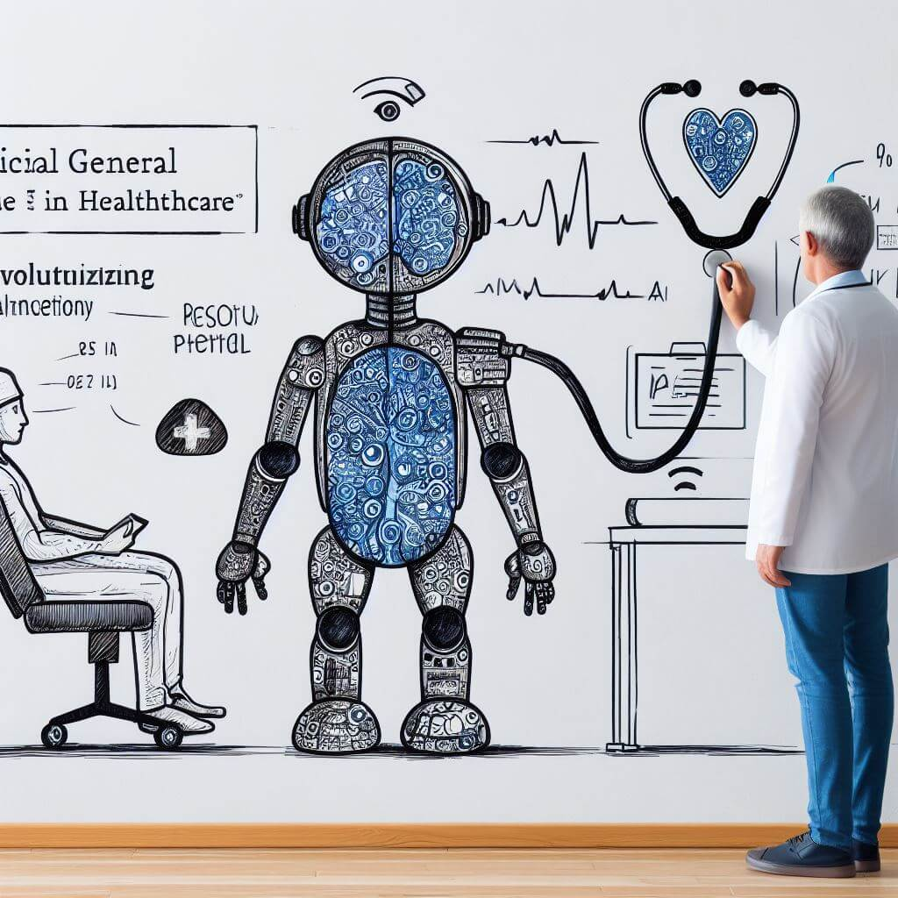
III. AGI Application Proposal
Artificial General Intelligence varies from standard AI in numerous important respects. While narrow AI excels at certain tasks, AGI can interpret, acquire, and apply information from numerous fields. It is capable of abstract reasoning, making judgments in the face of ambiguity, and improving over time
In healthcare, this means an AGI system might perform similarly to a highly competent physician who diagnoses ailments while taking into account the patient's history, lifestyle, genetics, and the latest medical research.
Proposed AGI Applications for Healthcare
One of the most transformational uses of AGI in healthcare is the creation of a Unified AGI Medical Assistant. This system would function as an intelligent, end-to-end healthcare solution, assisting both patients and medical personnel.
1. Comprehensive Diagnosis System.
The AGI system might use a patient's complete medical history, symptoms, genetic data, and lifestyle factors to deliver an accurate, rapid diagnosis. Unlike existing AI systems, which focus on single ailments, AGI may assess multiple situations simultaneously and uncover intricate relationships among them.
For example, a patient with exhaustion may be tested for anemia, thyroid diseases, mental health issues, and lifestyle concerns all at once, resulting in a more comprehensive diagnosis.
2. Personalized Treatment Plans
AGI may create individualized treatment strategies for each patient. It would account for genetic predispositions, probable medication interactions, and patient preferences. The algorithm might also simulate treatment outcomes and propose the most effective method.
3. Real-Time Clinical Decision Support.
During patient meetings, AGI might help clinicians by delivering real-time insights, recommending diagnostic procedures, and flagging potential hazards. This would increase the accuracy and efficiency of medical judgments.
4. Automated administrative processes.
AGI may manage administrative chores, including medical documentation, insurance claims, and appointment scheduling. This would considerably reduce healthcare professionals' workloads and allow them to devote more time to patient care.
5. Continuous Learning and Research Integration
AGI systems might constantly study new medical studies and update their knowledge base. This guarantees that healthcare providers always have access to the most current evidence-based procedures.
Benefits of AGI in healthcare
Implementing AGI in healthcare might have various benefits:
Improved Diagnostic Accuracy: By combining multiple data sources, AGI can eliminate errors and provide more accurate diagnoses.
Increased Efficiency: By automating routine processes, healthcare personnel can focus on more complex patients.
Enhanced Accessibility: AGI-powered systems can give medical assistance in rural or underdeveloped areas.
Cost reduction: Better resource utilization and less duplication reduce total healthcare expenses.
Personalized Care: Tailored therapies lead to better patient results and satisfaction.
Potential Risks and Ethics Concerns
Despite its promise, AGI in healthcare brings several serious challenges.
1. Data Privacy and Security.
Healthcare data is very sensitive. Maintaining the confidentiality and security of patient information is crucial. Unauthorized access or data breaches may have serious implications.
2. Bias and Fairness.
If AGI systems are trained on biased datasets, they may deliver uneven results across demographic groups. This might increase current healthcare inequities.
3. Worker Displacement
The automation of administrative and diagnostic operations may lessen the demand for certain professions in the healthcare sector. This raises worries about job displacement and the importance of worker reskilling.
4. Decision-Making and Accountability
It is difficult to assign blame for medical judgments made by AGI systems. It's unclear who should be held responsible if an AGI system misdiagnoses someone.
5. Ethical Technology Use
AGI has the potential to be applied in ways that prioritize financial gain over patient welfare. To stop abuse, strict ethical rules and regulations are required.
IV. Conclusion
By tackling its most urgent problems, artificial general intelligence can completely transform the healthcare sector. AGI has the potential to significantly improve the efficacy and efficiency of healthcare systems by automating administrative tasks, enabling individualized therapy, and enhancing diagnostic accuracy.
Adoption of AGI, however, needs to be done carefully. To ensure that the technology benefits all stakeholders, concerns such as prejudice, data privacy, and ethical obligations must be properly addressed.
AGI has the potential to become a vital healthcare tool in the future, enhancing rather than replacing human talents. The sector may evolve toward a more effective, accessible, and patient-centered form of care by fusing human knowledge with cutting-edge computer intelligence.
V. References
- Topol, E. (2019). Deep Medicine: How Artificial Intelligence Can Make Healthcare Human Again. Basic Books.
- Esteva, A., et al. (2017). Dermatologist-level classification of skin cancer with deep neural networks. Nature, 542(7639), 115–118.
- World Health Organization. (2021). Ethics and governance of artificial intelligence for health.
- McKinsey & Company. (2023). The future of AI in healthcare.
- Stanford University. (2024). AI Index Report.

