ICT 365

Software Development Frameworks

Assignment 2

Map Applications using WinForms and ASP .NET

Name: Syed Faizullah Hussaini

ID: 33243485

Table of Contents

**Comparison and Reflection3**

**Description4**

**Specification5**

**Brief Description of the Solution11**

**Additional Evidence of Testing**1**2**

**Source Code List14**

**Evaluation15**

**References16**

Comparison and Reflection

ASP.NET is a web development technology provided by .NET framework from Microsoft to produce dynamic webpages. It is a popular web-development framework for building web apps on the .NET platform. ASP .NET pages are text files with an .aspx file name extension. The ASP .NET runtime parses and compiles the file into a .NET framework class, and this class is used to dynamically process the incoming requests. It is interesting to note that the .aspx file is only compiled once, and the compiled type instance is subsequently reused across multiple requests. An ASP .NET page is created by simply taking an existing HTML file and changing its file name extension to .aspx. For better error messages for our asp .net pages, we can also add a file named Web.Config. The scripting language used with Asp .NET are Visual Basic .NET and C# .NET [1].

ASP .NET web forms enables us to establish an interaction to the web applications. The browser submits a web form to the web server and in response the server returns a web page [2]. The .Net framework is made of an object-oriented hierarchy. An ASP.NET web application is made of different pages. When a user requests a specific page, the IIS server assigns the page processing to the ASP.NET runtime system. The ASP.NET runtime system transforms the aspx page into an instance of a class. Hence, each ASP.NET page is an object itself [2].

XAML stands for Extensible Application Markup Language. It is a declarative language based on XML. It is a language that is normally used to instantiate .NET objects. It is mostly used for designing GUI’s, and the goal of XAML is to help in creating user interface elements. All XAML files are converted into BAML at runtime by MSBuild which is an assembly present in .NET framework. BAML is the binary representation of XAML that we see in our UI. The properties of Classes defined in XAML are specified as attributes. The code-behind class is generated using partial class concept of C#. This code-behind class is responsible for functioning of WPF application.

ASP .Net is easy to execute on the IIS server and requires less coding to build complex and large applications. It gives developers freedom to integrate various APIs to build projects and implement different useful features in the applications. Moreover, it is more fitting to use ASP .NET for applications that deal with SOAP XML data. Hence, it was more fitting to use ASP .NET for this assignment purpose. Both ASP .Net and XAML give developers graphical development environment and can be used to develop web applications. There is separation of code and UI in both XAML and ASP .NET, this allows us to clearly separate the roles of designer and developer. XAML is a declarative language which is based on XML. It is mainly used to develop GUIs and can be used for other purposes such as declaraing Workflows in Workflow Foundation. Unlike ASP.NET, XAML code gets converted into BAML code at runtime.

ASP.NET libraries can be used on .NET Core. So to migrate a WPF XAML app to .NET Core for integrating with ASP .NET, the first step is to review all the app’s dependencies and make sure that the references are in the format that enables us to easily migrate to .NET Core. The next step requires NuGet dependencies to be updated and the upgraded NuGet dependencies should use the <PackageReference> format. After that, the project file needs to be migrated to the new SDK-style format, and this requires us to either target .NET Core or .NET Standard compatibility. The relevant project file properties and items need to be copied to the new project file. Next, build issues need to be dealt with and this is done by adding a reference to the *Microsoft.Windows.Compatibility* package. The APL-level differences need to be spotted and fixes. Another important step would be to remove the *app.config* sections except the *appSettings* or *connectionStrings*, and then regenerated the generated code. The final step would be to confirm that the ported app works as expected by performing testing at runtime. There can be instances were exceptions like NotSupportedException pop-up, so these need to be dealt accordingly [3].

Description

The aim of this solution is to develop a simulation program that has a map as a foundation and is dependent on a person using lifelogging technology to input valuable personal information into the system, example, by uploading geotagged photos or status updates. This application can act as a kind of cognitive scaffold for Dementia sufferers supporting recall of important events, people and so on, in a person’s environment. The lifelog events are stored in a SOAP XML file which would act as the database for this application.

The first part of the assignment deals with Windows form. Windows forms is a Graphical User Interface (GUI) class library available in .Net framework. Its main feature is to provide a simple interface to develop desktop applications. It is also known as WinForms, and the applications developed using this platform are known as Windows Forms Applications. WinForms can only be used to develop Windows forms applications and does not support development of web applications. WinForms provides various types of controls like textbox, drop-down lists, radio buttons, etc [4].

In the second part of the assignment, the application is developed using ASP .NET which is a web application framework designed by Microsoft. ASP .NET is built on the Common Language Runtime (CLR) and allows the developers to run their code using both C# and VB. It is specially used by developers for creating dynamic web pages, web applications, web sites, etc. The web application developed using ASP .NET will run on Microsoft Internet Information Services or IIS server. The code behind will be written in C# by reusing some of the code developed in the first part of this assignment [5]. To connect with social media streams “Twitterinvi” API was used for tweeting messages on to the Twitter handle.

Specification

**Part 1**:

More than 20 events were added to a SOAP XML file with a minimum of two tracklog type events. The Windows form consists of a canvas map to display events from the SOAP XML file. The GMap.NET library was used to develop the canvas map. GMap.NET is a powerful, open-source and a cross-platform tool that enables geocoding and map presentation. GMap offers use of Google map, Yahoo map and Bing map, in this application I have implemented Google map. The events were plotted by extracting latitude and longitudes from the event information SOAP XML file. Markers have been used to represent an event on geographical location.

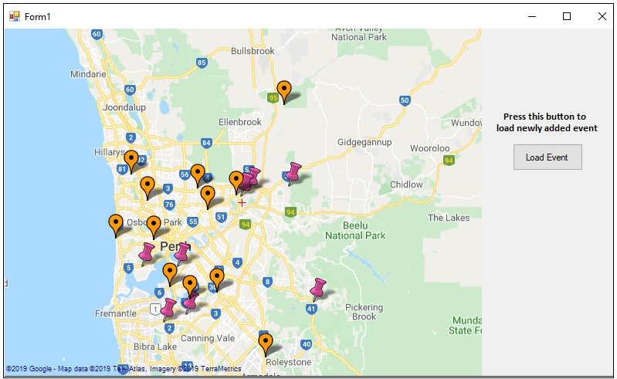

Figure 1: Displaying events on a map

Events from the SOAP file were read into a C# Dictionary using LINQ to XML. In C#, Dictionary is a collection that use to store key/value pairs. It is dynamic in nature because its size grows according to the requirement. In a Dictionary, the keys are always unique and not null as they are used to store and retrieve values from it. Only same type of elements can be stored in a Dictionary, and the size of a Dictionary is determined by the number of elements stored in it.



Figure 2: C# Dictionaries

The user is presented with an option to Add a new event, or Retrieve an event information by clicking on the canvas map. A pop-up box appears with buttons for making a selection to either add an event or inspect event.

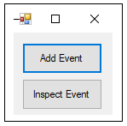

Figure 3: Choice box

When user presses the Add Event button, a drop-down list appears where the user can select the type of event, he/she wants to add. The different event types are photo, video, tracklog, facebook-status-update and tweet.

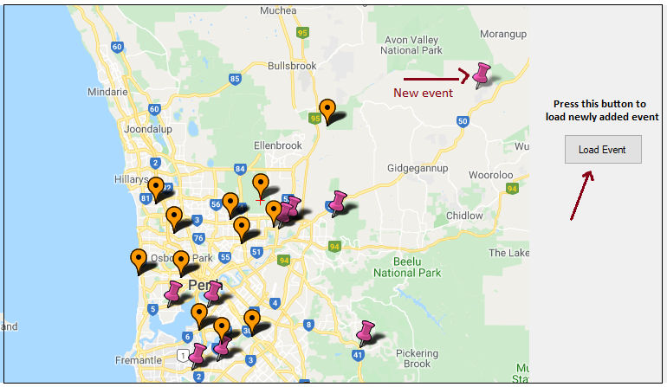

Figure 4: Adding new event

The new event information is added to Dictionary as well as to a XML file. After providing new event information, the Load Event button needs to be pressed to reload the canvas map.

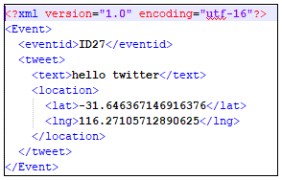

Figure 5: New event written to XML file

To retrieve information about an event, the user can simply click around the event and select Inspect Event button from the choice form. A sample of few event retrieval is shown in the figures below.

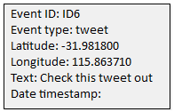

Figure 6: Tweet event

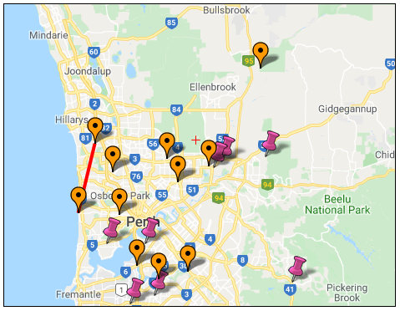

Figure 7: Tracklog event

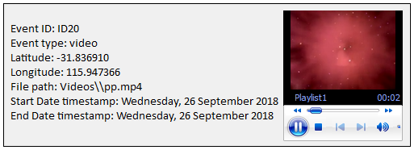

Figure 8: Video event

The instances were LINQ to XML was used in this solution are as follows:

1. When reading event information from the SOAP XML file into the dictionary.
2. Finding least distance value from a Dictionary that contains the distance of various events from a given point on the point.
3. Writing event information to XML file.

The .NET Framework uses XML extensively, and LINQ to XML provides a way to manipulate data in XML documents using the same syntax on arrays, collections, and databases. LINQ to XML also provides a set of classes for easily navigating and creating XML documents in your code. Each XML element name is represented by a node, and a node that contains other nodes is called a parent node. Nodes that have the same parent are called sibling nodes.

The Namespace **System.Xml.Linq** contains the classes used to manipulate a DOM in .NET, referred to collectively as LINQ to XML. The **XElement** class represents a DOM element node, and the **XDocument** class represents an entire XML document. The Xdocument’s Elements method can return all child elements, or only elements with a given tag name. The **Descendants** method returns all descendant elements with the given tag name, not just direct children.

There are two ways to read XML using LINQ to XML: Using the Xelement class or the XDocument class. Both the classes contain the ‘Load()’ method which accepts a file, a URL or XMLReader and allows XML to be loaded.

The XDocument class is used when you need to create an XML document containing XML declaration, XML Document Type (DTD) and processing instructions, comments or namespaces [6].

**Part 2**:

The platform used to develop the second part of the assignment is ASP .NET. For this application, the SOAP XML file contains information of different people and the level of support they can offer to the user. LINQ to XML was implemented again to read the XML file and the data was stored in a Dictionary.

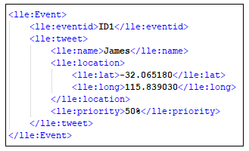

Figure 9: Data for ASP .NET application

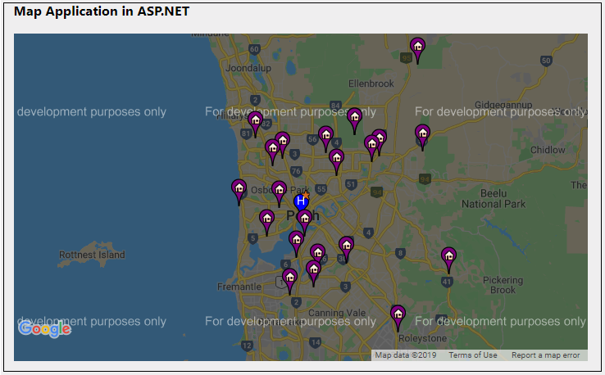

Figure 10: Map in ASP .NET

ASP .NET allows programmers to make use of APIs to develop applications. Application Program Interface (API) provides an interface to a server to make use of certain features. This solution makes use of jQuery and GMap APIs to load the canvas map. The markers represent the location of different individuals around the user. Hovering over the markers would display the information of the individual along with the level of support they can offer to assist the user. The level of support is represented in the form of percentage, and this gives the user guidance about whom to contact in order to request for support.

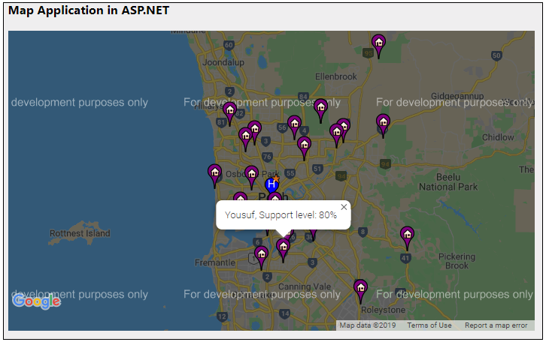

Figure 11: Level of support on Map

For interaction with social media streams Twitter platform was chosen. A C# .NET library called Tweetinvi allows us to access the Twitter REST API. It is a .NETCore and Portable class library that can be used for development desktop, mobile and web applications. Using this API messages can be tweeted by the user.

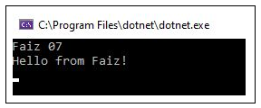

Figure 12: Console output

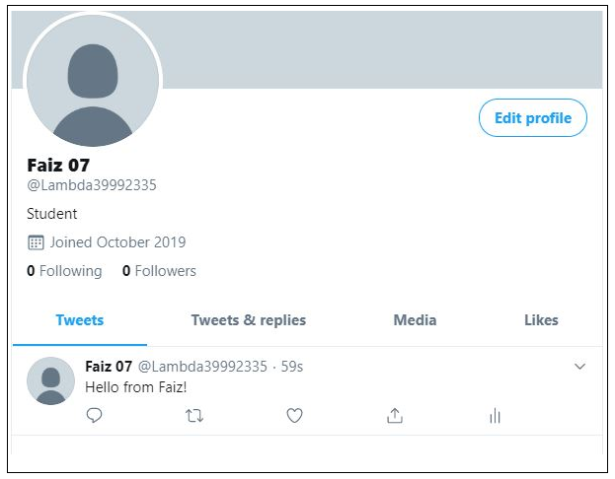

Figure 13: Message gets Tweeted

Brief description of the solution

I have classified the 5 different types of events into two groups. The class “Events1” was used to define a type of the “tweet” and “facebook-status-update” events, and the class “Events2” defines a type of the “photo”, “video” and “tracklog” events. This classification was done after analysing the similarities in the attributes of the five event types.

Since there are two classes then we also require two collections to store and manage them. Hence, two Dictionaries were used to store the events. Any new event that is added is also directly stored into the appropriate Dictionary. For retrieving event information, we compute the distance of all the events from a given point and store the values into a Dictionary against the event ID. The distance formula used to compute the distance is a variant of the Pythagorean theorem that deals with finding the distance between two points. Then using LINQ to XML, the least value was found from the Dictionary and its key was used to again to get the information of that event from the other two dictionaries that hold full event information.

The tracklog type events make use of GPX data files, these GPX files are in XML syntax. A third-party source code was used to extract the required information from the GPX files. The source has been acknowledged in the program code, the class “GPXManager” basically parses the GPX file to extract latitude and longitude values and stores them into a List data structure in the form of a coordinate point. Then a line is drawn between the different points present in the List to represent the tracklog route.

As for the second part of the assignment, the solution is a web application that has a GUI consisting of a map and text. The key aspect of this solution is to indicate the level of support available to a user from different people located around him. Application Program Interfaces were used to load the map and the markers for the front-end of this application. Hovering over the markers will present the names of different people and the level of support they can offer. This application reuses code from the first part of the assignment to load data from XML file into Dictionary. Also, a class has been to encapsulate the information about a person in the way similar to the first part which encapsulates event information into classes. The code for creating map on the web page has been sourced from a GitHub resource.

Additional evidence of testing

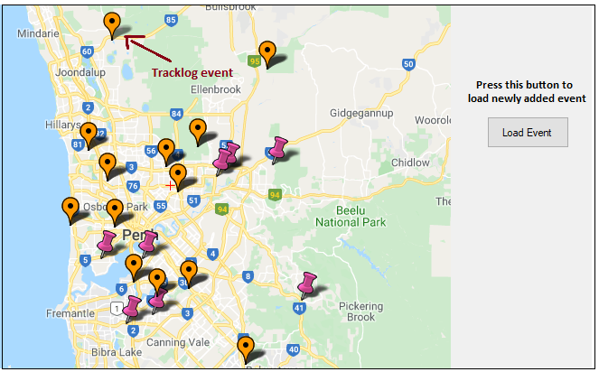

Figure 14: Adding tracklog type event

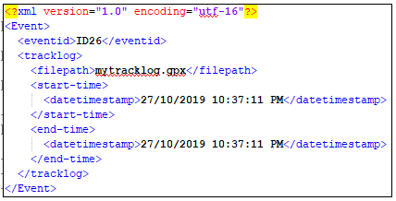

Figure 15: New tracklog event gets written to XML file called **NewEvent**

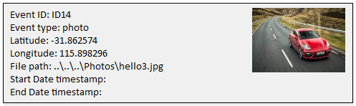

Figure 16: Photo event

Source code list

* The submission contains two folders named “Part1” and “Part2”

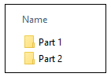

* Folder “Part1” contains the solution for the first part of the assignment



* The source for Part 1 is under the folder “MapApplication”

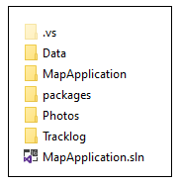

* Folder “Part2” contains the solution for the second part of the assignment

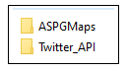

* The source code for map application using ASP.NET is under the directory “ASPGMaps”, and the source code for the Twitter social media stream is under the directory “Twitter_API”.

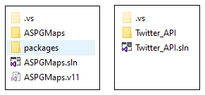

* Reused source code:

GPXManager - <https://weblogs.asp.net/jimjackson/using-linq-to-xml-with-c-to-read-gpx-files>

ASPGmaps - <http://www.dotnetawesome.com/2013/11/how-to-show-markerslocation-in-google.html>

Twitter API - <https://github.com/linvi/tweetinvi>

Evaluation

**Fully implemented and fully working**:

Part 1:

* Added at least 20 more events into the SOAP XML file.
* At least two tracklog type events added to the list of events.
* Created Windows form GUI using Visual Studio.
* Implemented the canvas map to display the vents from the SOAP file.
* Use of LINQ to XML to load the data from the SOAP file into C# Dictionary.
* Developed two different classes (Events1 and Events2) for the events.
* Displayed the events using suitable markers on the map.
* Giving user the option to Add a new event, or Retrieve information by clicking on the map.
* Use of a sub-form to obtain the relevant information about the event.
* Providing event information and associated media when retrieving an event.
* Drawing lines to represent the tracklog by reading coordinates from a GPX file.

Part 2:

* Displaying map and marker to represent the location of different people around the user.
* Displaying text containing information about people in the UI.
* Indicating the level of support people can offer by hovering over the markers

**Not fully working**:

Part 1:

* New events are not written in SOAP file format, rather they are written simply in XML format.
* Inconsistency in adding events of type “tweet” and “facebook-status-update”. New events may not get plotted on the map in the first attempt, but works properly in the subsequent attempts. This seems to be an issue in refreshing the map because even in the first attempt the event information is added to the Dictionary but fails to plot its marker.

Part 2:

* Attempted to implement the Facebook API to push messages to Facebook wall so that the user can communicate with people around him. But the project kept crashing after running it for 3-4 times. Hence, this feature had to be removed prior to submission.
* Was facing similar issue while implementing Twitter API, the NuGet packages kept crashing. Hence, instead decided to create a separate console application to demonstrate usage of Twitter API. The messages from the application are tweeted from the Twitter handle.

**Not implemented**:

Part 1:

* All tasks have been implemented.

Part 2:

* Input form for level of support does not record the inputs.

|  |  |  |
| --- | --- | --- |
| **Part 1** | **Tasks** | **Evaluation** |
|  | Task 01 | Fully Completed |
|  | Task 02 | Fully Completed |
|  | Task 03 | Fully Completed |
|  | Task 04 | Fully Completed |
|  | Task 05 | Fully Completed |
| **Part 2** |  |  |
|  | Task 01 | Not fully completed |
|  | Task 02 | Fully Completed |
|  | Task 03 | Completed (not all requirements met) |

References

[1] "ASP .NET Notes." <http://sce2.umkc.edu/BIT/burrise/it222/notes/aspdotnet.html> (accessed 27/10, 2019).

[2] tutorialspoint. "ASP.NET - Introduction." <https://www.tutorialspoint.com/asp.net/asp.net_introduction.htm> (accessed 27/10, 2019).

[3] Microsoft. "Migrating WPF Apps to .NET Core." <https://docs.microsoft.com/en-us/dotnet/desktop-wpf/migration/convert-project-from-net-framework> (accessed 27th-10, 2019).

[4] GeeksforGeeks. "Introduction to C# Windows Forms Applications." <https://www.geeksforgeeks.org/introduction-to-c-sharp-windows-forms-applications/> (accessed 27th-10, 2019).

[5] GeeksforGeeks. "Introduction to ASP.NET." <https://www.geeksforgeeks.org/introduction-to-asp-net/> (accessed 27th/10, 2019).

[6] C. S. U. L. Beach, "INTRODUCTION LINQ to XML," 2019.