ELECTRONIC ASSIGNMENT COVERSHEET | 

Student Number
Surname | Syed
Given name | Faiz
Email | imsyedfaiz@gmail.com
Unit Code
Unit name | ICT319 Intelligent Systems
Enrolment mode | Internal / external
Date | 24/08/2019
Assignment number | 1
Assignment name | Proposal
Tutor | Graham Mann

Student’s Declaration:

- Except where indicated, the work I am submitting in this assignment is my own work and has not been submitted for assessment in another unit.
- This submission complies with Murdoch University's academic integrity commitments. I am aware that information about plagiarism and associated penalties can be found at http://www.murdoch.edu.au/teach/plagiarism/. If I have any doubts or queries about this, I am further aware that I can contact my Unit Coordinator prior to submitting the assignment.
- I acknowledge that the assessor of this assignment may, for the purpose of assessing this assignment:
  - reproduce this assignment and provide a copy to another academic staff member; and/or
  - submit a copy of this assignment to a plagiarism-checking service. This web-based service may retain a copy of this work for the sole purpose of subsequent plagiarism checking, but has a legal agreement with the University that it will not share or reproduce it in any form.
- I have retained a copy of this assignment.

I am aware that I am making this declaration by submitting this document electronically and by using my Murdoch ID and password it is deemed equivalent to executing this declaration with my written signature.

Signed Faiz Syed

(Write your name in the space above)

Image Classification and Recognition Using Convolutional Neural Network

Description of Proposed Project:

This project deals with understanding and developing an image classification and recognition system built using a deep learning algorithm called Convolutional Neural Network (CNN). Image recognition has wide application in E-commerce, retail, security, astronomy, healthcare etc.

Uses of Image Recognition-
- Drones: Drones equipped with image recognition capabilities can provide vision-based automatic monitoring, inspection, and control of the assets located in remote areas.
- Military Surveillance: Detection of unusual activities in the border areas [1].

AI Methods and Tools:

Neural networks are inspired by biological neural systems. While neural networks and other pattern recognition detection methods have been around for the past 50 years, there has been significant development in the area of convolutional neural networks in the recent past [2].
Convolutional Neural Network (CNN) is a well-known deep learning architecture inspired by the natural visual perception mechanism of the living creatures [3]. Typically, a CNN would use 5 to 25 layers of pattern recognition, below is a diagram depicting a CNN system with 3 layers.

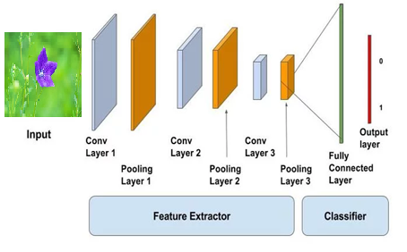
Tools:

MATLAB’s Neural Network toolbox will be used in developing the CNN. It provides extensive support and libraries to build neural networks using its platform.
MATLAB’s documentation on creating Deep learning Neural Networks for classification will be the prime reference during this project.

Source: https://www.mathworks.com/help/deeplearning/examples/create-simple-deep-learning-network-for-classification.html#responsive_offcanvas

Advantages of using MATLAB to build CNN:
- Stable platform
- Extensive support and documentation
- Provides real-time training progress

Data:

In this project, a well-known and commonly used dataset called CIFAR-10 will be used. The CIFAR-10 dataset contains 60,000 32x32 colour images in 10 different classes [4]. The 10 different classes represent airplanes, cars, birds, cats, deer, dogs, frogs, horses, ships and trucks. There are 6,000 images of each class[5].
Large dataset of images helps the computer to perform supervised learning and find patterns in the images, this way the system will be able to recognize and classify images into one of the 10 classes. Among those 6,000 images of each class, half of the images will be used for training and the other half will be used for testing the algorithm.

Source of dataset: https://www.cs.toronto.edu/~kriz/cifar.html

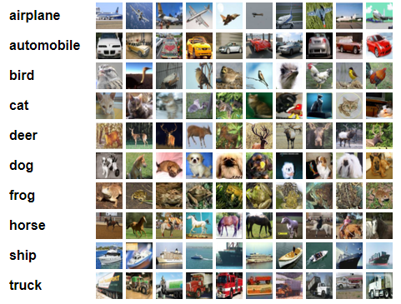
Evaluation Method:
The system performance will be evaluated in the following ways:
- Effect of number of filters on performance
- Effect of training on performance
- Plotting performance graphs

The value of epoch will be manipulated to understand its effect on parameters like error, prediction ability, and overall performance of the system.

References:

[1] S. Gupta. "Understanding Image Recognition and Its Uses." https://www.einfochips.com/blog/understanding-image-recognition-and-its-uses/#targetText=Image%20recognition%20is%20the%20ability,images%20through%20a%20camera%20system.

[2] R. R. K. Samer L. Hijazi, Chris Rowen, "Using Convolutional Neural Networks for Image Recognition," 2015.

[3] J. Gu et al., "Recent advances in convolutional neural networks," Pattern Recognition, vol. 77, pp. 354-377, 2018, doi: 10.1016/j.patcog.2017.10.013.

[4] T. a. Hope, Y. S. a. Resheff, and I. a. Lieder, Learning TensorFlow: a guide to building deep learning systems, First ed. (no. Book, Whole). Sebastopol, California: O'Reilly Media, 2017.

[5] P. Angelov, A. Gegov, C. Jayne, and Q. Shen, Advances in Computational Intelligence Systems: Contributions Presented at the 16th UK Workshop on Computational Intelligence, September 79, 2016. Springer Publishing Company, Incorporated, 2016, p. 508.

Grading Sheet for Assignment 1

1. Identification, Presentation and Clarity
Item | Your Check | Tutor’s Use Only
Submitted on time |  | Ok
Coversheet and Grading sheets filled in |  | Cover Sheet only
Spelling, diagram(s) and IEEE references correct |  | Layout is okay
Clear and understandable writing |  | Good
Marks | / 4 | 4

2. Description of the Problem
Item | Check | Tutor’s Use Only
Brief overview of problem, cite any prior work |  | All okay
Details of how the problem is to be represented |  | Looks promising
At least one clearly-explained goal is given |  | Yes, good
Marks | / 6 | 6

3. Tools, Methods, Knowledge/Data
Item | Check | Tutor’s Use Only
What method(s) will be used |  | Seems a reasonable choice
What available tool(s) will be used |  | Tool a reasonable choice
What knowledge/data will be needed and where  it will come from |  | Good
Marks | / 6 | 6

4. Proposed Evaluation
Item | Check | Tutor’s Use Only
How the solution will be evaluated |  | Good idea
What variables will be manipulated, measured |  | Possible variables suggested
Marks | / 4 | 4

Total Marks (Sections 1-4) | / 20 | 20

Tutor Comments:

