Untitled

Sim

2018년 4월 28일

library(ggplot2)  
library(gridExtra)  
a <- ggplot(data = mpg) +  
 geom_point(aes(x = displ, y = hwy, color = factor(cyl)))  
b <- ggplot(data = mpg) +  
 geom_point(aes(x = displ, y = hwy, color = factor(cyl)),  
 position = "jitter")  
grid.arrange(a, b, nrow=1, ncol=2)

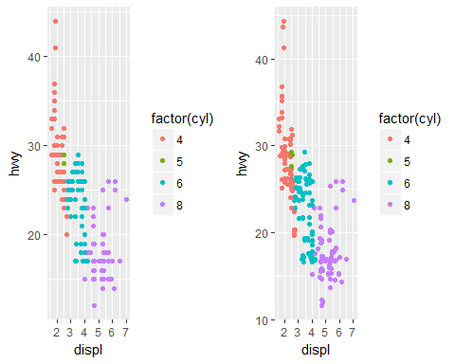

a <- ggplot(data = mpg) +   
 geom_boxplot(aes(x = class, y = hwy))  
b <- ggplot(data = mpg) +   
 geom_boxplot(aes(x = class, y = hwy)) +  
 coord_flip()  
grid.arrange(a, b, nrow=1, ncol=2)

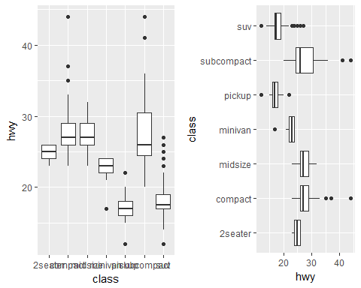

mpg$displ_fac <- factor(round(mpg$displ,0))  
a <- ggplot(data = mpg) +   
 geom_bar(aes(x = displ_fac))  
b <- ggplot(data = mpg) +   
 geom_bar(aes(x = displ_fac, color = class))  
c <- ggplot(data = mpg) +  
 geom_bar(aes(x = displ_fac, fill = class))  
grid.arrange(a, b, c, nrow=1, ncol=3)

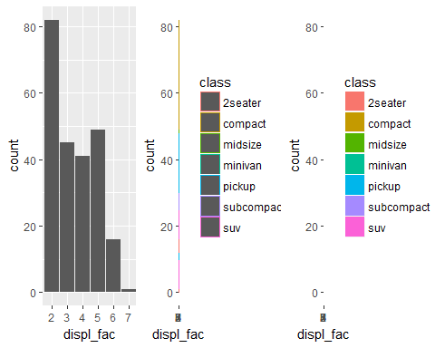

a <- ggplot(data = mpg) +  
 geom_bar(aes(x = displ_fac, fill = class), position = "fill")  
b <- ggplot(data = mpg) +  
 geom_bar(aes(x = displ_fac, fill = class), position = "dodge")  
grid.arrange(a, b, nrow=1, ncol=2)

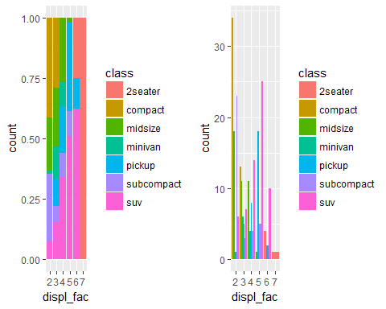

a <- ggplot(data = mpg) +   
 geom_bar(aes(x = class, fill = class))  
b <- a + coord_flip()  
c <- a + coord_polar()  
a

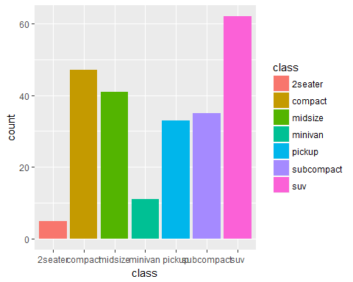

b

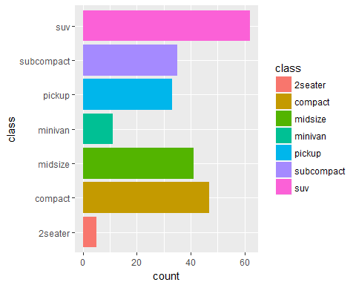

c

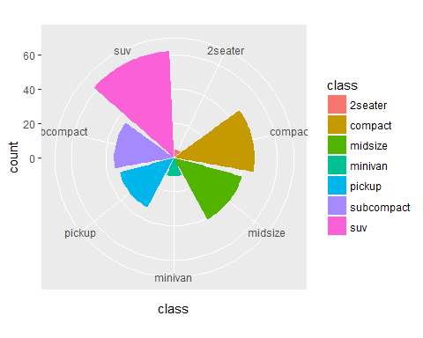

# open -> save -> close  
png("output_file.png")  
ggplot(data = mpg) +   
 geom_bar(aes(x = class, fill = class)) +   
 coord_flip()  
dev.off()

library(plotly)  
ggplotly(a)  
ggplotly(b)

head(mpg[,c("displ", "hwy", "cyl")],10)

## # A tibble: 10 x 3  
## displ hwy cyl  
## <dbl> <int> <int>  
## 1 1.8 29 4  
## 2 1.8 29 4  
## 3 2 31 4  
## 4 2 30 4  
## 5 2.8 26 6  
## 6 2.8 26 6  
## 7 3.1 27 6  
## 8 1.8 26 4  
## 9 1.8 25 4  
## 10 2 28 4