Unified Case Study: Retail Lakehouse & Real-Time Analytics Platform on Azure

Problem Statement
A global retail chain (stores + e-commerce) is struggling with:
- Disconnected systems (POS, website, warehouse, IoT sensors)
- Delayed reporting (daily batch, no real-time visibility)
- Poor inventory management leading to stock-outs
- No unified customer insights for personalization
The organization wants to build a modern data platform using Azure to:
- Centralize all retail data
- Support both batch and real-time analytics
- Enable advanced reporting and forecasting
- Ensure secure, scalable, and cost-optimized architecture

Skill Tower Developed in the Project
Core Data Engineering Stack
- Storage: Azure Data Lake Storage Gen2
- Integration: Azure Data Factory
- Processing: Azure Databricks
- Analytics: Azure Synapse Analytics

Streaming Stack
- Ingestion: Azure Event Hubs
- Processing: Stream Analytics

Security & Optimization
- Managed Identity, SAS, Service Principal
- Private Link, encryption, lifecycle policies
- Cost optimization & performance tuning
Use Case / Architecture Diagram
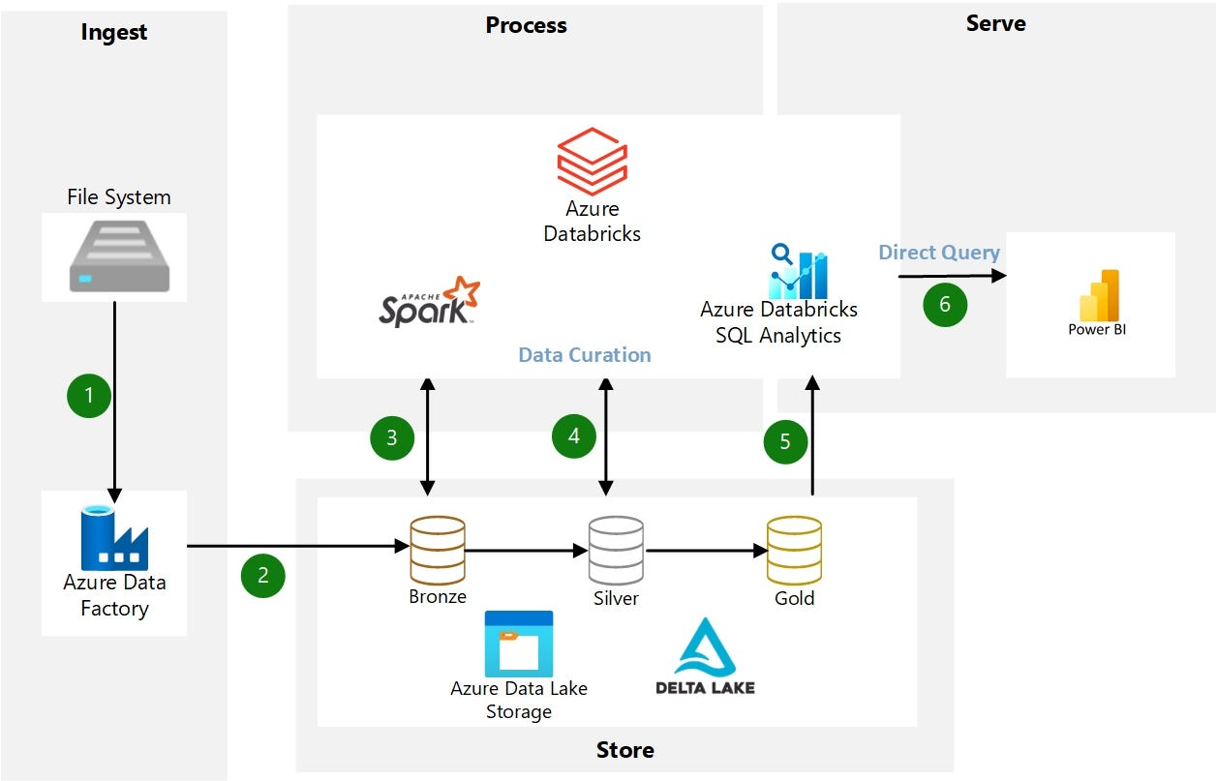
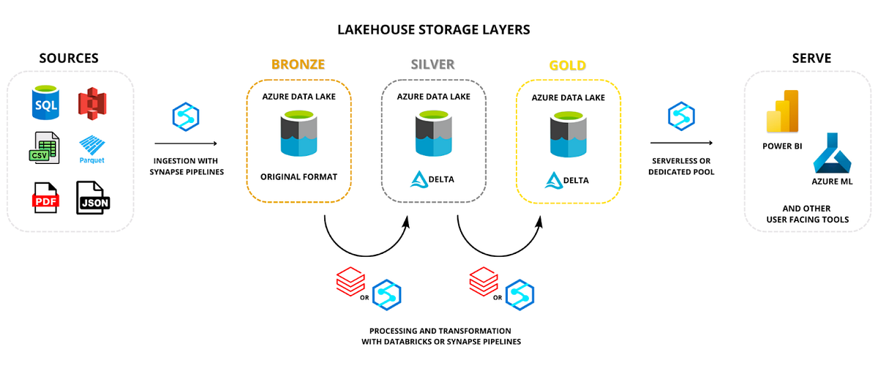

End-to-End Flow
Batch Layer
POS / E-commerce / ERP
↓
ADF Pipelines (Copy Activity + IR)
↓
ADLS Gen2 (Bronze Layer)
↓
Databricks (Cleaning → Silver)
↓
Databricks (Aggregation → Gold)
↓
Synapse SQL Pool (Analytics)
Streaming Layer
POS Events / IoT Sensors
↓
Event Hub / IoT Hub
↓
Stream Analytics (Windowing)
↓
ADLS + Synapse
Consumption Layer
Synapse → Power BI Dashboards

User Stories
Business Users
- As a store manager, I want real-time sales and inventory updates
- As a marketing team member, I want customer segmentation
Data Engineers
- Build ADF pipelines for ingestion
- Design ADLS storage & folder structure
- Implement Lakehouse architecture
- Process data using Databricks

Real-Time Team
- Stream POS events using Event Hub
- Apply windowing functions for real-time insights

Analysts
- Query curated data using Synapse SQL Pool
- Build dashboards for sales, inventory, and trends

Expected Deliverables
ADLS Gen2
- Storage architecture with containers: bronze/silver/gold
- Folder design:
/bronze/sales/year=2026/month=04/
/silver/sales_clean/
/gold/sales_summary/
- Access via Managed Identity, SAS
- Lifecycle rules (archive old data)
- Encryption enabled

Lakehouse
- Databricks + ADLS integration
- Bronze → Silver → Gold transformation
- Cost-aware storage (cold vs hot data)
- Performance optimization (partitioning, Delta format)

ADF
- Pipeline: PL_Retail_Ingestion
- Activities:
  - Copy Activity (POS → ADLS)
  - Data Flow (cleaning)
- Integration Runtime:
  - Azure IR + Self-hosted IR
- Parameterized pipelines
- Scheduled triggers (daily + event-based)
- Monitoring dashboards

Databricks
- Workspace deployment
- Cluster best practices:
  - Auto-scaling
  - Job clusters
- ADLS mounting
- Managed Identity integration
- Secure networking (Private Link)
- Production deployment with CI/CD

Streaming
- Event Hub for POS events
- IoT Hub for smart shelves (concept)
- Stream Analytics job
Example:
SELECT
productId,
COUNT(*) AS sales_count
FROM input
GROUP BY productId, TumblingWindow(minute, 1)
- Streaming output → ADLS + Synapse
- Monitoring streaming jobs

Synapse
- Dedicated SQL Pool setup
- Distribution:
  - Hash → sales fact table
- Partitioning by date
- Data loading via COPY INTO
Implementation Notes
- Use hierarchical namespace
- Partition by date
- Use Delta Lake
- Optimize file size
- Use parameterized pipelines
- Enable retries
- Auto-terminate clusters
- Use job clusters
- Use tumbling window for aggregation
- Handle late events
- Use hash distribution
- Partition large tables

Evaluation Rubrics
Criteria | Weightage
Architecture Design | 20%
ADF Pipelines | 15%
Lakehouse Implementation | 20%
Streaming Implementation | 15%
Synapse Optimization | 15%
Security & Governance | 10%
Documentation | 5%

