Assignment_4

Retriving information from tables:

Q1. Write a select Command that produces the order numbers, amount, and date for all rows in the table.

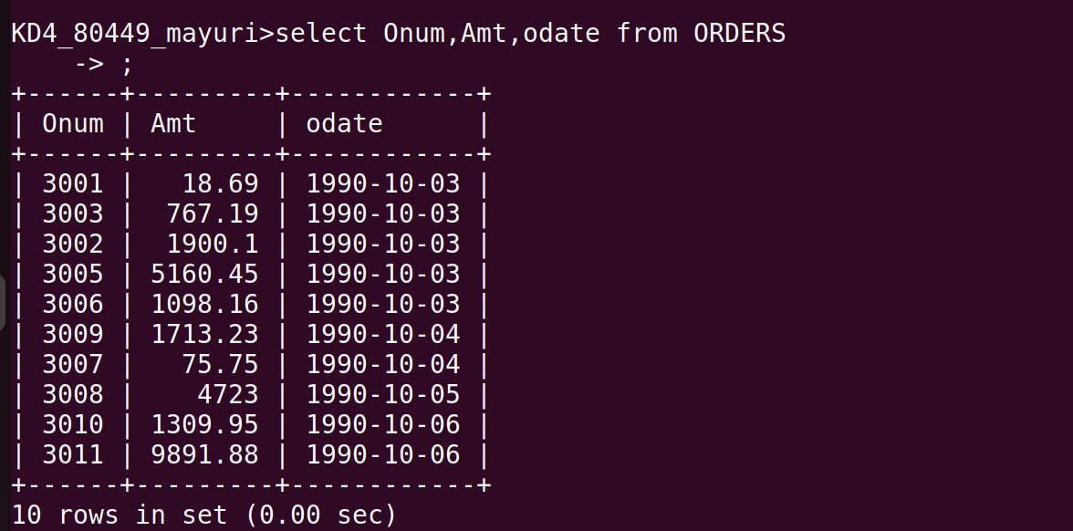
Q2. Write a query that produces all rows from the customers table for which the salesperson’s number is 1001.

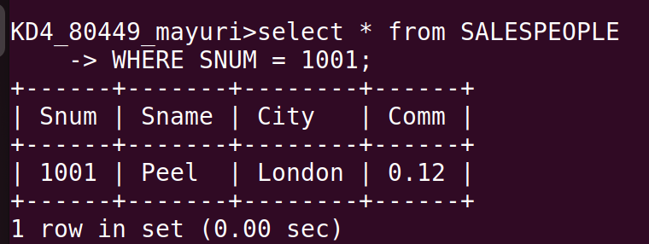

Q3. Write a query that displays the salespeople table with the columns in the following order: city, sname,snum,comm.

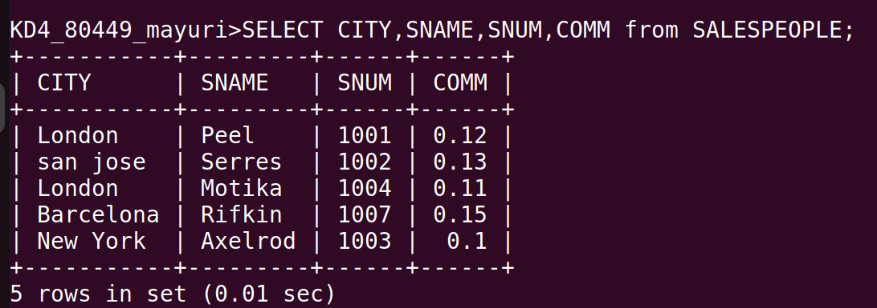

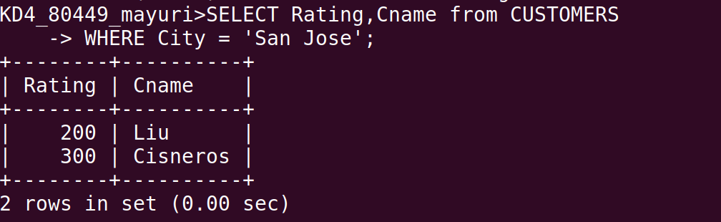
Q4. Write a select command that produces the rating following by the name of each customer in San jose.

