Q.1 Creating sample tables and inserting values.
Create the following tables withthe given structuresand insert sample data as specified:

A)SALESPEOPLE:

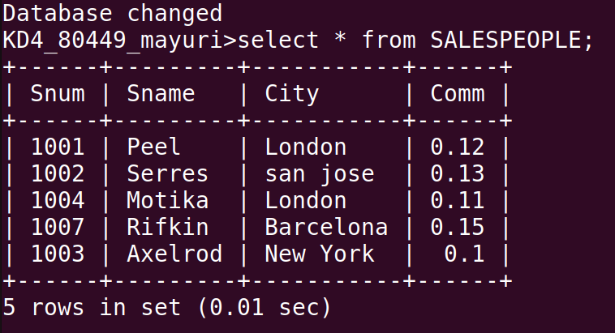

B) CUSTOMERS:
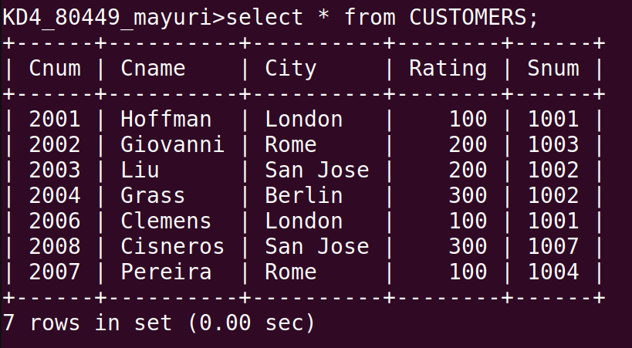

C) ORDERS:

