ASSIGNMENT_15

Using subqueries with DML commands.

Q.1 Assume there is a table called Multicust, with all of the same column definations as salespeople. Write a command that inserts all salespeople with more than one customer into this table.

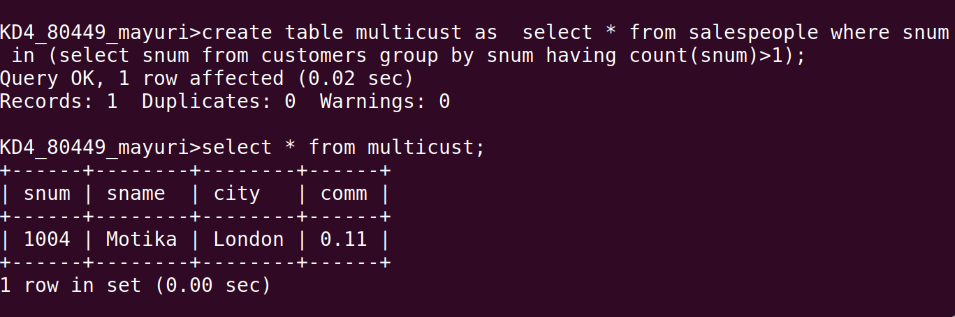

Q.2 Write a command that deletes all customers with no current orders.

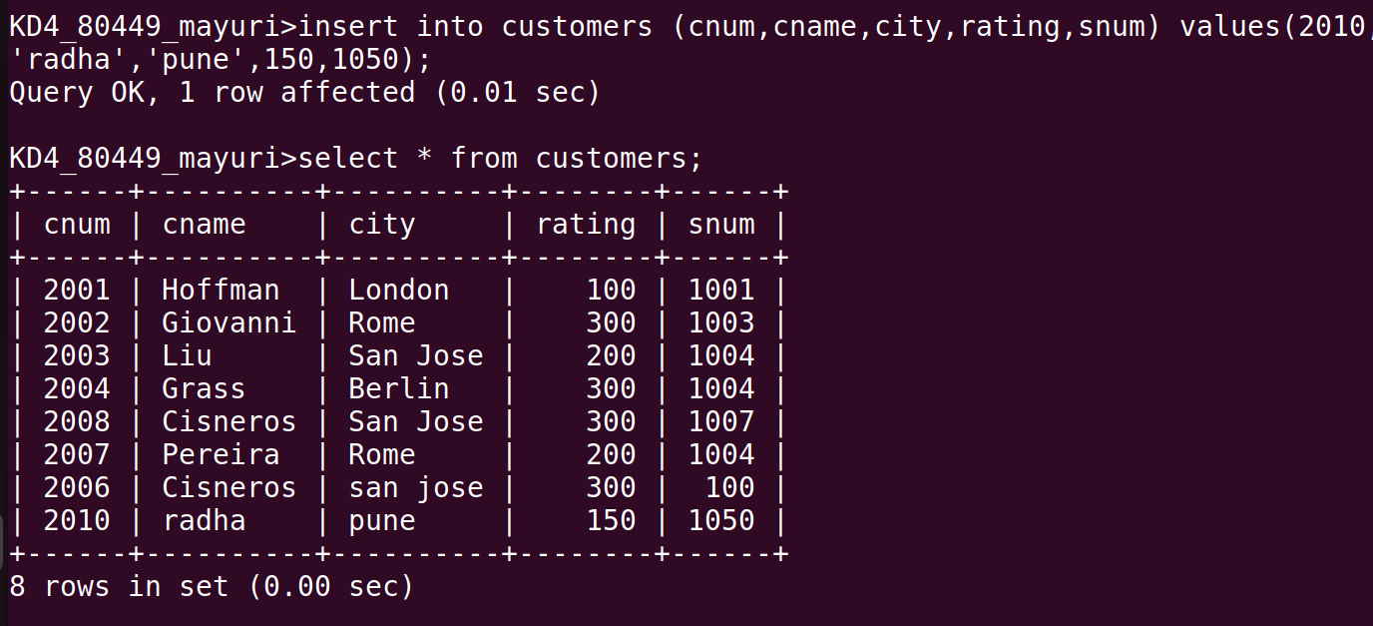

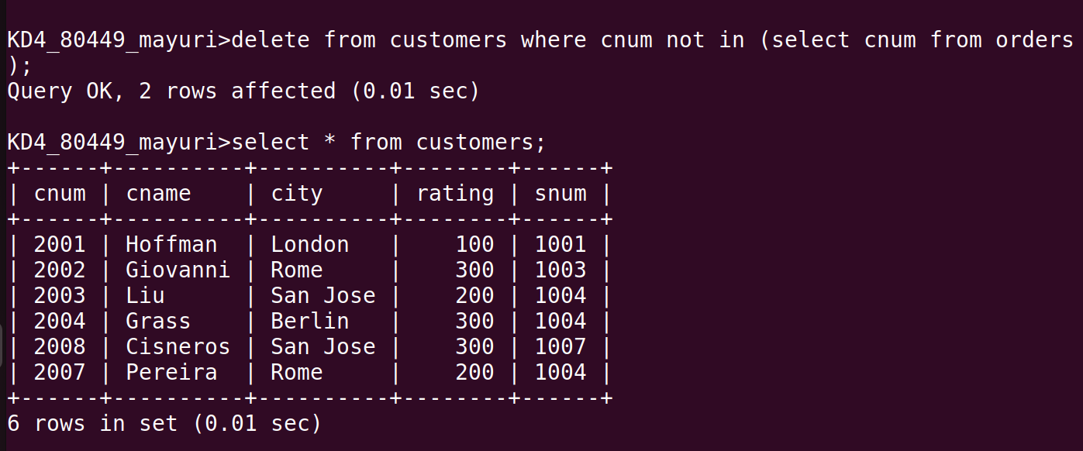

Q.3 Write a command that increases by twenty percent the commissions of all salespeople with total
orders above Rs. 3000.
