Assignment 9

Querring multiple tables at once.

Q.1 Write a query that lists each order number followed by the name of the customer who made the order.

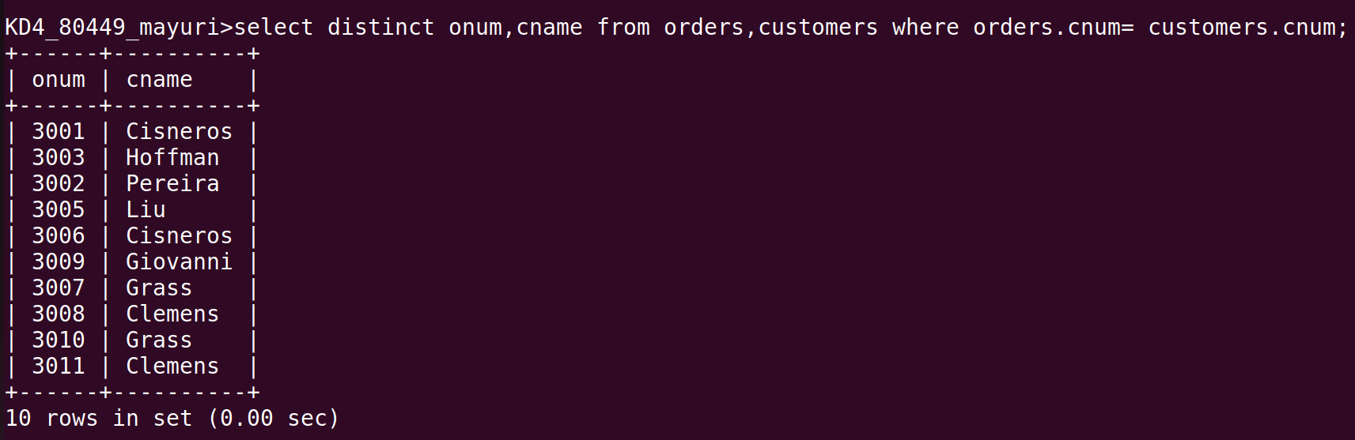

Q.2 Write a query that gives the names of both the salesperson and the customer for each order along with the order number.
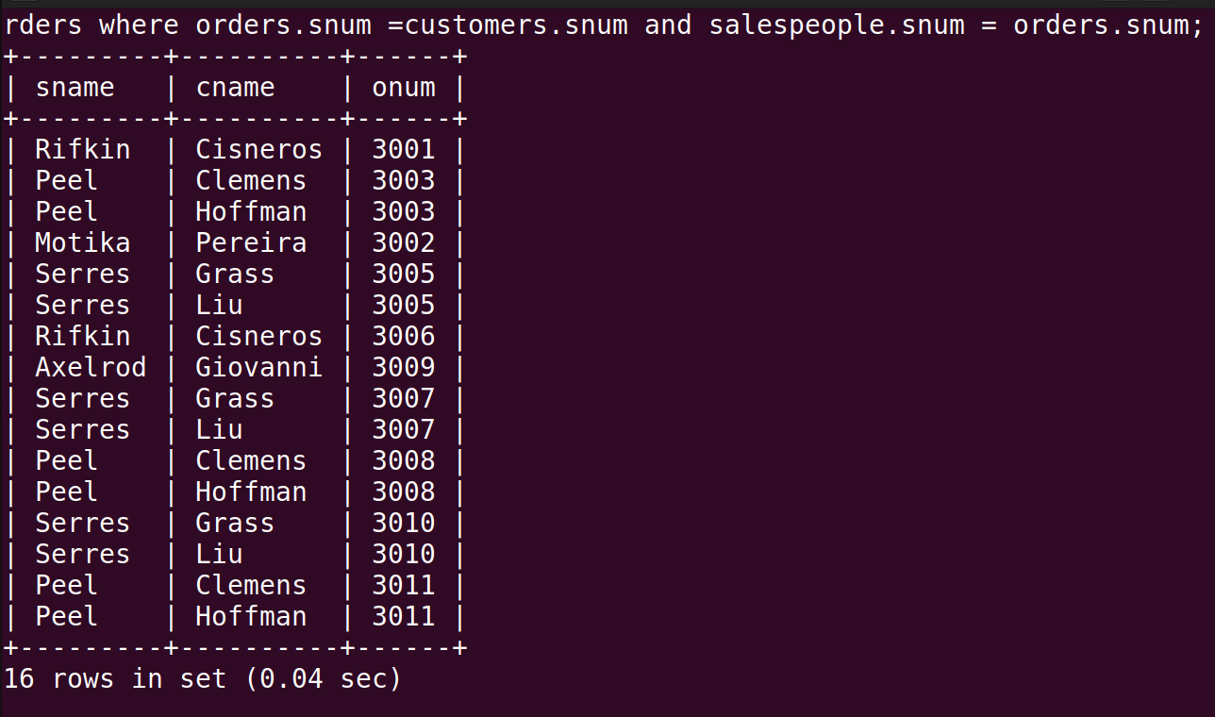

Q.3 Write a query that produces all coustomers serviced by salespeople with a commision above 12%. Output the customers ‘s name, the salesperson’s name , and salesperson’s name , and salesperson’s rate of commission.

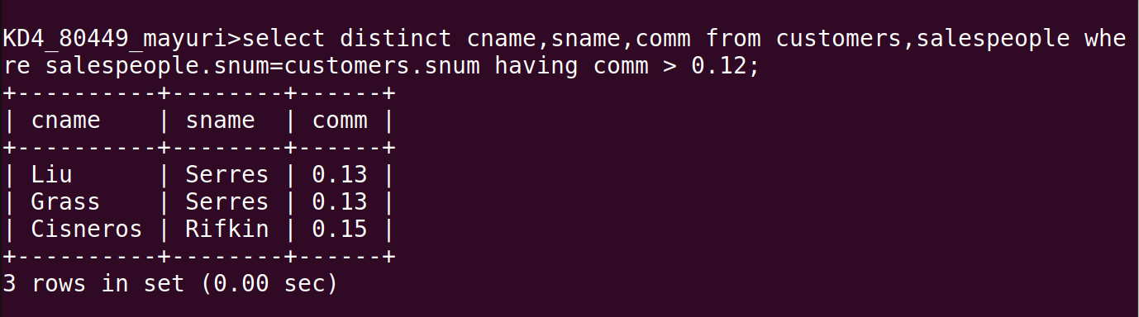

Q.4 Write a query that calculates the amount of the salesperson’s commission on each order by a customer with a rating above 100.
