ASSIGNMENT_14

Entering, Deleting,and Changing Field Values.

Q.1 Write a command that puts the following values , in their given order, into salespeople table:
city- san jose , name-Blanco, comm-NULL,cnum-1100.

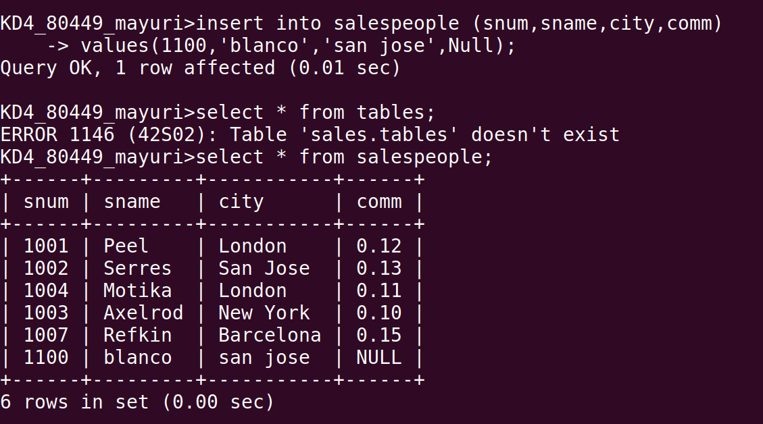

Q.2 Write a command that removes all orders from customer clemens from the orders table.

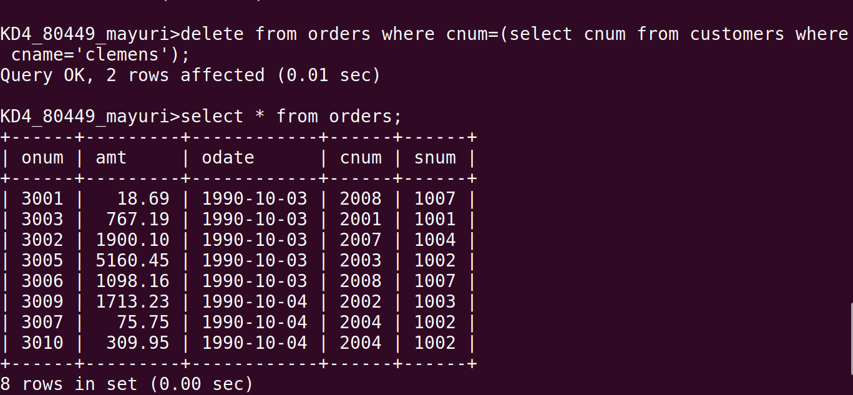

Q.3 Write a command that increases the rating of all customers in Rome by 100.

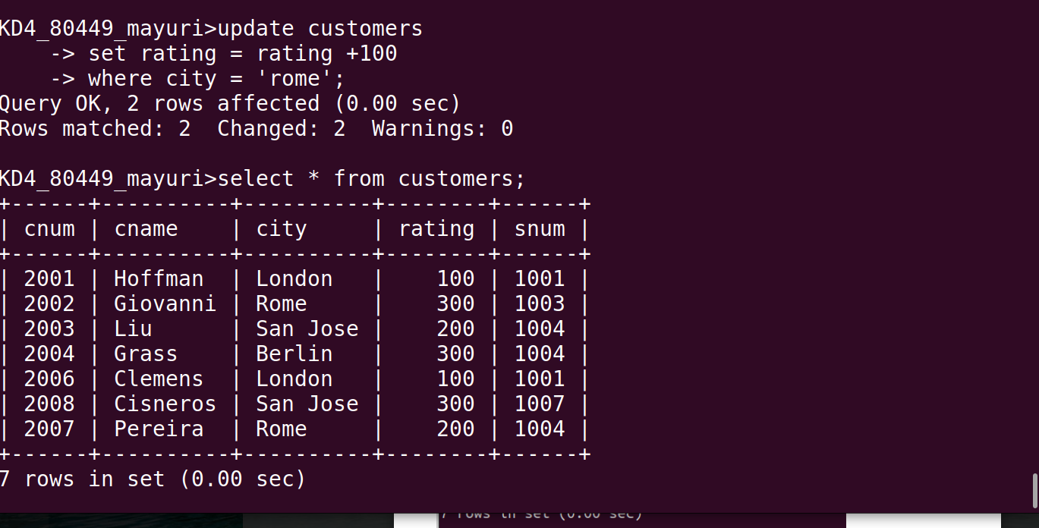

Q.4 Salesperson serres has left the company.Assign her customers to motika.
