ASSIGNMENT –5

Relational and logical operators.

Q 1. Write a query that will give you all orders for more than Rs 1000.

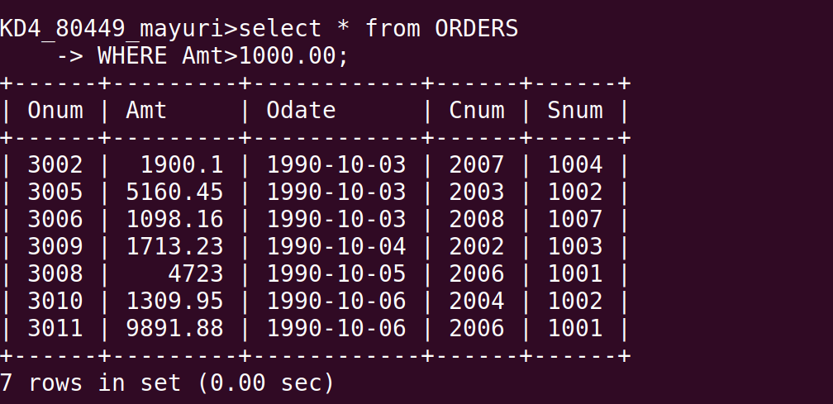
Q 2. Write a query that will give you the names and cities of all salespeople in london with a commission above .10

Q 3. Write a query on the customers table whose output will exclude all customers with a rating <= 100, unless they are located in rome.

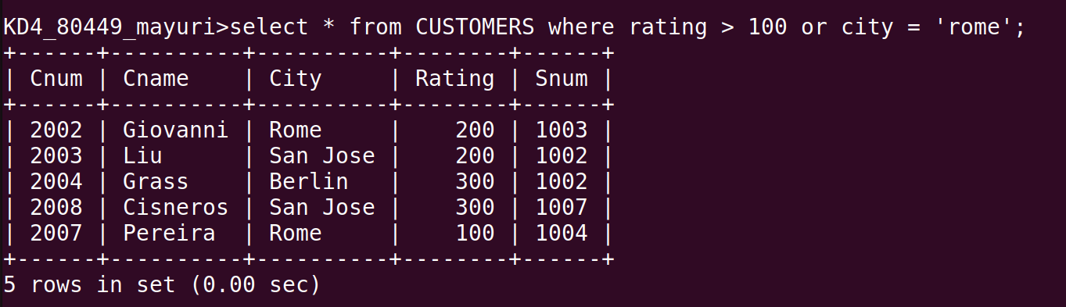

Q 4. What will be the output from the following query ?

Select * from orders
where (amt <1000 OR
NOT ( odate = ‘1990-10-03’
AND cnum > 2003)) ;

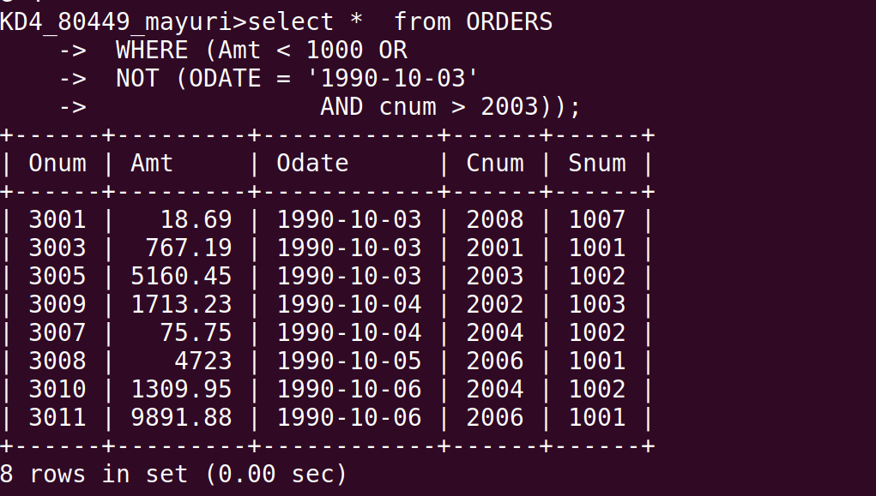
Q 5. What will be the output of the following query ?

select * from orders
where NOT ((odate = ‘1990-10-03’ OR snum
>1006) AND amt >=1500);
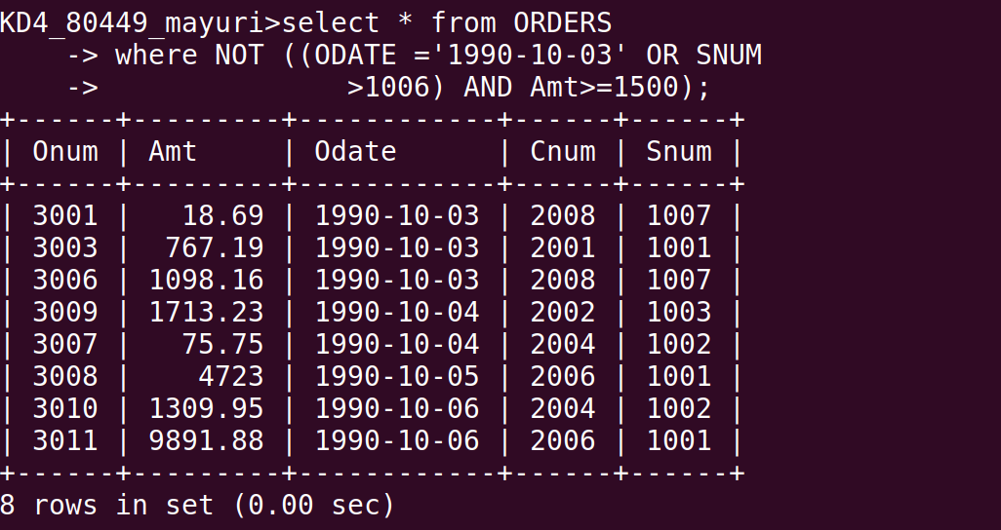

Q 6. What is a simpler way to write this query?

select snum,sname,city, comm from Salespeople
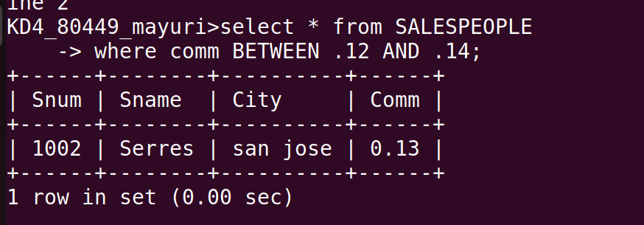
(comm > .12 OR comm < .14);

***

