ASSIGNMENT 7

Summarising data with aggregate functions.

Q 1. Write a query that counts all orders for october 3.

Q 2. Write a query that counts the number of differnt non null city values in the customers table.

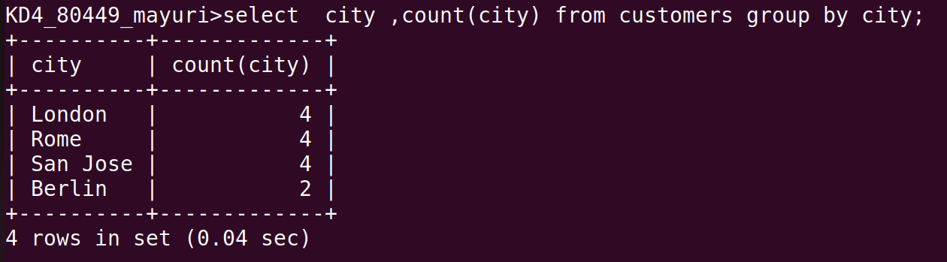

Q 3. Write a query that selects each customer’s samllest order.

Q 4. write a query that selects the highest rating in each city.

Q 5. writhe a query that selects the highest rating in each city.

Q 6. write a query that counts the no. Of salespeople registering orders for each day.
(if salesperson has more than one order on a givenday, he should be counted only once.)

