ASSIGNMENT_11

Q.1 Write a query that uses a subquery to obtian all orders for the customers named cisneros. Assume you do not know his customer number(cnum).

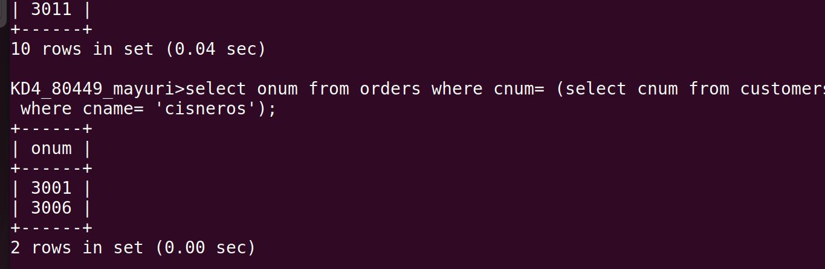

Q.2 Write a query that produces the names and ratings of all customers who have above-average orders.
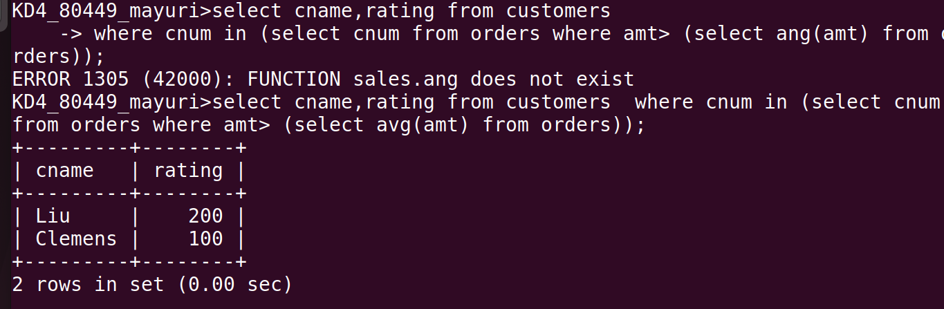

Q.3 Write a query that selects the total amount in orders for each salesperson for whom this total is greater than the amount of the largest order in the table.

