ASSIGNMENT_10

Q.1 Write a query that produces all pairs of salespeople who are living in the same city.
Exclude combining of salespeople with themselves as well as duplicate rows with the orders reversed.

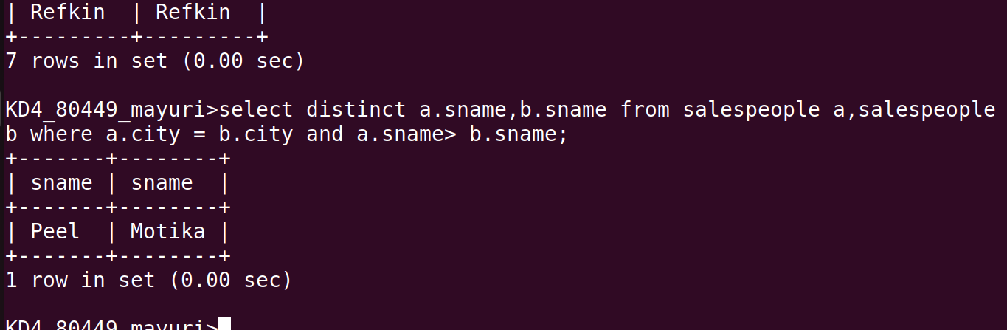

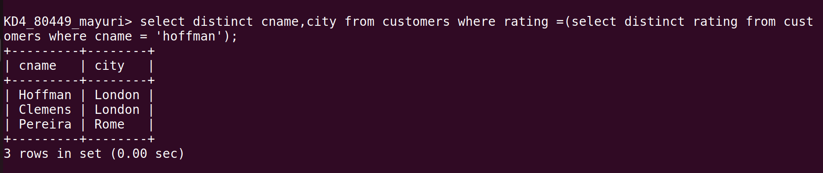
Q.2 Write query that produces the names and cities of all customers with the a hoffman.

