ASSIGNMENT_6

USING SPECIAL OPERATORS IN CONDITIONS.

Q .1 Write two diiferent queries that would produce all orders taken on 3rd or 4th,1990.

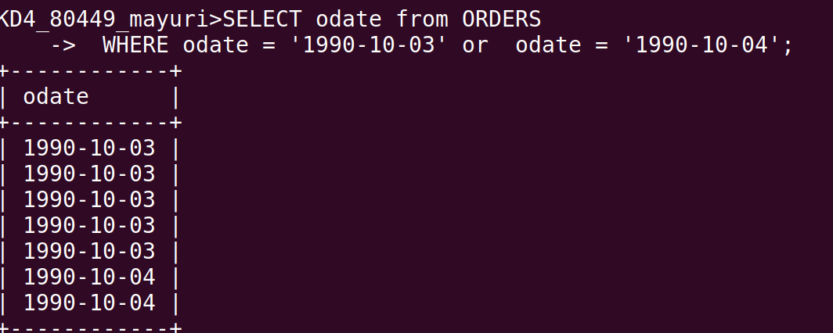

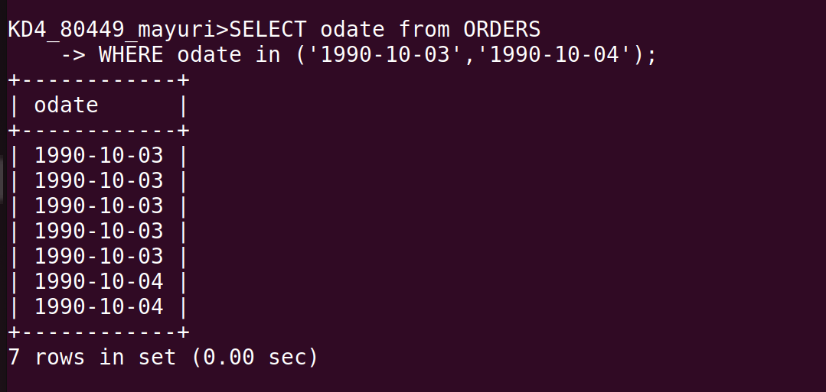

Q. 2 Write aquery thta selects all of the customers all of the coustomers serviced by peel or motika .
(Hint: the snum field relates the two tables to one another).

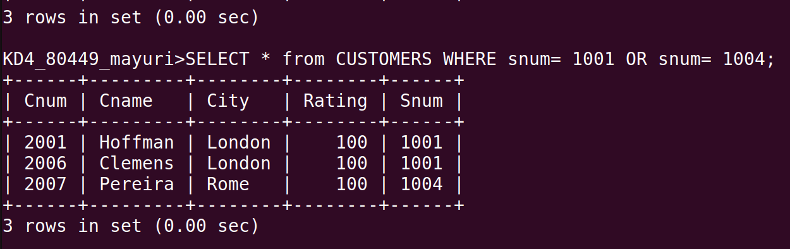

Q.3 Write a query that will produce all the customers whose names begin with a letter from ‘A’ to ‘G’.

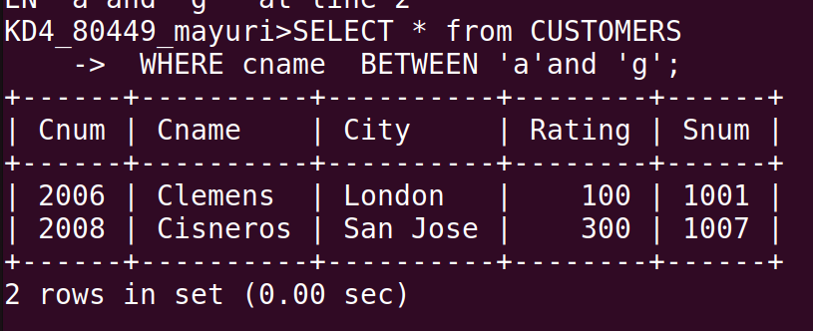
Q.4 Write a query that selects all customers whose names begin with the letter ‘c’.

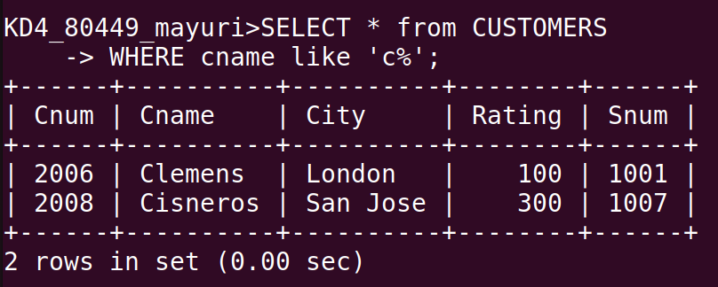

Q.5 Write a query that selects all orders exception those with zeroes or NULLs in the amt field.

