ASSIGNMENT_13

USING THE UNION clause.

Q.1 Creates a union of two queries that shows the names,cities,and ratings of all customers. Those with rating of 200 or greater will also have the words “High Rating ” while the others will have the words ‘Low Rating’.

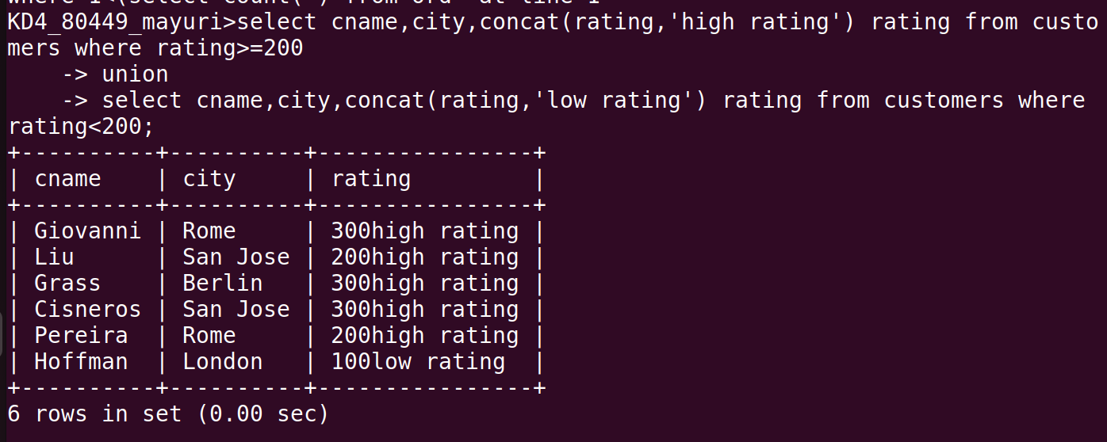

Q.2 Write a command that produces the name and no.of each salesperson and each customer with more than one current order. Put the results in alphabetical order.

Q.3 Form a union of three queries . Have the first select the snum of all salespeople in san jose, the second , the cnums of all customers in san jose; and the third onums of all orders on octber 3. Retain duplicates between the last two queries but eliminate any redundancies between either of them and first.
(Note: in the sample tables as given , there as given , thereas given, there would be no such redundancy. This is besides the point.)

