Shop.Com Marketing Performance and Business Intelligence Analytics, Visualization and Strategic Stakeholders Recommendation
1. Project Overview
Shop.com has invested significantly in digital marketing, content creation, and social media campaigns to increase brand visibility and attract potential customers. While these efforts have generated substantial traffic and engagement, business performance indicators suggest that customer interactions are not translating into expected sales outcomes.
This project analyzes customer engagement, conversion performance, product sales, content effectiveness, and customer sentiment to understand why high marketing activity is resulting in a relatively low conversion rate of 9.57%. The analysis examines the entire customer journey, from initial content exposure through purchase, to identify bottlenecks, inefficiencies, and missed revenue opportunities.
Using marketing, customer review, product performance, and engagement data, the project evaluates:
- Customer conversion trends over time
- Marketing funnel performance and customer drop-off points
- Social media engagement effectiveness
- Content type performance (Blog, Video, Social Media)
- Product-level conversion and sales performance
- Customer satisfaction and sentiment trends
- The relationship between marketing efforts and business outcomes
The ultimate objective is to uncover the key factors limiting conversion performance and provide actionable, data-driven recommendations that will improve customer acquisition efficiency, increase sales conversion, enhance customer satisfaction, and maximize marketing return on investment (ROI).
Business Objective
To determine why strong customer awareness and engagement are not translating into proportional sales growth, and to identify opportunities to improve conversion rates, customer experience, product performance, and overall marketing effectiveness.

Key Questions Addressed
- Where are customers dropping off within the conversion funnel?
- Which products generate the highest conversion rates and sales value?
- Does increased content production lead to improved engagement and purchases?
- Which content types drive the strongest customer engagement?
- What customer concerns are negatively affecting conversion performance?
- How can marketing resources be better allocated to maximize revenue and ROI?
- What strategic initiatives should be prioritized to improve business outcomes?
- Expected Business Outcomes
- Increased conversion rates
- Reduced customer funnel leakage
- Improved customer satisfaction scores
- Better alignment between marketing investments and revenue generation
- More effective product promotion strategies
- Enhanced customer retention and loyalty
- Higher marketing ROI through data-driven decision making

2. Dataset/Table Summary
SELECT name AS [TableName]
FROM sys.tables
ORDER BY name;
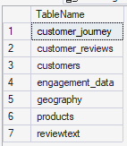
3. Exploratory Data Analysis using MS SQL
We began with data preparation and cleaning in MS SQL:
- Data Loading: Imported the dataset into database PortfolioProject_MarketingAnalytics
- dim_product table - checking and removing redundant [Category] column on
- dim_product table categorizing Price to (Low, Medium and High).
- dim_customer and dim_geography - combining the 2 table
- customer_reviews - replaced double space to single space [Reviews]
- engagement_data - Capitalize [ContentType], split [ViewsClicksCombined], change date format for [EngagementDate], remove Newsletter from [ContentType].
- customer_journey table - remove duplicates, filling [Duration] null values with duration_avg from

4. Advanced Sentiment Analysis with Python
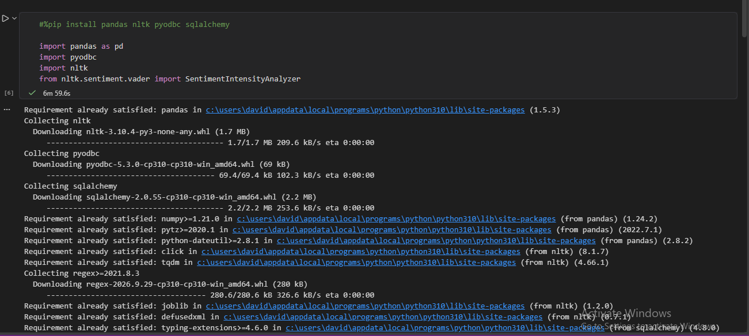
- Use Python library (VADER) to perform sentiment analysis on [ReviewText] column from customer_reviews table to know whether the customer gave a positive or negative review about a product. Saved the data frame
5. Data Visualization and Dashboard Development
Power BI Dashboard Development
Overview
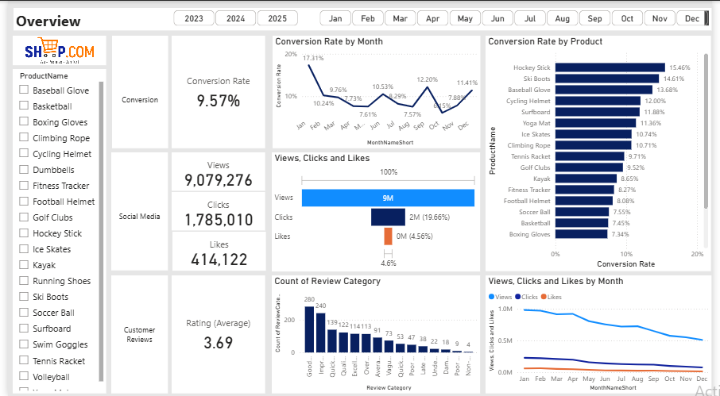

Conversion Details
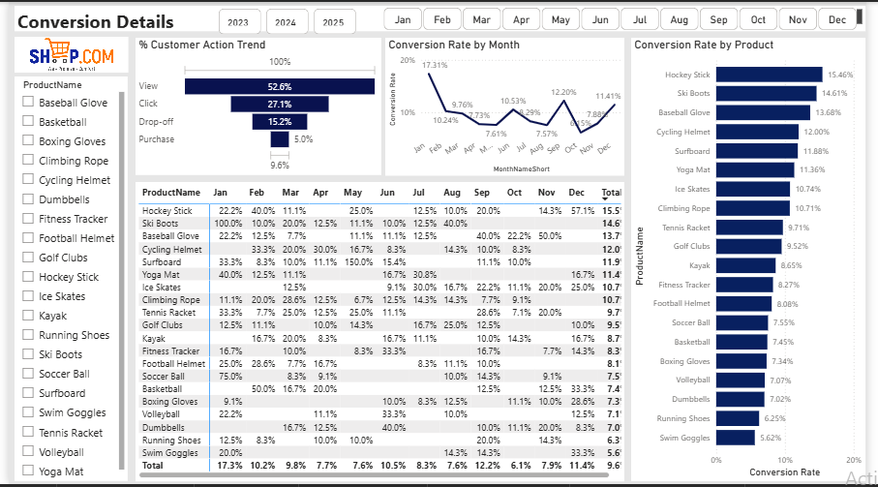
Social Media
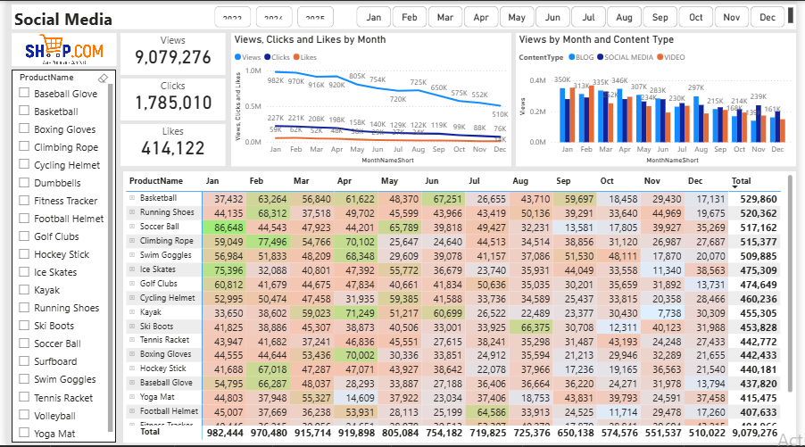

Customer Review
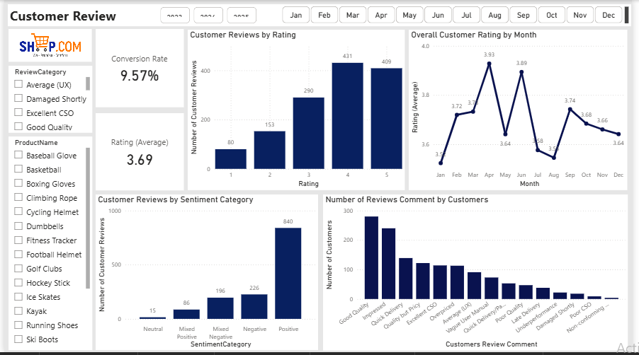
Engagement Review
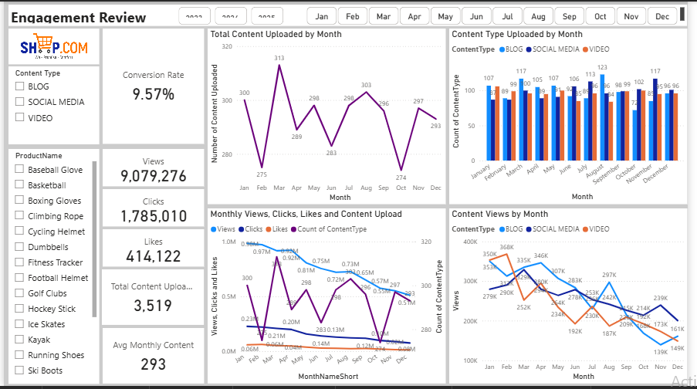

Content/Conversion Trend
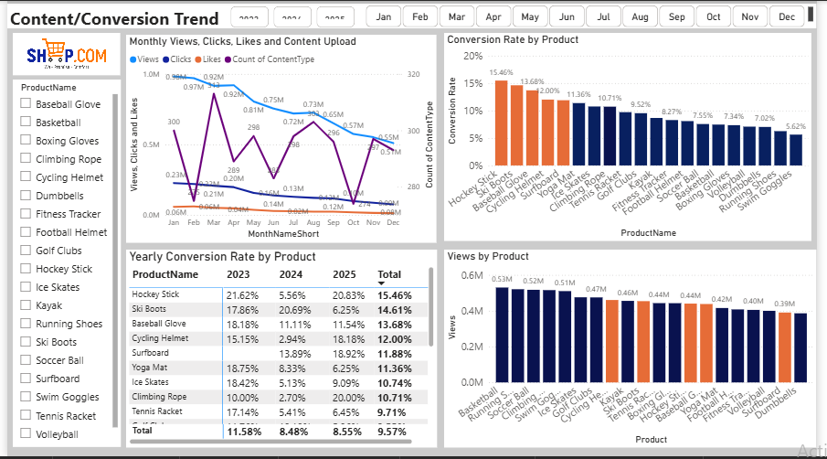
Product Purchase Review


