Bike Geometry PCA & Clustering
Saf, Tim & Liz
2025-09-11

MTB Frame Geometry Code
by:
Saf Flatters
Timothy Bolt
Lizanne van Nieuwenhuizen

Packages
#Install and load packages chunk
library(ggplot2)
library(dplyr)
##
## Attaching package: 'dplyr'
## The following objects are masked from 'package:stats':
##
## filter, lag
## The following objects are masked from 'package:base':
##
## intersect, setdiff, setequal, union
library(tidyr)
library(patchwork)
library(DataExplorer)
library(MVN)
library(corrplot)
## corrplot 0.95 loaded
library(psych)
##
## Attaching package: 'psych'
## The following object is masked from 'package:MVN':
##
## mardia
## The following objects are masked from 'package:ggplot2':
##
## %+%, alpha
library(ggbiplot)
##
## Attaching package: 'ggbiplot'
## The following object is masked from 'package:psych':
##
## reflect
library(grDevices)
library(devtools)
## Loading required package: usethis
library(factoextra)
## Welcome! Want to learn more? See two factoextra-related books at https://goo.gl/ve3WBa
library(gridExtra)
##
## Attaching package: 'gridExtra'
## The following object is masked from 'package:dplyr':
##
## combine
library(clustMixType)
library(cluster)
library(ggalluvial)
# library(plotly) # for 3d plot, not used rn

Data

Import
#Import data
allbikegeo <- read.csv("Data/geometrics.mtb-news.de.csv", sep = ";", stringsAsFactors = FALSE)

Data Cleaning

Dataframe Prep
Cleaned dataframe with numeric-only data and without Year and Suspension: mtbgeo[, geo_vars]
Cleaned dataframe with all numeric-only data: mtbgeo[, num_vars]
Cleaned dataframe with mixed data: mtbgeo
#Filter to Mountain bikes only
mtbgeo_only <- subset(allbikegeo, Category == "Mountain")
#Filter to remove 26" wheels
mtbgeo_only <- subset(mtbgeo_only, !grepl("26", Wheel.Size))
#Convert 0 Year to NA (for later removal)
mtbgeo_only$Year <- as.integer(mtbgeo_only$Year)
mtbgeo_only$Year[mtbgeo_only$Year == 0] <- NA
#Replace NA for rear suspension with 0 (assume hardtail)
mtbgeo_only$Suspension.Travel..rear. <- as.numeric(mtbgeo_only$Suspension.Travel..rear.)
mtbgeo_only$Suspension.Travel..rear.[is.na(mtbgeo_only$Suspension.Travel..rear.)] <- 0
#Remove rows with NA in 'Suspension.Travel..front.'
mtbgeo_only$Suspension.Travel..front. <- as.numeric(mtbgeo_only$Suspension.Travel..front.)
mtbgeo_only <- mtbgeo_only[!is.na(mtbgeo_only$Suspension.Travel..front.), ]
#Drop columns with too many missing values (> 1000)
keep_cols <- colSums(is.na(mtbgeo_only)) <= 1000
mtbgeo_reduced <- mtbgeo_only[, keep_cols]
#remove unneeded columns
mtbgeo_reduced <- mtbgeo_reduced[, !(names(mtbgeo_reduced) %in% c("Frame.Config", "URL", "Category"))]
#Keep only Medium-sized bikes to allow fair comparison of geometry
mtbgeo_medium <- mtbgeo_reduced[mtbgeo_reduced$Frame.Size %in% c("M", "Medium"), ]
#remove all rows that have any NA's in numeric/integer columns
num_cols <- sapply(mtbgeo_medium, function(x) is.numeric(x) || is.integer(x))
vars_to_check <- names(mtbgeo_medium)[num_cols]
mtbgeo_clean <- mtbgeo_medium[complete.cases(mtbgeo_medium[, vars_to_check]),]
#rename dataframe and check
mtbgeo <- mtbgeo_clean
# str(mtbgeo)
# anyNA(mtbgeo)
#Create numeric only dataframe
num_vars <- sapply(mtbgeo, is.numeric)
# str(mtbgeo[, num_vars])
#Create numeric only without suspension and Year vars dataframe
drop_vars <- c("Year", "Suspension.Travel..rear.", "Suspension.Travel..front.")
geo_vars <- sapply(mtbgeo, is.numeric) & !(names(mtbgeo) %in% drop_vars)
str(mtbgeo[, geo_vars])
## 'data.frame': 616 obs. of 10 variables:
## $ Reach : num 454 450 450 440 433 440 440 450 435 427 ...
## $ Stack : num 624 613 613 624 599 603 603 603 622 628 ...
## $ STR : num 1.37 1.36 1.36 1.42 1.38 ...
## $ Head.Tube.Angle : num 65 64 63.5 64 65.4 65 65 64 66.5 66 ...
## $ Seat.Tube.Angle.Effective: num 75.5 76.5 76.5 75 75 75 75 75.7 74 75 ...
## $ Head.Tube.Length : num 90 110 110 110 110 110 110 110 130 110 ...
## $ Seat.Tube.Length : num 425 435 435 430 440 420 420 420 435 440 ...
## $ Chainstay.Length : num 435 428 441 435 428 ...
## $ Wheelbase : num 1197 1214 1214 1222 1181 ...
## $ Bottom.Bracket.Offset : num 60 9 9 30 9 9 9 9 20 28 ...

Standardisation
mtbgeo_zscores <- mtbgeo #make copy
mtbgeo_zscores[, geo_vars] <- scale(mtbgeo_zscores[, geo_vars]) #standardise geo_vars
str(mtbgeo_zscores)
## 'data.frame': 616 obs. of 18 variables:
## $ Brand : chr "Alchemy" "Alutech" "Alutech" "Alutech" ...
## $ Model : chr "Argos" "CNC E-Fanes" "eFanes 29/275 Comp" "Fanes 29" ...
## $ Year : int 2022 2021 2022 2022 2015 2019 2019 2022 2015 2016 ...
## $ Motorized : chr "false" "true" "true" "false" ...
## $ Frame.Size : chr "M" "M" "M" "M" ...
## $ Wheel.Size : chr "29″" "Mullet 29/27,5" "Mullet 29/27,5" "29″" ...
## $ Reach : num 0.215 0.0668 0.0668 -0.3037 -0.5631 ...
## $ Stack : num 0.327 -0.434 -0.434 0.327 -1.402 ...
## $ STR : num -0.063484 -0.081367 -0.081367 0.000477 -0.050435 ...
## $ Head.Tube.Angle : num -0.152 -0.81 -1.139 -0.81 0.111 ...
## $ Seat.Tube.Angle.Effective: num -0.282 0.271 0.271 -0.559 -0.559 ...
## $ Head.Tube.Length : num -0.52666 0.00715 0.00715 0.00715 0.00715 ...
## $ Seat.Tube.Length : num 0.21 0.861 0.861 0.535 1.186 ...
## $ Chainstay.Length : num -0.5151 -1.1475 0.0687 -0.5151 -1.1475 ...
## $ Wheelbase : num -0.1953 0.0833 0.0833 0.2144 -0.4576 ...
## $ Bottom.Bracket.Offset : num 1.911 -1.096 -1.096 0.142 -1.096 ...
## $ Suspension.Travel..rear. : num 0 170 170 170 170 170 170 170 130 150 ...
## $ Suspension.Travel..front.: num 140 170 170 170 170 170 170 170 150 160 ...

Category Psuedo-labels (Y)
# make y label groups for validation ("Cross-country", "Trail", "Enduro", "Downhill")
mtbgeo_groups <- mtbgeo %>%
mutate(
Category = case_when(
# Downhill: both ends ≥ 180 (must have rear)
!is.na(Suspension.Travel..rear.) &
Suspension.Travel..front. >= 180 & Suspension.Travel..rear. >= 180 ~ "Downhill",
# Enduro: rear 150–180 AND front 140–190 (must have rear)
!is.na(Suspension.Travel..rear.) &
Suspension.Travel..rear. >= 145 & Suspension.Travel..rear. <= 180 &
Suspension.Travel..front. >= 140 & Suspension.Travel..front. <= 190 ~ "Enduro",
# Cross-country: front 100–120 AND (no rear OR rear ≤ 120)
Suspension.Travel..front. >= 100 & Suspension.Travel..front. <= 120 &
(is.na(Suspension.Travel..rear.) | Suspension.Travel..rear. <= 130) ~ "Cross-country",
# Trail: front 121–160 AND rear ≤ 150 (must have rear)
!is.na(Suspension.Travel..rear.) &
Suspension.Travel..front. >= 121 & Suspension.Travel..front. <= 160 &
Suspension.Travel..rear. <= 150 ~ "Trail",
TRUE ~ "Other"
)
)
# order
mtbgeo_groups$Category <- factor(mtbgeo_groups$Category, levels = c("Cross-country", "Trail", "Enduro", "Downhill"))
# Count bikes in each group
mtbgeo_groups %>%
count(Category)
## Category n
## 1 Cross-country 83
## 2 Trail 202
## 3 Enduro 288
## 4 Downhill 43
# View(mtbgeo_groups[mtbgeo_groups$Category == "Other", ])
# Count bikes per category
cat_counts <- mtbgeo_groups %>%
count(Category)
pal_geo <- c("Downhill"="purple",
"Enduro"="mediumturquoise",
"Trail"="yellowgreen",
"Cross-country"="#F8766D")
# Plot number bikes per category
ggplot(cat_counts, aes(x = Category, y = n, fill = Category)) +
geom_col(width = 0.7) +
geom_text(aes(label = n), vjust = -0.4, size = 4) +
scale_fill_manual(values = pal_geo, guide = "none") +
labs(
title = "Number of Bikes per Category",
x = "Category",
y = "Count of Bikes"
) +
theme_classic(base_size = 13) +
theme(
legend.position = "none",
plot.title = element_text(face = "bold", hjust = 0.5)
)
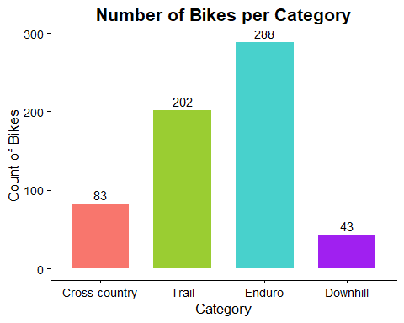

Exploration & Assumption Checks

Outliers
Due to the data being datascraped from the internet, we suspected it may have outliers that aren’t true outliers but more like data entry mistakes.
outlier_rows <- apply(abs(mtbgeo_zscores[, geo_vars]), 1, max) > 7 # Flag rows where any geometry z-score exceeds our threshold
print(mtbgeo[outlier_rows, ]) # View the outliers (without standardised values)
## Brand Model Year Motorized Frame.Size Wheel.Size
## 2216 Giant Reign Advanced Pro 0 2021 false M 29″
## 2600 Intense Sniper XC 2022 false M 29″
## 4493 Rocky Mountain Instinct Powerplay 2022 true M 29″
## 4494 Rocky Mountain Instinct Powerplay 2022 true M 29″
## 5239 Scott Spark 2022 false M 29″
## Reach Stack STR Head.Tube.Angle Seat.Tube.Angle.Effective
## 2216 451.0 622.0 1.379157 64.6 76.4
## 2600 44.5 575.0 12.921348 67.5 74.0
## 4493 45.0 620.0 13.777778 64.7 75.7
## 4494 456.0 518.0 1.135965 65.0 77.0
## 5239 440.0 607.5 1.380682 65.8 75.9
## Head.Tube.Length Seat.Tube.Length Chainstay.Length Wheelbase
## 2216 1000 431 439.0 1220
## 2600 95 437 439.0 1152
## 4493 100 420 437.0 1225
## 4494 100 420 436.0 1224
## 5239 90 440 437.5 1
## Bottom.Bracket.Offset Suspension.Travel..rear. Suspension.Travel..front.
## 2216 27.0 146 170
## 2600 38.0 100 100
## 4493 36.0 140 150
## 4494 32.0 140 150
## 5239 43.5 120 130
# View((mtbgeo[outlier_rows, ]))
# remove above observations
mtbgeo <- mtbgeo[!outlier_rows, ]
mtbgeo_zscores <- mtbgeo_zscores[!outlier_rows, ]
mtbgeo_groups <- mtbgeo_groups[!outlier_rows, ]
nrow(mtbgeo)
## [1] 611
nrow(mtbgeo_groups)
## [1] 611
Matrix_mtbgeo_z <- as.matrix(mtbgeo_zscores[, geo_vars])
# mvn(Matrix_mtbgeo_z, mvn_test = "royston", univariate_test = "AD") #or mvn_test = "hz" or "royston" or
multivariate_diagnostic_plot(Matrix_mtbgeo_z)
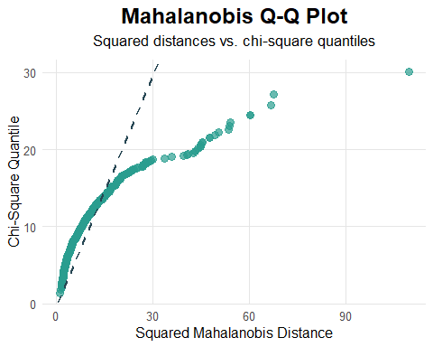
univariate_diagnostic_plot(Matrix_mtbgeo_z, type = "boxplot")
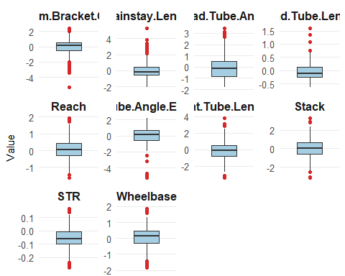
# Check for outliers shown with mahalanobis and remove outlier (2022 Lapace Prorace)
md <- mahalanobis(Matrix_mtbgeo_z,
center = colMeans(Matrix_mtbgeo_z),
cov = cov(Matrix_mtbgeo_z))
sqrt(max(md))
## [1] 10.45501
maxmala <- which.max(md)
mtbgeo[which.max(md), ]
## Brand Model Year Motorized Frame.Size Wheel.Size Reach Stack STR
## 2700 Lapierre Prorace 2022 false M 29″ 435 597 1.372414
## Head.Tube.Angle Seat.Tube.Angle.Effective Head.Tube.Length
## 2700 68 74 90
## Seat.Tube.Length Chainstay.Length Wheelbase Bottom.Bracket.Offset
## 2700 430 420 1114 -62
## Suspension.Travel..rear. Suspension.Travel..front.
## 2700 0 100
mtbgeo <- mtbgeo[-maxmala, ] # remove above observation
mtbgeo_zscores <- mtbgeo_zscores[-maxmala, ] # remove above observation
mtbgeo_groups <- mtbgeo_groups[-maxmala, ] # remove above observation
# column means
(colMeans(mtbgeo[, geo_vars]))
## Reach Stack STR
## 449.537344 619.559426 1.379396
## Head.Tube.Angle Seat.Tube.Angle.Effective Head.Tube.Length
## 65.224869 76.014672 108.393443
## Seat.Tube.Length Chainstay.Length Wheelbase
## 421.699180 440.348885 1211.078131
## Bottom.Bracket.Offset
## 27.677000
# (View(cov(mtbgeo[, geo_vars])))
This was moved to after outliers were removed as it wasn’t a good representation of the data
# Check distributions of each variable
vars <- c(names(mtbgeo)[geo_vars],
"Suspension.Travel..rear.",
"Suspension.Travel..front.")
df_long <- mtbgeo[, vars] |>
pivot_longer(everything(), names_to = "var", values_to = "val") # Long format for faceting
n_geo <- length(geo_vars)
pal_geo <- grDevices::hcl.colors(n_geo, palette = "viridis")
pal_susp <- grDevices::hcl.colors(2, palette = "reds")
pal <- c(pal_geo, pal_susp)
ggplot(df_long, aes(x = val, fill = var)) +
geom_density(alpha = 0.7) +
facet_wrap(~ var, scales = "free", ncol = 3) +
scale_fill_manual(values = pal, guide = "none") +
labs(title = "Distribution of Geometry Variables + Suspension",
x = "Geometry Variables",
y = "Density") +
theme_classic() +
theme(
plot.title = element_text(hjust = 0.5, color = "slateblue4", size = 16),
axis.title.x = element_text(size = 14),
axis.title.y = element_text(size = 14)
)
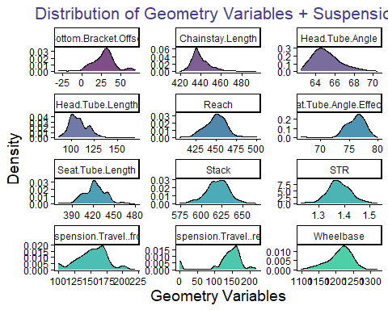

Correlation
# Correlation matrix
Matrix_mtbgeo <- as.matrix(mtbgeo[, geo_vars])
round(cor(Matrix_mtbgeo), 4)
## Reach Stack STR Head.Tube.Angle
## Reach 1.0000 0.1781 -0.7803 -0.3836
## Stack 0.1781 1.0000 0.4747 -0.4575
## STR -0.7803 0.4747 1.0000 0.0599
## Head.Tube.Angle -0.3836 -0.4575 0.0599 1.0000
## Seat.Tube.Angle.Effective 0.5225 0.1730 -0.3626 -0.3424
## Head.Tube.Length 0.0295 0.3485 0.2032 -0.1321
## Seat.Tube.Length -0.0700 -0.1259 -0.0077 0.3777
## Chainstay.Length -0.0141 0.2900 0.2040 -0.0724
## Wheelbase 0.6275 0.5548 -0.2094 -0.8367
## Bottom.Bracket.Offset -0.1946 -0.0815 0.1264 0.4880
## Seat.Tube.Angle.Effective Head.Tube.Length
## Reach 0.5225 0.0295
## Stack 0.1730 0.3485
## STR -0.3626 0.2032
## Head.Tube.Angle -0.3424 -0.1321
## Seat.Tube.Angle.Effective 1.0000 -0.0273
## Head.Tube.Length -0.0273 1.0000
## Seat.Tube.Length -0.1602 0.0987
## Chainstay.Length -0.0613 0.2731
## Wheelbase 0.3973 0.2782
## Bottom.Bracket.Offset -0.1132 -0.3143
## Seat.Tube.Length Chainstay.Length Wheelbase
## Reach -0.0700 -0.0141 0.6275
## Stack -0.1259 0.2900 0.5548
## STR -0.0077 0.2040 -0.2094
## Head.Tube.Angle 0.3777 -0.0724 -0.8367
## Seat.Tube.Angle.Effective -0.1602 -0.0613 0.3973
## Head.Tube.Length 0.0987 0.2731 0.2782
## Seat.Tube.Length 1.0000 0.1254 -0.2020
## Chainstay.Length 0.1254 1.0000 0.4124
## Wheelbase -0.2020 0.4124 1.0000
## Bottom.Bracket.Offset 0.0637 -0.2267 -0.5601
## Bottom.Bracket.Offset
## Reach -0.1946
## Stack -0.0815
## STR 0.1264
## Head.Tube.Angle 0.4880
## Seat.Tube.Angle.Effective -0.1132
## Head.Tube.Length -0.3143
## Seat.Tube.Length 0.0637
## Chainstay.Length -0.2267
## Wheelbase -0.5601
## Bottom.Bracket.Offset 1.0000
# Correlation plot
corrplot(cor(Matrix_mtbgeo), method = "color", type = "upper",
tl.col = "black", tl.srt = 45, addCoef.col = "black",
number.cex = 0.6) # correlation heatmap
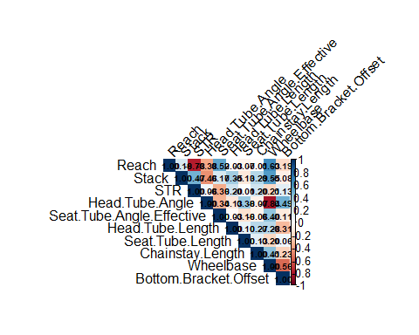
# Use MSA to check suitable correlations for PCA (see report PCA references)
cortest.bartlett(cor(mtbgeo[, geo_vars]), n = nrow(mtbgeo[, geo_vars]))
## $chisq
## [1] 6961.725
##
## $p.value
## [1] 0
##
## $df
## [1] 45
KMO(cor(mtbgeo[, geo_vars]))
## Kaiser-Meyer-Olkin factor adequacy
## Call: KMO(r = cor(mtbgeo[, geo_vars]))
## Overall MSA = 0.45
## MSA for each item =
## Reach Stack STR
## 0.40 0.33 0.34
## Head.Tube.Angle Seat.Tube.Angle.Effective Head.Tube.Length
## 0.49 0.96 0.72
## Seat.Tube.Length Chainstay.Length Wheelbase
## 0.75 0.24 0.54
## Bottom.Bracket.Offset
## 0.54
# remove weak MSA variables < 0.4
weak_vars <- c("Chainstay.Length", "STR", "Stack")
# check correlation and MSA of strong MSA variables < 0.48
strong_vars <- sapply(mtbgeo, is.numeric) &
!(names(mtbgeo) %in% c("Year",
"Suspension.Travel..rear.",
"Suspension.Travel..front.",
weak_vars))
KMO(cor(mtbgeo[, strong_vars]))
## Kaiser-Meyer-Olkin factor adequacy
## Call: KMO(r = cor(mtbgeo[, strong_vars]))
## Overall MSA = 0.61
## MSA for each item =
## Reach Head.Tube.Angle Seat.Tube.Angle.Effective
## 0.54 0.59 0.78
## Head.Tube.Length Seat.Tube.Length Wheelbase
## 0.48 0.60 0.58
## Bottom.Bracket.Offset
## 0.83
Matrix_mtbstrong <- as.matrix(mtbgeo[, strong_vars])
corrplot(cor(Matrix_mtbstrong), method = "color", type = "upper",
tl.col = "black", tl.srt = 45, addCoef.col = "black",
number.cex = 0.6) # correlation heatmap
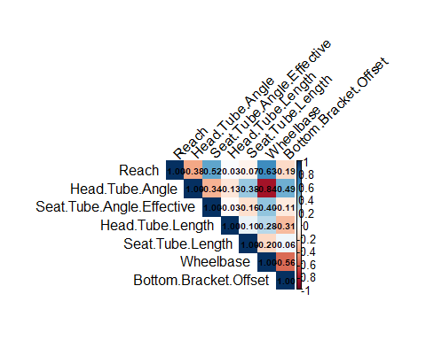

Linearity
# outputs a PDF to file of scatterplots of all combinations of variables to check linearity
vars <- names(mtbgeo)[strong_vars]
pdf("scatterpairs_all.pdf", width = 6, height = 5)
# loop over all pairs
cmb <- combn(vars, 2, simplify = FALSE)
for (xy in cmb) {
x <- xy[1]; y <- xy[2]
plot(mtbgeo[[x]], mtbgeo[[y]],
xlab = x, ylab = y, pch = 20, col = "grey40",
main = paste(y, "vs", x))
abline(lm(mtbgeo[[y]] ~ mtbgeo[[x]]), lty = 2, col = "black") # visual linear fit
}
dev.off()
## png
## 2

Principal Component Analysis
# Perform PCA:
pca <- princomp(mtbgeo[, strong_vars], #PCA
cor = TRUE)
pca$loadings
##
## Loadings:
## Comp.1 Comp.2 Comp.3 Comp.4 Comp.5 Comp.6 Comp.7
## Reach 0.397 0.269 0.458 0.433 0.534 0.296
## Head.Tube.Angle -0.496 0.281 -0.170 -0.149 0.558 -0.559
## Seat.Tube.Angle.Effective 0.331 0.419 0.358 -0.335 -0.656 -0.207
## Head.Tube.Length 0.157 -0.657 0.114 -0.716 0.105
## Seat.Tube.Length -0.193 -0.342 0.743 0.404 -0.353
## Wheelbase 0.542 0.126 0.272 -0.180 -0.759
## Bottom.Bracket.Offset -0.362 0.442 0.133 -0.409 0.529 -0.451
##
## Comp.1 Comp.2 Comp.3 Comp.4 Comp.5 Comp.6 Comp.7
## SS loadings 1.000 1.000 1.000 1.000 1.000 1.000 1.000
## Proportion Var 0.143 0.143 0.143 0.143 0.143 0.143 0.143
## Cumulative Var 0.143 0.286 0.429 0.571 0.714 0.857 1.000
summary(pca) # Std. dev, Proportion of Var, Cumulative Var
## Importance of components:
## Comp.1 Comp.2 Comp.3 Comp.4 Comp.5
## Standard deviation 1.7305214 1.1425085 1.0211798 0.81926231 0.71028431
## Proportion of Variance 0.4278149 0.1864751 0.1489726 0.09588439 0.07207197
## Cumulative Proportion 0.4278149 0.6142900 0.7632626 0.85914697 0.93121894
## Comp.6 Comp.7
## Standard deviation 0.62983170 0.29116905
## Proportion of Variance 0.05666971 0.01211134
## Cumulative Proportion 0.98788866 1.00000000
eigvals <- pca$sdev^2 # eigenvalues λ_i
eigvals
## Comp.1 Comp.2 Comp.3 Comp.4 Comp.5 Comp.6 Comp.7
## 2.99470429 1.30532566 1.04280813 0.67119074 0.50450380 0.39668797 0.08477941

Component Selection
# Select n components
pve <- eigvals / sum(eigvals) # proportion of total variance
round(cbind(Eigenvalue = eigvals,
Proportion = pve,
CumProp = cumsum(pve)), 3)
## Eigenvalue Proportion CumProp
## Comp.1 2.995 0.428 0.428
## Comp.2 1.305 0.186 0.614
## Comp.3 1.043 0.149 0.763
## Comp.4 0.671 0.096 0.859
## Comp.5 0.505 0.072 0.931
## Comp.6 0.397 0.057 0.988
## Comp.7 0.085 0.012 1.000
plot(pca, type = "l", main = "Scree Plot of Principal Components")
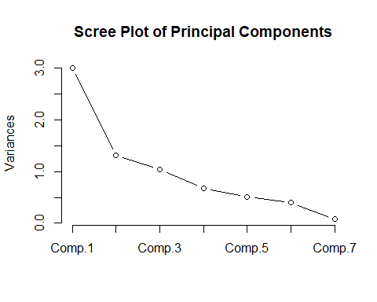
## Bar scree (optional) + Kaiser line at 1 (on correlation, λ=1 rule)
barplot(eigvals, names.arg = paste0("PC", seq_along(eigvals)),
main = "Eigenvalues (Bar Scree)", ylab = "Eigenvalue")
abline(h = 1, col = 2, lty = 2)
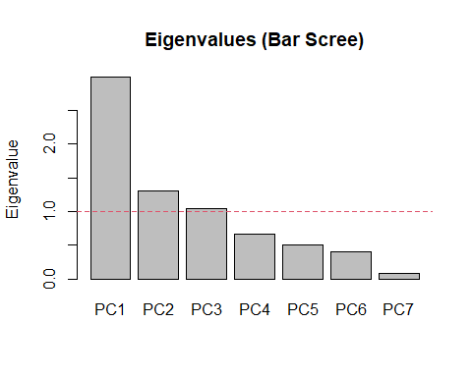
summary(pca)
## Importance of components:
## Comp.1 Comp.2 Comp.3 Comp.4 Comp.5
## Standard deviation 1.7305214 1.1425085 1.0211798 0.81926231 0.71028431
## Proportion of Variance 0.4278149 0.1864751 0.1489726 0.09588439 0.07207197
## Cumulative Proportion 0.4278149 0.6142900 0.7632626 0.85914697 0.93121894
## Comp.6 Comp.7
## Standard deviation 0.62983170 0.29116905
## Proportion of Variance 0.05666971 0.01211134
## Cumulative Proportion 0.98788866 1.00000000
loadings <- pca$loadings
print(loadings)
##
## Loadings:
## Comp.1 Comp.2 Comp.3 Comp.4 Comp.5 Comp.6 Comp.7
## Reach 0.397 0.269 0.458 0.433 0.534 0.296
## Head.Tube.Angle -0.496 0.281 -0.170 -0.149 0.558 -0.559
## Seat.Tube.Angle.Effective 0.331 0.419 0.358 -0.335 -0.656 -0.207
## Head.Tube.Length 0.157 -0.657 0.114 -0.716 0.105
## Seat.Tube.Length -0.193 -0.342 0.743 0.404 -0.353
## Wheelbase 0.542 0.126 0.272 -0.180 -0.759
## Bottom.Bracket.Offset -0.362 0.442 0.133 -0.409 0.529 -0.451
##
## Comp.1 Comp.2 Comp.3 Comp.4 Comp.5 Comp.6 Comp.7
## SS loadings 1.000 1.000 1.000 1.000 1.000 1.000 1.000
## Proportion Var 0.143 0.143 0.143 0.143 0.143 0.143 0.143
## Cumulative Var 0.143 0.286 0.429 0.571 0.714 0.857 1.000
K <- which(cumsum(pve) >= 0.80)[1] # first K with ≥80% cumulative variance
K
## Comp.4
## 4
# pca scores for each bike
id_cols <- c("Brand", "Model", "Year")
scores_df <- cbind(
mtbgeo[, intersect(id_cols, names(mtbgeo)), drop = FALSE],
as.data.frame(pca$scores)
)
head(scores_df)
## Brand Model Year Comp.1 Comp.2 Comp.3 Comp.4
## 54 Alchemy Argos 2022 -1.12220658 1.9271429 0.21213758 0.6055906
## 65 Alutech CNC E-Fanes 2021 0.80899997 -0.7787171 0.39605044 0.7578285
## 68 Alutech eFanes 29/275 Comp 2022 0.97231320 -0.7789735 0.30337402 0.8138334
## 81 Alutech Fanes 29 2022 -0.02323165 -0.6662922 -0.29358611 0.4141721
## 85 Alutech Fanes 5.0 2015 -0.95385396 -1.4810823 0.02610024 0.8944237
## 90 Alutech Fanes 6.0 2019 -0.21179039 -0.9291561 -0.77881421 0.4530563
## Comp.5 Comp.6 Comp.7
## 54 1.1222645 -0.7246885 0.16334824
## 65 -0.6102684 -0.3017038 0.55459387
## 68 -0.5611432 -0.4853208 0.73863923
## 81 0.3562469 -1.0043172 0.09158096
## 85 -0.9762645 -0.2141265 0.42597192
## 90 -0.6257484 0.3098214 0.39760815

PCA Biplot
# Biplot using pseudo-labelled colours with 50% probability ellipses, showing variable orthogonality
mtbgeo_groups$Category <- factor(mtbgeo_groups$Category, levels = c("Cross-country", "Trail", "Enduro", "Downhill"))
ggbiplot(pca,
obs.scale = 2,
var.scale = 2,
point.size = 1.2,
varname.adjust = 2,
groups = mtbgeo_groups$Category,
ellipse = TRUE,
ellipse.linewidth = 0.2,
circle = FALSE,
ellipse.prob = .5) +
theme_classic() +
labs(title = "PCA biplot with bike categories (50% probability ellipses)") +
theme(legend.direction = 'horizontal',
legend.position = 'top')
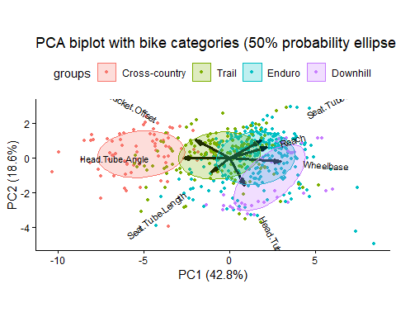

Clustering (K means)

Choosing k
# put the pca scores into a dataframe
clustering_data <- as.data.frame(pca$scores)
colnames(clustering_data) <- c("PC1", "PC2", "PC3", "PC4")
clustering_sub2 <- clustering_data[ , 1:2]
clustering_sub3 <- clustering_data[ , 1:3]
clustering_sub4 <- clustering_data[ , 1:4]
# do some sort of test to figure out what k should be
set.seed(123)
( sub2_p1 <- fviz_nbclust(clustering_sub2, kmeans, method = "wss") )
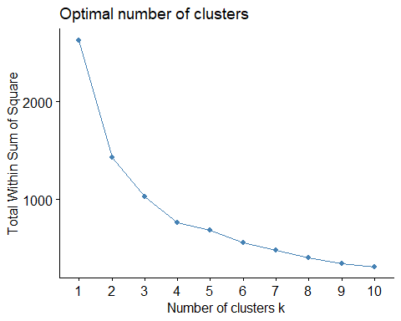
( sub2_p2 <- fviz_nbclust(clustering_sub2, kmeans, method = "silhouette") )
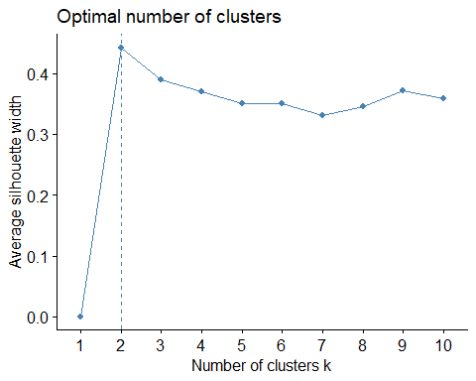
( sub2_p3 <- fviz_nbclust(clustering_sub2, kmeans, method = "gap_stat") )
## Warning: `aes_string()` was deprecated in ggplot2 3.0.0.
## ℹ Please use tidy evaluation idioms with `aes()`.
## ℹ See also `vignette("ggplot2-in-packages")` for more information.
## ℹ The deprecated feature was likely used in the factoextra package.
## Please report the issue at <https://github.com/kassambara/factoextra/issues>.
## This warning is displayed once every 8 hours.
## Call `lifecycle::last_lifecycle_warnings()` to see where this warning was
## generated.
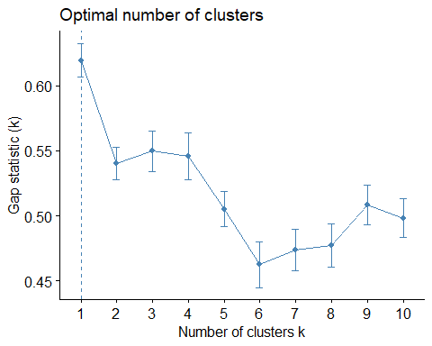
# fviz_nbclust(clustering_sub3, kmeans, method = "wss")
# fviz_nbclust(clustering_sub4, kmeans, method = "wss")
grid.arrange(grobs = c(sub2_p1, sub2_p2), ncol=2)
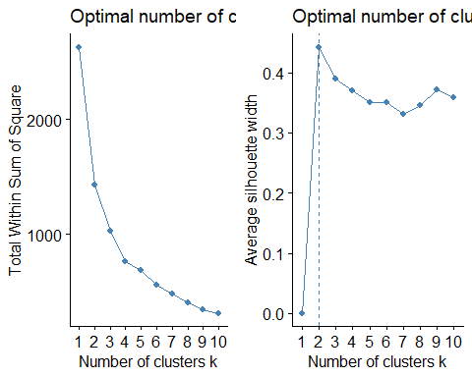
#Anything from 3 to 6 clusters is optimal. I will do clustering and print plots with 3, 4, 5 and 6 clusters and then see which one looks best.

Clusters
# Check to see what data looks like before being clustered, guess what points would realistically be grouped together
plot(clustering_sub2$PC1, clustering_sub2$PC2)
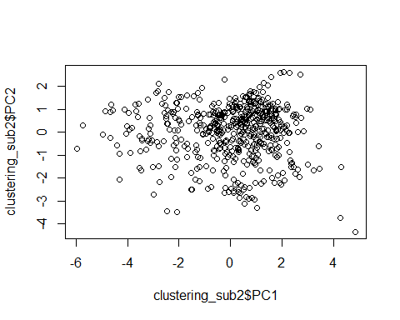
obs_kclusts <- function(k, clust_data) {
kmTest <- kmeans(clust_data, centers=k, nstart = 20)
ratio <- kmTest$betweenss/kmTest$totss
print(paste("ratio for",k,"clusters:", ratio))
return(kmTest)
}
print_kclusts <- function(kmTest, clust_data) {
plot_k <- fviz_cluster(kmTest, geom = "point", data = clust_data, choose.vars = c("PC1", "PC2")) +
ggtitle(paste("k =", k)) + theme_minimal()
plot_k
}
clustering_data <- clustering_sub2
n <- 7 # max number of clusters to test
results <- list()
for (k in 2:n) {
results[[paste0("k", k)]] <- obs_kclusts(k, clustering_data)
}
## [1] "ratio for 2 clusters: 0.455072654186252"
## [1] "ratio for 3 clusters: 0.609928521715944"
## [1] "ratio for 4 clusters: 0.708715247003452"
## [1] "ratio for 5 clusters: 0.757696117650921"
## [1] "ratio for 6 clusters: 0.79151910283358"
## [1] "ratio for 7 clusters: 0.82100429539077"
lapply(results, print_kclusts, clustering_data)
## $k2
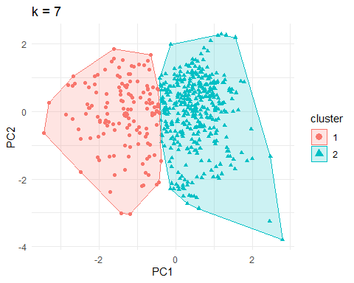
##
## $k3
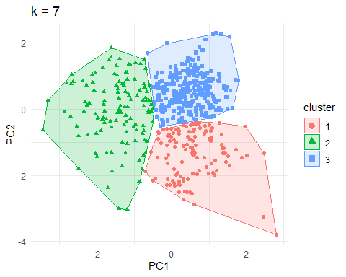
##
## $k4
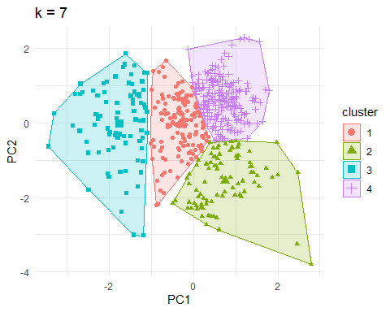
##
## $k5
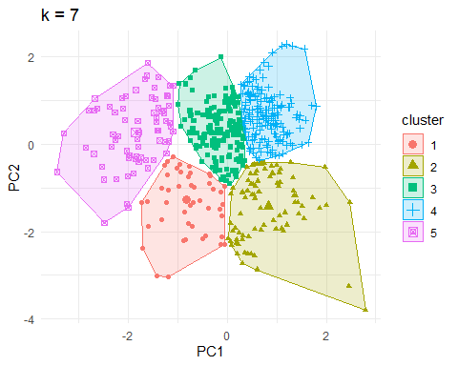
##
## $k6
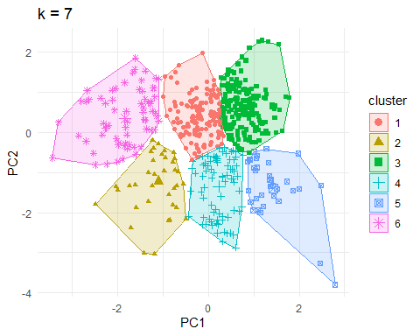
##
## $k7
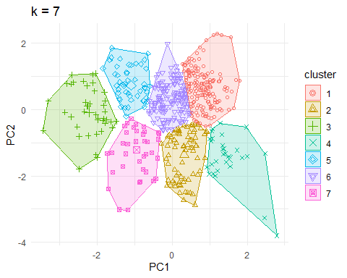
plots <- list()
for (k in 2:n) {
kmTest <- kmeans(clustering_sub2, centers = k, nstart = 20)
plots[[paste0("k", k)]] <- fviz_cluster(kmTest, geom = "point", data = clustering_sub2, choose.vars = c("PC1", "PC2")) + ggtitle(paste("k =", k))
}
ktest <- kmeans(clustering_sub2, centers = 2, nstart = 20)
fviz_cluster(ktest, geom = "point", data = clustering_sub2, choose.vars = c("PC1", "PC2")) + ggtitle("k = 3") + theme_classic()
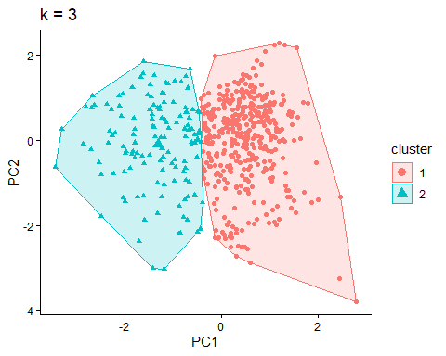
grid.arrange(grobs = plots, ncol = 3)
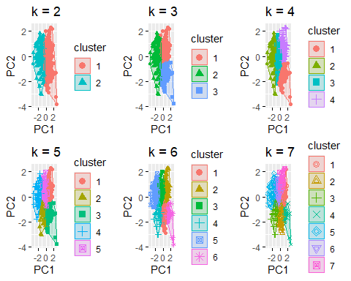

Sankey and Confusion charts
bike_confusion_table <- function(data, cluster_data) {
data_clone <- data
data_clone$cluster <- factor(cluster_data$cluster)
data_clone$Category <- factor(mtbgeo_groups$Category, levels = c("Cross-country", "Trail", "Enduro", "Downhill"))
# confusion-style table
tab <- table(Cluster = data_clone$cluster, Category = data_clone$Category)
prop.table(tab, 1) # row %: composition of each cluster
return(tab)
}
bike_sankey <- function(table, plot_title) {
df_alluv <- as.data.frame(table) %>% as_tibble()
ggplot(df_alluv, aes(axis1 = Category, axis2 = Cluster, y = Freq)) +
geom_alluvium(aes(fill = Category), width = 0.1, alpha = 0.6) +
geom_stratum(aes(fill = Category), width = 0.05, alpha=0.3) +
# scale_fill_brewer(palette = "Dark2", name = "Category") +
geom_text(stat = "stratum", aes(label = after_stat(stratum)), hjust = 0, nudge_x = 0.03) +
labs(title = plot_title, y = "", subtitle = "Flow Weight = No. of Bikes") +
theme_void() + theme(axis.text.y = element_blank(), axis.text.x = element_blank())
}
(table1 <- bike_confusion_table(clustering_data, results$k6))
## Category
## Cluster Cross-country Trail Enduro Downhill
## 1 11 99 60 0
## 2 10 21 16 0
## 3 0 39 143 20
## 4 0 19 43 17
## 5 0 5 25 6
## 6 60 16 0 0
prop.table(table1, 1)
## Category
## Cluster Cross-country Trail Enduro Downhill
## 1 0.06470588 0.58235294 0.35294118 0.00000000
## 2 0.21276596 0.44680851 0.34042553 0.00000000
## 3 0.00000000 0.19306931 0.70792079 0.09900990
## 4 0.00000000 0.24050633 0.54430380 0.21518987
## 5 0.00000000 0.13888889 0.69444444 0.16666667
## 6 0.78947368 0.21052632 0.00000000 0.00000000
bike_sankey(table1, "Bike Category → 6 k-means Clusters")
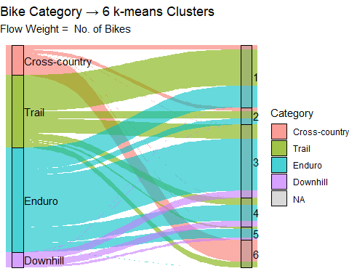
####3D plot
# # This is for the wrong clusters atm, k4 is for 2 PCs but is being plotted for sub3 (3 PCs)
#
# plot_ly(data = clustering_sub3, x = ~PC1, y = ~PC2, z = ~PC3, color = ~factor(k4$cluster),
# colors = c("#E41A1C", "#377EB8", "#4DAF4A"), type = "scatter3d", mode = "markers") %>%
# layout(title = "3D PCA space - k = 3 clusters")

Mixed clustering

Mixed dataframe creation
# mixed_df: data.frame with numeric columns and categorical columns as factors
# id_cols <- c("Brand", "Model", "Year", "Motorized", "Wheel.Size") # all categorical columns in mtbgeo
id_cols <- c("Brand", "Year", "Motorized", "Wheel.Size") # subset of categories from industry expert
mixed_df <- cbind(
mtbgeo[, intersect(id_cols, names(mtbgeo)), drop = FALSE],
as.data.frame(mtbgeo[, strong_vars]) # use subset of strong vars -> don't need to use standaridised ones
)
# head(mixed_df)
# mixed_df$Brand = as.factor(mixed_df$Brand) # need to turn these categorical variables into clusters
# mixed_df$Model = as.factor(mixed_df$Model)
# mixed_df$Motorized = as.factor(mixed_df$Motorized)
# mixed_df$Year = as.factor(mixed_df$Year)
# mixed_df$Wheel.Size = as.factor(mixed_df$Wheel.Size)
# Ensure types are correct
mixed_df[] <- lapply(mixed_df, function(x) if (is.character(x)) factor(x) else x)
mixed_df$Year = as.factor(mixed_df$Year)
head(mixed_df)
## Brand Year Motorized Wheel.Size Reach Head.Tube.Angle
## 54 Alchemy 2022 false 29″ 454 65.0
## 65 Alutech 2021 true Mullet 29/27,5 450 64.0
## 68 Alutech 2022 true Mullet 29/27,5 450 63.5
## 81 Alutech 2022 false 29″ 440 64.0
## 85 Alutech 2015 false 27,5″ / 650B 433 65.4
## 90 Alutech 2019 false 27,5″ / 650B 440 65.0
## Seat.Tube.Angle.Effective Head.Tube.Length Seat.Tube.Length Wheelbase
## 54 75.5 90 425 1197
## 65 76.5 110 435 1214
## 68 76.5 110 435 1214
## 81 75.0 110 430 1222
## 85 75.0 110 440 1181
## 90 75.0 110 420 1192
## Bottom.Bracket.Offset
## 54 60
## 65 9
## 68 9
## 81 30
## 85 9
## 90 9
###Finding optimal k for mixed
fit_kproto <- function(k, df, nstart, d_gower) {
fit <- suppressMessages(suppressWarnings( kproto(df, k = k, nstart = nstart) ))
sil_mean <- NA
if(!is.null(d_gower) && k > 1) {
sil_mean <- silhouette(as.integer(fit$cluster), d_gower)[,3]
}
fit_df <- data.frame(k = k, tot_withinss = fit$tot.withinss, # k-prototypes TWSS (lower is better)
lambda = fit$lambda, # balance used
sil_mean = sil_mean)
return(fit_df)
}
kproto_sweep <- function(df, k_range, nstart = 20, seed = 123, do_silhouette = TRUE) {
set.seed(seed)
d_gower <- NULL
if (do_silhouette) {
d_gower <- daisy(df, metric = "gower") # Compute Gower for silhouettes (optional)
}
k_sweep <- lapply(k_range, fit_kproto, df = df, nstart = nstart, d_gower = d_gower)
df_out <- bind_rows(k_sweep) # “Explained dissimilarity” relative to k=1
df_out <- df_out %>%
mutate(tot_withinss_k1 = first(tot_withinss),
explained = 1 - (tot_withinss / tot_withinss_k1))
return(df_out)
}
plot_mixed_elbow <- function(mixed_sweep) { # Elbow plot for k-prototypes
ggplot(mixed_sweep, aes(k, tot_withinss)) +
geom_line(color="steelblue") + geom_point(color="steelblue") + theme_classic() +
scale_x_continuous(breaks = 1:10) +
labs(title = "k-prototypes elbow (total within-cluster dissimilarity)",
x = "k", y = "Total withinss (lower is better)")
}
plot_mixed_exp_diss <- function(mixed_sweep) { # explained dissimilarity in % (relative to k=1)
ggplot(sweep_df, aes(k, explained)) +
geom_line(color="steelblue") + geom_point(color="steelblue") + theme_classic() +
scale_y_continuous(labels = scales::percent_format()) +
labs(title = "Explained dissimilarity vs k",
x = "k", y = "Explained dissimilarity")
}
# Optional: silhouette (using Gower) to corroborate elbow
plot_mixed_silhouette <- function(mixed_sweep) {
ggplot(filter(mixed_sweep, k > 1), aes(k, sil_mean)) +
geom_line(color="steelblue") + geom_point(color="steelblue") + theme_classic() +
labs(title = "Average silhouette vs k (Gower distance)",
x = "k", y = "Average silhouette")
}
# Run the sweep
ks <- 1:10
sweep_df <- kproto_sweep(mixed_df, k_range = ks, do_silhouette = TRUE)
## 0 0
## 0 observation(s) with NAs.
p1 <- plot_mixed_elbow(sweep_df)
p2 <- plot_mixed_exp_diss(sweep_df)
p3 <- plot_mixed_silhouette(sweep_df)
p1
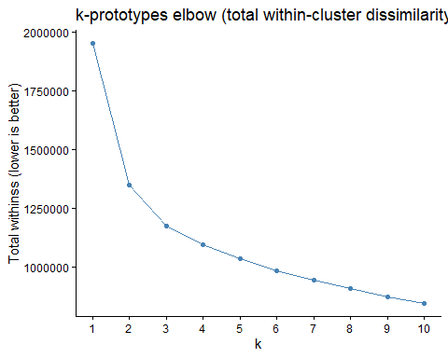
p2
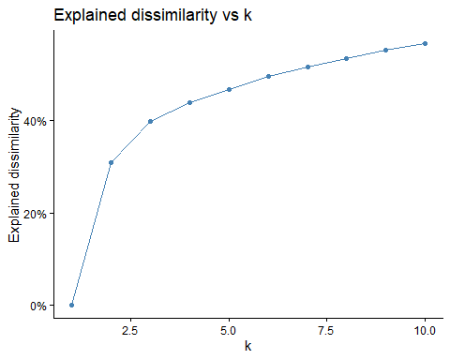
# grid.arrange(grobs = c(p1,p2,p3), ncol = 3)
###Optimal k for mixed
# k-prototypes (handles mixed types)
set.seed(123)
kmix3 <- kproto(mixed_df, k = 3, lambda = NULL, nstart = 20)
## # NAs in variables:
# lambda = NULL => auto-estimated balance between numeric and categorical parts
# kmix$centers # data frame: numeric columns are means; factors are modes
# kmix$lambda # numeric↔categorical balance used
# kmix$size # cluster sizes
# kmix$withinss # within-cluster dissimilarity per cluster
# kmix$tot.withinss # total within-cluster dissimilarity
# summary(kmix)
kmix3
## Distance type: huang
##
## Numeric predictors: 7
## Categorical predictors: 4
## Lambda: 485.2853
##
## Number of Clusters: 3
## Cluster sizes: 281 118 211
## Within cluster error: 479840.8 239929.7 455828.3
##
## Cluster prototypes:
## Brand Year Motorized Wheel.Size Reach Head.Tube.Angle
## 1 Cube 2021 false 29″ 449.2707 65.11726
## 2 Cube 2022 false 29″ 435.2924 67.49661
## 3 Canyon 2022 false 29″ 457.8588 64.09773
## Seat.Tube.Angle.Effective Head.Tube.Length Seat.Tube.Length Wheelbase
## 1 76.08875 107.2420 418.3370 1208.628
## 2 74.56186 105.5847 431.7458 1154.164
## 3 76.72848 111.4976 420.5583 1246.169
## Bottom.Bracket.Offset
## 1 28.05932
## 2 43.79407
## 3 18.15450

Plotting optimal ks for mixed
kmix <- kmix3
# kmix <- kmix4
# kmix <- kmix6
mixed_plots <- clustMixType::clprofiles(kmix, mixed_df)
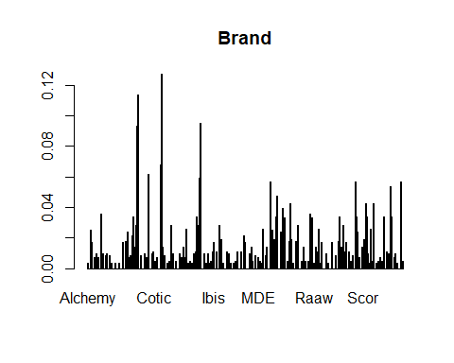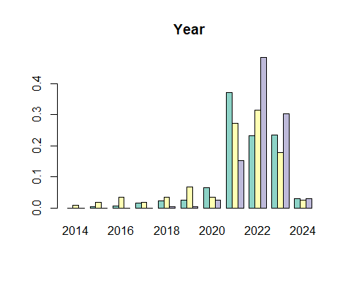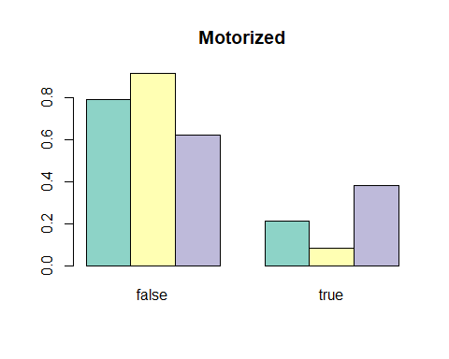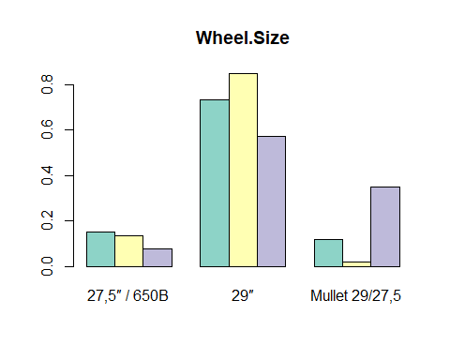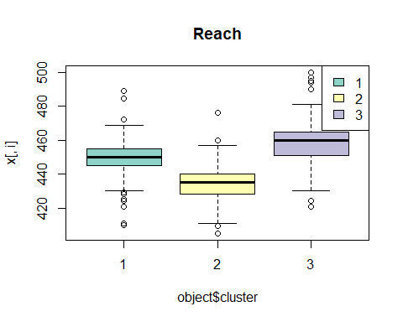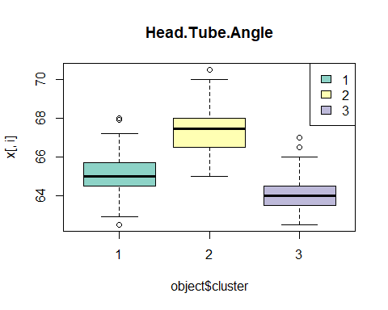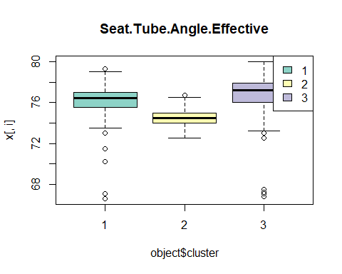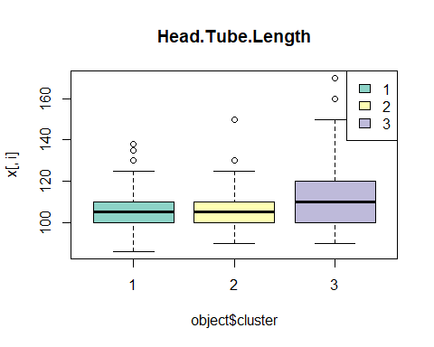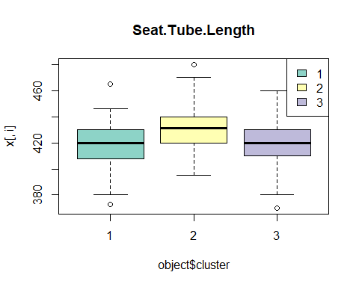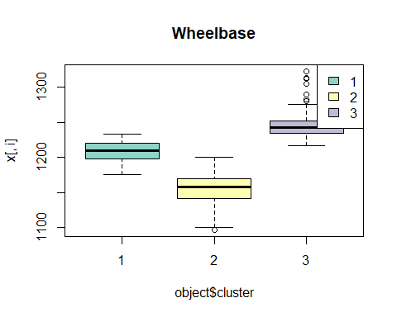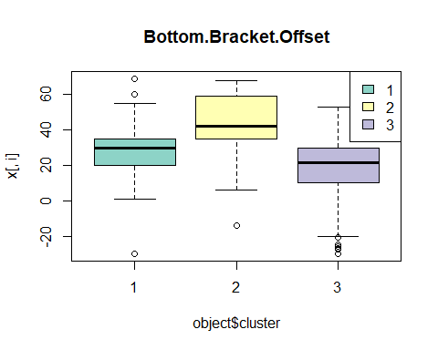
mixed_with_pc <- mixed_df
mixed_with_pc$PC1 <- pca$scores[,"Comp.1"]
mixed_with_pc$PC2 <- pca$scores[,"Comp.2"]
mixed_with_pc$Category <- factor(mtbgeo_groups$Category, levels = c("Cross-country", "Trail", "Enduro", "Downhill"))
mixed_with_pc$kproto <- factor(kmix$cluster)
mixed_with_pc$kmeans <- factor(results$k3$cluster)
# mixed_with_pc$kmeans <- factor(results$k4$cluster)
# mixed_with_pc$kmeans <- factor(results$k6$cluster)
plot_df <- data.frame(x = mixed_df[,"Reach"],
y = mixed_df[,"Wheelbase"],
cluster = factor(kmix$cluster))
ggplot(plot_df, aes(x, y, color = cluster)) +
geom_point(alpha = 0.8) +
labs(title = "k-prototypes clusters on Reach vs Wheelbase", x = "Reach", y = "Wheelbase") +
stat_ellipse(aes(fill = cluster, group = cluster), type = "norm", geom = "polygon", level = 0.9, linewidth = 0.8, alpha = 0.25) +
theme_classic()
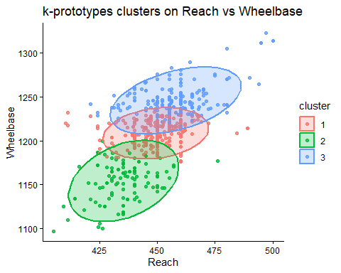
# p_kproto <- ggplot(mixed_with_pc, aes(PC1, PC2, color = factor(kmix$cluster), shape = Category)) +
p_kproto <- ggplot(mixed_with_pc, aes(PC1, PC2, color = kproto)) +
geom_point(alpha = 0.8) +
# scale_shape_manual(values = c(16, 17, 15, 3)) +
stat_ellipse(aes(fill = kproto, group = kproto), type = "norm", geom = "polygon", level = 0.9, linewidth = 0.8, alpha = 0.25) +
labs(title = "k-prototypes clusters on PC map: k = 6", color = "kproto") +
theme_classic()
#
# p_kmeans <- ggplot(mixed_with_pc, aes(PC1, PC2, color = kmeans)) +
# geom_point(alpha = 0.8) +
# stat_ellipse(aes(fill = kmeans, group = kmeans), type = "norm", geom = "polygon", level = 0.9, linewidth = 0.8, alpha = 0.25) +
# labs(title = "k-means clusters on PC map", color = "kmeans") +
# theme_classic()
# ggplot(mixed_with_pc, aes(PC1, PC2)) +
# geom_point(aes(color = kproto), alpha = 0.75, size = 1.8) +
# stat_ellipse(aes(color = kproto, group = kproto), type = "norm", level = 0.90, linetype = 1) +
# stat_ellipse(aes(color = kmeans, group = kmeans), type = "norm", level = 0.90, linetype = 2) +
# labs(title = "Ellipses: k-prototypes (solid) vs k-means (dashed)",
# color = "Cluster") +
# theme_minimal()
p_kproto
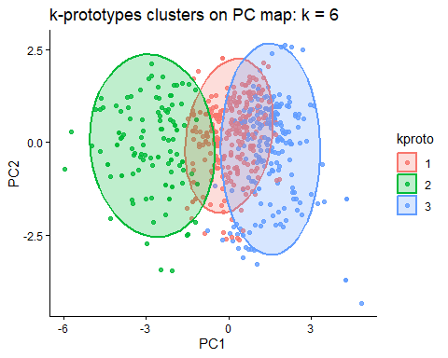
# p_kmeans
mixed_table <- bike_confusion_table(mixed_df, kmix)
mixed_table
## Category
## Cluster Cross-country Trail Enduro Downhill
## 1 8 131 135 7
## 2 73 41 4 0
## 3 0 27 148 36
bike_sankey(mixed_table, "Bike Category → 3 k-prototypes Clusters")
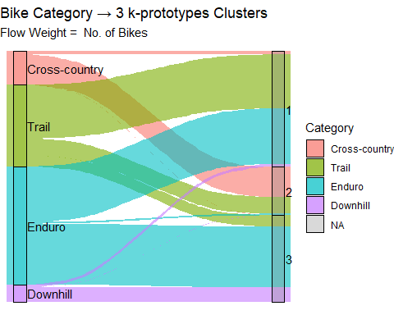

SVM - extra marks

Packages for SVM
# SVM: multi-class classification on numeric geometry-only features
# Extra packages required for this SVM section
library(e1071)
##
## Attaching package: 'e1071'
## The following object is masked from 'package:ggplot2':
##
## element
library(caret)
## Loading required package: lattice
library(lattice)

Dataframe with labels
set.seed(1234)
# Build labelled data frame: X = geometry vars only, y = Category from mtbgeo_groups
feature_names <- names(mtbgeo)[geo_vars]
svm_df <- mtbgeo[, feature_names, drop = FALSE] %>%
mutate(Category = factor(mtbgeo_groups$Category))

Split into Train/Test
# Stratified train/test split as classes are imbalanced and we need them all represented in train and test sets
idx <- caret::createDataPartition(svm_df$Category, p = 0.7, list = FALSE)
train <- svm_df[idx, ]
test <- svm_df[-idx, ]

Add class weights
# Compute class weights to address imbalance (median frequency scaling)
freq <- table(train$Category)
class_wts <- as.numeric(median(freq) / freq)
names(class_wts) <- names(freq)
freq
##
## Cross-country Trail Enduro Downhill
## 57 140 201 31

Hyperparameter tuning for Gamma and Cost
# Hyperparameter tuning (radial kernel)
gamma_grid <- 2^(-9:-1) # reasonable range for gamma (RBF width)
cost_grid <- 2^(-1:9) # reasonable range for C (regularisation)
# try every (C, gamma) pair on 5 fold CV on training data
tuned <- e1071::tune.svm(
x = train[, feature_names],
y = train$Category,
kernel = "radial",
gamma = gamma_grid,
cost = cost_grid,
class.weights = class_wts,
scale = TRUE, # safe standardisation inside svm
tunecontrol = tune.control(cross = 5) # 5-fold CV
)
# note to team: this will take a bit to find best
best <- tuned$best.model # gets best (C, gamma) found by CV
best
##
## Call:
## best.svm(x = train[, feature_names], y = train$Category, gamma = gamma_grid,
## cost = cost_grid, class.weights = class_wts, kernel = "radial",
## scale = TRUE, tunecontrol = tune.control(cross = 5))
##
##
## Parameters:
## SVM-Type: C-classification
## SVM-Kernel: radial
## cost: 256
##
## Number of Support Vectors: 182
best$cost; best$gamma # confirm what's in the final model
## [1] 256
## [1] 0.03125

Get Predictions
# Test-set predictions
pred <- predict(best, newdata = test[, feature_names])

Validation visualisations

Confusion Matrix
# Confusion matrix
cm <- caret::confusionMatrix(pred, test$Category)
cm
## Confusion Matrix and Statistics
##
## Reference
## Prediction Cross-country Trail Enduro Downhill
## Cross-country 23 9 0 0
## Trail 0 43 13 1
## Enduro 1 7 68 4
## Downhill 0 0 5 7
##
## Overall Statistics
##
## Accuracy : 0.779
## 95% CI : (0.7115, 0.8372)
## No Information Rate : 0.4751
## P-Value [Acc > NIR] : < 2.2e-16
##
## Kappa : 0.6649
##
## Mcnemar's Test P-Value : NA
##
## Statistics by Class:
##
## Class: Cross-country Class: Trail Class: Enduro
## Sensitivity 0.9583 0.7288 0.7907
## Specificity 0.9427 0.8852 0.8737
## Pos Pred Value 0.7188 0.7544 0.8500
## Neg Pred Value 0.9933 0.8710 0.8218
## Prevalence 0.1326 0.3260 0.4751
## Detection Rate 0.1271 0.2376 0.3757
## Detection Prevalence 0.1768 0.3149 0.4420
## Balanced Accuracy 0.9505 0.8070 0.8322
## Class: Downhill
## Sensitivity 0.58333
## Specificity 0.97041
## Pos Pred Value 0.58333
## Neg Pred Value 0.97041
## Prevalence 0.06630
## Detection Rate 0.03867
## Detection Prevalence 0.06630
## Balanced Accuracy 0.77687

Accuracy scores
# Per-class precision/recall/F1
per_class_metrics <- {
lev <- levels(test$Category)
res <- lapply(lev, function(l) {
tp <- sum(test$Category == l & pred == l)
fp <- sum(test$Category != l & pred == l)
fn <- sum(test$Category == l & pred != l)
precision <- ifelse(tp + fp == 0, NA, tp / (tp + fp))
recall <- ifelse(tp + fn == 0, NA, tp / (tp + fn))
f1 <- ifelse(
is.na(precision) | is.na(recall) | precision + recall == 0,
NA,
2 * precision * recall / (precision + recall)
)
data.frame(class = l, precision, recall, f1)
})
do.call(rbind, res)
}
accuracy <- mean(pred == test$Category)
print(per_class_metrics)
## class precision recall f1
## 1 Cross-country 0.7187500 0.9583333 0.8214286
## 2 Trail 0.7543860 0.7288136 0.7413793
## 3 Enduro 0.8500000 0.7906977 0.8192771
## 4 Downhill 0.5833333 0.5833333 0.5833333

Confusion Heatmap
# Confusion heatmap
cm_df <- as.data.frame(table(Truth = test$Category, Pred = pred))
ggplot(cm_df, aes(x = Pred, y = Truth, fill = Freq)) +
geom_tile() +
geom_text(aes(label = Freq), size = 4) +
labs(title = "SVM confusion matrix (test set)", x = "Predicted", y = "True") +
theme_classic(base_size = 13) +
scale_fill_gradient(name = "Count", low = "grey95", high = "steelblue4")
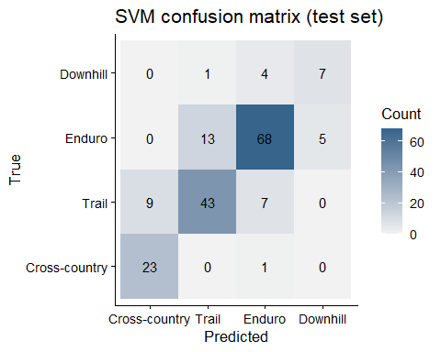

Decision Regions in PCA space
# PCA on train dataset only
Xtr <- train[, feature_names]
pcs <- princomp(Xtr, cor = TRUE, scores = FALSE)
# 2 = k PCs (This is just for plotting so no need to align with actual PCA and we just train SVM on the first two)
var_expl <- pcs$sdev^2 / sum(pcs$sdev^2)
k <- 2
# project train/test to PC space
train_scores <- as.data.frame(predict(pcs, newdata = Xtr)[, 1:k])
test_scores <- as.data.frame(predict(pcs, newdata = test[, feature_names])[, 1:k])
train_scores$Category <- train$Category
test_scores$Category <- test$Category
# Train SVM on PC1, PC2
svm_pca <- e1071::svm(Category ~ ., data = {
sc <- as.data.frame(predict(pcs, Xtr)[, 1:2])
sc$Category <- train$Category
sc
}, kernel = "radial", gamma = best$gamma, cost = best$cost,
class.weights = class_wts, scale = TRUE)
# Decision regions grid
ts2 <- as.data.frame(predict(pcs, test[, feature_names])[, 1:2])
names(ts2) <- c("Comp.1","Comp.2")
rng1 <- range(ts2$Comp.1); rng2 <- range(ts2$Comp.2)
grid <- expand.grid(`Comp.1` = seq(rng1[1], rng1[2], length.out = 200),
`Comp.2` = seq(rng2[1], rng2[2], length.out = 200))
grid$pred <- predict(svm_pca, grid)
ggplot() +
geom_raster(data = grid, aes(`Comp.1`, `Comp.2`, fill = pred), alpha = 0.25) +
geom_point(data = transform(ts2, Category = test$Category),
aes(`Comp.1`, `Comp.2`, colour = Category), size = 1.8) +
labs(title = "SVM decision regions in PCA space") +
theme_classic(base_size = 13) +
guides(fill = "none")
