Twinned Cities
Total cities: 10895
Cities with >2 connections: 4

Distribution (degree <=2)
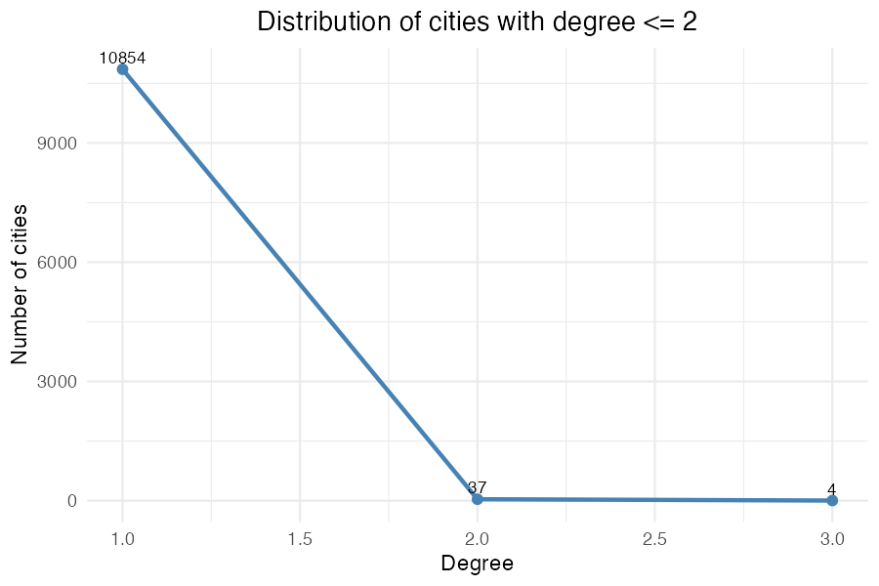

Top 20 cities by degree
