Sister Cities: Connections

Top cities by degree
id | name | degree
Springfield, Us | Springfield, Us | 3
Columbus, Us | Columbus, Us | 3
Columbia, Us | Columbia, Us | 3
Miyoshi, Jp | Miyoshi, Jp | 3
Konan, Jp | Konan, Jp | 2
Pasadena, Us | Pasadena, Us | 2
Kansas City, Us | Kansas City, Us | 2
Jackson, Us | Jackson, Us | 2
Taizhou, Cn | Taizhou, Cn | 2
Portsmouth, Us | Portsmouth, Us | 2
Newport, Us | Newport, Us | 2
Troy, Us | Troy, Us | 2
Richmond, Us | Richmond, Us | 2
Shawnee, Us | Shawnee, Us | 2
Concord, Us | Concord, Us | 2
Midland, Us | Midland, Us | 2
Lakewood, Us | Lakewood, Us | 2
Princeton, Us | Princeton, Us | 2
Huế, Vn | Huế, Vn | 2
Tilburg, Nl | Tilburg, Nl | 2

Top 20 chart
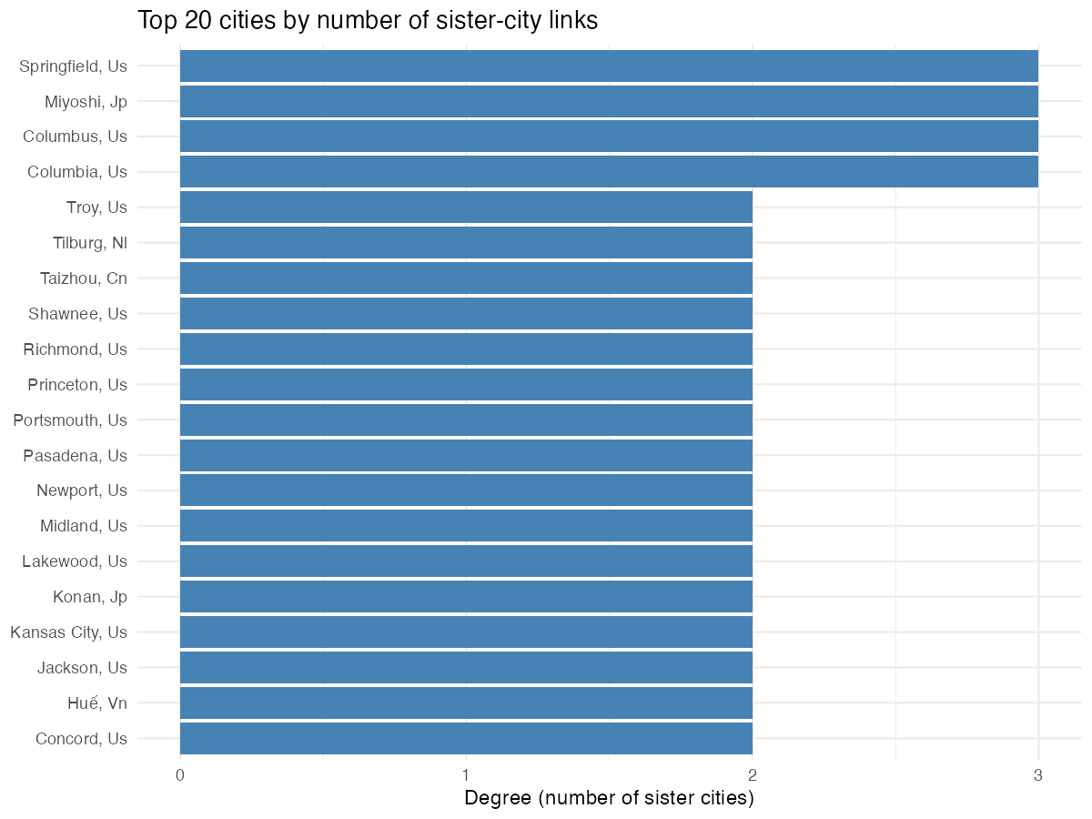

Degree distribution
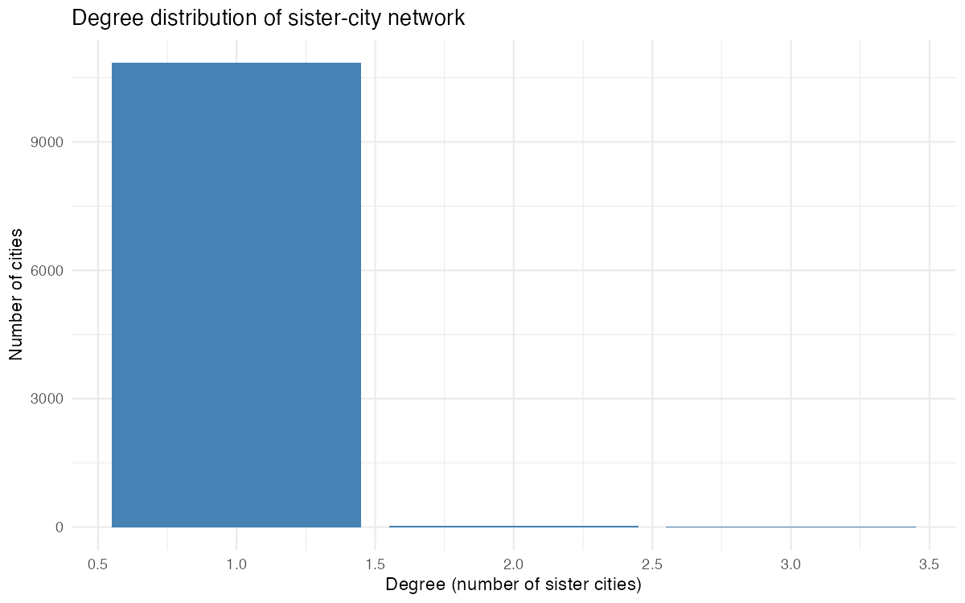

Network plot
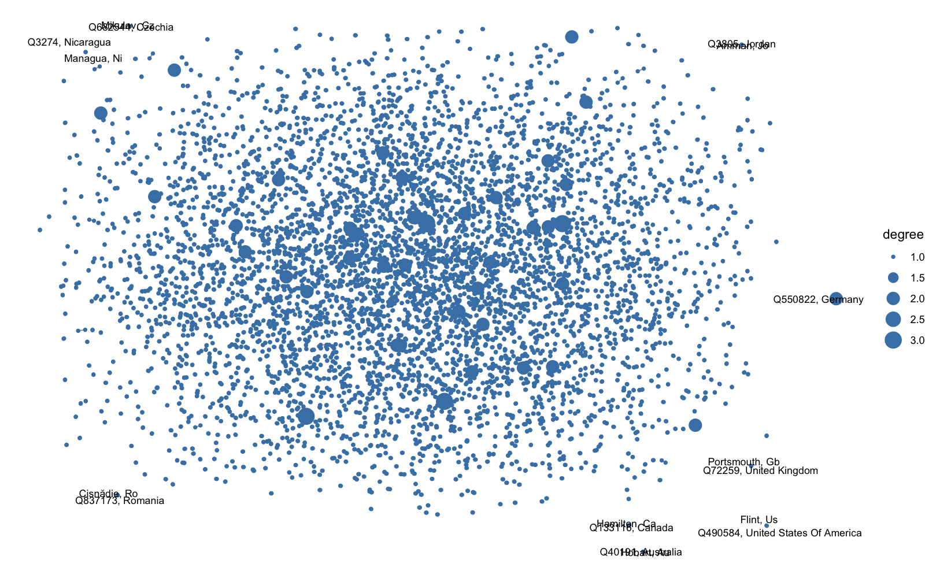

Degree summary
metric | count
degree_1 | 10,854
degree_2 | 37
degree_3 | 4

