Installation Instructions of

MACROS,
PROGRAMS,
DATASETS,
ENTERPRISE MINER NODES

for SAS-Press Book 60502

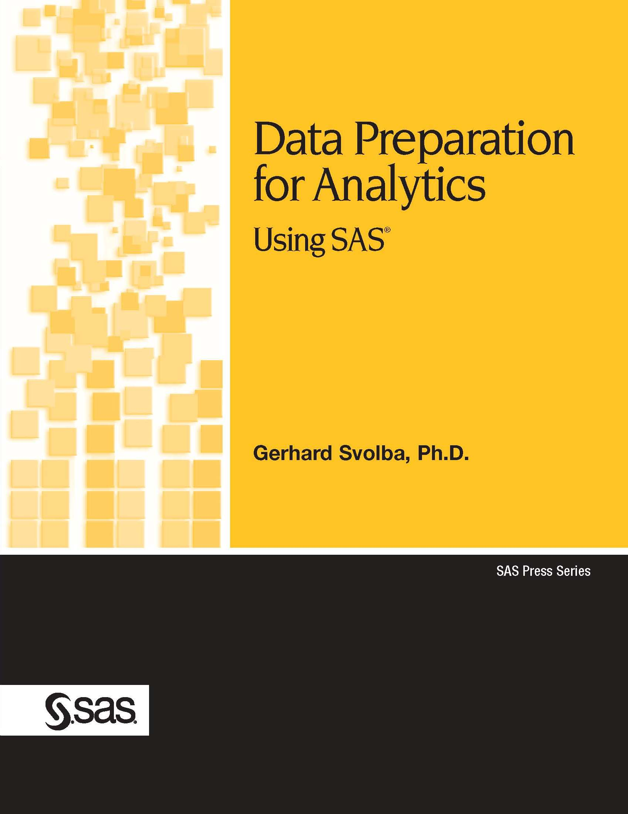

Release 3.2 per June 18th, 2008

Description of this document

Rationale
This document describes installation instructions of the macros, programs and datasets that are used in the SAS Press book “Data Preparation for Analytics” by Gerhard Svolba (book code 60502). Additionally the installation and usage of the respective “Data Preparation Extension Nodes” for SAS Enterprise are described.
This document and the respective SAS files can be downloaded from: http://support.sas.com/publishing/bbu/companion_site/60502.html Link: “Example Code and Data.”
Also check out the most recent version:

Change History of this Document

Date | Version | Changes and Enhancements
2006-12-06 | 2.2 | Initial Creation of the SAS Files.  Inclusion of the “Concentration” Node for SAS Enterprise Miner
2008-06-18 | 3.2 | New version of the MAKEWIDE and MAKELONG macros also transposes the more than one variable.  SAS Enterprise Miner Extension Nodes: Upgrade from EM 5.2 to EM 5.3; different interpretation of default values in the XML Files.

For any questions and comments please contact:
saspress@sas.com; Subject: Feedback to Data Preparation for Analytics

Disclaimer and error tracking
Note that neither SAS nor the author takes responsibility for errors and/or their consequences in the SAS code or the SAS tools provided here. There is no SAS technical support for the content of the macros or the SAS Enterprise Miner extension nodes.
Anyhow, the author is happy to receive your feedback, comments, usage experiences and improvement suggestions when using these SAS tools. If possible and applicable, the author will provide updated versions of the SAS tools through the SAS Press Companion page.

Development Environment
The development environment for the macros, programs and extension nodes is a desktop installation of SAS 9.1.3 and EM 5.2 on a WindowsXP operating system.

Installing the Content of the ZIP-File

Step 1 – Extract the ZIP file to a directory of you choice
- Select or create a directory in a file system and extract the ZIP file.
- Make sure that you check the “Use Folder Names” option.
Note that some datasets have the same name (e.g. Chapter 25 and Chapter 26) and need therefore to be extracted to different directories.

Step 2 – Include the SAS File with the Macro Definitions

After extracting the ZIP-File you will find a the macros in .\01 Macros\Macros.sas. You can include this file to your SAS – Session, e.g. with the following statements:
%INC ‘....\01 Macros\Macros.sas’;
This will define the following SAS macros to your SAS-Session. You find details to the macros, their parameters and usage examples in the book “Data Preparation for Analytics”.
- MAKEWIDE
- MAKELONG
- TRANSP_CAT
- REPLACE_MV
- INTERACT
- SHIFT
- FILTER
- CONCENTRATE
- CREATEPROPS
- PROPSCORING
- TARGETCHART
- RESTRICTEDSAMPLE
- SAMPLINGVAR
- CLUS_SAMPLE
- CLUS_SAMPLE_RES
- ALERTNUMERICMISSING
- ALTERCHARMISSING
- REMEMBERCATEGORIES
- CHECKCATEGORIES
- REMEBERDISTRIBUTION
- SCOREDISTRIBUTION
- MAKEWIDE_DS
- MAKELONG_DS
- TRANSP_CAT_DS
Now you are ready to use the macros.

Step 3 – Copy the SAS datasets to the respective SAS – Library
Most of the SAS datasets that are used in the book are located in directory “.\02 Data”. The datasets for the case studies in chapter 25, 26 and 27 are located in separate directories. When using the files, note that across chapters, some of them have the same name.

Case Study Data
The case studies in chapter 25 and 26 use the datasets from a work library, chapter 27 expects the data to be in a library called SALES. Note that library SALES must not be a SPDE-Engine or Metadata-Library as a SAS format catalog is created in this library in the program.
The author suggests to define SAS libraries to the subdirectories “02 Data/Chapter25”, “02 Data/Chapter26” and “02 Data/Chapter27”, e.g. using the following code.
LIBNAME chap25 “02 Data/Chapter25”;
LIBNAME chap26 “02 Data/Chapter26”;
LIBNAME sales “02 Data/Chapter27”;
Before running the code for e.g. the case study in chapter 25, use the following statement to copy the datasets to the work statement.
Proc copy in = chap25 out = work;
Run;
This is preferable as it is sometimes hard to determine or to access the directory of the current work library.

Other Data
Some of the datasets that are used in the book are directly created by the respective programs. Please observe that different datasets across chapters can have the same name.
In library “02 Data Various Datasets” you find datasets that are used throughout the book. All datasets except the FITNESS dataset are taken from the SAMPSIO library. This library comes with an SAS Enterprise Miner installation. If you have SAS Enterprise Miner installed you will not need to copy these datasets. Otherwise define a library called SAMPSIO to this directory.
Note that you should not do this if you have already a SAS Enterprise Miner installation on your machine as you will re-root the SAMPSIO library and loose the access to many other demo datasets, that come with SAS Enterprise Miner.
The FITNESS dataset can also be found in other SAS examples. Note that this version has an additional variable PERSONNR in order to enumerate the rows.

Step 4 – Use the SAS Programs
You can start using the SAS Programs in directory “03 Programs”. Note that there is one program file per chapter.

Optional: Installing the SAS Enterprise Extension Nodes

Step 1a: Installation for EM 5.2 Full Desktop systems
Use the following steps to install the extension nodes on a system that is not running the EM 5.2 Analytics Platform (mid-tier). You can check your configuration by selecting
Help → Configuration from the main menu.
- Close the EM 5.2 client application.
- Find the SAS root directory, for example: C:Program Files\SAS
- Find the SAS AP directory, for example: C:\Program Files\SAS\SASAPCore
- Copy the XML Files of the directory 04 Enterprise Miner Nodes\XML to the Enterprise Miner extension subdirectory. C:\Program Files\SAS\SASAPCore\apps\EnterpriseMiner\ext
- Copy the GIF Files of the sub-directories gif16 and gif32 in 04 Enterprise Miner Nodes\GIF to the Enterprise Miner extension subdirectory. C:\Program Files\SAS\SASAPCore\apps\EnterpriseMiner\ext\gif16 and gif32
- Restart the EM 5.2 client application

Step 1b: Installation for EM 5.2 Shared Platform systems
Follow these steps to install the extension nodes on the EM 5.2 Shared Platform system. You do not need to update each individual end-user client. The extension nodes will be available to all users.
- Close the EM 5.2 shared platform
- Find the SAS root directory, for example: C:\Program Files\SAS
- Find the SAS AP directory, for example: C:\Program Files\SAS\SASAPCore
- Copy the XML Files of the directory 04 Enterprise Miner Nodes\XML to the Enterprise Miner extension subdirectory. C:\Program Files\SAS\SASAPCore\apps\EnterpriseMiner\ext
- Copy the GIF Files of the sub-directories gif16 and gif32 in 04 Enterprise Miner Nodes\GIF to the Enterprise Miner extension subdirectory. C:\Program Files\SAS\SASAPCore\apps\EnterpriseMiner\ext\gif16 and gif32
- Restart the EM 5.2 Shared Platform

Step 2: Install the Source Code
- Open a SAS display manager system session (normal SAS session).
- Open each node of 04 Enterprise Miner Nodes\SourceCode in the program editor
- Select FILE → SAVE AS OBJECT
- Save the source code in the SASHELP.EMEXT catalog under the same name as the file name (e.g. SASHELP.EMEXT.CONCENTRATION
- Do not confuse the SASHELP.EMEXT catalog with the SASHELP.EMTEXT catalog!

Macro Usage
In order to avoid problems with non-existing macros definitions in a SAS-Session, the extension nodes do not call the same SAS macro instances as are described above and contained in the macros.sas file. If one of the data preparation macros is needed in an extension node, the source code contains its own copy of the macro. Therefore any changes to the macros in MACROS.SAS have no influence on the extension nodes.

Optional: Using the SAS Enterprise Extension Nodes for Data Preparation

See the document:
Extending SAS Enterprise Miner with Data Preparation for Analytics Nodes 3_3.doc
for more details

