**TEST CASES**

**Test case – 1**

**Query :** Implementation of binary tree in C++

**Solution:**

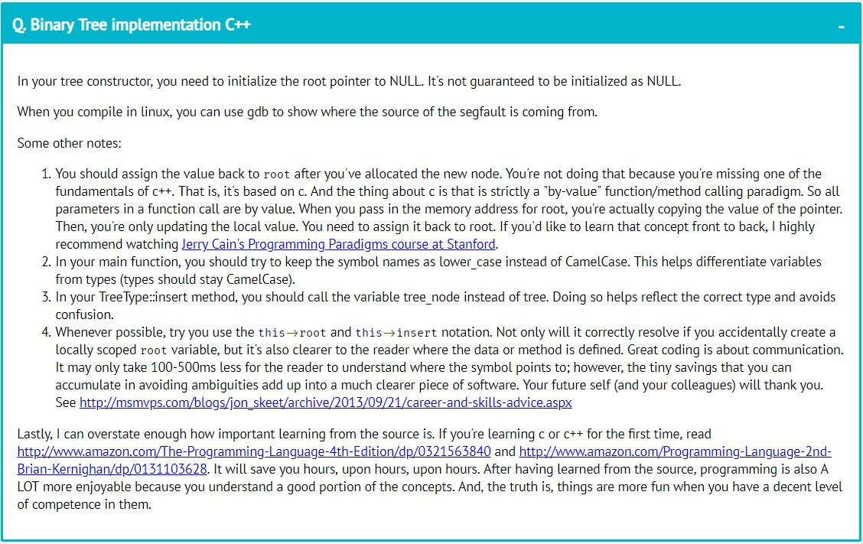

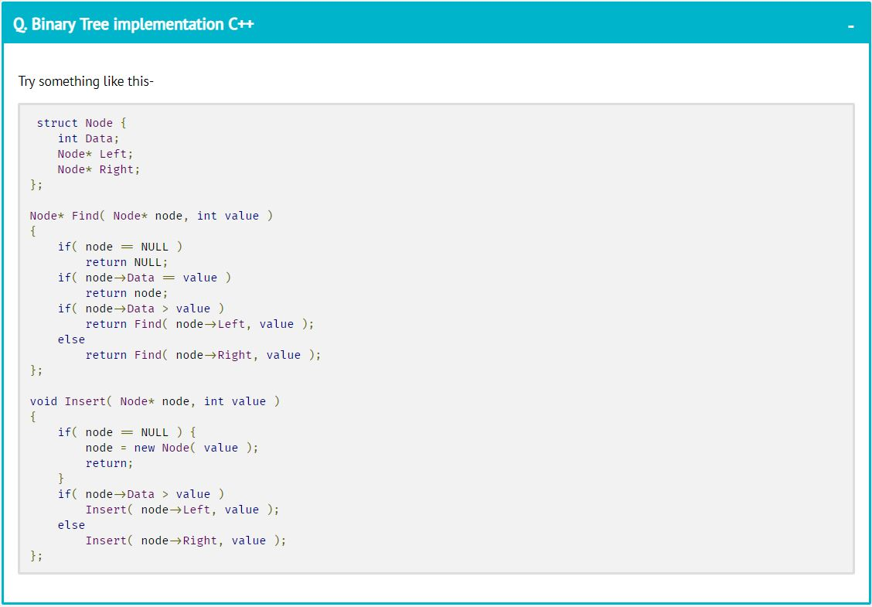

And results continue so on based on **k** value.

**Test case – 2**

**Query:** Declaration of a vector

**Solution:**

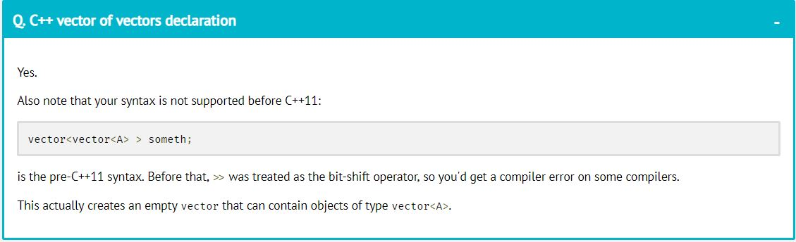

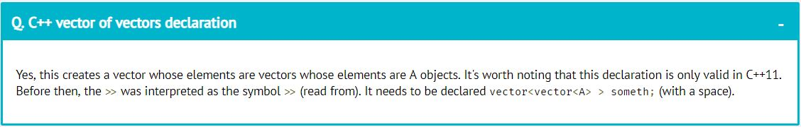

And results continue so on based on **k** value.

**Test case – 3**

**Query:** flask passing html to templates

**Solution:**

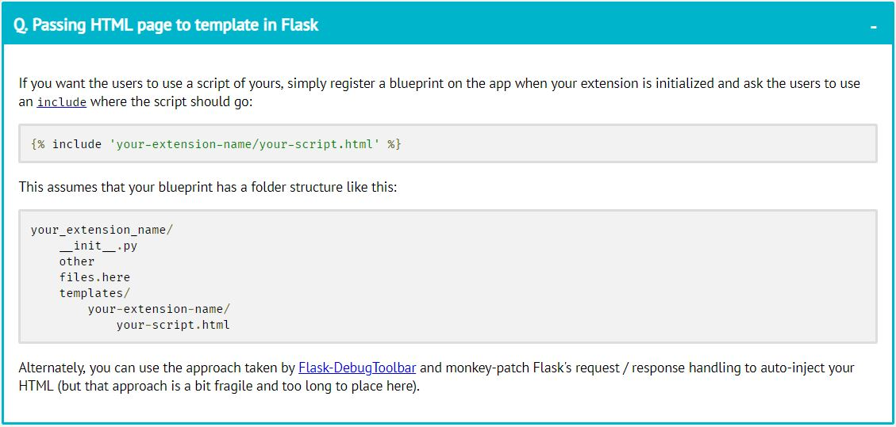

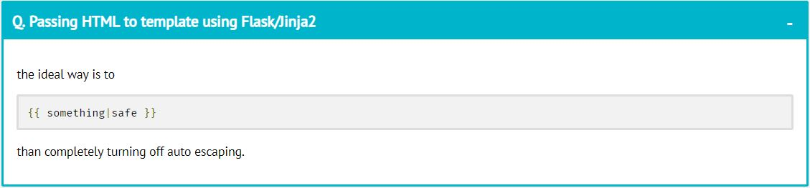

And results continue so on based on **k** value.

**Test case – 4**

**Query :** Inheritace in C++

**Solution:**

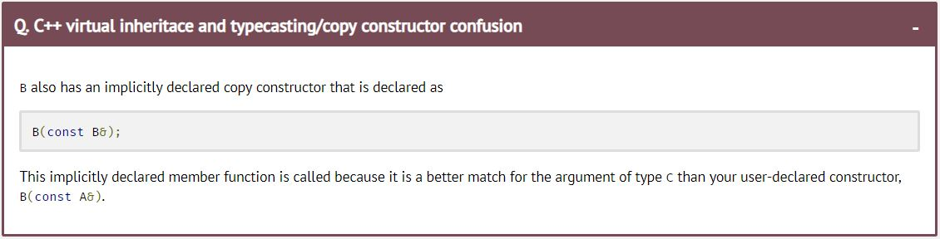

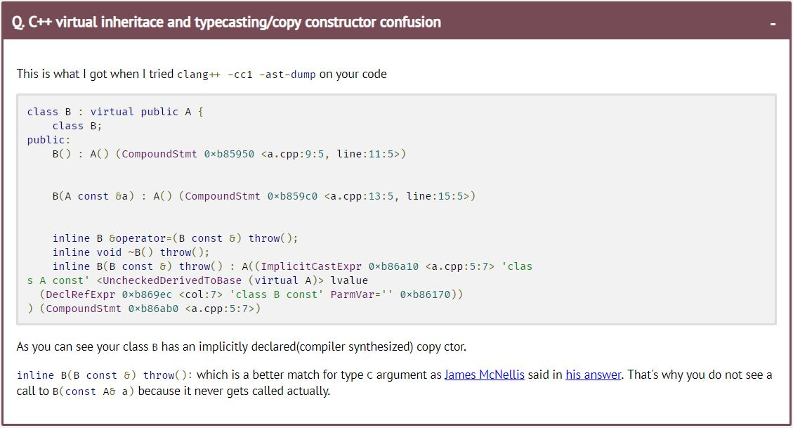

And results continue so on based on **k** value.