Packet Tracer - Configuring Named Standard ACLs

1. Topology

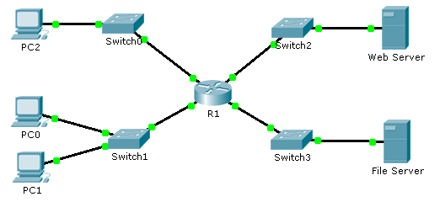

1. Addressing Table

|  |  |  |  |  |
| --- | --- | --- | --- | --- |
| Device | Interface | IP Address | Subnet Mask | Default Gateway |
| R1 | F0/0 | 192.168.10.1 | 255.255.255.0 | N/A |
| F0/1 | 192.168.20.1 | 255.255.255.0 | N/A |
| E0/0/0 | 192.168.100.1 | 255.255.255.0 | N/A |
| E0/1/0 | 192.168.200.1 | 255.255.255.0 | N/A |
| File Server | NIC | 192.168.200.100 | 255.255.255.0 | 192.168.200.1 |
| Web Server | NIC | 192.168.100.100 | 255.255.255.0 | 192.168.100.1 |
| PC0 | NIC | 192.168.20.3 | 255.255.255.0 | 192.168.20.1 |
| PC1 | NIC | 192.168.20.4 | 255.255.255.0 | 192.168.20.1 |
| PC2 | NIC | 192.168.10.3 | 255.255.255.0 | 192.168.10.1 |

1. Objectives

Part 1: Configure and Apply a Named Standard ACL

Part 2: Verify the ACL Implementation

1. Background / Scenario

The senior network administrator has tasked you to create a standard named ACL to prevent access to a file server. All clients from one network and one specific workstation from a different network should be denied access.

1. Configure and Apply a Named Standard ACL
   1. Verify connectivity before the ACL is configured and applied.

All three workstations should be able to ping both the **Web** **Server** and **File Server**.

* 1. Configure a named standard ACL.

Configure the following named ACL on **R1**.

R1(config)# **ip access-list standard File_Server_Restrictions**

R1(config-std-nacl)# **permit host 192.168.20.4**

R1(config-std-nacl)# **deny any**

**Note:** For scoring purposes, the ACL name is case-sensitive.

* 1. Apply the named ACL.
     1. Apply the ACL outbound on the interface Fast Ethernet 0/1.

R1(config-if)# **ip access-group File_Server_Restrictions out**

* + 1. Save the configuration.

1. Verify the ACL Implementation
   1. Verify the ACL configuration and application to the interface.

Use the **show access-lists** command to verify the ACL configuration. Use the **show run** or **show ip interface fastethernet 0/1** command to verify that the ACL is applied correctly to the interface.

* 1. Verify that the ACL is working properly.

All three workstations should be able to ping the **Web Server**, but only **PC1** should be able to ping the **File Server**.