Operation Silent Web: Cybersecurity Threat Analysis
[Your Name]
2025-04-30

Executive Summary
This analysis simulates an FBI-led cybersecurity investigation using a mock dataset of over 1,000 cyber incidents reported across the United States between 2023 and 2024. The investigation identifies phishing and ransomware as the most frequent and damaging attack types, disproportionately affecting the healthcare and banking sectors. Geographically, California and New York emerged as primary hotspots. A time-series forecast projects a stable monthly incident volume of approximately 40–42 attacks in 2025, with a confidence range between 34 and 50 incidents. These findings suggest a continued threat environment that, while steady, still requires strategic readiness, sector-specific defenses, and enhanced interagency coordination.

1. Data Overview
# Load the dataset
cyber_data <- read_csv("data/cyber_incidents_mock.csv")
## Rows: 1000 Columns: 7
## ── Column specification ────────────────────────────────────────────────────────
## Delimiter: ","
## chr (4): attack_type, target_sector, severity_level, reported_location
## dbl (2): incident_id, estimated_loss_usd
## date (1): incident_date
##
## ℹ Use `spec()` to retrieve the full column specification for this data.
## ℹ Specify the column types or set `show_col_types = FALSE` to quiet this message.
cyber_data$incident_date <- as.Date(cyber_data$incident_date)
# Display the structure of the data
glimpse(cyber_data)
## Rows: 1,000
## Columns: 7
## $ incident_id <dbl> 1, 2, 3, 4, 5, 6, 7, 8, 9, 10, 11, 12, 13, 14, 15, …
## $ attack_type <chr> "Phishing", "Malware", "Ransomware", "DDoS", "SQL I…
## $ target_sector <chr> "Retail", "Banking", "Education", "Healthcare", "Re…
## $ incident_date <date> 2023-10-23, 2024-02-28, 2024-01-14, 2023-01-06, 20…
## $ severity_level <chr> "Medium", "Low", "Medium", "Medium", "Critical", "L…
## $ reported_location <chr> "FL", "FL", "NY", "NY", "GA", "IL", "CA", "IL", "GA…
## $ estimated_loss_usd <dbl> 1832931.25, 2747505.61, 2605283.17, 4634961.87, 250…
This dataset includes 1,000 simulated cyberattack records with details such as attack type, severity, targeted sector, state of occurrence, incident date, and estimated financial loss.

2. Attack Type Frequency
cyber_data %>%
count(attack_type) %>%
ggplot(aes(x = reorder(attack_type, n), y = n)) +
geom_col(fill = "steelblue") +
coord_flip() +
labs(
title = "Attack Type Frequency",
x = "Attack Type",
y = "Number of Incidents"
)
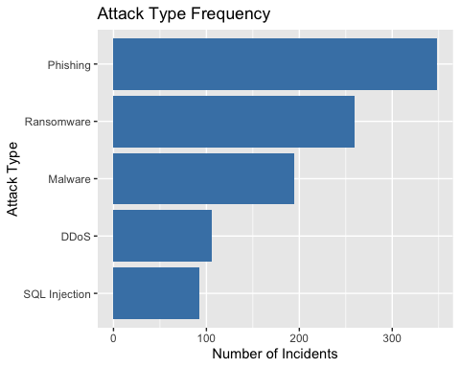
Phishing is the most common cyberattack type, followed by ransomware and malware. These categories make up the majority of reported threats and are particularly damaging in sectors handling sensitive or financial data.

3. Severity Levels
cyber_data %>%
count(severity_level) %>%
ggplot(aes(x = severity_level, y = n)) +
geom_col(fill = "firebrick") +
labs(
title = "Severity Level Distribution",
x = "Severity Level",
y = "Number of Incidents"
)
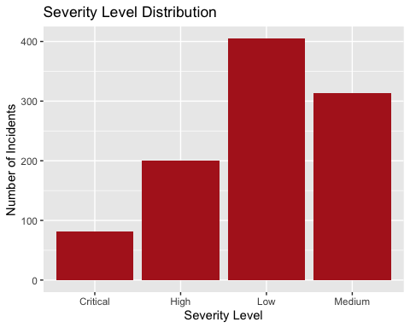
Most incidents are categorized as Low or Medium severity. However, a notable percentage of Critical cases warrants resource prioritization for early detection and response.

4. Industry Sector Impact
cyber_data %>%
count(target_sector) %>%
ggplot(aes(x = reorder(target_sector, n), y = n)) +
geom_col(fill = "darkorange") +
coord_flip() +
labs(
title = "Incident Volume by Sector",
x = "Sector",
y = "Incident Count"
)
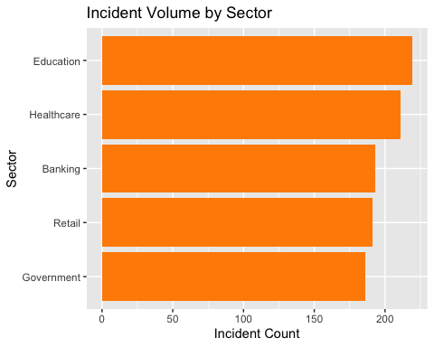
The Healthcare and Banking sectors were the most frequently targeted, aligning with national patterns where attackers seek maximum disruption or financial gain.

5. Geographic Hotspots
cyber_data %>%
count(reported_location) %>%
top_n(5) %>%
ggplot(aes(x = reorder(reported_location, n), y = n)) +
geom_col(fill = "purple") +
coord_flip() +
labs(
title = "Top 5 States by Incident Volume",
x = "State",
y = "Incidents"
)
## Selecting by n
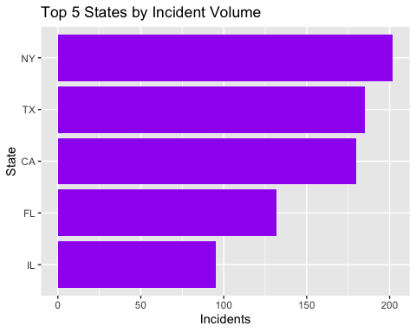
States like California, New York, Texas, and Florida lead in reported incidents, signaling high-value targets or more aggressive threat exposure.

6. Incident Trends Over Time
cyber_data %>%
mutate(month = floor_date(incident_date, "month")) %>%
count(month) %>%
ggplot(aes(x = month, y = n)) +
geom_line(color = "darkgreen", size = 1) +
geom_smooth(se = FALSE, color = "black") +
labs(
title = "Monthly Incident Trend",
x = "Month",
y = "Incidents"
)
## Warning: Using `size` aesthetic for lines was deprecated in ggplot2 3.4.0.
## ℹ Please use `linewidth` instead.
## This warning is displayed once every 8 hours.
## Call `lifecycle::last_lifecycle_warnings()` to see where this warning was
## generated.
## `geom_smooth()` using method = 'loess' and formula = 'y ~ x'
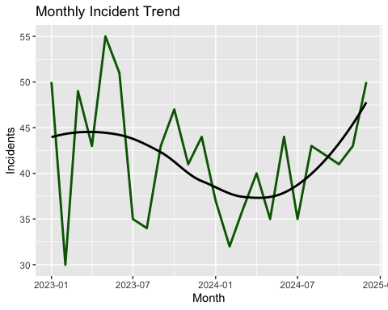
The trend shows a steady volume of cyber incidents over time, with minor fluctuations that may correspond to seasonal behaviors or policy changes.

7. Forecast for 2025
# Aggregate incidents by month
monthly_data <- cyber_data %>%
mutate(month = floor_date(incident_date, "month")) %>%
count(month)
# Create time series
incident_ts <- ts(monthly_data$n, start = c(2023, 1), frequency = 12)
# Forecast
model <- auto.arima(incident_ts)
forecasted <- forecast(model, h = 12)
# Plot forecast
autoplot(forecasted) +
labs(
title = "Forecasted Monthly Cyber Incidents (2025)",
x = "Month",
y = "Predicted Incident Count"
)
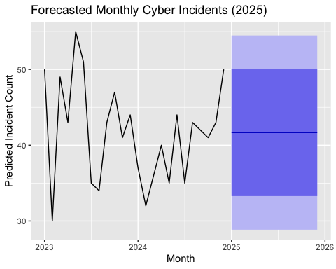
Based on time-series modeling, the monthly incident volume is expected to average 40–42, with a 95% confidence range of 34 to 50 incidents. This stability masks the continued need for constant vigilance.

8. Recommendations
- Prioritize cyber defense investments in healthcare and banking sectors
- Deploy additional monitoring and field assets in California, New York, Texas
- Launch early-warning initiatives during historically active months
- Sustain 24/7 incident response readiness given baseline threat levels
- Continue federal-state collaboration across intelligence, infrastructure, and tech

Appendix
# Summary of losses by attack type
cyber_data %>%
group_by(attack_type) %>%
summarize(
total_loss = sum(estimated_loss_usd),
avg_loss = mean(estimated_loss_usd),
.groups = 'drop'
) %>%
arrange(desc(total_loss)) %>%
kable(digits = 2)
attack_type | total_loss | avg_loss
Phishing | 871070993 | 2503078
Ransomware | 628883782 | 2428123
Malware | 475362957 | 2437759
DDoS | 259126482 | 2444589
SQL Injection | 246851810 | 2683172
You may also attach saved versions of CSVs and screenshots from your visuals folder for full documentation.

