Nice job defining the algorithms you intend to use and the ways in which they operate! I would revise your definitions for parametric and non-parametric algorithms slightly -- both types take in parameters in order to define and tune their performance (even KNN has to decide how many neighbors it wants to call up!). Try to dig in deeper with your analysis and figure out what the distinction is (Hint: it regards the distributions within the data).

- Parametric data contains all the data for the model within a few parameters. Nonparametric models also take in parameters but it will not contain all the data for the model. More specifically it depends on the current state of data. Although this is the case, nonparametric models are able to represent subtle aspects of data. Parameters are said to be infinite in dimensions and can represent the characteristics in the data much better than parametric models.

The lack of a provided benchmark is understandable, but I would still recommend creating your own benchmark. A good candidate is choosing a naive prediction based on the data in order to tailor it to your problem -- if the distribution centers around 0, what happens to your MSE if you just predict 0 all the time? If S6 is the most similar variable to S1, what happens if you only predict using that feature? Try to think about what value your model can add compared to more primitive strategies for prediction.

- For the benchmark, I created a naïve prediction target based on the current averages of the data. The mean squared error will be the average squared values of the correct values, if the prediction values are zero all the time. Predicting features that are similar to the target could result in a more accurate score.
Nice job getting to a predictive model that generated strong results! Make sure you list the final parameters that emerged from your PCA for loop and the grid search -- what features were you sending into the grid search and what was the optimal combination? What was the number of components used for preprocessing? How much of the explained variance percentage was retained?
- The final model was a linear regression model. The winning model object was represented by the variable winner. The function that prints out parameter information for this trained object/model is called best_estimator_. Therefore printing out winner.best_estimator_ results with the data:
- LinearRegression(copy_X=True, fit_intercept=True, n_jobs=-1, normalize=True)
- The principal component was 2. The next iterations prove pointless since no other pca n_components provide a better accuracy score.

Refer back to my previous comments on benchmarks -- it's hard to say how strong of a result your 85.006% accuracy was without a reference to a more basic predictor to beat. I would also provide more analysis on the 85.006% accuracy metric -- since this is a regression problem, what does it mean to be accurate for a prediction?
I would also include the MSE since you defined that as a metric within your algorithm and discuss the performance of that metric. How did the MSE change for small targets compared to large targets? The MSE is able to gain a more granular look at the model's errors beyond an accuracy percentage.
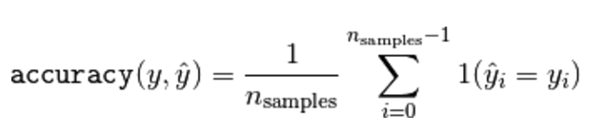
- What does it mean to be 85% accurate for regression
  - According to the scikit learning page, accuracy algorithm is a little different than mean squared error. The accuracy algorithm checks if the predicted value is the correct values. If it is, adds a one, else it adds nothing. The total sum is then averaged for the final accuracy score. Therefore the accuracy score is defined as the fraction of correct predictions.
  - This is different from mean squared error which sums all the differences between correct and prediction values, which is then averaged according to the number of values.
  - Find score for naïve prediction target and then compare with your final accuracy
- add mean squared error along with accuracy
- Create benchmark
- test benchmark and record score
- write about benchmark
- compare benchmark score with latest result score

