Table of Contents

1 INTRODUCTION 5

1.1 Date 5

1.2 Purpose 5

1.3 Brief description of the study and cohort accrual status 5

2 STUDY HIGHLIGHTS 7

2.1 About 7

2.2 Recruitment summary 7

2.3 Cumulative recruitment graph 7

3 PERFORMANCE INDICATORS 8

3.1 About 8

3.2 Monthly accrual 8

3.2.1 Participant accrual 8

3.2.2 Enrolment per arm 8

3.2.3 Screened outs 8

3.3 Participants retention 9

3.3.1 Terminations per arm 9

3.3.2 Missed Visit 9

3.3.3 Monthly retention rate 9

3.4 Quality control rates 10

4 STUDY STATUS REPORT/STUDY SPECIFIC TABLES 11

4.1 About 11

4.2 Baseline 11

4.3 Follow-ups 16

4.4 Protocol deviations and violations 19

4.5 Adverse events (AE) 19

4.5.1 Severity 19

4.5.2 Serious Adverse Event (SAE) 19

4.5.3 AE summary 20

4.5.4 SAE summary 20

4.5.5 AE and ART 20

4.5.6 AE and TB Drug 20

|  |  |
| --- | --- |
|  | |
| **CAPRISA 093 – INSTI’s FOR THE MANAGEMENT OF HIV-ASSOCIATED TB (INSIGHT STUDY)** | |
| *A phase 2b study to evaluate the efficacy, safety and pharmacokinetics of a combination of Bictegravir, Emtricitabine, and Tenofovir Alafenamide Fumarate for treatment of HIV-1 infection in patients with drug-susceptible tuberculosis on a Rifampicin-based treatment regimen* | |
| **Study Progress, Data and Safety Monitoring Plan** | |
| **Principal Investigator:** | Dr Anushka Naidoo |
| **Co-Principal investigators:** | Prof. Kelly E Dooley (Co-PI)\nProf. Kogieleum Naidoo (Co-I) |
| **Protocol Statistician:** | Nonhlanhla Yende-Zuma |
| **Study Statistician:** | Marothi Peter Letsoalo |
| **Data Manager:** | Kea Dikgale |
| **Report Prepared by:** | Marothi Peter Letsoalo |
|  |  |
|  |  |
| 15 July 2022 | |
|  | |

# INTRODUCTION

## Date

This report was finalised on 15 July 2022. This is a summary of the data as on 30 June 2022.

## Purpose

To monitor participant accrual, retention and study progress at each site as reflected by data submitted to the database and monitor performance regarding data management and quality. To provide key clinical, safety or study-specific outcome measures to guide interim discussions by the study team and assess progress and improve participants’ management.

This report will be generated monthly and or as requested by the study PI. The data manager will be responsible for ensuring that data included in the report has been quality controlled and is as accurate as possible up until the cut-off date specified in the report for data that is included. The study statistician is responsible for generating the report from the study database and will provide the data report to the study investigators, DSMC members, PSRT DAIDS and any other party agreed upon with the PI. The report will be provided to the DAIDS program officer (Dr Tania Lombo) and DAIDS Medical Officer (Dr Pablo Belaunzaran) quarterly.

The data manager and qualified study statistician have been trained on the study protocol and have access the most recent version of the study protocol.

## Brief description of the study and cohort accrual status

This study is being conducted to assess the antiretroviral activity of a fixed-drug, single tablet, combination of Bictegravir 50mg/ Emtricitabine 200mg/ Tenofovir alafenamide 25mg (Biktarvy®) dosed twice daily in HIV-1 infected, ART-naïve patients with TB co-infection receiving a rifampicin-based tuberculosis (TB) treatment regimen. This study will assess the activity of Bictegravir and dolutegravir-containing ART regimens in patients with drug-susceptible TB through 48 weeks.

# STUDY HIGHLIGHTS

## About

The study highlights includes important recruitment dates, statistics and cumulative graph.

## Recruitment summary

|  |  |
| --- | --- |
| Date site open | 07 December 2021 |
| First screening date | 08 December 2021 |
| First enrolment date | 18 February 2022 |
| Planned enrolment end date | 07 May 2023 |
| Number of participants enrolled | 11 |
| Average enrolled per month* | 1.83 |
| *Average enrolled per month is calculated as randomized patients divided by the number of months of recruitment time | |

## Cumulative recruitment graph

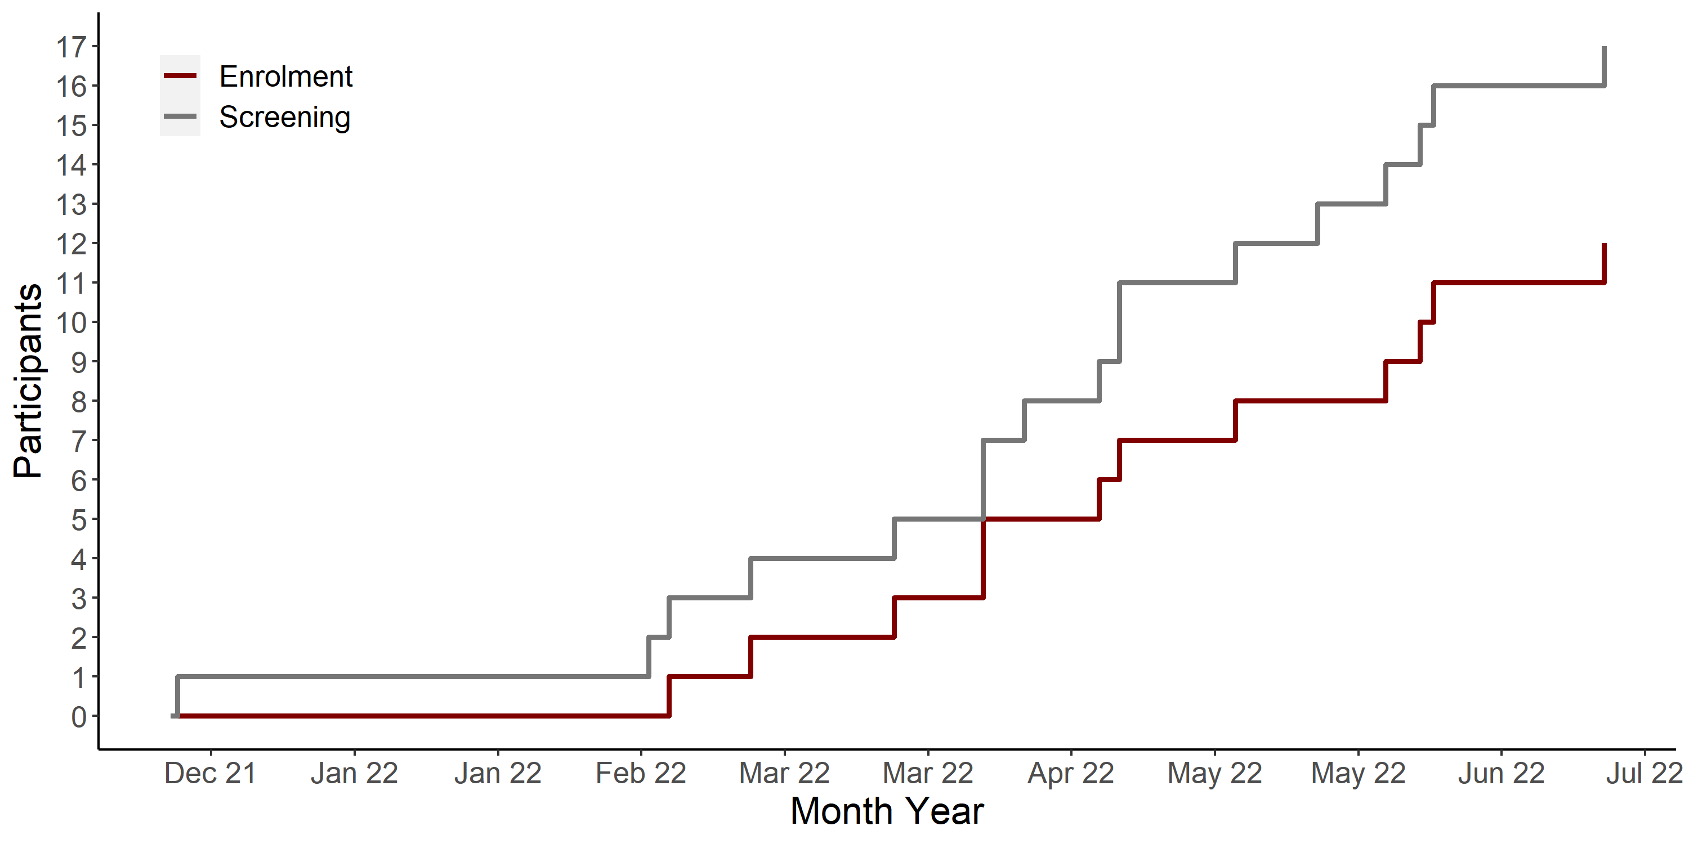

Figure 1: Screening and Enrolment cumulative recruitment graph

# PERFORMANCE INDICATORS

## About

The three key performance indicators reported on are: accrual, retention and QC rates.

## Monthly accrual

### Participant accrual

Table 1: Participant monthly accrual

|  | | Screened | | Enrolled | | Enrolment | |
| --- | --- | --- | --- | --- | --- | --- | --- |
| Year | Month | N | Cum | N | Cum | Ratio1 | Rate2 |
| 2021 | December | 1 | 1 | 0 | 0 |  |  |
| 2022 | January | 0 | 1 | 0 | 0 |  | 0.00 |
| February | 2 | 3 | 1 | 1 | 3.00 | 0.50 |
| March | 2 | 5 | 2 | 3 | 1.67 | 1.00 |
| April | 6 | 11 | 4 | 7 | 1.57 | 1.75 |
| May | 2 | 13 | 1 | 8 | 1.63 | 1.60 |
| June | 3 | 16 | 3 | 11 | 1.45 | 1.83 |
| 1Enrolment ratio is calculated as cumulated screenings divided by enrolments. | | | | | | | |
| 2Enrolment rate is calculated as randomized patients divided by the number of months of recruitment time | | | | | | | |

e database yet)