Research Status

Project Question
Can graph-based neural architectures improve next-step disruption prediction in directed synthetic supply-chain networks relative to a feature-only baseline?

Current Setup
- Graph family: tiered_scale_free
- Edge semantics: directed
- Main graph sizes studied: N20, N40
- Seeds currently aggregated: 1, 2, 3

Data Generation
- Graphs are generated as directed tiered scale-free supply-chain networks.
- Node states evolve through:
  - exogenous shock
  - endogenous propagation
  - probabilistic recovery

Input Features
- health: current operating/disrupted state
- exposure: disruption pressure from upstream neighbors
- time_to_recovery: disruption duration proxy
- betweenness centrality: added in memory for Graphormer only

Models Compared
- Baseline: feature-only node classifier
- GCN: adjacency-based local message passing
- Graph Transformer: masked local self-attention
- Graphormer: global attention with structural bias

Current Main Results

N20 tiered_scale_free, seeds = 1, 2, 3
- Baseline: 0.8639 +/- 0.0356
- GCN: 0.7936 +/- 0.0471
- Graph Transformer: 0.8636 +/- 0.0356
- Graphormer: 0.8422 +/- 0.0468

N40 tiered_scale_free, seeds = 1, 2, 3
- Baseline: 0.8456 +/- 0.0196
- GCN: 0.7810 +/- 0.0182
- Graph Transformer: 0.8457 +/- 0.0235
- Graphormer: 0.8392 +/- 0.0161

Main Interpretation
- GCN is consistently weaker than the baseline and transformer variants.
- The masked Graph Transformer is essentially tied with the baseline.
- Graphormer is competitive but does not currently outperform the baseline.
- Current evidence suggests important relational information is already encoded in node-level features, especially exposure.

Current Conclusion
In the present simulator and feature design, graph transformer architectures do not yet show a decisive advantage over a strong feature-only baseline. The main insight is not that graph models fail in general, but that their incremental value is limited when relational effects are already heavily encoded through feature engineering.

Figures
Figure 1. Accuracy vs graph size.
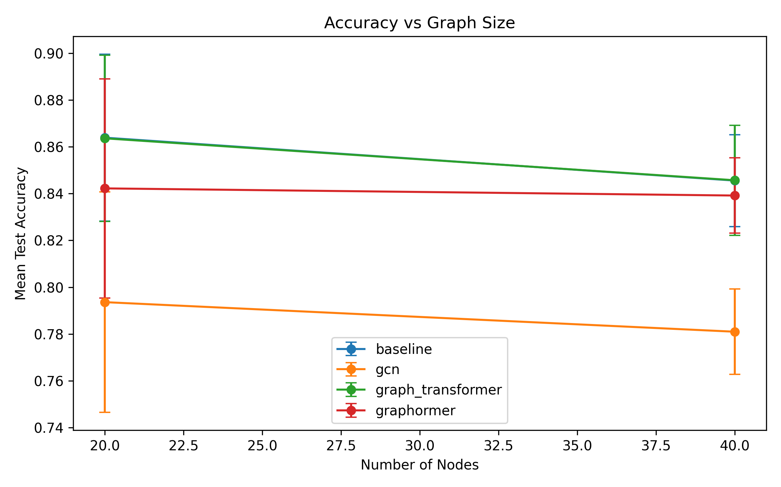
Accuracy vs Graph Size
Figure 2. Per-model comparison by graph size.
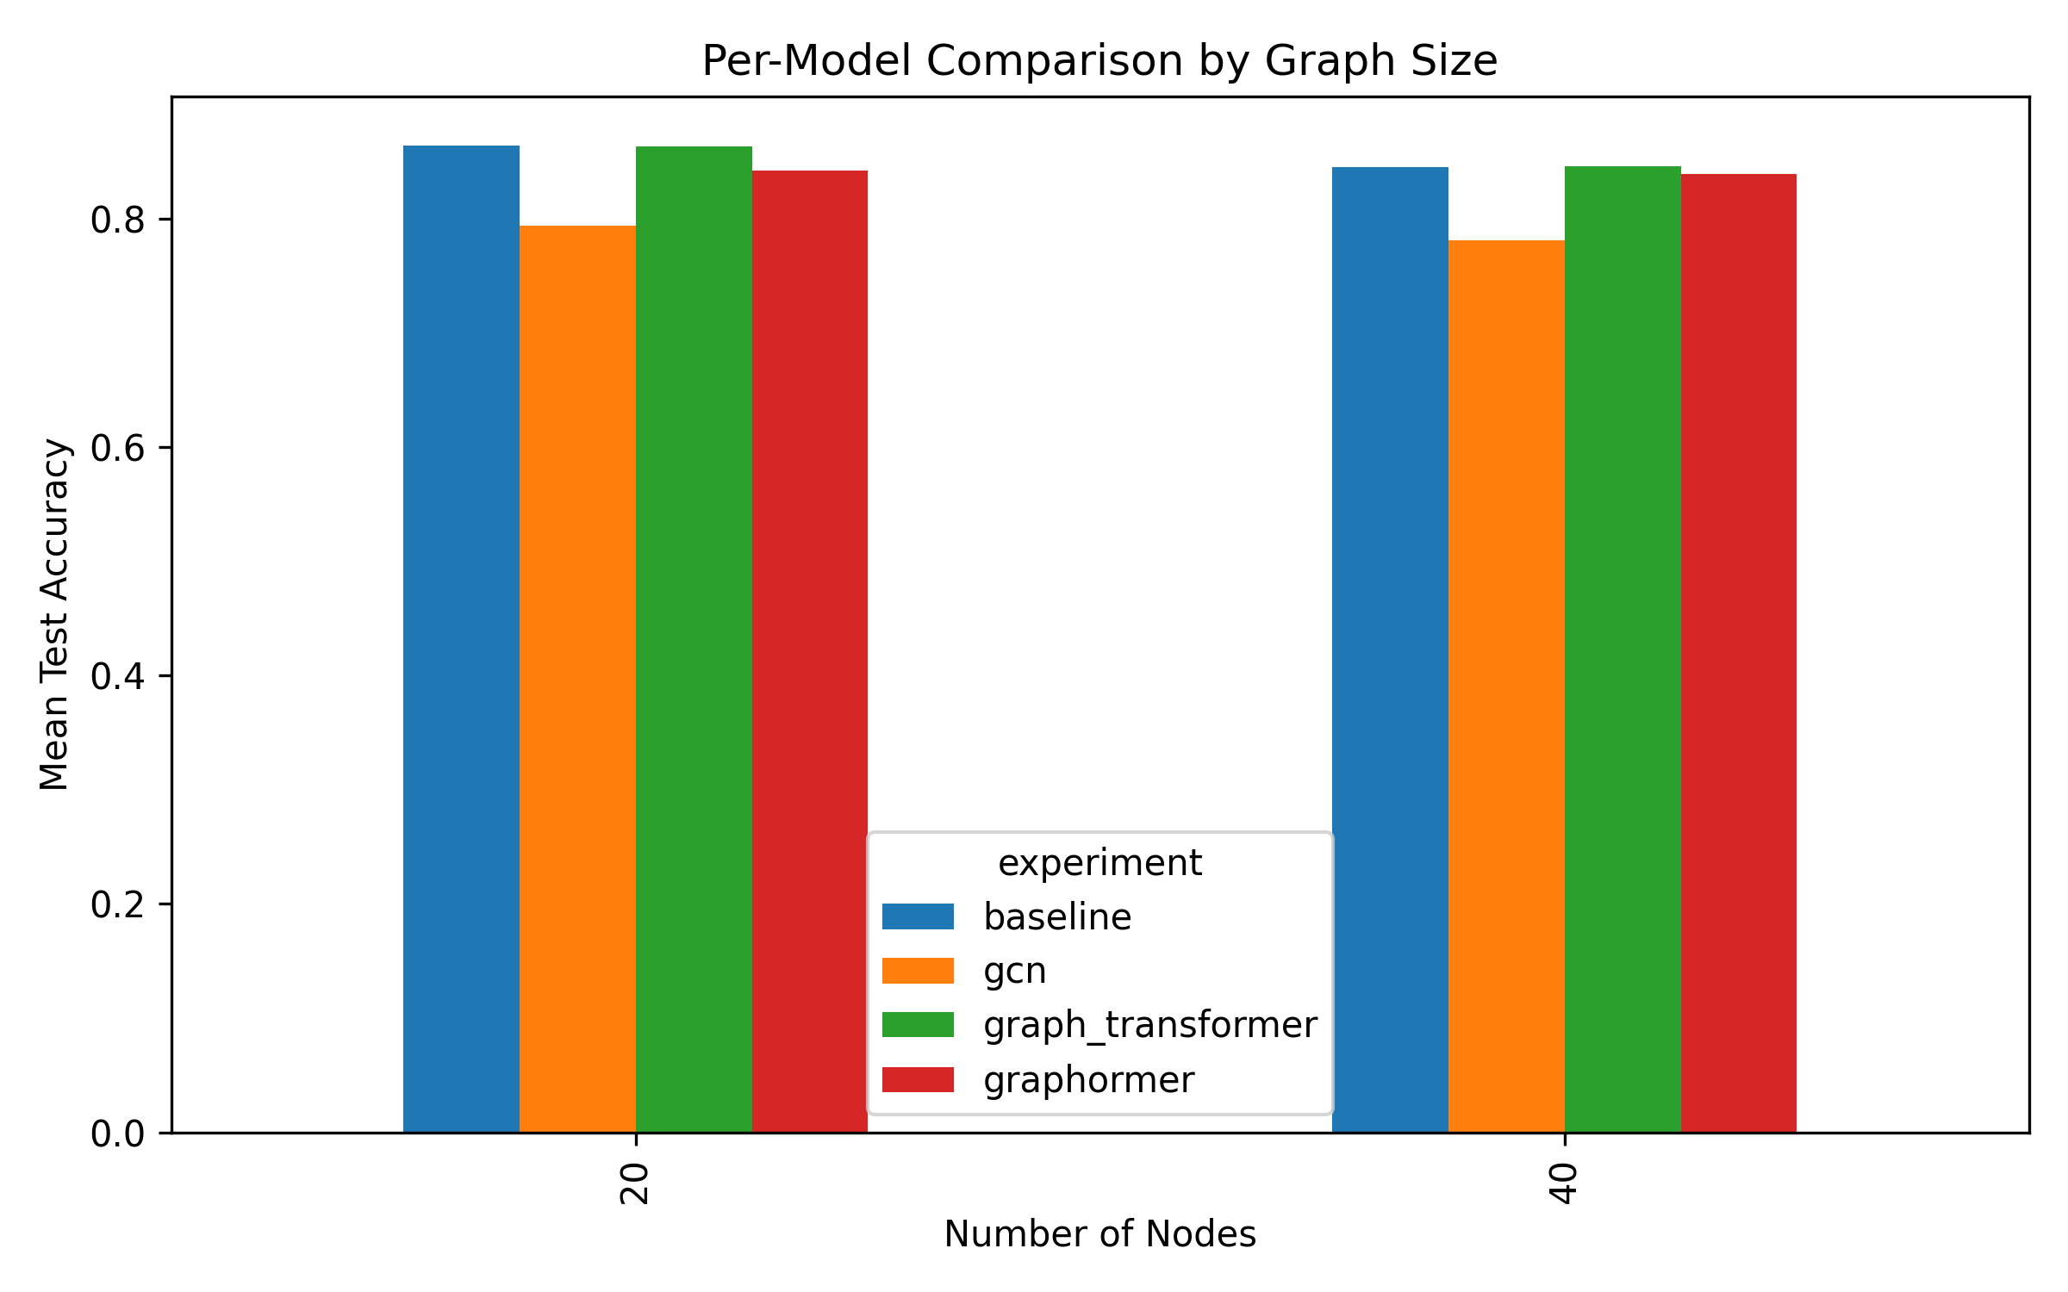
Per-Model Comparison
Figure 3. Training curves for N20_tiered_scale_free.
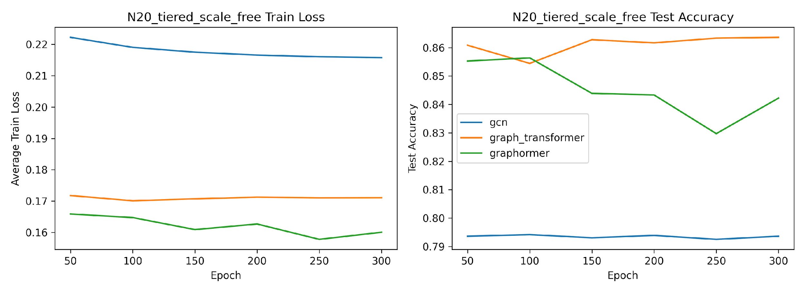
Training Curves N20
Figure 4. Training curves for N40_tiered_scale_free.
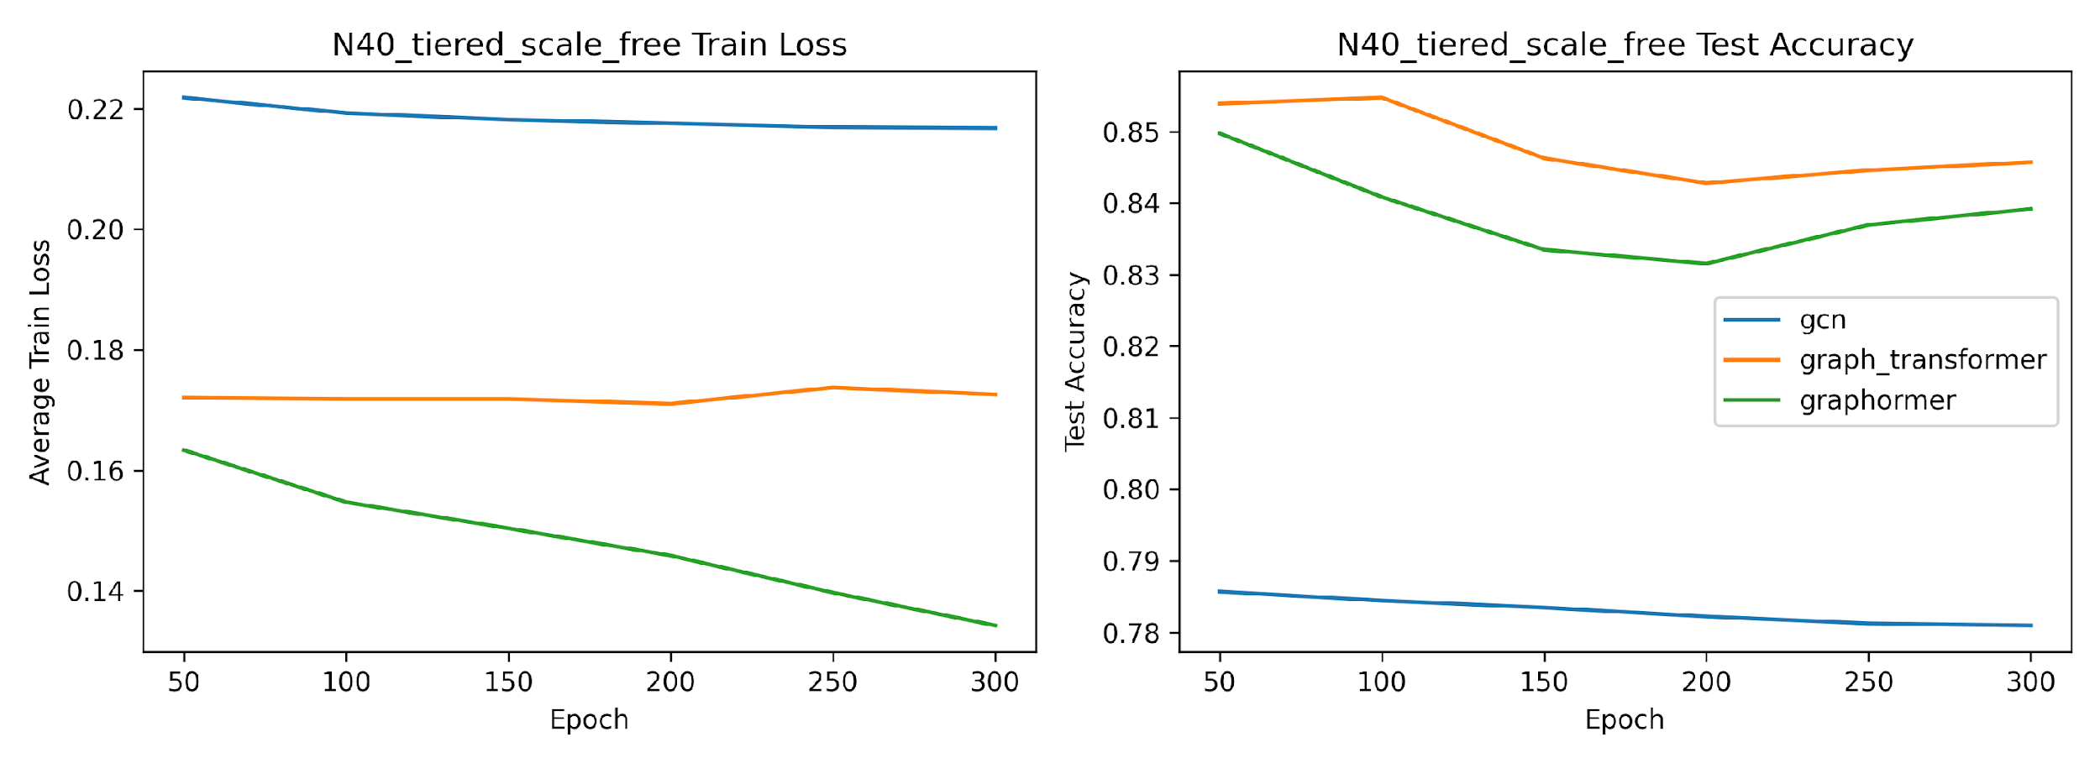
Training Curves N40

Key Files
- PAPER_PREP.md
- EXPERIMENT_LOG.md
- DRAFT_PAPER.md
- runs/results_summary.csv
- runs/figures/results_by_model_size.csv

Next Steps
- Add more graph sizes and seeds if needed
- Consider ablation experiments on exposure
- Consider settings where graph structure is less pre-encoded in node features
- Decide whether to continue this line or pivot to a stronger graph-dependent setup

