**Introduction to CI**

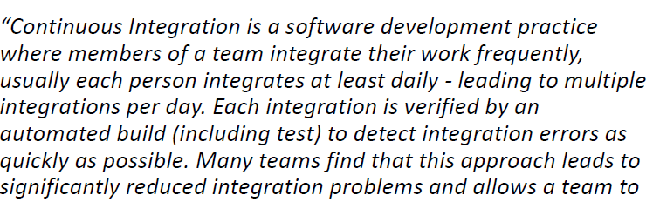



**Jenkins** is an open source Continuous Integration server capable of orchestrating a chain of actions that help to achieve the Continuous Integration process (and not only) in an automated fashion.

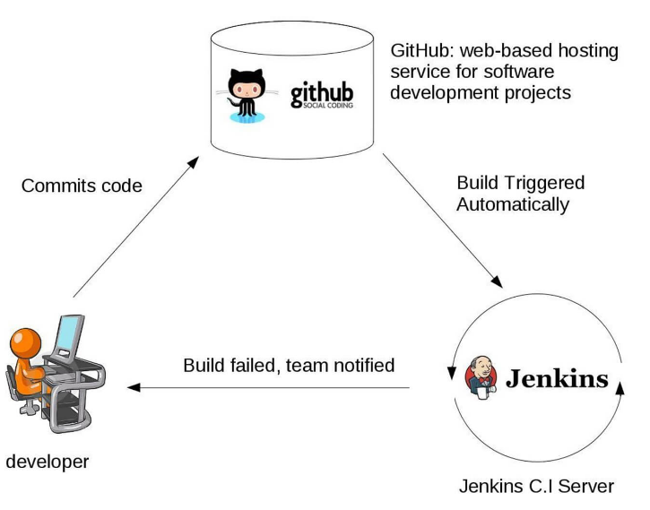

**Jenkins Plugins**

By default, Jenkins comes with a limited set of features. If you want to integrate your Jenkins installation with version control tools like Git, then you need to install plugins related to Git. In fact, for integration with tools like Maven, Amazon EC2, you need to install respective plugins in your Jenkins.

## Advantages of using Jenkins

* Jenkins is being managed by the community which is very open. Every month, they hold public meetings and take inputs from the public for the development of Jenkins project.
* As technology grows, so does Jenkins. So far Jenkins has around 320 plugins published in its plugins database. With plugins, Jenkins becomes even more powerful and feature rich.
* Jenkins also supports cloud-based architecture so that you can deploy Jenkins in cloud-based platforms.
* The reason why Jenkins became popular is that it was created by a developer for developers.

## Conclusion:

* In Continuous Integration, after a code commit, the software is built and tested immediately
* Jenkins is an open source Continuous Integration server capable of orchestrating a chain of actions
* Before Jenkins when all Developers had completed their assigned coding tasks, they used to commit their code all at same time. Later, Build is tested and deployed.
* After Jenkins the code is built and test as soon as Developer commits code. Jenkin will build and test code many times during the day
* By default, Jenkins comes with a limited set of features. If you want to integrate your Jenkins installation with version control tools like Git, then you need to install plugins related to Git
* The biggest pros of Jenkins is that it is managed by the community which holds public meetings and take inputs from the public for the development of Jenkins projects
* The biggest con of Jenkin is that Its interface is out dated and not user friendly compared to current UI trends.

**Manage Jenkins**

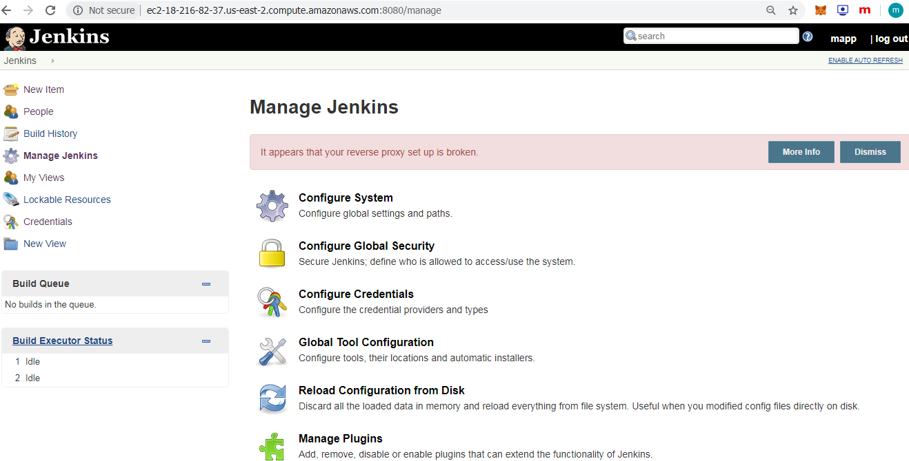

Create New item (Job)