**Jenkins Email Notification**

if you are using your Gmail account for sending email then please disable 2-way authentication and enable less secure app access to your account.

<https://myaccount.google.com/lesssecureapps>

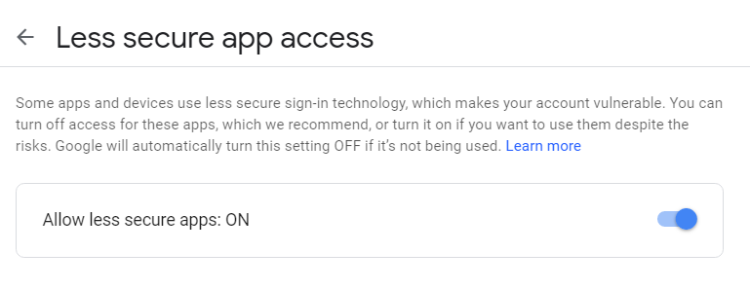

Google Account URL : <https://myaccount.google.com/>

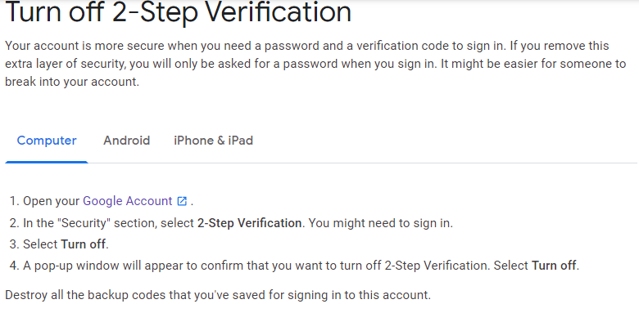

<https://www.google.com/accounts/DisplayUnlockCaptcha>

