Find Access Key:

1. Go to the [IAM console](https://console.aws.amazon.com/iam/home#home).
2. From the navigation menu, click Users.
3. Select your IAM user name.
4. Click User Actions, and then click Manage Access Keys.
5. Click Create Access Key.
6. Your keys will look something like this:
   1. Access key ID example: ABCDEF0123456789ABCD
   2. Secret access key example: abcdef0123456/789ABCD/EF0123456789abcdef
7. Click Download Credentials, and store the keys in a secure location.

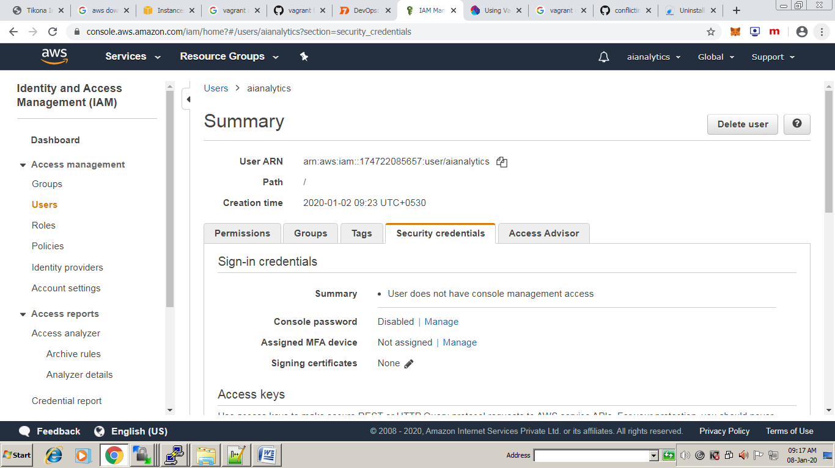

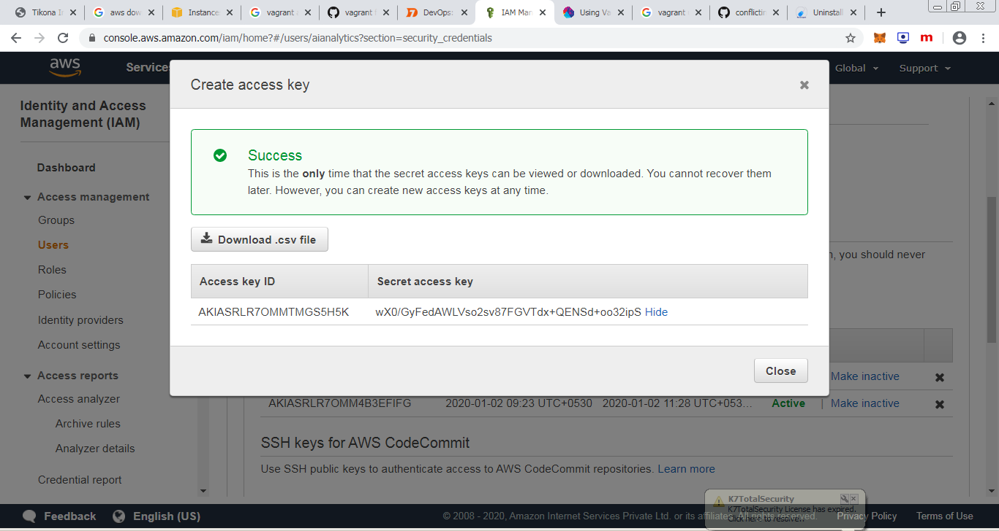

**Configuration Parameters**

This provider exposes quite a few provider-specific configuration options:

* access_key_id - The access key for accessing AWS
* ami - The AMI id to boot, such as "ami-12345678"
* availability_zone - The availability zone within the region to launch the instance. If nil, it will use the default set by Amazon.
* aws_profile - AWS profile in your config files. Defaults to *default*.
* aws_dir - AWS config and credentials location. Defaults to *$HOME/.aws/*.
* instance_ready_timeout - The number of seconds to wait for the instance to become "ready" in AWS. Defaults to 120 seconds.
* instance_check_interval - The number of seconds to wait to check the instance's state
* instance_package_timeout - The number of seconds to wait for the instance to be burnt into an AMI during packaging. Defaults to 600 seconds.
* instance_type - The type of instance, such as "m3.medium". The default value of this if not specified is "m3.medium". "m1.small" has been deprecated in "us-east-1" and "m3.medium" is the smallest instance type to support both paravirtualization and hvm AMIs
* keypair_name - The name of the keypair to use to bootstrap AMIs which support it.
* monitoring - Set to "true" to enable detailed monitoring.
* session_token - The session token provided by STS
* private_ip_address - The private IP address to assign to an instance within a [VPC](http://aws.amazon.com/vpc/)
* elastic_ip - Can be set to 'true', or to an existing Elastic IP address. If true, allocate a new Elastic IP address to the instance. If set to an existing Elastic IP address, assign the address to the instance.
* region - The region to start the instance in, such as "us-east-1"
* secret_access_key - The secret access key for accessing AWS
* security_groups - An array of security groups for the instance. If this instance will be launched in VPC, this must be a list of security group Name. For a nondefault VPC, you must use security group IDs instead (<http://docs.aws.amazon.com/cli/latest/reference/ec2/run-instances.html>).
* iam_instance_profile_arn - The Amazon resource name (ARN) of the IAM Instance Profile to associate with the instance
* iam_instance_profile_name - The name of the IAM Instance Profile to associate with the instance
* subnet_id - The subnet to boot the instance into, for VPC.
* associate_public_ip - If true, will associate a public IP address to an instance in a VPC.
* ssh_host_attribute - If :public_ip_address, :dns_name, or :private_ip_address, will use the public IP address, DNS name, or private IP address, respectively, to SSH to the instance. By default Vagrant uses the first of these (in this order) that is known. However, this can lead to connection issues if, e.g., you are assigning a public IP address but your security groups prevent public SSH access and require you to SSH in via the private IP address; specify :private_ip_address in this case.
* tenancy - When running in a VPC configure the tenancy of the instance. Supports 'default' and 'dedicated'.
* tags - A hash of tags to set on the machine.
* package_tags - A hash of tags to set on the ami generated during the package operation.
* use_iam_profile - If true, will use [IAM profiles](http://docs.aws.amazon.com/IAM/latest/UserGuide/instance-profiles.html) for credentials.
* block_device_mapping - Amazon EC2 Block Device Mapping Property
* elb - The ELB name to attach to the instance.
* unregister_elb_from_az - Removes the ELB from the AZ on removal of the last instance if true (default). In non default VPC this has to be false.
* terminate_on_shutdown - Indicates whether an instance stops or terminates when you initiate shutdown from the instance.
* endpoint - The endpoint URL for connecting to AWS (or an AWS-like service). Only required for non AWS clouds, such as [eucalyptus](https://github.com/eucalyptus/eucalyptus/wiki).

Local VM creation using virtualbox

------------------------------------

sudo apt update

sudo apt install virtualbox

sudo apt install vagrant

check vagrant version

-------------------------

vagrant --version

mkdir ~/my-first-vagrant-project

cd ~/my-first-vagrant-project

vagrant init centos/7

vagrant up

