Bigger Zone, Bigger Effect? A Rapid Review of Urban Congestion Charges and Low Emission Zones
Hyesop Shin (School of Environment, University of Auckland)
Draft 6 (rapid review), 4 November 2026
Abstract
Congestion charges and low emission zones range from a single street to a metropolis. This rapid review compared 205 ex-post estimates of change in traffic and air quality from 92 studies by zone size and by location inside or outside the zone. Larger zones did not show larger effects. Reductions tended to be larger in zones under 10 square kilometres, and London’s enlarged zones showed smaller effects than its central zones. Effects did not stop at the boundary. Charges displaced traffic to bypass roads, while NO₂ fell outside emission zones too. More than 20 German zones have been lifted without evaluation.
Keywords: congestion charging, low emission zone, zone size, boundary, rapid review, air quality

1. Questions
Congestion charges and low emission zones (LEZs) act on vehicles inside a boundary, so the boundary decides which trips and vehicles are affected. We use LEZ for any zone that restricts or charges vehicles by emission standard, including the United Kingdom’s Clean Air Zones (CAZs), London’s Ultra Low Emission Zone (ULEZ) and Italian limited traffic zones (ZTLs), and give each scheme its own name when citing it. Zones range from under 1 km² in Lisbon to over 1,500 km² in London. Reviews have grouped their effects by scheme type or health outcome (Chamberlain et al., 2023, Holman et al., 2015), not by zone size, even as London extended its ULEZ to the whole city in 2023 and German cities lifted their LEZs. We ask three questions.
- Across cities, and within cities that enlarged a zone, do larger zones show larger or smaller measured changes in traffic and NO₂ inside the zone?
- Do effects stop at the boundary? Where studies measured outside the zone as well, how do the two changes compare, and does this differ between charges and emission zones?
- What evidence would be needed to separate zone size from other features of a scheme, and where is it missing?

2. Methods
We followed Cochrane rapid review guidance (Garritty et al., 2021). A compiled database listed 65 road charging and access schemes in 59 cities. We excluded 29 without a bounded zone, mostly linear tolls, and added 13 schemes with known evaluations, giving 50 (Supplementary Figure S4). One reviewer searched Google Scholar, Crossref and publisher sites scheme by scheme, then city by city, for peer-reviewed ex-post estimates of change in traffic or ambient pollution, and checked key estimates against full texts. This yielded 205 estimates from 92 studies, 162 of them on 29 of the 50 schemes (Supplementary Tables S13 and S14). Durham and Valletta, whose estimates originate in council monitoring and a conference paper, were not used.
For each scheme phase we took one headline estimate, the percentage change in traffic for charges and in NO₂ inside the zone for LEZs, from the earliest evaluation window, then the strongest design, then the median. Zone area is the area in which the effect was measured, grouped as small (under 10 km²), medium (10 to 50 km²) and large (50 km² or more), cut-offs that fall in the two widest gaps between observed areas. Estimates reported only as not significant are shown as zero. Cities that reported the same outcome for an original and an enlarged zone were compared directly (London’s Western Extension counts as an enlargement). For the second question we took every study that reported a change outside the zone as well as inside it and applied the same selection rule to the pair, using a study’s raw inside and outside changes where its inside estimate was measured against the outside sites (Supplementary Table S8). Estimates were not pooled. Data and code are deposited [repository DOI to add].

3. Findings
3.1 Zone size
Of 27 scheme phases with a headline estimate, 23 had a known zone area (Tables 1 and 2). Reported reductions tended to be larger in zones under 10 km², but the pattern is weak and rests on few cases (Figure 1, Supplementary Table S3). For charges the median change in traffic was −18% in three small zones and −12% in three medium zones, and no charge zone was large. For LEZs the median change in NO₂ was −15% in small zones (n = 6), −12% in medium zones (n = 5) and 0% in large zones (n = 6), but four of the six large zones showed no detectable effect, and the other two (Barcelona, Brussels) fell by 16% and 13%.
Three cities compared an original and an enlarged zone on the same outcome (Figure 2). London’s congestion charge cut traffic by about 12% in the central zone (Givoni, 2012) and by 5%, on a different metric, in the Western Extension that nearly doubled it (Ait Bihi Ouali et al., 2021). London’s ULEZ cut roadside NO₂ by about 20% within three months of its 2019 launch in central London, but its 2023 expansion to all of London had no detectable effect over the same window (+1%, 95% interval −2% to +5%). By then 93% of vehicles entering the zone already complied, against 61% at the central launch (Tong et al., 2025). Lisbon went the other way. NO₂ fell by 12% in the 0.68 km² Zone 1 and by 22% in the surrounding Zone 2, although Zone 2 applied a looser standard and both are uncontrolled before-after estimates (Santos et al., 2019).
Where LEZ evaluations also counted traffic, volumes changed little. In Glasgow traffic fell by 16% on one street and did not change on another while NO₂ fell by 28% and 13% (Shin et al., 2024). In Madrid Central traffic fell by 4% to 8% inside the zone and rose by 4% in the rest of the city, and the fall inside disappeared within seven months as compliant vehicles replaced older ones (Moral-Carcedo, 2024, Tassinari, 2024). Emission zones change which vehicles enter more than how many.
3.2 The boundary
Of the 205 estimates, 44 from ten cities also reported a change outside the zone, and nine scheme phases had a usable pair (Figure 3, Supplementary Table S8). Charges moved traffic. In Gothenburg cordon traffic fell by 12% while traffic on the Norrleden bypass rose by 26% (Börjesson and Kristoffersson, 2015). Milan’s Ecopass cut traffic outside the zone by 3 to 4% against 18% inside (Rotaris et al., 2010, Danielis et al., 2012). Emission zones did not keep their effect inside. NO₂ fell by 9% in the area adjoining London’s central ULEZ against 19% inside (Prieto-Rodriguez et al., 2022, Tong et al., 2025), and by 4% near Madrid Central against 28% inside (Salas et al., 2021). Around the Birmingham CAZ the fall outside exceeded the fall inside, and around the Sheffield CAZ the two were nearly equal (Liu et al., 2023, Williams et al., 2025). The exception is the pooled German estimate, where NO₂ rose by 22% within 500 m of the border while falling by 10% inside, read by the authors as ring-road displacement (Sarmiento et al., 2023). London’s 2023 expansion joins the two questions. When the central zone opened in 2019, NO₂ fell at background sites in outer London but not at its traffic sites, and bringing outer London inside the zone in 2023 changed those sites no more (Tong et al., 2025). Both times little non-compliant traffic was left to remove.
3.3 What is missing
Separating zone size from other features of a scheme needs evaluations that report zone area, compliance at launch and changes outside the zone. Few do. Zone area was reported in a peer-reviewed article for five of the 23 phases, compliance at launch was available for six, and ten cities reported an outside change. London and Germany supplied 84 of the 205 estimates. Outside Europe only New York and Singapore had evaluations within our inventory, with Seoul and Greater Tokyo found outside it. Removal is the largest gap. At least 22 German LEZs were lifted between 2020 and 2025, most after 12 to 16 years in operation (Supplementary Table S6). In Baden-Württemberg, which lifted 17 of them, a zone went once measured NO₂ had stayed for about three years below a threshold of 33 to 36 µg/m³, set from the state agency’s estimate of the largest rise that removal could cause (LUBW, 2020). Where the remaining effect of a zone was estimated, it was 0.7 to 3 µg/m³. None of these removals has been evaluated afterwards.
3.4 Summary
A bigger zone did not bring a bigger effect. Smaller zones tended to report larger proportional reductions, London’s enlarged zones came with smaller effects, partly because few vehicles remained non-compliant, and only Lisbon’s larger zone showed the larger reduction. Nor did effects stop at the boundary. Charges displaced some traffic to bypass roads, whereas NO₂ fell outside emission zones almost as much as inside, consistent with fleet renewal reaching the whole city, so part of the gain from enlarging a zone may already have arrived. The German removals and London’s 2023 expansion rest on the same fact read in opposite directions. Once most vehicles comply, a zone has little left to remove, which justified lifting zones in Germany and limited what London gained by enlarging one. A single reviewer, mixed designs and few cases per category limit these conclusions (Supplementary S5). The lifted German zones offer a natural experiment of removal.

Table 1
Congestion charges, by zone area. Traffic change is the headline estimate inside the zone or at the cordon. Zone is the area in which the effect was measured. Measured after is the time from launch to the midpoint of the evaluation window, not how long the scheme ran. Control means an untreated control group or natural experiment. Charge at launch is the price when the evaluated phase began, at 2023 prices in US dollars at purchasing power parity. Current charge or status is in local currency as checked in November 2026 (Supplementary Table S12). Four Nordic toll rings without a recoverable zone area are listed last. Sources are in Supplementary Tables S1 and S2.
Scheme | Start | Zone (km²) | Size class | Traffic change (%) | Measured after (years) | Design | Charge or fine at launch (2023 USD PPP) | Current charge or status (2026)
Singapore | 1975 | 6.0 | Small | −44.0 | 0.1 | Before-after | 10 | Replaced by ERP (1998)
Milan Area C | 2012 | 8.2 | Small | −14.5 | 0.6 | Control | 10 | EUR 7.50 a day
Milan Ecopass | 2008 | 8.2 | Small | −17.6 | 0.5 | Before-after | 11 (middle band) | Replaced by Area C (2012)
London Congestion Charge | 2003 | 21.4 | Medium | −11.8 | 0.5 | Before-after | 13 | GBP 18 a day
New York | 2025 | 23.8 | Medium | −11.0 | 0.3 | Before-after | 9 | USD 9 at peak
Stockholm | 2006 | 30.0 | Medium | −21.4 | 0.5 | Adjusted before-after | 3 per crossing | SEK 45 per passage at peak
Bergen | 1986 |  | Not recovered | −6.5 | 0.5 | Before-after | 2 per crossing | NOK 64 per passage at peak
Gothenburg | 2013 |  | Not recovered | −11.4 | 0.5 | Before-after | 3 per crossing | SEK 22 per passage at peak
Oslo | 1990 |  | Not recovered | −4.0 | 0.5 | Before-after | 3 per crossing | NOK 47 per passage at peak
Trondheim | 1991 |  | Not recovered | −10.0 | 0.5 | Before-after | 2 per crossing | Ended (2005), new toll NOK 44 at peak

Table 2
Low emission zones, including the United Kingdom’s Clean Air Zones (CAZs) and Italian limited traffic zones (ZTLs), by zone area. NO₂ change is the headline estimate inside the zone, and zero marks an estimate reported only as not significant. Compliant at launch is the share of vehicles meeting the standard when the phase began, where reported. Other columns as in Table 1.
Scheme | Start | Zone (km²) | Size class | NO₂ change (%) | Measured after (years) | Design | Charge or fine at launch (2023 USD PPP) | Compliant at launch (%) | Current charge or status (2026)
Lisbon | 2012 | 0.68 | Small | −12.0 | 2.8 | Before-after |  |  | fine EUR 60 to 300
Sheffield CAZ (no cars) | 2023 | 2.4 | Small | +2.5 | 0.7 | Control | 15 (vans, taxis) |  | GBP 10 a day (vans, taxis)
Glasgow | 2023 | 3.1 | Small | −20.5 | 0.3 | Before-after | fine 91 |  | fine GBP 60
Madrid Central | 2018 | 4.7 | Small | −28.5 | 0.3 | Control | fine 188 |  | Replaced (2021), fine EUR 200
Rome ZTL | 2001 | 6.0 | Small | −18.0 | 2.5 | Model |  |  | fine EUR 83 to 332
Birmingham CAZ | 2021 | 7.7 | Small | −3.4 | 0.5 | Control | 14 | 79.8 | GBP 8 a day
London ULEZ (2019, central London) | 2019 | 21.4 | Medium | −19.0 | 0.4 | Control | 23 | 60.9 | GBP 12.50 a day
Bradford CAZ (no cars) | 2022 | 22.0 | Medium | −27.0 | 0.5 | Adjusted before-after | 15 (vans, taxis) | 96.4 | GBP 7 to 9 a day (taxis, vans)
Antwerp | 2017 | 22.9 | Medium | −12.2 | 5.9 | Control | fine 216 |  | fine EUR 150
Munich | 2008 | 44.0 | Medium | +2.4 | 1.0 | Before-after | fine 76 |  | fine EUR 100
Amsterdam (trucks only) | 2009 | 47.2 | Medium | −4.9 | 1.0 | Before-after | fine 286 |  | fine EUR 310 (lorries)
Berlin | 2008 | 88.0 | Large | 0.0 | 3.5 | Before-after | fine 76 |  | fine EUR 100
Barcelona | 2020 | 95.0 | Large | −15.8 | 1.5 | Control | fine 208 |  | fine EUR 200
Milan Area B | 2019 | 128 | Large | 0.0 | 0.3 | Control | fine 160 |  | fine EUR 83
Brussels | 2018 | 161 | Large | −13.3 | 5.0 | Control | fine 594 | 99.5 | fine EUR 350
London LEZ (heavy vehicles) | 2008 | 1,528 | Large | 0.0 | 1.5 | Before-after | 452 (lorries) |  | GBP 100 or 300 a day (lorries)
London ULEZ expansion to all of London (2023) | 2023 | 1,529 | Large | +1.3 | 0.2 | Control | 19 | 92.6 | GBP 12.50 a day

Figures
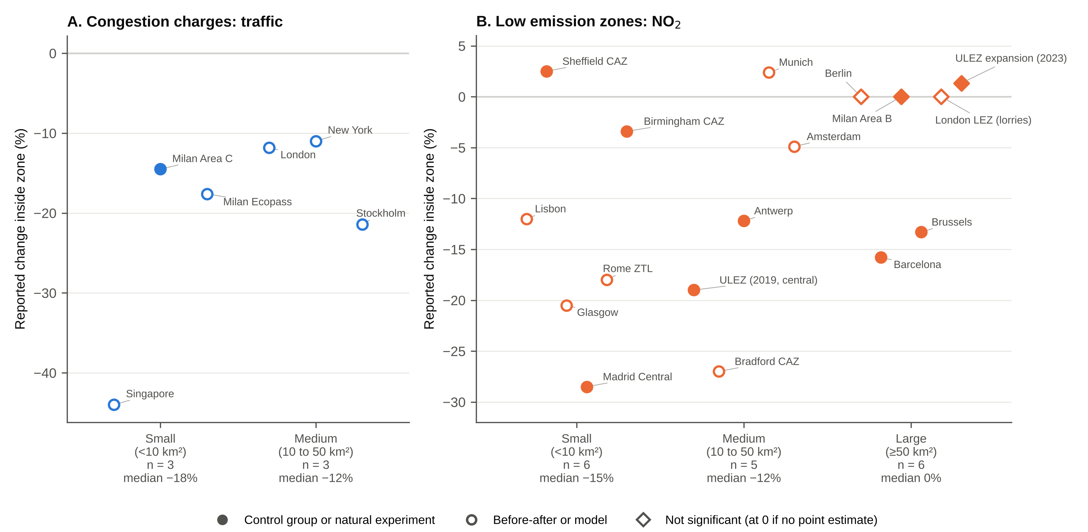
Figure 1. Headline effect by zone size category. (A) Congestion charges, change in traffic. (B) Low emission zones, change in NO₂ inside the zone. Each point is one scheme phase. Filled circles have an untreated control group or natural experiment, and open circles are before-after comparisons or models. Diamonds are not significant, plotted at the reported point estimate or at zero where none was reported. Category medians are given under each axis label. Diamonds are filled where the design has a control. The two panels use different vertical scales. Four Nordic toll rings without a recoverable zone area are not shown.
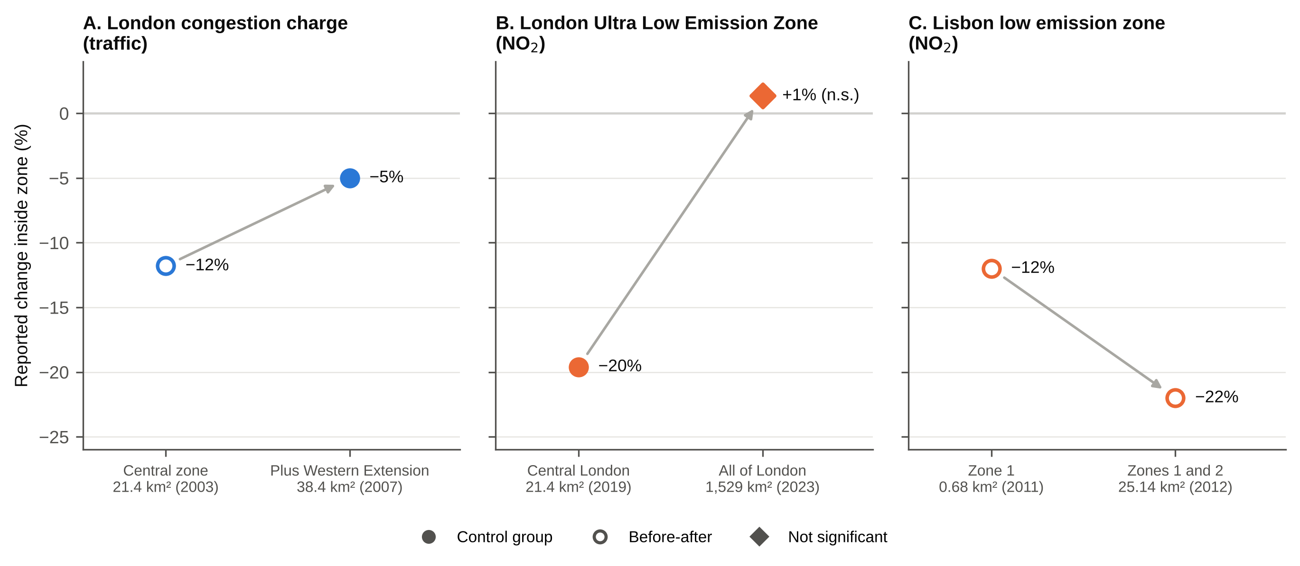
Figure 2. Reported change inside the zone for an original and an enlarged zone in the same city. (A) London congestion charge, traffic. The enlarged-zone estimate is for the added Western Extension only and uses a different metric. (B) London ULEZ, roadside NO₂, at its 2019 launch in central London and after its 2023 expansion to all of London (same evaluation, three months after each). (C) Lisbon low emission zone, NO₂ in Zone 1 and in the surrounding Zone 2. Filled markers have a control group. The diamond is not significant (Tong et al., 2025, their Supplementary Table S6). Sources are in Supplementary Table S4.
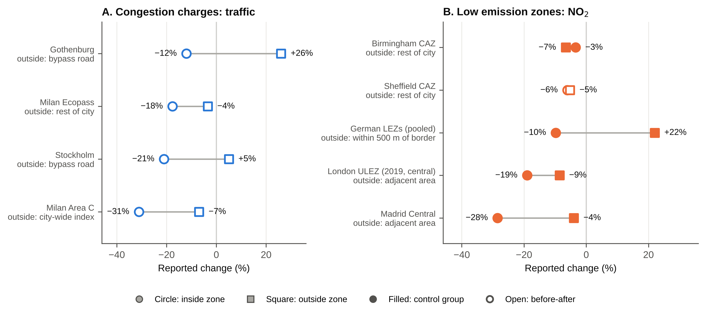
Figure 3. Reported change inside and outside the zone where the same study reported both. (A) Congestion charges, traffic. (B) Low emission zones, NO₂. Circles are the change inside the zone and squares the change outside it, with the outside location given under each name. Filled markers have a control group, and open markers are before-after comparisons. Where several estimates qualified (London ULEZ, Milan Ecopass), the median is shown. The Sheffield CAZ shows the study’s raw inside and outside changes, since its headline estimate in Figure 1 is measured relative to the outside sites. The German estimate pools many zones. Sources are in Supplementary Table S8.

Acknowledgements
The scheme inventory started from the Congestion Charging Database compiled by Rose [surname to add], whose work is gratefully acknowledged. [Funding statement to add.]

References
Ait Bihi Ouali, L., Musuuga, D., & Graham, D. J. (2021). Quantifying responses to changes in the jurisdiction of a congestion charge: A study of the London western extension. PLOS ONE, 16(7), e0253881. https://doi.org/10.1371/journal.pone.0253881
Börjesson, M., & Kristoffersson, I. (2015). The Gothenburg congestion charge. Effects, design and politics. Transportation Research Part A, 75, 134-146. https://doi.org/10.1016/j.tra.2015.03.011
Chamberlain, R. C., Fecht, D., Davies, B., & Laverty, A. A. (2023). Health effects of low emission and congestion charging zones: A systematic review. The Lancet Public Health, 8(7), e559-e574. https://doi.org/10.1016/S2468-2667(23)00120-2
Danielis, R., Rotaris, L., Marcucci, E., & Massiani, J. (2012). A medium term evaluation of the Ecopass road pricing scheme in Milan: Economic, environmental and transport impacts. Economics and Policy of Energy and the Environment, 2012(2), 49-83. https://doi.org/10.3280/EFE2012-002004
Garritty, C., Gartlehner, G., Nussbaumer-Streit, B., King, V. J., Hamel, C., Kamel, C., Affengruber, L., & Stevens, A. (2021). Cochrane Rapid Reviews Methods Group offers evidence-informed guidance to conduct rapid reviews. Journal of Clinical Epidemiology, 130, 13-22. https://doi.org/10.1016/j.jclinepi.2020.10.007
Givoni, M. (2012). Re-assessing the results of the London congestion charging scheme. Urban Studies, 49(5), 1089-1105. https://doi.org/10.1177/0042098011417017
Holman, C., Harrison, R., & Querol, X. (2015). Review of the efficacy of low emission zones to improve urban air quality in European cities. Atmospheric Environment, 111, 161-169. https://doi.org/10.1016/j.atmosenv.2015.04.009
Liu, B., Bryson, J. R., Sevinc, D., Cole, M. A., Elliott, R. J. R., Bartington, S. E., Bloss, W. J., & Shi, Z. (2023). Assessing the impacts of Birmingham’s Clean Air Zone on air quality: Estimates from a machine learning and synthetic control approach. Environmental and Resource Economics, 86, 203-231. https://doi.org/10.1007/s10640-023-00794-2
LUBW Landesanstalt für Umwelt Baden-Württemberg. (2020). Abschätzung zur Wirkung von Umweltzonen in Baden-Württemberg vor dem Hintergrund abnehmender Stickstoffdioxidkonzentrationen. Report for the Ministerium für Verkehr Baden-Württemberg.
Moral-Carcedo, J. (2024). Dissuasive effect of low emission zones on traffic: The case of Madrid Central. Transportation, 51, 25-49. https://doi.org/10.1007/s11116-022-10318-4
Prieto-Rodriguez, J., Perez-Villadoniga, M. J., Salas, R., & Russo, A. (2022). Impact of London Toxicity Charge and Ultra Low Emission Zone on NO₂. Transport Policy, 129, 237-247. https://doi.org/10.1016/j.tranpol.2022.10.010
Rotaris, L., Danielis, R., Marcucci, E., & Massiani, J. (2010). The urban road pricing scheme to curb pollution in Milan, Italy: Description, impacts and preliminary cost-benefit analysis assessment. Transportation Research Part A, 44(5), 359-375. https://doi.org/10.1016/j.tra.2010.03.008
Salas, R., Perez-Villadoniga, M. J., Prieto-Rodriguez, J., & Russo, A. (2021). Were traffic restrictions in Madrid effective at reducing NO₂ levels? Transportation Research Part D, 91, 102689. https://doi.org/10.1016/j.trd.2020.102689
Santos, F. M., Gómez-Losada, Á., & Pires, J. C. M. (2019). Impact of the implementation of Lisbon low emission zone on air quality. Journal of Hazardous Materials, 365, 632-641. https://doi.org/10.1016/j.jhazmat.2018.11.061
Sarmiento, L., Wägner, N., & Zaklan, A. (2023). The air quality and well-being effects of low emission zones. Journal of Public Economics, 227, 105014. https://doi.org/10.1016/j.jpubeco.2023.105014
Shin, H., Silverman, E., Li, Y., Tian, Y., & Zhao, Q. (2024). Did the implementation of Low Emission Zone in Glasgow change the traffic flow and air quality? Findings. https://doi.org/10.32866/001c.123382
Tassinari, F. (2024). Low emission zones and traffic congestion: Evidence from Madrid Central. Transportation Research Part A, 185, 104099. https://doi.org/10.1016/j.tra.2024.104099
Tong, C., Dai, Y., Cole, M., Elliott, R. J. R., Bartington, S. E., Liu, B., & Shi, Z. (2025). Further improvement in London’s air quality demands more than the Ultra Low Emission Zone policy. npj Clean Air, 1(1), 29. https://doi.org/10.1038/s44407-025-00030-9
Williams, G., Chan, H. K.-H., & Ortiz, P. F. (2025). Exploring the effects of Sheffield’s clean air zone on air quality and traffic volume. Environmental Research Communications, 7, 085009. https://doi.org/10.1088/2515-7620/adf52f

