Does Zone Size Matter? A Rapid Review of Ex-post Evaluations of Urban Congestion Charges and Low Emission Zones
Hyesop Shin (School of Environment, University of Auckland)
Draft 5 (rapid review), 3 November 2026
Abstract
Congestion charges and low emission zones range from a single street to a metropolis. This rapid review compared 115 ex-post estimates of change in traffic and nitrogen dioxide from 61 studies across zone sizes. Across cities, reductions tended to be larger in zones under 10 square kilometres, and four of six zones over 50 showed no detectable effect. Within cities, London’s enlarged charging and emission zones showed smaller effects than its central zones, whereas Lisbon’s larger zone showed a larger reduction. Zone size alone did not predict effect. More than 20 German emission zones have been lifted without evaluation.
Keywords: congestion charging, low emission zone, zone size, boundary, rapid review, air quality

1. Questions
Zone-based congestion charges and low emission zones (LEZs) act on vehicles that cross or circulate inside a boundary, so the boundary decides which trips and vehicles are affected. Zones range from 0.35 km² in Durham to over 1,500 km² in London. Reviews have grouped their effects by scheme type or health outcome (Chamberlain et al., 2023, Holman et al., 2015), but not by zone size. Yet London extended its Ultra Low Emission Zone (ULEZ) to the whole city in 2023, and German cities have been lifting their LEZs since 2020. We ask three questions.
- How do changes in traffic and NO₂ measured inside the zone differ across zone size categories?
- Where a city enlarged its zone, how did the measured effect change?
- Where are the main gaps in this evidence?

2. Methods
We followed Cochrane rapid review guidance (Garritty et al., 2021). From a compiled database of 65 urban road charging and access schemes we kept those with a bounded zone and added schemes with known evaluations, giving 50 zone-based schemes (Supplementary S1). Point-based charges, such as the temporary charge introduced in Oxford in October 2025, were excluded. For each scheme one reviewer searched Google Scholar, Crossref and publisher sites in October and November 2026, and screened the reference lists of three reviews. We included ex-post estimates of change in traffic or ambient pollution, preferred peer-reviewed sources, and checked key estimates against full texts.
For each scheme phase we took one headline estimate, the percentage change in traffic for charges and in NO₂ inside the zone for LEZs, from the earliest evaluation window, then the strongest design, then the median. Zone area is the area in which the effect was measured, grouped as street (under 1 km²), city centre (1 to under 10 km²), inner city (10 to under 50 km²), whole city (50 to under 500 km²) and metropolitan (over 500 km²). Estimates reported only as not significant are shown as zero. We also identified cities that enlarged a zone and reported the same outcome for the original and the enlarged zone. London’s Western Extension (2007 to 2011) was treated as such an enlargement rather than as a separate scheme. London’s Low Emission Zone (from 2008, mainly heavy diesel vehicles across Greater London) and its ULEZ (from 2019, cars, vans and motorcycles, enlarged in 2021 and 2023) are separate schemes and are analysed separately. Changes in charges or rules, suspensions and removals are listed in Supplementary Table S5. With few cases per category and standard errors rarely reported, we did not pool estimates. Data and code are deposited [repository DOI to add].

3. Findings
3.1 Effects by zone size
Of the 50 schemes, 29 had an ex-post estimate, and 25 phases had both a headline estimate and a known zone area (Table 1). Reported reductions tended to be larger in zones under 10 km², but the pattern is weak and rests on few cases (Figure 1, Supplementary Table S3). For charges the median change in traffic was −55% in two street zones, −18% in three city-centre zones and −12% in three inner-city zones. Both street schemes (Durham and Valletta) rest on council monitoring and a conference paper, and estimates from journal articles alone showed no relationship with area (Supplementary Table S9). For LEZs the median change in NO₂ was −12% in the single street zone, −18% in city-centre zones (n = 5), −12% in inner-city zones (n = 5), −7% in whole-city zones (n = 4) and zero in both metropolitan zones. The last two medians are pulled towards zero by four zones with no detectable effect (Berlin, Milan Area B, the London LEZ for heavy vehicles and the 2023 expansion of the ULEZ to all of London). Without them the whole-city median was −15%, close to that of city-centre zones.
3.2 Larger zones within the same city
Three cities reported the same outcome for an original and an enlarged zone (Figure 2). London’s central congestion charge cut traffic in the zone by about 12% (Givoni, 2012). The Western Extension, which nearly doubled the charged area in 2007, cut traffic in the added area by 5% (Ait Bihi Ouali et al., 2021), although the two estimates use different metrics, and its removal in 2011 produced no significant change. In the same evaluation, London’s ULEZ cut roadside NO₂ by about 20% within three months of its 2019 launch in central London, but its expansion to all of London in 2023 had no detectable effect over the same window. By then 93% of vehicles entering the zone already complied, against 61% at the central launch (Tong et al., 2025). Lisbon went the other way. NO₂ fell by 12% in the 0.68 km² Zone 1 and by 22% in the surrounding Zone 2, although Zone 2 applied a looser standard (Santos et al., 2019). Both Lisbon estimates are before-after comparisons without a control.
Within a fixed boundary, higher charges and stricter rules were followed by further reductions in six of seven cases, four of them before-after comparisons, and suspending or removing a charge brought traffic back in Milan (+14.5%, Gibson & Carnovale, 2015) and Trondheim (+11%, Meland et al., 2010) (Supplementary Table S5). Where charge effects were measured more than once, the latest estimate was 0.76 to 1.21 times the first (Supplementary Table S7).
3.3 Gaps
The evidence is concentrated. London and Germany supplied 53 of the 115 estimates, and no inventory scheme in China, Latin America, Indonesia, France or Poland had one. A campaign group counted about 320 LEZs in Europe alone by 2022 (Clean Cities Campaign, 2022), so the 33 emission zones in our inventory are an evaluation-rich subset rather than a representative sample. Removal is the largest gap. At least 22 German LEZs were lifted between 2020 and 2025, including Tübingen in 2024 (Supplementary Table S6). For Tübingen, Reutlingen and Ulm the regional authority cited a state agency estimate that the zones’ remaining effect was very small (Regierungspräsidium Tübingen, 2024). We found no ex-post evaluation of any removal.
3.4 Summary
Between cities, smaller zones tended to report larger proportional reductions in traffic and NO₂, and most of the largest zones showed none. Within cities the evidence is three cases and is mixed. In London the larger zone came with a smaller effect, partly because the 2023 ULEZ expansion launched when few vehicles remained non-compliant, while in Lisbon the larger zone showed the larger reduction. Zone size alone therefore did not predict effect. Averages over a larger zone may also include more places with little traffic, which we could not test. A single reviewer, mixed designs and few cases per category limit these conclusions (Supplementary section S5). Evaluations should report zone area, compliance at launch and measurement location, and the lifted German zones offer a natural experiment of removal across a range of sizes.

Table 1
Headline effect, zone size and stringency by scheme phase. Effect is the percentage change in traffic (charges) or NO₂ inside the zone (LEZs). Zone is the area in which the effect was measured, and coverage is that area as a share of the GHSL urban centre (European Commission, Joint Research Centre, 2024). Years is the midpoint of the evaluation window (window end for cumulative estimates). Control means an untreated control group or natural experiment. Zero marks an estimate reported only as not significant. Durham’s denominator is a GHS-SMOD dense urban cluster, and Bradford lies in the Leeds urban centre. Effect sources are in Supplementary Table S1, and area, charge and compliance sources in Table S2.
Scheme | Type | Start | Zone (km²) | Size category | Coverage (%) | Effect (%) | Years | Design | Charge or fine (2023 USD PPP) | Compliant at launch (%)
Durham | Charge | 2002 | 0.35 | Street | 2.7 | −85.0 | 1.0 | Before-after | 5 per exit
Valletta | Charge | 2007 | 0.80 | Street | 0.8 | −25.0 | 1.0 | Before-after | 2 per hour
Singapore | Charge | 1975 | 6.0 | City centre | 1.4 | −44.0 | 0.1 | Before-after | 10
Milan Area C | Charge | 2012 | 8.2 | City centre | 1.0 | −14.5 | 0.6 | Control | 10
Milan Ecopass | Charge | 2008 | 8.2 | City centre | 1.0 | −17.6 | 0.5 | Before-after | 11 (middle band) | 58
London central zone | Charge | 2003 | 21.4 | Inner city | 1.3 | −11.8 | 0.5 | Before-after | 13
New York | Charge | 2025 | 23.8 | Inner city | 0.8 | −11.0 | 0.3 | Before-after | 9
Stockholm | Charge | 2006 | 30.0 | Inner city | 8.8 | −21.4 | 0.5 | Adjusted before-after | 3 per crossing
Bergen | Charge | 1986 |  | Not recovered |  | −6.5 | 0.5 | Before-after | 2 per crossing
Gothenburg | Charge | 2013 |  | Not recovered |  | −11.4 | 0.5 | Before-after | 3 per crossing
Oslo | Charge | 1990 |  | Not recovered |  | −4.0 | 0.5 | Before-after | 3 per crossing
Trondheim | Charge | 1991 |  | Not recovered |  | −10.0 | 0.5 | Before-after | 2 per crossing
Lisbon | LEZ | 2012 | 0.68 | Street | 0.2 | −12.0 | 2.8 | Before-after
Sheffield (no cars) | LEZ | 2023 | 2.3 | City centre | 1.1 | +2.5 | 0.7 | Control | 15 (vans, taxis)
Glasgow | LEZ | 2023 | 3.1 | City centre | 1.0 | −20.5 | 0.3 | Before-after | fine 91
Madrid Central | LEZ | 2018 | 4.7 | City centre | 0.7 | −28.6 | 0.3 | Control | fine 188
Rome | LEZ | 2001 | 6.0 | City centre | 1.3 | −18.0 | 2.5 | Model
Birmingham | LEZ | 2021 | 7.8 | City centre | 1.1 | −3.4 | 0.5 | Control | 14 | 79.8
London ULEZ (2019, central London) | LEZ | 2019 | 21.4 | Inner city | 1.3 | −19.0 | 0.4 | Control | 23 | 60.9
Bradford (no cars) | LEZ | 2022 | 22.0 | Inner city | 6.9 | −27.0 | 0.5 | Adjusted before-after | 15 (vans, taxis) | 96.4
Antwerp | LEZ | 2017 | 22.9 | Inner city | 7.0 | −12.2 | 5.9 | Control | fine 216
Munich | LEZ | 2008 | 44.0 | Inner city | 12.8 | +2.4 | 1.0 | Before-after | fine 76
Amsterdam (trucks only) | LEZ | 2009 | 47.2 | Inner city | 15.3 | −4.9 | 1.0 | Before-after | fine 286
Berlin | LEZ | 2008 | 88.0 | Whole city | 12.9 | 0.0 | 3.5 | Before-after | fine 76
Barcelona | LEZ | 2020 | 95.0 | Whole city | 21.7 | −15.8 | 1.5 | Control | fine 208
Milan Area B | LEZ | 2019 | 128 | Whole city | 16.3 | 0.0 | 0.3 | Control | fine 160
Brussels | LEZ | 2018 | 161 | Whole city | 68.7 | −13.3 | 5.0 | Control | fine 594 | 99.5
London LEZ (heavy vehicles) | LEZ | 2008 | 1,528 | Metropolitan | 92.7 | 0.0 | 1.5 | Before-after | 452 (lorries)
London ULEZ expansion to all of London (2023) | LEZ | 2023 | 1,529 | Metropolitan | 92.7 | 0.0 | 0.1 | Control | 19 | 92.6

Figures
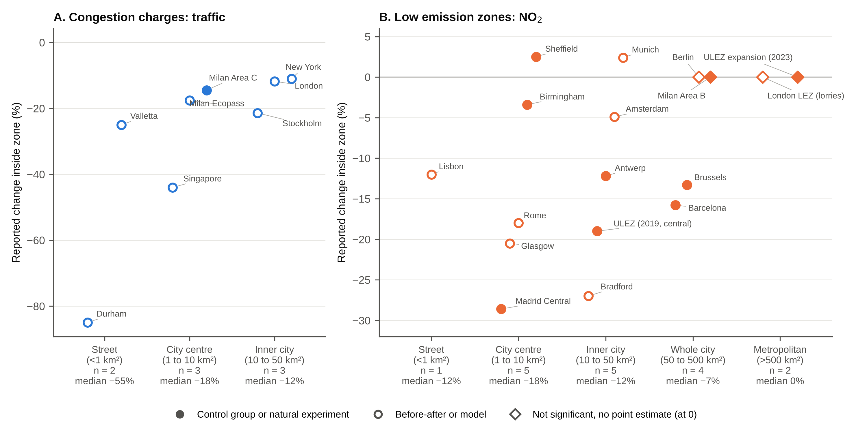
Figure 1. Headline effect by zone size category. (A) Congestion charges, change in traffic. (B) Low emission zones, change in NO₂ inside the zone. Each point is one scheme phase. Filled circles have an untreated control group or natural experiment, and open circles are before-after comparisons or models. Diamonds are estimates reported only as not significant, plotted at zero. Category medians are given under each axis label. Diamonds are filled where the design has a control. The two panels use different vertical scales. Four Nordic toll rings without a recoverable zone area are not shown.
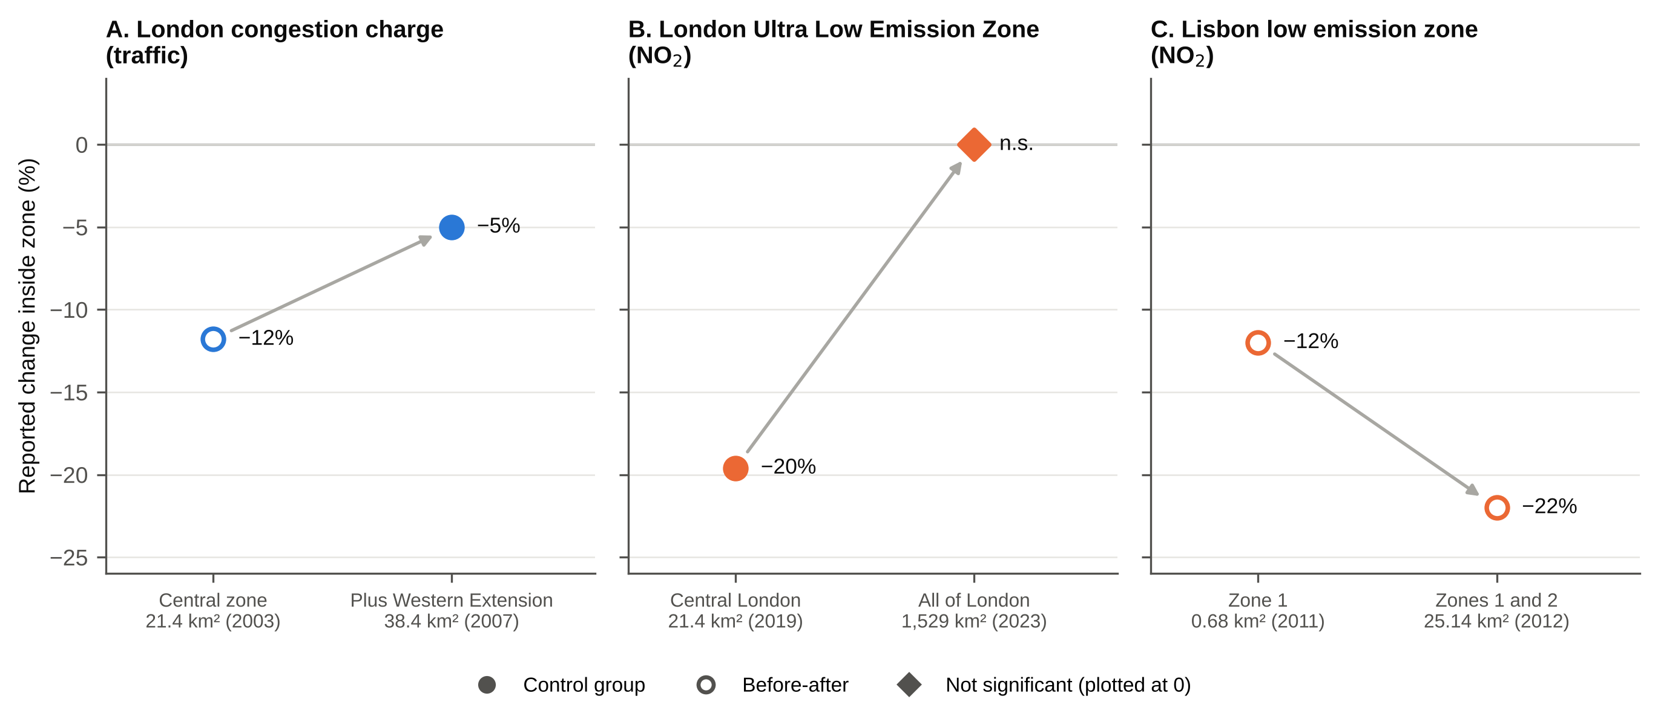
Figure 2. Reported change inside the zone for an original and an enlarged zone in the same city. (A) London congestion charge, traffic. The enlarged-zone estimate is for the added Western Extension only and uses a different metric. (B) London ULEZ, roadside NO₂, at its 2019 launch in central London and after its 2023 expansion to all of London (same evaluation, three months after each). (C) Lisbon low emission zone, NO₂ in Zone 1 and in the surrounding Zone 2. Filled markers have a control group. The diamond is not significant and is plotted at zero. Sources are in Supplementary Table S4.

References
Ait Bihi Ouali, L., Musuuga, D., & Graham, D. J. (2021). Quantifying responses to changes in the jurisdiction of a congestion charge: A study of the London western extension. PLOS ONE, 16(7), e0253881. https://doi.org/10.1371/journal.pone.0253881
Chamberlain, R. C., Fecht, D., Davies, B., & Laverty, A. A. (2023). Health effects of low emission and congestion charging zones: A systematic review. The Lancet Public Health, 8(7), e559-e574. https://doi.org/10.1016/S2468-2667(23)00120-2
Clean Cities Campaign. (2022). The development trends of low- and zero-emission zones in Europe. Clean Cities Campaign.
European Commission, Joint Research Centre. (2024). GHS Urban Centre Database 2025 (GHS-UCDB R2024A, version 1.2) [Data set]. Global Human Settlement Layer.
Garritty, C., Gartlehner, G., Nussbaumer-Streit, B., King, V. J., Hamel, C., Kamel, C., Affengruber, L., & Stevens, A. (2021). Cochrane Rapid Reviews Methods Group offers evidence-informed guidance to conduct rapid reviews. Journal of Clinical Epidemiology, 130, 13-22. https://doi.org/10.1016/j.jclinepi.2020.10.007
Gibson, M., & Carnovale, M. (2015). The effects of road pricing on driver behavior and air pollution. Journal of Urban Economics, 89, 62-73. https://doi.org/10.1016/j.jue.2015.06.005
Givoni, M. (2012). Re-assessing the results of the London congestion charging scheme. Urban Studies, 49(5), 1089-1105. https://doi.org/10.1177/0042098011417017
Holman, C., Harrison, R., & Querol, X. (2015). Review of the efficacy of low emission zones to improve urban air quality in European cities. Atmospheric Environment, 111, 161-169. https://doi.org/10.1016/j.atmosenv.2015.04.009
Meland, S., Tretvik, T., & Welde, M. (2010). The effects of removing the Trondheim toll cordon. Transport Policy, 17(6), 475-485. https://doi.org/10.1016/j.tranpol.2010.05.001
Regierungspräsidium Tübingen. (2024). Luftreinhalteplan für den Regierungsbezirk Tübingen, Teilplan Stadt Tübingen, 3. Fortschreibung. Regierungspräsidium Tübingen.
Santos, F. M., Gómez-Losada, Á., & Pires, J. C. M. (2019). Impact of the implementation of Lisbon low emission zone on air quality. Journal of Hazardous Materials, 365, 632-641. https://doi.org/10.1016/j.jhazmat.2018.11.061
Tong, C., Dai, Y., Cole, M., Elliott, R. J. R., Bartington, S. E., Liu, B., & Shi, Z. (2025). Further improvement in London’s air quality demands more than the Ultra Low Emission Zone policy. npj Clean Air, 1(1), 29. https://doi.org/10.1038/s44407-025-00030-9

