Sensitivity analyses

1 Summary
- Level depends on the threshold. Changing the 45-minute public transport (PT) threshold changes the level of the trapped share considerably. It is above 90% at 30 minutes, 68.3% to 70.4% at 45 minutes and 38.5% to 45.4% at 60 minutes.
- The deprivation gradient does not. At every threshold from 35 minutes upwards, charged commuters in the most deprived neighbourhoods (NZDep D8-10) are more likely to be trapped than those in the least deprived (D1-3), under all three schemes. The concentration index (CI) of the trapped share is negative throughout this range and becomes stronger as the threshold rises.
- Very short thresholds. Below about 30 minutes almost every charged commute is trapped, so there is little variation left for a gradient to appear in.
- Above 60 minutes. The travel-time matrix has a 60-minute ceiling. Thresholds up to 60 minutes are exact. Thresholds from 65 to 90 minutes need the matrix re-routed with a longer ceiling.
- Relative criterion. A PT/car travel-time ratio cannot yet be tested reliably, because car travel times are not stored and many comparisons need PT times beyond the 60-minute ceiling.
- Corridor width. Widening or narrowing the 3c corridor changes the number charged but leaves the trapped share at 70% to 71% and the trapped-share CI (NZDep2023) in the neutral band.
- Deprivation measure. Ranking SA2s by household income instead of NZDep2023 keeps the sign of every CI and makes the trapped-share CI larger (moderate under equivalised income).

2 Public transport threshold

2.1 Design
The manuscript classifies a charged car commute as trapped when the same residence to workplace journey cannot be made by PT within 45 minutes (median over the 07:00 to 09:00 departure window). Here the classification is repeated at every threshold from 20 to 60 minutes in five-minute steps. Nothing else changes. The charged set is fixed by the scheme boundary, so the charged counts and the CI of the charged share are identical at every threshold. Only the split between trapped commuters and those with an alternative moves.

2.2 Results
Table 1. Trapped share (% of charged car commuters) by PT threshold
PT threshold (min) | 1a | 1c | 3c
20 | 99.6 | 99.3 | 97.5
25 | 98.7 | 98.0 | 95.1
30 | 95.1 | 94.6 | 90.8
35 | 89.4 | 89.1 | 85.9
40 | 80.0 | 80.0 | 78.5
45 | 68.3 | 69.9 | 70.4
50 | 56.6 | 58.6 | 61.3
55 | 46.4 | 47.4 | 52.2
60 | 38.5 | 39.6 | 45.4
Highlighted row: the 45-minute headline used in the manuscript.
Table 2. Deprivation gradient in the trapped share at selected thresholds
Threshold (min) | Scheme | Trapped, D1-3 (%) | Trapped, D8-10 (%) | Gap (pp) | CI, trapped share
30 | 1a | 96.0 | 100.0 | 4.0 | −0.002
30 | 1c | 94.1 | 100.0 | 5.9 | −0.005
30 | 3c | 91.2 | 98.9 | 7.7 | −0.003
40 | 1a | 74.5 | 99.1 | 24.6 | −0.045
40 | 1c | 73.1 | 99.1 | 26.0 | −0.048
40 | 3c | 75.3 | 96.1 | 20.8 | −0.027
45 | 1a | 58.8 | 95.7 | 36.9 | −0.089
45 | 1c | 60.8 | 95.5 | 34.7 | −0.078
45 | 3c | 65.8 | 91.6 | 25.8 | −0.043
50 | 1a | 44.7 | 90.8 | 46.1 | −0.142
50 | 1c | 48.5 | 86.5 | 38.0 | −0.106
50 | 3c | 55.9 | 83.1 | 27.2 | −0.058
60 | 1a | 27.3 | 74.3 | 47.0 | −0.216
60 | 1c | 31.5 | 66.2 | 34.7 | −0.144
60 | 3c | 41.5 | 63.0 | 21.5 | −0.064
Trapped (%) = share of the group's charged commuters with no PT journey within the threshold. CI weighted by charged commuters, SA2s ranked from most to least deprived, so a negative value means trapping is concentrated among the more deprived. |CI| < 0.05 neutral, 0.05 to 0.10 mild, 0.10 to 0.20 moderate, above 0.20 strong.
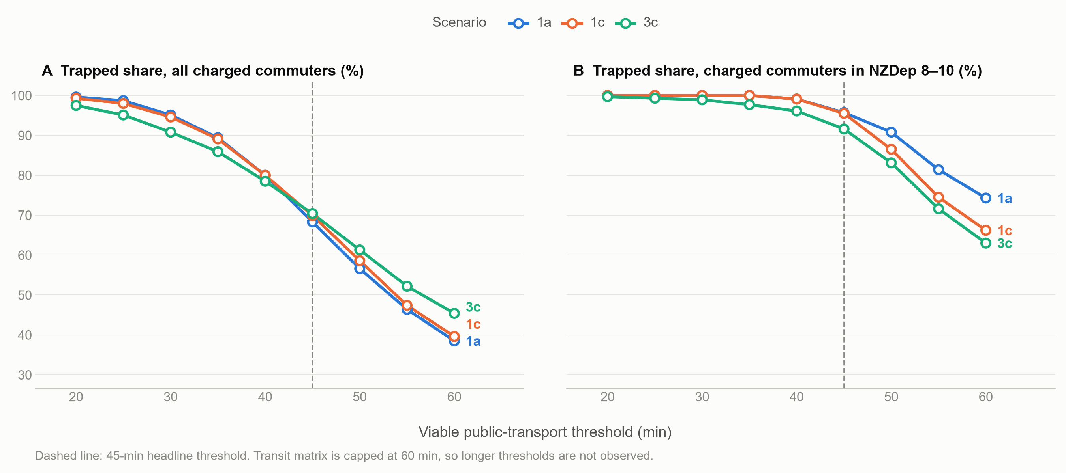
Figure 1. Trapped share of all charged commuters (A) and of charged commuters living in NZDep D8-10 (B), by PT threshold. Both panels share one scale. The dashed line marks the 45-minute headline.

2.3 Interpretation
The trapped share is sensitive to the threshold, as expected. Under 1a it falls from 95.1% at 30 minutes to 38.5% at 60 minutes. At 60 minutes fewer than half of the charged commuters are trapped under every scheme, so the headline that most charged commuters cannot switch holds at 45 minutes but not at 60.
The deprivation gradient is the more robust finding. At 45 minutes between 59 and 66 in 100 charged commuters from D1-3 are trapped against more than 90 in 100 from D8-10. At 60 minutes the rates are lower for everyone, but the gap remains large (47.0, 34.7 and 21.5 percentage points for 1a, 1c and 3c). The trapped-share CI moves from neutral at 35 minutes to −0.216 (1a), −0.144 (1c) and −0.064 (3c) at 60 minutes. In other words, a more generous threshold gives more commuters an alternative, but those gains go mainly to the less deprived.
At 30 minutes and below the classification saturates. More than 90% of charged commuters are trapped in every group, and the CI of the trapped share is close to zero. This is a floor effect rather than evidence of equal access.

2.4 Thresholds above 60 minutes
The travel-time matrix (stage 2) was computed with a 60-minute ceiling, beyond which a pair is recorded as unreachable. The 60-minute result above is exact. R5 reports the median travel time across departure minutes, and that median is at most 60 minutes only when more than half of the departures arrive within 60 minutes, whatever the ceiling. For thresholds above 60 minutes no new information is available, so the trapped share stays flat at its 60-minute value. Testing 65 to 90 minutes requires re-running stage 2 with a 90-minute ceiling (about 20 minutes of routing), then stages 4c and 4h. This is a setting in the pipeline, not a limit of r5py.

2.5 Relative criterion (PT/car travel-time ratio)
A relative criterion treats a commute as having an alternative when the PT time is at most k times the car time. Car travel times are not stored by the pipeline, so they were approximated here as the R5 driving-route distance divided by an assumed door-to-door peak speed of 25, 30 or 40 km/h. PT times above 60 minutes are unobserved, so a commute whose ratio test would need a longer PT time is counted as trapped (censored).
Table 3. Trapped share (%) and censored share (% of charged) under a PT/car ratio criterion
Car speed (km/h) | Ratio k | Trapped 1a | Trapped 1c | Trapped 3c | Censored 1a | Censored 1c | Censored 3c
25 | 1.5 | 89.3 | 93.1 | 95.2 | 21.9 | 24.0 | 30.2
25 | 2.0 | 73.3 | 78.1 | 84.6 | 32.7 | 35.4 | 40.4
30 | 1.5 | 96.2 | 97.7 | 98.3 | 13.3 | 14.4 | 21.3
30 | 2.0 | 82.5 | 87.9 | 91.7 | 26.7 | 29.5 | 34.8
40 | 1.5 | 99.9 | 99.9 | 100.0 | 3.8 | 3.9 | 9.0
40 | 2.0 | 96.2 | 97.7 | 98.3 | 13.3 | 14.4 | 21.3

Under any plausible ratio the trapped share is 73% or higher, and with a 1.5 ratio it is above 89% for every scheme and speed. The result is also highly uncertain, since between 4% and 40% of charged commuters cannot be tested because their PT time would exceed the 60-minute ceiling, and the car times are themselves a proxy. The relative criterion should therefore be reported only after car travel times have been routed (stage 4g, saving the itinerary duration) and the PT matrix extended to 90 minutes. The direction of the result is consistent with the manuscript's limitation that the 45-minute absolute measure is likely to understate the share without a realistic alternative.

3 Corridor width (scheme 3c)
Scheme 3c is a buffer of the state-highway centrelines plus the 1a city-centre cordon. The headline uses a 1 km half-width. The same buffer was built at 500 m and 2 km (build_scenario_3c.py) and the classification repeated (stage 4f).
Table 4. Scheme 3c at three corridor half-widths
Half-width | Charged | Charged (%) | Trapped (%) | CI trapped share (NZDep) | CI trapped share (equiv. income)
500 m | 56,898 | 22.8 | 71.2 | −0.049 | −0.124
1,000 m | 66,027 | 26.4 | 70.4 | −0.043 | −0.113
2,000 m | 83,547 | 33.4 | 69.9 | −0.040 | −0.096

The number charged rises with the corridor width, from about 57,000 to 84,000, but the trapped share barely moves (69.9% to 71.2%). The trapped-share CI stays neutral with NZDep2023 and moves only from moderate to mild with equivalised income as the corridor widens. The corridor width therefore affects how many people pay, not whether those who pay can switch.

4 Deprivation measure
NZDep2023 is a composite index. The CIs were recomputed with SA2s ranked by 2023 Census median household income instead: raw, equivalised by the square root of household size, and per capita (stage 4e, common sample of 497 SA2s).
Table 5. Concentration indices by ranking variable
Scheme | Measure | NZDep2023 | Income | Income (equiv.) | Income (per cap.)
- | Baseline accessibility | +0.040 | +0.010 | +0.111 | +0.198
1a | Charged share | +0.216 | +0.229 | +0.294 | +0.322
1a | Trapped share | −0.089 | −0.113 | −0.164 | −0.192
1a | Trapped, all car commuters | +0.130 | +0.122 | +0.146 | +0.156
1c | Charged share | +0.198 | +0.215 | +0.271 | +0.298
1c | Trapped share | −0.078 | −0.120 | −0.158 | −0.179
1c | Trapped, all car commuters | +0.123 | +0.102 | +0.129 | +0.141
3c | Charged share | +0.202 | +0.221 | +0.304 | +0.347
3c | Trapped share | −0.043 | −0.076 | −0.113 | −0.135
3c | Trapped, all car commuters | +0.161 | +0.152 | +0.204 | +0.231
Positive = concentrated among the less disadvantaged. Charged share and trapped share of all car commuters are positive because the less deprived are more often charged.
Every CI keeps its sign under all four rankings. The trapped-share CI is larger under income than under NZDep2023 (for example 1a: −0.089 with NZDep, −0.164 with equivalised income), so NZDep2023 gives the more conservative reading. The baseline accessibility CI is neutral with NZDep2023 (+0.040) but moderate with equivalised income (+0.111), which is worth a sentence in the RQ1 discussion.

