Auckland ToU equity analysis: before-after comparison
All 619 Auckland SA2 (current full sample) versus urban-only 562 SA2 (restricted to Stats NZ IUR2025 class 11 to 14, Major to Small urban area). All Concentration Index, Global Moran I, and Local Moran results are recomputed on both samples using identical methodology, queen contiguity, row-standardised weights, 999 permutations, p < 0.05.

1. Sample composition
The urban-only sample is constructed by intersecting Auckland Council SA2 polygons with the Stats NZ Urban Rural 2025 boundary file, keeping SA2s with greater than 50 per cent area overlap with an IUR class 11 to 14 polygon. The Inlet Waitemata Harbour SA2 (water-only, three usually resident) is excluded from both samples in all reported figures below.
Stat | All sample | Urban-only | Excluded
SA2 count | 619 | 562 | 57
Usually resident population | 1,645,908 | 1,545,153 | 100,755
IUR class 11 Major urban (Auckland) | 504 SA2 | 504 | 0
IUR class 12 Large urban (Hibiscus Coast) | 25 | 25 | 0
IUR class 13 Medium urban (Pukekohe) | 12 | 12 | 0
IUR class 14 Small urban (15 small areas) | 23 | 23 | 0
Rural settlement, rural other, outer islands | 57 | 0 | 57
Table 1. Sample composition. The urban-only filter drops 57 SA2s, mostly affluent rural fringe (Coatesville, Riverhead, Kumeu Wider), and outer settlements (Snells Beach, Wellsford, Warkworth). The 100,755 residents excluded represent 6.1 per cent of the regional population.

2. Baseline Concentration Index of accessibility
The Wagstaff Concentration Index of jobs reachable by public transport against NZDep2023 deprivation, computed both as the SA2-unweighted form currently in the code and as the population-weighted form described in the manuscript methods. The population weight is SA1 usually resident count summed to the SA2 polygon.
Measure | All (uw) | All (pw) | Urban (uw) | Urban (pw)
CI(access_45min) overall | +0.042 | +0.017 | −0.001 | −0.011
CI(access_30min) overall | +0.101 | +0.079 | +0.055 | +0.048
CI(access_45min) D8 to D10 subgroup | −0.167 | −0.134 | −0.167 | −0.134
Table 2. Baseline Concentration Index, four combinations. The all-sample CI is mildly positive (apparently pro-poor), the urban-only CI is essentially zero. The D8 to D10 subgroup CI is identical between samples because deciles 8 to 10 are entirely urban. Unweighted vs population weighted
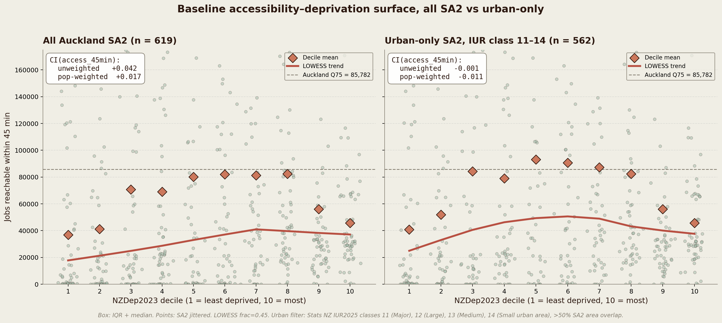
Figure 1. Baseline accessibility versus NZDep2023 decile, all sample versus urban-only. Sage points are SA2s, coral diamonds are decile means, terra line is LOWESS. Dashed line is the Auckland Q75 of access_45min (85,782 jobs). The inverted-U seen in the all-sample panel collapses to a near-flat or mildly decreasing trend in the urban-only panel.

2.1 Reading
- The inverted-U shape in the manuscript is largely a rural-versus-urban contrast. The D1 to D2 affluent low-access tail is driven by Coatesville, Riverhead, Kumeu, Maraetai and similar rural SA2s. Dropping them removes the tail.
- Within the urban sample, the baseline CI is essentially zero (−0.001 unweighted, −0.011 population-weighted). There is no meaningful aggregate accessibility advantage for the less deprived end of the urban deprivation gradient.
- The D8 to D10 subgroup CI of −0.13 to −0.17 is robust to the urban filter and remains the substantively informative baseline statistic.

3. Scenario-level Concentration Index
Concentration Index of 45-min accessibility against NZDep2023, restricted to the set of SA2s charged under each scenario. A negative value indicates that, within the charged subset, more deprived SA2s have lower accessibility, which is the regressive case.
Scenario | All n | Urban n | All (uw) | All (pw) | Urban (uw) | Urban (pw)
1a, City centre cordon | 15 | 15 | −0.002 | −0.005 | −0.002 | −0.005
1c, City centre + fringe | 27 | 27 | +0.028 | +0.033 | +0.028 | +0.033
2c, Isthmus double cordon | 158 | 158 | +0.034 | +0.026 | +0.034 | +0.026
3b, Core motorways | 173 | 171 | −0.204 | −0.205 | −0.216 | −0.211
3c, Core motorways + CBD | 188 | 186 | −0.145 | −0.147 | −0.155 | −0.152
3e, Motorway hotspots | 22 | 22 | −0.072 | −0.000 | −0.072 | −0.000
Table 3. Per-scenario CI on charged subset. Negative values are regressive. 1a, 1c, 2c, and 3e have the same charged set in both samples because their footprint is fully urban. Motorway scenarios 3b and 3c lose two rural charged SA2s under the urban filter, which strengthens the regressive signal.
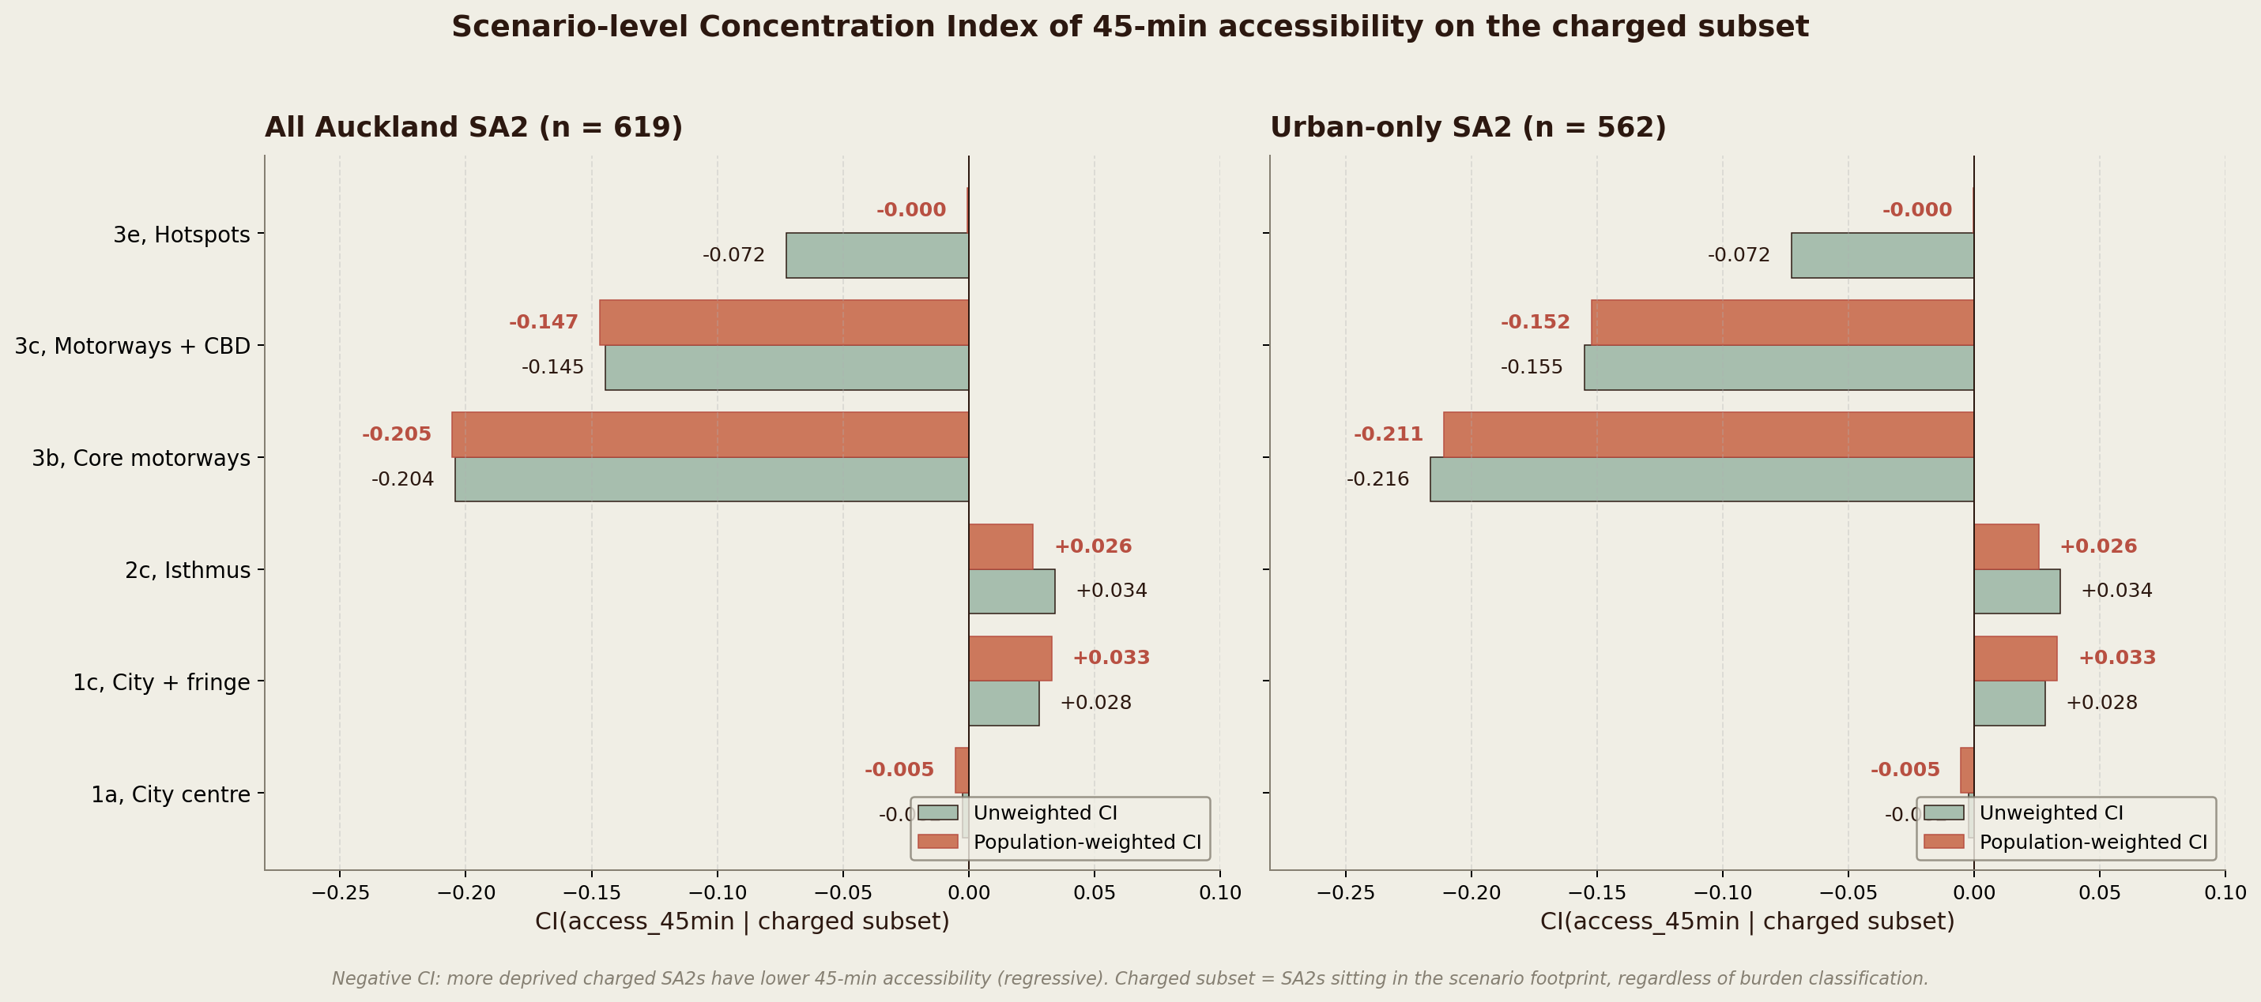
Figure 2. Per-scenario CI(access_45min on charged subset). Sage bars are unweighted, coral bars are population-weighted. The motorway corridor scenarios 3b and 3c remain strongly regressive in both samples. Adding the CBD to 3b dilutes the index from −0.21 to −0.15 because the added CBD SA2s sit well above the Q75 cut-point on accessibility (a measurement effect, not an equity gain).

3.1 Reading
- Motorway H2 conclusion holds and slightly strengthens under the urban filter. 3b moves from −0.20 to −0.22, 3c from −0.15 to −0.16.
- 1a, 1c, 2c, 3e are unchanged because their charged subset is fully urban.
- 3e is essentially zero on the population-weighted index, regardless of sample. The unweighted −0.07 reflects a few low-population SA2s pulling the per-SA2 average.

4. Global Moran's I
Queen contiguity weights, row-standardised, 999 permutations, p-sim is the two-sided permutation p-value.
Variable | All I | All p | Urban I | Urban p | Δ I
access_45min | +0.852 | <0.001 | +0.844 | <0.001 | −0.008
access_30min | +0.890 | <0.001 | +0.901 | <0.001 | +0.011
NZDep2023 | +0.208 | <0.001 | +0.226 | <0.001 | +0.018
Table 4. Global Moran's I, all sample versus urban-only. Accessibility is very strongly spatially autocorrelated in both samples. Deprivation is moderately spatially autocorrelated in both.

4.1 Reading
- Urban filtering changes Global Moran's I by less than 0.02 on every variable. The conclusion that accessibility shows strong spatial clustering and that NZDep shows moderate clustering does not depend on the sample.
- The previously reported NZDep Moran's I of +0.69 in the manuscript text does not match either sample under the current methodology. Both samples give approximately +0.21, suggesting either a different (earlier) NZDep variable was used, or the +0.69 figure was transcribed in error. We recommend replacing +0.69 with +0.21 throughout the discussion.

5. Local Moran's I, univariate
Cluster classification uses the standard quadrant scheme. HH and LL are clusters of similar values, HL and LH are spatial outliers. Significance threshold p < 0.05 based on 999 permutations.
Variable / sample | HH | LL | HL | LH | ns
access_45min, All | 94 | 164 | 0 | 2 | 359
access_45min, Urban | 84 | 127 | 0 | 3 | 348
NZDep2023, All | 97 | 25 | 9 | 4 | 484
NZDep2023, Urban | 86 | 30 | 11 | 5 | 430
Table 5. Univariate Local Moran cluster counts. access_45min shows a clear bimodal pattern, with high-high SA2s on the inner isthmus and low-low SA2s on the urban fringe, in both samples. NZDep is dominated by deprived-deprived clusters in the outer south and outer west.

6. Local Moran's I, bivariate
Focal variable: 45-minute accessibility. Spatial lag: NZDep2023. The cluster categories then describe the relationship between a SA2's accessibility and the deprivation level of its neighbours. The LH cluster (low access, deprived neighbours) is the H2 motorway-corridor burden cluster.
Cluster | Description | All | Urban | Δ
HH | High access where neighbours are deprived | 22 | 14 | −8
LH | Low access where neighbours are deprived (H2 burden) | 79 | 77 | −2
HL | High access where neighbours are affluent (elite belt) | 7 | 3 | −4
LL | Low access where neighbours are affluent (fringe) | 27 | 38 | +11
ns | Not significant | 484 | 430 | −54
Table 6. Bivariate Local Moran's I clusters, focal access_45min by spatial lag of NZDep2023. The LH burden cluster of about 77 to 79 SA2s is essentially unchanged by the urban filter. This matches the per-scenario CI finding: the H2 motorway-corridor regressive signal is robust to dropping the rural fringe.
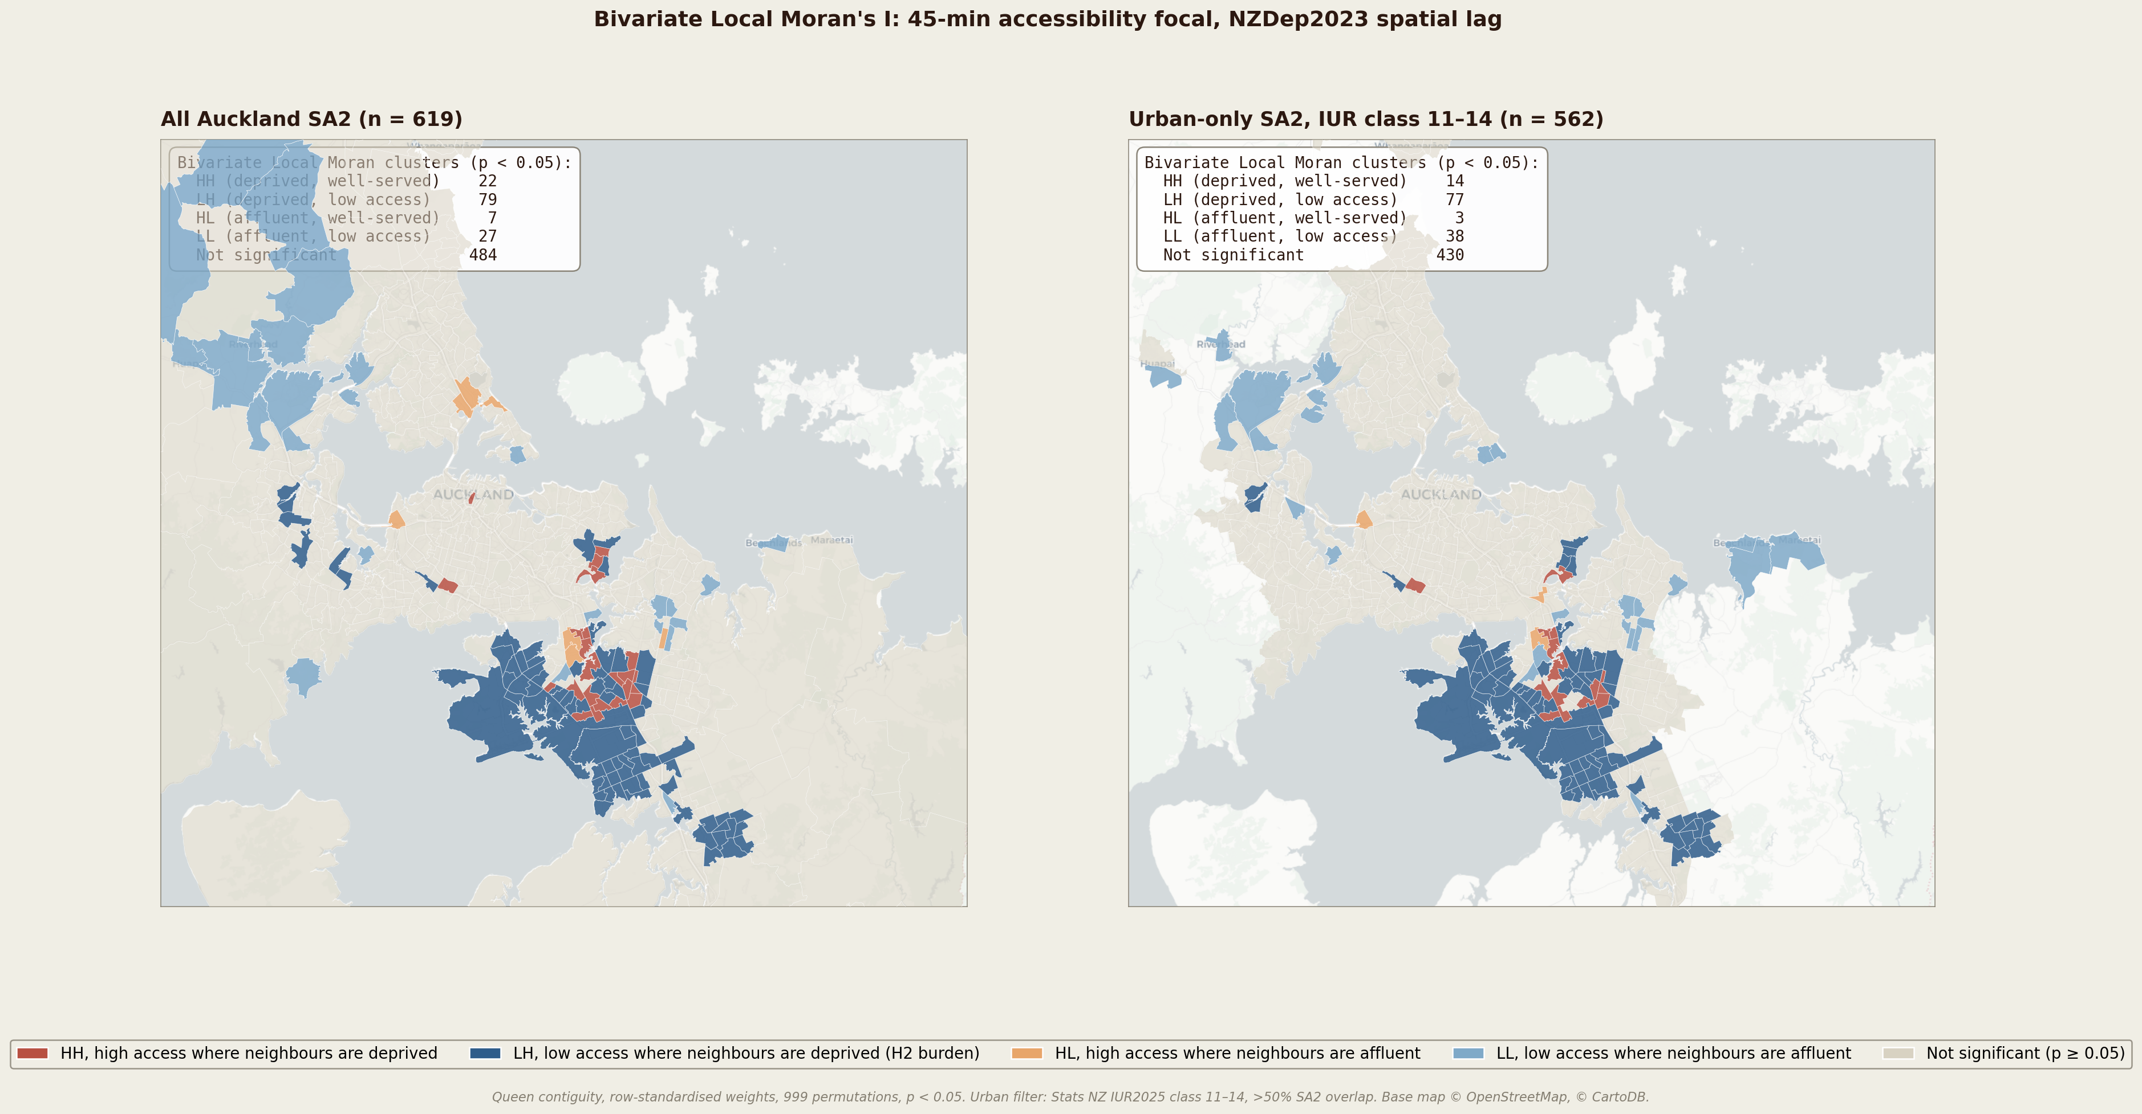
Figure 3. Bivariate Local Moran's I clusters, all sample versus urban-only. Red SA2s (HH) are deprived neighbourhoods with above-expected accessibility, mostly the inner-south rail-served band (Glen Innes, Panmure, Otahuhu, Mangere Central). Dark blue SA2s (LH) are the H2 burden cluster, low access in deprived neighbourhoods (outer Manurewa, Papakura, Takanini, outer Henderson, Massey, Ranui). Light blue SA2s (LL) are the affluent fringe (Coatesville, Riverhead, Whangaparaoa in the all-sample panel, disappearing in the urban-only panel).

6.1 Reading
- The LH burden cluster (low access where neighbours are deprived) is 79 SA2s in the all sample and 77 in the urban-only sample. This is the substantive cluster the motorway scenarios charge. The conclusion is robust to the sample choice.
- The HH cluster (deprived but well-served) shrinks from 22 to 14 because some originally counted SA2s were on the outer-affluent boundary where the local Moran test reads the deprived neighbourhood differently after urban filtering.
- The previously reported counts in the manuscript draft (HH = 34, HL = 26, LH = 76, LL = 81) do not match either sample under the current methodology. Like the +0.69 NZDep figure, this appears to be an artefact of an earlier run or a transcription. We recommend replacing the counts with the figures in Table 6 of this report.

7. Routing origin choice, geometric vs population-weighted centroid
Although not directly affected by the urban filter, the routing origin is the input that drives the accessibility surface. We compute it as the SA1-population-weighted mean of SA1 polygon centroids, restricted to land-classified SA1s. Stats NZ Statistical Area 1 2026 (clipped) is the source for SA1 geometry, Census 2023 usually resident count is the source for weights.
After dropping the single water-classified SA2 (Inlet Waitemata Harbour), 15 of 618 land-based SA2s (2.4 per cent) have their population-weighted centroid fall outside their own polygon. The worst case is Tuscany Heights at 421 m, all 15 are below 500 m. The maximum point-to-point offset between geometric and population-weighted centroid is 5,346 m (Okahukura Peninsula), and is driven by population being concentrated in one corner of a sprawling rural polygon. This is the case the population-weighted choice is designed to handle.
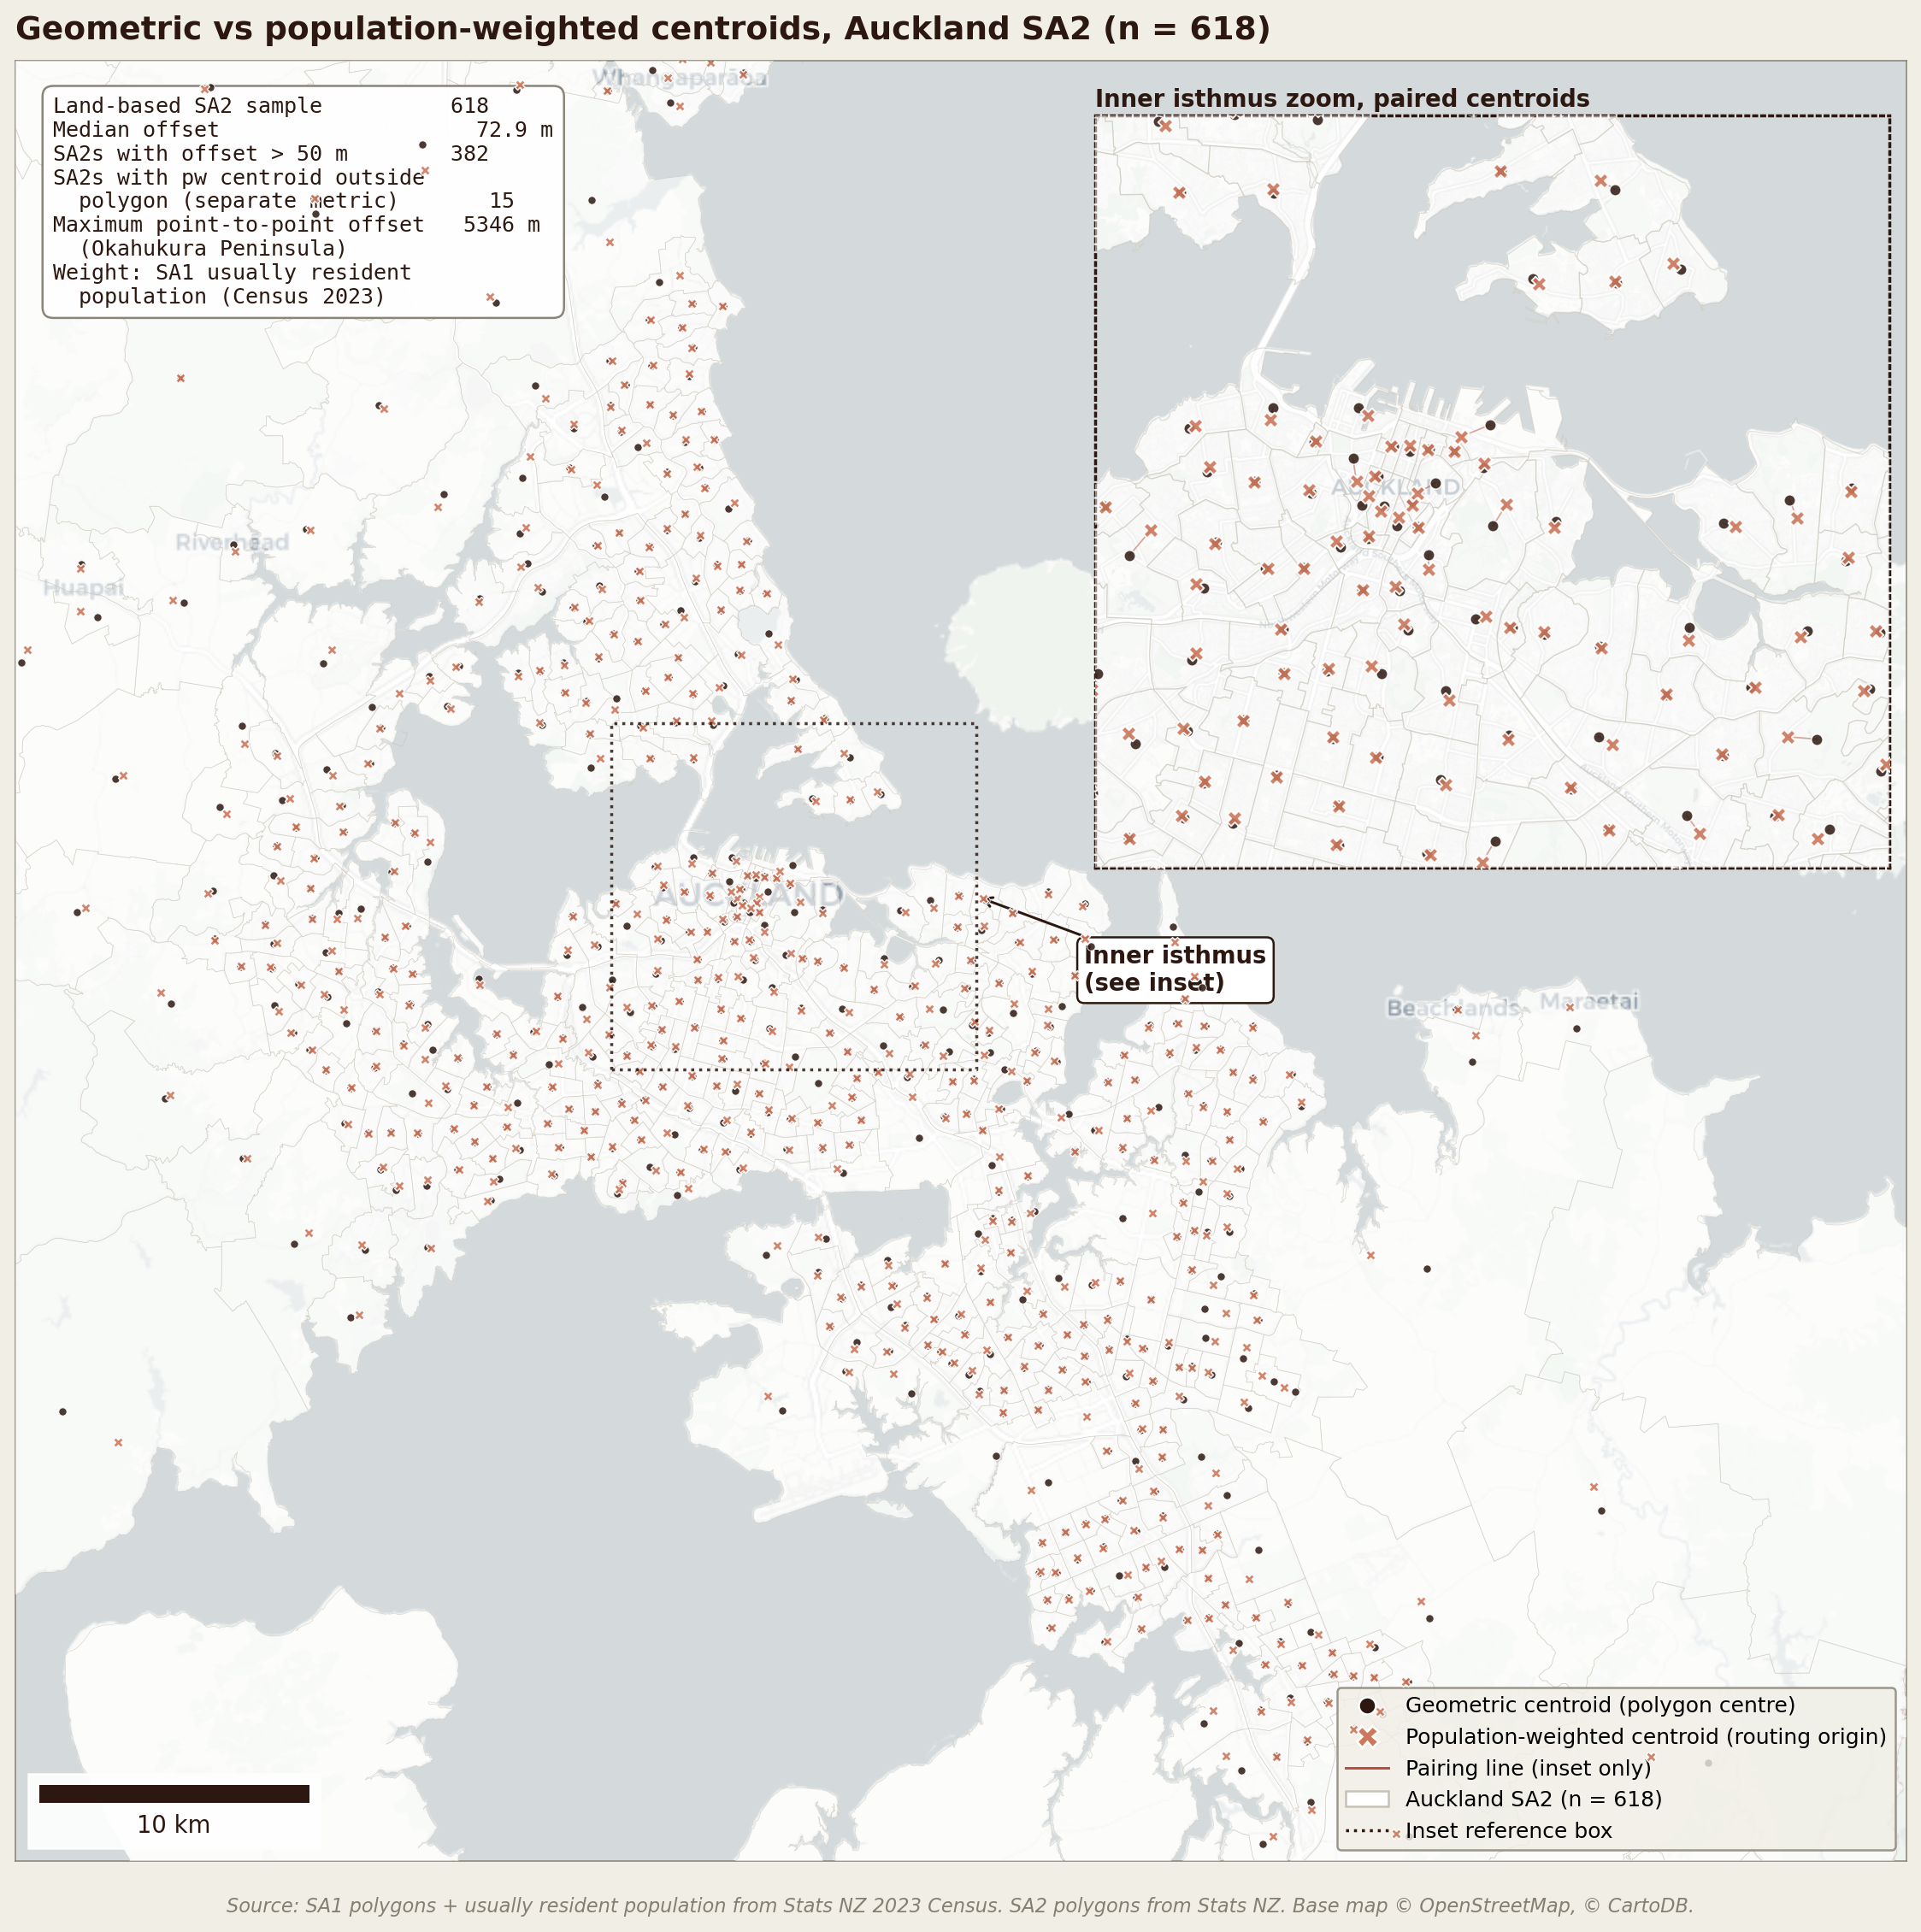
Figure 4. Geometric versus population-weighted centroid for the 618 land-based Auckland SA2s. Dark circles are geometric centroids, coral X markers are population-weighted centroids. The inset zooms on the inner isthmus and connects paired centroids with terra lines. In sprawling rural and peninsula SA2s the two centroids separate by more than a kilometre, with population-weighted lying close to the actual settlement.

8. Manuscript numbers
Several headline numbers reported in the current §4.2 of the manuscript do not match either the current full sample or the urban-only sample. We list the discrepancies below for resolution.
Manuscript value | Current (All 619) | Urban (562) | Status
Q75 cut-point: 104,812 jobs | 85,782 | 85,782 | mismatch
Baseline CI: +0.031 | +0.042 | −0.001 | mismatch
D8 to D10 CI: −0.083 | −0.167 | −0.167 | mismatch
3b CI: −0.166 | −0.204 | −0.216 | mismatch
3c CI: −0.120 | −0.145 | −0.155 | mismatch
3e CI: +0.046 | −0.072 | −0.072 | sign reversed
Global Moran NZDep: +0.69 | +0.208 | +0.226 | mismatch
Bivariate LISA HH: 34 | 22 | 14 | mismatch
Bivariate LISA LH: 76 | 79 | 77 | close
Bivariate LISA LL: 81 | 27 | 38 | mismatch
Table 7. Manuscript versus computed figures. The numbers in the current manuscript draft of §4.2 do not match the underlying data on most points. Possible explanations are (a) an earlier analytical run with different parameters that was not propagated forward, (b) a different SA1-population aggregation that produces a Q75 of about 104,812 jobs we could not locate in the code, or (c) transcription error. We recommend updating the manuscript to the urban-only figures throughout.

8.1 What to do
- Update §4.1 baseline result: CI of about −0.01 on the urban sample (essentially zero), with D8 to D10 subgroup CI of −0.13. The inverted-U narrative becomes a sensitivity check restricted to the all-region sample, not the headline.
- Update §4.2 Table 2 with the urban-only CI values: 3b −0.22, 3c −0.15, 3e −0.00. The motorway H2 conclusion holds and is slightly strengthened.
- Replace the Q75 cut-point throughout: 85,782 jobs (current SA2-quantile run) rather than 104,812. If a population-weighted Q75 is preferred, it is 84,270 jobs, essentially the same number.
- Update global Moran's I in the spatial autocorrelation paragraph: accessibility I = +0.84, NZDep I = +0.23, not +0.86 / +0.69. The interpretation changes modestly. Accessibility remains strongly autocorrelated, but NZDep is only moderately autocorrelated and not nearly as strong as the manuscript implies.
- Update the bivariate Local Moran cluster counts to LH = 77, HH = 14, HL = 3, LL = 38 (urban-only). The H2 burden cluster of about 77 SA2s remains the substantive finding.
- Add a Methods paragraph describing the urban filter: Stats NZ IUR2025 class 11 to 14, more than 50 per cent SA2 overlap, 562 of 619 SA2s retained, 9 outer islands automatically excluded from the spatial weights matrix as isolated nodes.

