Bastion Host:
- AzureBastionSubnet gerekir.
- Tier: Basic, Standard: autoscaling (ihtiyaca gore bastion host sayisini artirir.

Once the application security group is attached to a network interface , it can be assigned to any network interface assigned to virtual machines within the same virtual network.

Update Management: VM'in running olmasi gerek. Windows ve Linux icin calisir.

Microsoft Antimalware for Azure VM - 134

Containers: - 140-147

Putty - 140

WinSCP: - 141
- PuTTY gibi ama dosyalari da gorebiliyoruz.
- Hem local hem de remotun dosyalarini karsilikli tasiyabiliyoruz.

Blueprint:
- Management Group veya Subscription seviyesinde tanimlanabilir.
- RG seviyesinde tanimlanmaz.

Storage Explorer:
Access Key ile tum Storage account'a ulasilabilir.
Change access level: Container seviyesinde tanimlanir.
SAS (Shared access signature): Objeye belirli sure icin ulasim imkani tanir. Blob SAS URL ile ulasilir objeye veya Storage Explorerdan.
SAS: Blob ve Account seviyesinde paylasilabilir. Storage Account > Shared access signature
Account seviyesinde SAS verirken istenen serviceleri ve permissionslar secilebilir.
Account seviyesinde SAS verirsek yalniz Storage Explorer ile calisisir. Browserden blob seviyesindeki SAS calisisr.
Storage Explorer > Add an account
RBAC ile giris en guvenilir yol.
Encryption yalniz Blob ve File'lar icin gecerlidir.

1.Your company has deployed a system onto their Azure environment. The system consists of an application hosted via the Azure Web App service. The application connects to a database hosted on the Azure SQL database service. You have to implement the following requirement
a) Ensure that the data within a column named SSN within a table is encrypted. Only the application should be allowed to decrypt the data.
b) The application must make use of a managed identity to get the keys required for the decryption process.
C: Always encrypted using Key vault

2.Your company has deployed a system onto their Azure environment. The system consists of an application hosted via the Azure Web App service. The application connects to a database hosted on the Azure SQL database service. You have to implement the following requirement
a) Ensure that the data within a column named SSN within a table is encrypted. Only the application should be allowed to decrypt the data.
b) The application must make use of a managed identity to get the keys required for the decryption process.
Which of the following needs to be configured to ensure that the application can retrieve the keys?
C: Configure an access policy in the Azure Key Vault.

3. Can Security Admin role delegate access to another user for appvault?
C: No (It does not provide any sort of permissions over the key vault.)

4.Can User Access Administrator role delegate access to another user for appvault?
C: Yes

5.Restore the Secret Backup to Another Vault in different region same geography and same subscription.
(Baska Geography veya Subs'a restore olmaz.)
C: Yes

6.Your company has an Azure AD tenant and an Azure subscription. They have an Azure SQL database defined as part of their Azure subscription. The Azure AD tenant is also synced to the company’s on-premises Active Directory setup via Azure AD Connect. The company wants a set of users to be able to log onto the Azure SQL database with the use of their on-premises Active Directory credentials. You have to ensure to reduce the authentication prompts in the process. Which of the following method should you use from SQL Server Management Studio for this requirement?
C: Active Directory - Inyegrated

7. Your company recently created an Azure subscription.
You have been tasked with making sure that a specified user is able to implement Azure AD Privileged Identity Management (PIM).
Which of the following is the role you should assign to the user?
- A. The Global administrator role. Most Voted

8. Note: The question is included in a number of questions that depicts the identical set-up. However, every question has a distinctive result. Establish if the solution satisfies the requirements.
Your company has an Active Directory forest with a single domain, named weylandindustries.com. They also have an Azure Active Directory (Azure AD) tenant with the same name.
You have been tasked with integrating Active Directory and the Azure AD tenant. You intend to deploy Azure AD Connect.
Your strategy for the integration must make sure that password policies and user logon limitations affect user accounts that are synced to the Azure AD tenant, and that the amount of necessary servers are reduced.
8.1.Solution: You recommend the use of pass-through authentication and seamless SSO with password hash synchronization.
Does the solution meet the goal?
C: Yes

8.2. Solution: You recommend the use of federation with Active Directory Federation Services (AD FS).
Does the solution meet the goal?
C: No (A federated authentication system relies on an external trusted system to authenticate users. Some companies want to reuse their existing federated system investment with their Azure AD hybrid identity solution. The maintenance and management of the federated system falls outside the control of Azure AD. It's up to the organization by using the federated system to make sure it's deployed securely and can handle the authentication load.)

8.3. Solution: You recommend the use of password hash synchronization and seamless SSO.
Does the solution meet the goal?
C: Yes

9. Your company has an Active Directory forest with a single domain, named weylandindustries.com. They also have an Azure Active Directory (Azure AD) tenant with the same name.
After syncing all on-premises identities to Azure AD, you are informed that users with a givenName attribute starting with LAB should not be allowed to sync to Azure AD.
Which of the following actions should you take?
- A. You should make use of the Synchronization Rules Editor to create an attribute-based filtering rule. Most Voted

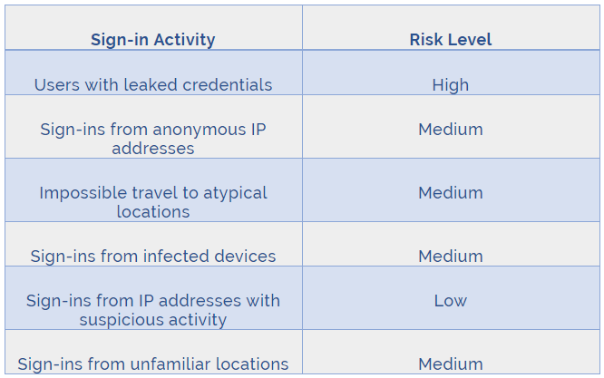

You have been tasked with configuring an access review, which you plan to assigned to a new collection of reviews. You also have to make sure that the reviews can be reviewed by resource owners.
You start by creating an access review program and an access review control.
You now need to configure the Reviewers.
Which of the following should you set Reviewers to?
- C. Group Owners.

Your company recently created an Azure subscription. You have, subsequently, been tasked with making sure that you are able to secure Azure AD roles by making use of Azure Active Directory (Azure AD) Privileged Identity Management (PIM).
Which of the following actions should you take FIRST?
- B. You should consent to Azure Active Directory (Azure AD) Privileged Identity Management (PIM).

You need to consider the underlined segment to establish whether it is accurate.
You have been tasked with creating a different subscription for each of your company's divisions. However, the subscriptions will be linked to a single Azure Active Directory (Azure AD) tenant.
You want to make sure that each subscription has identical role assignments.
You make use of Azure AD Privileged Identity Management (PIM).
Select `No adjustment required` if the underlined segment is accurate. If the underlined segment is inaccurate, select the accurate option.
- A. No adjustment required

