UserDAO:

insertUser(User):



updateUser():



deleteUser(int):



测试get单个记录



getUserById(int)

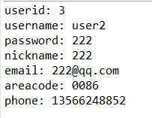

testGetAllUser()错误

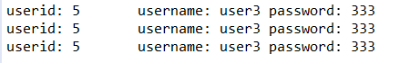

改正后：

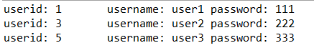

getUserByEmail(String)：

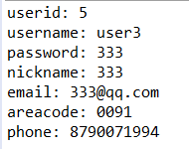

MovieDAO：

insertMovie(Movie):



updateMovie(Movie):



deleteMovie(int):



getMovieById(int):

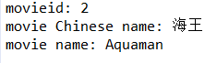

getAllMovie()错误

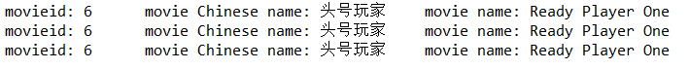

改正后：



ActorDAO:

insertActor(Actor)



updateActor(Actor)



deleteActor(Int)



getActorById(int):



getAllActor()错误：

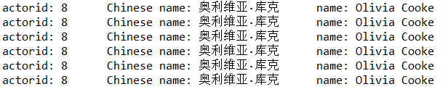

改正后

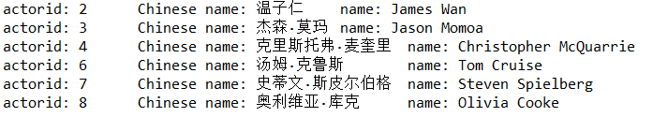

TypeDAO

insertType(Type):



updateType(Type):



deleteType(Type):



getTypeById(int)



getAllType()错误

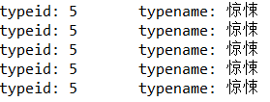

改正后

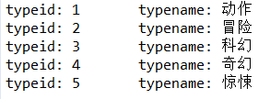

CastDAO:

insertCast(Cast):



updateCast(Cast):



deleteCast(int):



getCastByMovieId错误

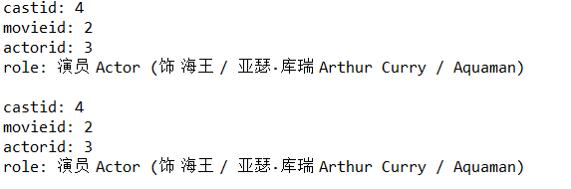

改正后：

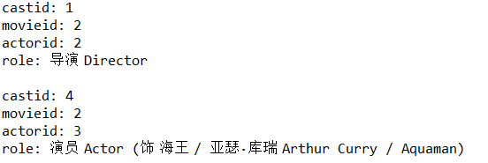

getCastByActorId错误

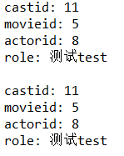

改正后:

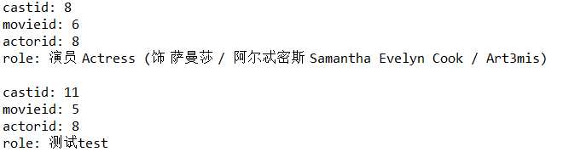

MovieTypeDAO:

insertMovieType(int):



updateMovieType(int,int,int,int):



deleteMovieType(int,int):



getMovietypeByMovieId(int):

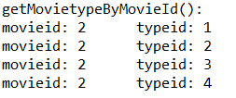

getMovietypeByTypeId(int):

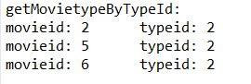

TopicDAO:

insertTopic(Topic):



updateTopic(Topic):



deleteTopic(int):



getTopicById(int):

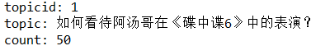

getAllTopic():



MovieCommentDAO:

insertMovieComment(int):



updateMoiveComment(MovieCommnet):



deleteMoiveComment(int):



getMovieCommentByMovieId(int):



getMovieCommentByUserId(int):



MovierRviewDAO:

insertMovieReview(MovieReview):



updateMovieReview(MovieReview):



deleteMovieReview(MovieReview):



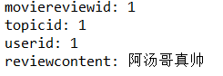

getMovieReviewByTopicId(int):



getMovieReviewByUserId(int)



MovieReviewCommentDAO:

insertMovieReviewComment(MovieReviewComment):



updateMovieReviewComment(MovieReviewComment):



deleteMovieReviewComment(int):



getMovieReviewCommentByMovieReviewId(int):

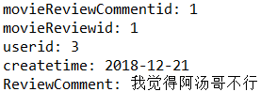

getMovieReviewCommentById(int):



getMoieReviewCommentByUserId(int):

