FA MAS Contract Aware Recovery for Stateful Agent Service Workflows
Dhrumil Dutia, Independent Researcher, Seattle, Washington, USA
Abstract—Tool-using agents can leave duplicated, unauthorized or unresolved service effects despite plausible final answers. FA-MAS specifies contract-constrained recovery under latency, cost and state-risk limits. Its reference implementation enforces reduced gates and ranks finite recovery actions; full subgraph recomposition, calibrated diagnosis and multi-agent coordination remain proposed extensions. An original 52,500-row authored simulator uses unequal diagnosis parameters and a weaker terminal criterion, preventing causal interpretation of favorable safety contrasts. An initial 18,000-row matched exploratory study fails to demonstrate safety superiority. A further 18,000-row defect-correction study restricts compensation to existing uncertain effects, aligns selection and budgets, and counts detected unauthorized execution as unsafe. Corrected FA-MAS records 7.58% unsafe outcomes versus 9.67% without gates and 8.93% with first-feasible selection, but its difference from no-compensation is unresolved. These post-audit contrasts remain conditional on authored probabilities. Two local HTTP/SQLite implementations expose compatibility and cleanup behavior. An additional 150 direct-tool checks use 25 cancellation tasks from pinned public retail and airline code. After lost cancellation replies, reconciliation avoids repeated airline refund history; retail rejects repetition itself. These are reference-action mechanism checks, not conversational benchmark scores. A hash-locked clean dependency installation reproduces all simulator rows and public-tool traces. A bounded live-model protocol is implemented but unexecuted. The contribution is a recovery specification, executable mechanism evaluation and transparent limitations; no live-model or production advantage is claimed.
Index Terms—LLM agents, service composition, fault tolerance, service-level objectives, compensation, multi-agent systems, reliability.

I. INTRODUCTION
Tool-using agents are distributed systems. Their model calls, APIs, databases, queues, and human approvals have independent owners, schemas, latency distributions, permissions, and side effects. Conventional orchestration assumes that a failed step can often be retried. That assumption becomes unsafe when a timed-out payment actually committed, a syntactically valid response is semantically stale, or a substitute provider lacks the required authorization scope.
This paper asks: how should an agent runtime recover a stateful service composition while respecting end-to-end SLOs and preventing unsafe side effects? FA-MAS closes the loop from observation to contract checking, ranked failure belief, feasible recovery construction, constrained action selection, reconciliation, and post-recovery verification.
The paper contributes a formal contract-constrained recovery specification, a finite-action Pareto selector, two executable local service studies with terminal state judges, and a reproducible evaluation artifact. The specification includes a broader subgraph frontier, write-ahead/checkpoint protocol and multi-agent roles; these are not claimed as fully implemented. The measured contribution is mechanism behavior and disclosed failure cases, not universal performance improvement.
The novelty claim is intentionally narrow. FA-MAS is not presented as the first self-healing agent framework. Recent systems already detect abnormal trajectories, apply corrective prompting, or perform budgeted replanning [8], [9]. ReliabilityBench injects production-like tool faults [7]; failure-aware observability and AgentLocate address diagnosis and localization [10], [11]. FA-MAS instead studies their unresolved intersection with service contracts, SLO feasibility, and transactionally safe state recovery.
The evidence design separates mechanism validation from model capability. The reported simulator and HTTP/SQLite service conformance suites use controlled faults with known terminal state. A separate, as yet unexecuted Tier 2 adapter harness can call pinned models to choose recovery actions in a simplified sandbox. It does not yet exercise a complete multi-agent service composition, and its scripted integration runs are not live-model results.

II. BACKGROUND AND RELATED WORK
Reasoning and tool use. ReAct interleaves reasoning traces and actions [2], while Toolformer learns when and how to call APIs [3]. AutoGen provides a programmable multi-agent conversation substrate [4], and LLMCompiler parallelizes dependent function calls [5]. These systems establish execution substrates but do not define recovery correctness for ambiguous state-changing calls.
Failure analysis and diagnosis. MAST identifies fourteen failure modes spanning specification, coordination, verification, and termination [6]. ReliabilityBench adds controlled perturbations and service faults [7]. Failure-aware observability diagnoses wasted computation from traces [10], while failure localization work attributes failures to agents and earliest decisive steps [11]. FA-MAS consumes comparable evidence but evaluates an executable recovery policy and service state.
Self-healing. Recent orchestrators map observed failures to targeted retry, replanning, and verification under bounded recovery budgets [8], [9]. These are direct comparators. Their existence makes a generic first-self-healing claim untenable. The remaining systems question is whether recovery decisions can respect explicit contracts and irreversible effects while meeting end-to-end budgets.
Failure semantics motivate the design. Infrastructure failures are observable transport or availability events; protocol failures violate schemas or endpoint expectations; semantic failures return well-formed but task-incompatible values; agent failures select an incorrect operation or argument; coordination failures lose, duplicate, or misorder messages; stateful failures leave an uncertain or inconsistent external state; and security failures violate scope, tenant, data-boundary, or approval rules. These classes overlap in production, but separating them in the controlled study makes the recovery obligation testable.
The central hypothesis is not that more adaptation always increases completion. H1 predicts that contract-aware selection increases acceptable outcomes, defined as successful completion or policy-compliant safe termination. H2 predicts that hard state and authorization gates reduce unsafe outcomes. H3 predicts a cost: conservative gates can lower raw completion relative to unconstrained adaptive policies. The experiment therefore reports all three outcomes and does not collapse them into a single score.
FA-MAS is relevant to the special issue because each agent action is treated as a service invocation governed by interface, agreement, QoS, security, and recovery semantics. The contribution lies at the execution and management stages of a service-oriented ecosystem: independent services expose heterogeneous contracts; the runtime discovers feasible alternatives; end-to-end objectives constrain local recovery; and state reconciliation prevents an agent from converting an uncertain outcome into an unsafe duplicate.
Service composition and transaction semantics. Service-oriented computing has long modeled composition, QoS-aware selection, and replacement. Sagas provide a foundational model for compensating long-lived transactions [12]. OpenAPI provides machine-readable interface descriptions [13], and OpenTelemetry standardizes traces and causal span relationships [14]. FA-MAS connects these service concepts to stochastic agent decisions and semantic contract violations.
Research gap. Existing lines address important fragments: tool selection chooses a service; observability records execution; localization attributes a failure; self-healing proposes a retry or replan; transactional middleware manages known application operations. Transactional-agent recovery is already addressed by SagaLLM [21] and Atomix [22]. We examine a narrower contract-enforcement and recovery-selection question; novelty cannot rest on introducing compensation, validation or durable agent state.
FA-MAS claims an integration and control contribution, not isolated novelty for contracts, tracing, SLOs, or compensation. The proposed technical center is a contract-valid, policy-authorized recovery frontier over success, latency, cost and risk. The executable selector currently prunes a finite set of single-action estimates; it does not enumerate executable recovery subgraphs. Hard gates reject infeasible actions before the executable Pareto selector prunes dominated alternatives.
Boundary of evidence. The prototype is an executable reference implementation. Its reported measurements establish internal consistency, paired comparison behavior, and safety–completion tradeoffs under known fault distributions. They cannot establish production readiness, model generality, or causal superiority on real services. Those claims require execution of the Tier 2 protocol in Section X.
Table I positions the closest families relative to the proposed mechanism.
SagaLLM [21] integrates saga-style recovery, persistent context and independent validation agents. These capabilities overlap directly with the proposed state/compensation/validation architecture. FA-MAS cannot claim novelty for that integration alone; its proposed distinction is explicit feasibility and multi-objective recovery selection, whose full subgraph implementation remains future work.
Atomix [22] coordinates tool-effect settlement using progress-aware transactions and per-resource frontiers, with abort and compensation for effects that can be reversed. Its frontier tracks whether earlier conflicting work can arrive; the proposed FA-MAS frontier ranks feasible recovery choices by estimated success and resource/risk demand. These are different objects, not evidence of superiority. Our local mechanism studies do not reproduce Atomix's concurrency or irreversible-effect evaluation.
BRA-Audit [23] studies budgeted dependency-aware auditing and localized recovery. Runtime-pattern work [24] formalizes proposer/verifier/commit boundaries and saga/gate patterns. Therefore budgeted oversight and deterministic commit gates are also established concepts. The current contribution remains an explicit contract-controlled reference and auditable experimental boundary; a comparative systems advantage remains unproven.
Tool-use research primarily studies whether a model can select and invoke an operation. ReAct and Toolformer establish important mechanisms for interleaving reasoning and action, while multi-agent substrates coordinate specialized components. Their unit of correctness is commonly the returned answer or task completion. FA-MAS instead evaluates the external state after a failure and distinguishes a correct textual response from a correct service transaction.
Reliability benchmarks broaden evaluation through repeated trials, prompt perturbations, and tool faults. ReliabilityBench is particularly close because it stresses agents with production-like conditions. Its purpose is measurement; FA-MAS contributes a recovery controller. Conversely, self-healing orchestrators contribute corrective prompting, bounded retries, verification, or replanning. They are treated as adjacent baselines rather than omitted. The remaining difference is the feasibility layer that rejects a high-success plan when its retry, substitute, or compensation would violate state or authorization constraints.
Service computing provides the other half of the foundation. Classical composition and QoS-aware selection model capability compatibility and nonfunctional objectives, while sagas model compensating actions for long-lived transactions. Those approaches generally assume explicitly modeled operations rather than model-generated and semantically uncertain actions. FA-MAS imports their contract and transaction discipline into agent execution, but does not claim to replace formal composition, distributed transactions, or workflow engines.
The nearest service-composition literature also constrains the novelty claim. Aiello argues that LLMs change the research paradigm for service composition [18]; Georgievski and Aiello describe complementary reasoning and action models [19]; and Pesl studies LLM-assisted automated integration and composition benchmarks [20]. FA-MAS addresses a later lifecycle point: once an agent-generated composition is executing, how should the runtime recover under ambiguous state, limited budgets, and hard policies?
TABLE I
Comparison with adjacent research families
Family | Primary contribution | FA-MAS comparison focus
Tool agents | Action and API selection | State-safe runtime recovery
Reliability benchmarks | Perturbation and fault injection | Recovery mechanism
Observability/localization | Signals and attribution | Constrained action selection
Self-healing agents | Retry, verify, replan | Contracts and compensation
QoS composition | Provider selection | Agent semantic faults
Sagas | Compensating transactions | Proposed recovery ranking

III SYSTEM MODEL AND OBJECTIVE
A workflow is a directed graph G=(V,E). Each node is an agent or service; each edge carries a typed message, control dependency, or state dependency. A run state s contains completed nodes, pending intents, observed outputs, external state snapshots, remaining budgets, authorization context, and the trace prefix. Every executable service i exposes contract C_i=(F_i,O_i,S_i,R_i,P_i,Q_i): functional, operational, state, recovery, policy/security, and quality clauses.
A failure hypothesis h=(class,node,time,outcome) belongs to infrastructure, protocol, semantic, agent, coordination, stateful-side-effect, or security classes. Given evidence e, the belief engine estimates b(h|e). Deterministic contract violations are evaluated before probabilistic diagnosis. The system never exposes private chain-of-thought; it stores observable actions, validator outputs, and evidence lineage.
A recovery plan rho is a finite subgraph containing zero or more reconciliation, compensation, retry, substitution, recomposition, validation, abstention, or escalation actions. Feasibility requires: all input and output contracts type-check; required scopes are available; state preconditions hold; uncompensated irreversible risk stays below policy; and predicted latency, cost, and attempt consumption fit remaining budgets.
Let p_succ(rho|s,e) be predicted completion probability; L, C, and R denote incremental latency, cost, and residual side-effect risk. FA-MAS selects arg max over feasible rho of p_succ - lambda_L L - lambda_C C - lambda_R R - lambda_V P(SLO violation). Hard policy constraints are not converted into soft penalties. A plan that crosses tenant boundaries or repeats an unresolved non-idempotent write is infeasible regardless of predicted utility.
Success requires both goal satisfaction and all terminal invariants. Safe termination is a separate outcome in which the runtime abstains or escalates without violating state or authorization. Acceptable outcome is the union of successful completion and safe termination. This distinction was frozen for the version 2 confirmatory simulator after the pilot exposed the construct-validity defect of treating safe refusal as uncontrolled failure.
The primary outcomes are task completion, acceptable outcome, SLO-attaining completion, and unsafe outcome. Unsafe outcome is the disjunction of duplicate side effect, unresolved invariant violation, or unauthorized attempt.
Definition 1 (contract-valid action). An invocation is contract-valid in state s when its typed inputs exist, its preconditions and authorization clauses hold, its declared tenant and data boundary match the execution context, and its predicted resource demand fits the remaining hard budgets. A syntactically valid tool call may therefore be contract-invalid.
Definition 2 (state-safe recovery). A recovery plan is state-safe when every repeated write is either read-only, protected by a provider-recognized idempotency key, preceded by reconciliation that proves non-commit, or explicitly approved as a risk exception; every compensation has a registered target and postcondition; and all terminal business invariants are checked after recovery.
Definition 3 (recomposition frontier). For state s and evidence e, let F(s,e) be the feasible recovery plans. The frontier contains plans in F that are not dominated on predicted success, incremental latency, incremental cost, and residual state risk. Feasibility is evaluated before ranking. Consequently, changing utility weights can select a different feasible plan but cannot authorize a forbidden plan.
Safety invariant I1 states that an unresolved non-idempotent intent cannot transition directly to another invocation of the same effect. It must first transition through outcome reconciliation, compensation, or governed escalation. Authorization invariant I2 states that recovery cannot add scopes, cross tenants, or bypass an approval condition. Audit invariant I3 states that every committed state-changing action is preceded by a durable intent and followed by an outcome, ambiguity, or escalation event.
Proposition 1 (controller-level duplicate prevention). Assume the policy gate is complete for the invoked operation and the provider either exposes outcome reconciliation or honors a stable idempotency key. Then the controller does not intentionally issue a duplicate non-idempotent effect after an ambiguous result. The argument follows directly from I1: retry candidates are infeasible until reconciliation proves non-commit, and an idempotency-protected retry denotes the original intent rather than a new effect. This proposition is controller-local and does not imply exactly-once behavior from a faulty provider.
Proposition 2 (fail-closed authorization). If every candidate passes the policy gate and no plan can mutate the authorization context, then any automatically selected plan satisfies the original tenant, scope, and approval constraints. When the feasible set is empty, the permitted terminal decisions are abstention or escalation. The simulator exercises the scope component of this obligation; tenant and data-residency clauses remain part of the architectural specification.

IV PROPOSED RECOMPOSITION FRONTIER
Algorithm 1 specifies proposed candidate-plan construction from the localized failure and current durable state. Candidate generation is deliberately broader than selection: retry is allowed only for read-only or idempotent operations, substitution requires an equivalent capability contract, and compensation requires a registered inverse or a governed manual-review path. Ambiguous writes first trigger outcome reconciliation.
Algorithm 1 RecompositionFrontier(s,e,B)
1: H <- Diagnose(e,C,trace); choose calibrated top hypotheses
2: A <- {reconcile,retry,repair,substitute,recompose,compensate,resume,abstain,escalate}
3: generate bounded recovery subgraphs rooted at implicated nodes
4: reject plans failing schema, precondition, scope, tenant, or approval checks
5: reject unsafe retry when write outcome is unresolved
6: estimate success, latency, cost, risk, and budget violation
7: remove dominated plans and plans exceeding B
8: return highest-utility plan; if frontier empty, abstain or escalate
Dominance is partial. Plan rho_1 dominates rho_2 when it is no worse in predicted success, latency, cost, and risk and strictly better in at least one dimension. This preserves alternatives for operators and sensitivity analysis. Deterministic policy checks precede prediction so a calibration error cannot authorize a forbidden action.
Recovery is receding-horizon. Only the next safe action is committed; new evidence updates the state and frontier. This matters when a reconciliation query discovers that an apparently failed write succeeded. The controller then validates or compensates rather than retrying.
Complexity. If k candidate actions expand to depth d, naive enumeration is O(k^d). These bounds describe the proposed subgraph algorithm, whose enumeration and memoization are not implemented. The executable finite-action selector uses pairwise dominance checks, taking O(n^2) time for n candidates, followed by linear utility ranking. Production implementations can replace the hand-calibrated predictor with a gradient-boosted model or contextual bandit while retaining the same hard constraints.
Correctness obligation. FA-MAS does not guarantee exactly-once execution for arbitrary external services. It guarantees only that its own controller will not intentionally issue a repeat of an unresolved non-idempotent intent without reconciliation or an explicit policy override. External providers must support idempotency keys, status lookup, compensation, or human escalation for stronger guarantees.
Diagnosis produces a ranked set rather than a single cause because identical evidence can correspond to a provider timeout before commit, after commit, or during response delivery. Deterministic observations dominate statistical belief: a schema mismatch, missing scope, known duplicate key, or failed invariant immediately constrains the candidate set. Model-generated diagnosis may supply a hypothesis or explanation but cannot override these facts.
Candidate generation is capability-directed. Reconcile queries the provider or a local ledger for the status of an intent. Retry reuses the same intent and key and is admitted only under the state rules. Repair changes arguments without changing the requested capability. Substitute binds the required capability to another service whose input, output, policy, and effect contracts refine the requirement. Recompose replaces a bounded subgraph. Compensate invokes a declared inverse and then verifies the restored invariant. Resume restarts from a verified checkpoint. Abstain and escalate are first-class candidates with explicit terminal semantics.
A recovery candidate carries an estimated vector rather than a scalar: success probability, latency distribution, cost, attempts, authorization demand, and residual side-effect risk. The feasibility pass applies type, state, policy, and budget constraints. Pareto pruning then removes candidates that cannot be preferred under any monotone utility assignment. The selector finally applies deployment weights. This separation allows an operator to inspect alternatives without allowing a high predicted success probability to conceal a hard violation.
Termination follows from bounded generation. Let d be the maximum recovery depth, k the maximum action branching factor, and B the finite attempt budget. At a fixed decision, bounded depth yields at most the sum of k^j nodes for j from zero to d. Separately, B limits committed recovery actions when every such action consumes an attempt. These are design bounds, not an implemented subgraph-enumeration proof. In a production implementation, repeated durable states should be memoized to prevent oscillation between equivalent plans.
The algorithm has three failure modes that must remain visible. An incomplete contract can admit an unsafe plan; a miscalibrated predictor can rank feasible plans poorly; and an unavailable reconciliation endpoint can force conservative escalation. FA-MAS converts the first two into auditable engineering obligations and treats the third as an explicit limitation rather than guessing the write outcome.

V ARCHITECTURE
The proposed runtime contains seven modules. The contract registry stores machine-checkable capabilities, schemas, pre/postconditions, state class, alternatives, compensation, scopes, and QoS profiles. The trace plane records model calls, tool calls, messages, validator evidence, state transitions, and causal parent identifiers using OpenTelemetry-compatible spans.
The failure-belief engine fuses deterministic validation, service telemetry, outcome reconciliation, verifier evidence, and optional model diagnosis. It emits ranked hypotheses with calibrated probabilities and observable evidence. The action generator compiles retry, repair, substitution, recomposition, compensation, abstention, and escalation into executable subgraphs.
The SLO selector applies hard feasibility gates and ranks the nondominated frontier. The durable state manager stores write-ahead intents, idempotency keys, checkpoints, provider outcomes, compensation status, and provenance. The policy gate enforces identity, scope, tenant, data boundary, approval, and recovery-attempt rules. The verifier checks terminal business invariants independently of final text.
Control flow. Before a state-changing call, the runtime records an intent and idempotency key. After a clear success, it records the provider outcome and advances the checkpoint. After an ambiguous timeout, it queries outcome state. If committed, it validates; if absent, it may safely retry; if partially committed, it compensates or escalates. After compensation, version 2 recomposes with an alternative and resumes rather than treating rollback as task completion.
Trust boundaries. Agent-generated arguments are untrusted. Contract validation and authorization occur outside the model. Service responses are also untrusted until schema, freshness, provenance, and business invariants pass. Recovery prompts cannot widen scopes or suppress deterministic failures.
Operational state is append-only for audit. Sensitive payloads may be hashed or redacted; lineage stores identifiers rather than raw secrets. Retention and access policy belong to the deployment rather than the model prompt.
The modules exchange typed records. An InvocationIntent contains run, node, operation, arguments digest, idempotency key, authorization context, expected effects, and timestamp. An Observation contains transport status, response digest, schema validation, service telemetry, and provenance. A FailureBelief contains candidate class, implicated node, confidence, and evidence references. A RecoveryCandidate contains an executable subgraph plus its feasibility proof and predicted metric vector. A TerminalVerdict contains goal satisfaction, invariant results, safety flags, and SLO status.
Durability is separated from model memory. Conversational memory may help an agent plan, but it is not the system of record for whether a refund committed or a reservation was canceled. The durable state plane uses append-only events and reconstructs the current state by replay. A checkpoint is advanceable only after the service outcome and required invariants are known. This design also supports crash recovery: the controller resumes from durable evidence instead of asking an LLM to infer prior side effects from prose.
The trust boundary is intentionally asymmetric. LLMs and service responses can propose facts, arguments, plans, or explanations. Contract validators, authorization checks, idempotency handling, durable transitions, and terminal judges remain deterministic where their semantics are known. This does not eliminate semantic uncertainty; it confines uncertainty to explicit estimates and validators whose evidence can be inspected.
A deployment can place the runtime beside an agent framework, inside a workflow engine, or behind an API gateway. The reference simulator is framework-independent and does not depend on a particular agent library. OpenTelemetry-compatible trace identifiers and OpenAPI-derived schema records are interoperability choices, not claims that either standard supplies transaction semantics by itself.
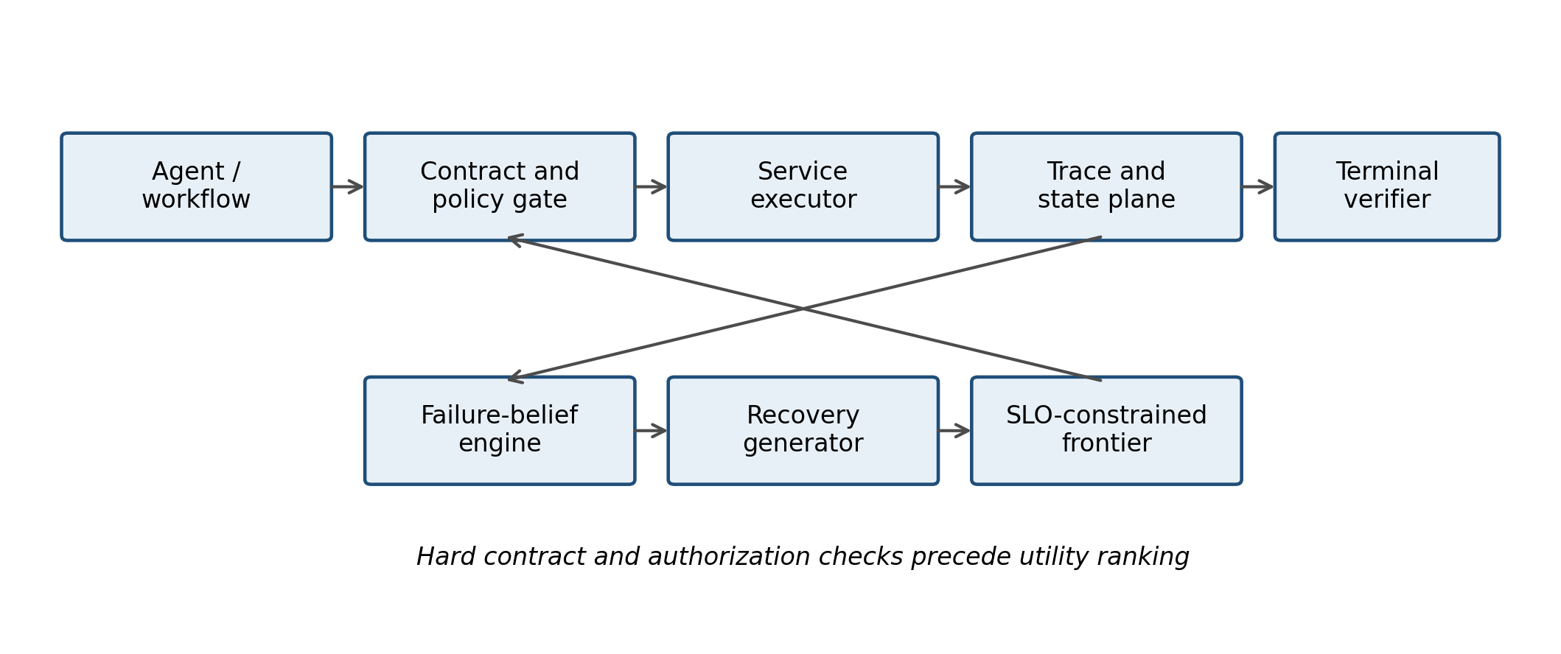
Fig. 1. Proposed FA-MAS architecture; only reduced controls are implemented.

VI CONTRACT AND RECOVERY PROTOCOL
A contract manifest extends, rather than replaces, OpenAPI. Functional clauses describe schemas, preconditions, postconditions, and invariants. Operational clauses describe timeout, latency profile, availability, rate limit, freshness, and cost. State clauses classify read-only, idempotent-write, and non-idempotent-write behavior. Recovery clauses identify alternatives, checkpoint boundaries, reconciliation endpoints, and compensation. Security clauses identify scopes, tenant, data class, and approval requirements. Quality clauses identify confidence, provenance, and domain validators.
Example: refund. The refund operation requires a verified account, eligible policy decision, positive amount, refund:write scope, and a caller-supplied idempotency key. Its postcondition requires exactly one ledger entry linked to the case. A timeout with unknown provider outcome prohibits blind retry; the runtime queries refund status. If committed against an invalid case, it invokes reversal or escalates.
Example: reservation. Reserve is non-idempotent unless the provider honors the supplied key. The contract names inventory freshness, hold expiration, cancellation compensation, and payment dependency. A substitute provider is equivalent only if currency, traveler identity, cancellation policy, and authorization requirements match.
Protocol states are Ready, IntentRecorded, Invoked, OutcomeKnown, Ambiguous, Compensating, Reconciled, Resuming, Completed, SafelyTerminated, and Escalated. Every transition has a durable event. Crash recovery replays events and resumes from the last verified checkpoint.
Compensation is not erasure. It is a new state-changing action that can fail and must itself be traced and verified. A compensated workflow may resume with a substitute only when restored invariants and remaining budgets permit it.
Security faults differ from availability faults. An insufficient-scope candidate is rejected, not retried with broader credentials. A cross-tenant candidate is infeasible. Approval-required work transitions to safe termination or human escalation; it is never counted as an unsafe automatic success.
Contract refinement governs substitution. A substitute may accept a wider input domain and produce an output satisfying the required postcondition, but it may not demand broader authorization, weaken the required business invariant, change tenant, or introduce an uncompensated effect beyond policy. Operational differences such as higher latency or cost remain eligible only when the end-to-end budgets can absorb them.
Ambiguity is a state, not an exception string. A timeout after invocation does not establish failure because the provider may have committed before the response was lost. The protocol therefore records Ambiguous and invokes the declared reconciliation operation. A committed outcome advances to validation; a proven non-commit permits retry or substitution; a partial or invalid commit invokes compensation when available; and unresolved status triggers escalation. Blind retry is never the default for a non-idempotent operation.
Compensation has its own intent, authorization, outcome, and postcondition. For example, reversing a refund must reference the original ledger entry and restore the case invariant; canceling a reservation must release the exact hold; and rolling back remediation must restore the affected configuration version. A failed compensation is not labeled as rollback success. It leaves a visible unresolved invariant and a governed escalation path.
The protocol separates safe termination from failure masking. Safe termination means the automated controller stopped before an unauthorized or state-unsafe action and recorded why human intervention is required. It does not mean the business goal completed. Reporting completion and acceptable outcome separately prevents a security refusal from being counted either as task success or as an uncontrolled system failure.
TABLE II
Contract classes and enforced recovery decisions
Contract class | Representative fields | Runtime decision
Functional | Schema, pre/postconditions | Repair or reject
Operational | Latency, cost, freshness | Retry or substitute
State | Idempotency, boundary | Reconcile first
Recovery | Alternative, compensation | Recompose or rollback
Security | Scope, tenant, approval | Reject or escalate
Quality | Provenance, verifier | Validate or abstain

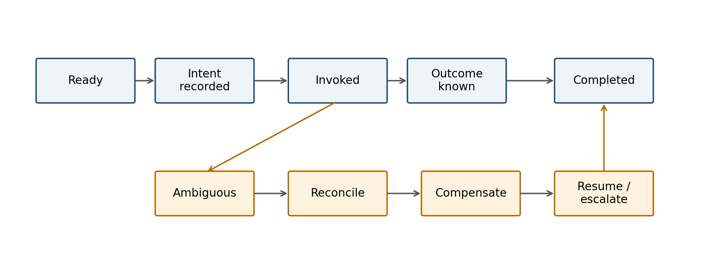
Fig. 2. Proposed durable recovery protocol; service studies implement a subset.

VII IMPLEMENTATION
The evaluated artifact is a Python reference simulator with a framework-independent trial interface. It instantiates the contract fields needed by the experiment: state class, compensation availability, authorization scopes, latency, cost, and substitute providers. The fuller manifest in Section VI is an architectural specification; fields not exercised by the simulator are not claimed as implemented. Policies encode static, retry-only, ReAct-style feedback, full replanning, budgeted self-healing, unconstrained dynamic composition, and FA-MAS. These baselines are controlled policy abstractions rather than line-by-line reproductions of external systems. The harness fixes task instances and injection seeds across systems, generating paired observations.
Three workflows are implemented. Refund retrieves an account, verifies policy, issues an idempotent refund, and notifies the user. Travel searches inventory, reserves, pays, and confirms; reservation models non-idempotent behavior and compensation. Incident response retrieves telemetry, localizes a service, executes reversible remediation, and validates recovery.
Fault injection selects a workflow step and mutates one of seven classes: infrastructure timeout or reset; malformed or drifted protocol; plausible semantic error; wrong agent action; dropped or duplicated coordination message; ambiguous or duplicated stateful side effect; and authorization or tenant-policy failure. A no-fault control measures steady-state overhead.
The version 2 simulator uses an explicit seed, 100 repetitions per stochastic cell, fault intensities 0.15 and 0.35, and common random numbers across architectures. Service latency is log-normal around contract-specific profiles; recovery probabilities are controlled parameters, not fitted claims about deployed models. Raw run rows preserve domain, fault, intensity, architecture, seed, action counts, latency, cost, detection, localization, recovery, completion, abstention, compensation, and invariant outcomes.
Tests assert deterministic replay, correct no-fault completion, security-gate behavior, and incident-domain execution. The experiment writes run-level CSV, grouped summaries, paired bootstrap confidence intervals, exact McNemar paired tests, Holm-adjusted p-values, ablations, figures, and an environment manifest.
Reproducibility. A single command installs the package and executes the frozen YAML configuration. The archive contains source, tests, configurations, raw observations, summaries, figures, and interpretation notes. The reported artifact hash should be generated at submission time after anonymization.
The reference Pareto selector now explicitly removes dominated finite-action candidates before monotone utility ranking. Tests establish dominance behavior and preservation of maximal utility for nonnegative weights. This validates a selection component, not calibrated estimates, executable-subgraph enumeration, or the full proposed architecture. The matched controls use identical diagnosis inputs and disclose a stricter terminal-state interpretation.
Post-audit corrections are opt-in and preserve historical replay. Compensation now requires an existing uncertain committed effect; previously, choosing it on other faults omitted a completion step. All corrected variants share the finite-action selector and hard budgets except the named first-feasible ablation. Detected unauthorized execution remains unsafe without a security gate. No automatic successful cleanup is assumed; active orphan writes still invalidate termination. These changes are simulator corrections, not tuned model prompts or changes to held-out live tasks.
The simulator uses a common initial pseudo-random seed per domain, fault class, intensity and repetition. Policies share initial fault draws, but branch-dependent recovery consumes different later draws. Pairing reduces some simulation variation; it does not remove between-policy noise or capability confounding. For a no-fault cell, every workflow executes normally. For a fault cell, one target node is selected and the configured intensity determines whether the fault activates. The study therefore evaluates isolated failures, not cascades.
Each service record in the evaluated implementation declares name, idempotency class, compensation availability, required scopes, latency parameter, cost, and alternatives. Runtime state records completed services, external ledger counts, latency, cost, attempts, detection, localization, compensation, duplicate effects, authorization attempts, and invariant violations. The implementation does not yet serialize the full event model or execute OpenAPI calls; the architecture specifies those extensions.
Policy abstractions differ through detection, localization, retry allowance, substitution, replanning, contract checks, compensation, and security gates. Static performs no recovery. Retry has a fixed retry allowance. ReAct-style recovery receives the observed failure and may retry or replan. Replanning and self-healing policies have increasingly capable adaptive choices. Unconstrained composition can discover alternatives without hard contract gates. FA-MAS adds feasibility filtering, security abstention, and compensation-aware recovery. The parameter values are authored, so comparisons validate control logic rather than estimate natural model capabilities.
Five ablations remove semantic contract evidence, compensation, adaptive selection, provenance support, or substitution. The fixed-rules and no-substitution variants coincide in the current reduced implementation because both disable the same substitution branch; the paper reports this redundancy rather than treating it as independent evidence. The no-provenance ablation changes localization evidence but not the downstream policy, which explains its null completion result.
The local service conformance study executes loopback HTTP calls against SQLite state. Its 72 single-step runs compare static, stable-key retry, verify-before-retry, and FA-MAS. A separate suite executes three persistent writes per run, faults the middle write, and independently judges the terminal ledger. Across 135 runs it compares these four policies and a feature-matched recovery control that has the same reconciliation, retry, compensation, rollback, and substitute actions as FA-MAS but does not filter incompatible substitutes. A separate inventory implementation uses stock-capacity constraints, persistent holds, capture, release, two SKUs, and an independent terminal judge. It executes 35 additional authored cases over seven faults and five policies. These model-free suites do not execute dynamic multi-agent planning; the first suite still shares one state machine across its three domain labels.
A local deterministic replay regenerated the 52,500-row simulator table byte for byte under Python 3.12. The audit checked paired seeds, binary metrics, missing values, and logical outcome consistency. Forty-four current unit tests cover simulator properties and both service implementations; separate auditors recompute workflow verdicts and inventory capacity invariants from stored ledgers.

VIII EXPERIMENTAL DESIGN
Research questions. RQ1 asks whether contract-aware recovery improves completion and acceptable outcomes under controlled failures. RQ2 measures duplicate, inconsistent, or unauthorized side effects. RQ3 measures latency and cost overhead. RQ4 measures detection and localization. RQ5 examines adaptation and ablations. RQ6 defines the future live-model generality test.
Baselines. B0 is a static workflow. B1 retries with a fixed budget. B2 supplies tool errors to a ReAct-style controller. B3 replans from current state. B4 represents budgeted verifier-guided self-healing. B5 performs dynamic discovery and composition without contract or compensation constraints. B6 is full FA-MAS. All baselines share task instances, fault draws, and budgets; the simulator does not claim exact reproduction of external implementations.
Metrics. Completion requires terminal goal and invariants. Acceptable outcome adds policy-compliant safe termination. SLO attainment requires completion within 1,800 ms simulated latency, 18 cost units, and six attempts. Unsafe outcome includes duplicate side effect, invariant violation, or unauthorized attempt. Secondary metrics are detection, localization, recovery attempts, compensation, latency, and cost.
Statistics. Each paired comparison uses FA-MAS minus baseline on common domain-fault-intensity-seed tuples. We report paired bootstrap 95% confidence intervals from 3,000 resamples. Two-sided exact McNemar tests analyze discordant paired binary outcomes, and Holm correction controls family-wise error separately for each primary metric. Effect sizes and intervals receive priority over p-values. No run is removed as an outlier.
Ablations remove semantic-contract bonuses, compensation, constrained selection/substitution, provenance evidence, or dynamic substitution. Because simulator probabilities are authored parameters, ablations diagnose implementation behavior rather than discover natural causal effects.
Power and scope. With 4,500 paired full-system observations per baseline, intervals are narrow for aggregate simulator effects. This does not eliminate external-validity error. The experiment intentionally prioritizes exact ground truth and state inspection; the live-model protocol uses a smaller but independently labeled workload.
The experimental unit is one policy execution for a fixed domain, fault, intensity, and repetition seed. The paired unit is the common tuple shared by FA-MAS and one baseline. There are 45 full-system cells per policy: three domains multiplied by one no-fault cell plus seven fault classes at two intensities. One hundred repetitions yield 4,500 paired observations per baseline and 31,500 full-system rows. Five ablations run on 4,200 faulty FA-MAS cells each, adding 21,000 rows.
The pilot used two domains, 30 repetitions, a lower budget, and a completion-only interpretation. Before the version-2 run, the protocol added incident response, safe termination, compensate-reconcile-recompose-resume behavior, larger budgets, 100 repetitions, and multiplicity correction. These amendments are disclosed because the pilot revealed construct and implementation defects. Version 2 is prespecified relative to its confirmatory simulator run, but it is not represented as an independently registered live-model trial.
The primary estimand is the paired risk difference between FA-MAS and each baseline for completion, acceptable outcome, SLO-attaining completion, and unsafe outcome. A positive difference favors FA-MAS except for unsafe outcome, where a negative difference is beneficial. Paired bootstrap intervals resample tuple-level differences. Exact McNemar tests use the two discordant counts, and Holm adjustment is applied separately across the six baseline comparisons within each outcome family.
Latency and cost are simulated service quantities, not wall-clock or provider-billing measurements. They determine feasibility and expose internal tradeoffs but cannot be converted into production dollars or milliseconds. Detection and localization are also implementation diagnostics because their probabilities are authored. The primary externally meaningful result is therefore limited to behavior of the specified controller under the disclosed distributions.
No observations are excluded. Timeout, abstention, failure, and unsafe termination are retained. The analysis does not tune utility weights after observing version-2 outcomes. Because the current data contain one selected fault target per run, domain-fault interactions are descriptive; compound and cascading failures are reserved for the live-model protocol.
TABLE III
Prespecified controlled-simulator design
Factor | Levels
Domains | Refund, travel, incident
Fault classes | 7 plus no-fault
Intensity | 0.15, 0.35
Architectures | 7
Repetitions | 100 per stochastic cell
Full-system pairs | 4,500 per baseline
All run rows | 52,500 including ablations

IX RESULTS
RQ1 Reliability. FA-MAS completes 85.0% of all runs and reaches an acceptable outcome in 88.4%. It exceeds static and retry-only completion by 9.3 and 2.9 percentage points, respectively. Against ReAct-style recovery the completion difference is +1.84 points, with a bootstrap interval of +1.02 to +2.64. FA-MAS completion is lower than full replanning (-0.96 points), self-healing (-1.58), and unconstrained composition (-1.29). Exact paired tests with Holm correction agree with the interval direction, but the practical interpretation rests on effect size and the explicitly simulated design rather than p-values.
Acceptable outcome changes the ranking because FA-MAS safely terminates 3.42% of runs rather than attempting unauthorized recovery. It exceeds all baselines on acceptable outcome: +12.76 points over static, +6.33 over retry, +5.27 over ReAct, +2.47 over replanning, +1.84 over self-healing, and +2.13 over unconstrained composition. All paired intervals exclude zero; Holm-adjusted exact McNemar p-values are below 0.025.
RQ2 Safety. FA-MAS unsafe outcomes are 4.87%, compared with 17.24% static, 11.89% retry, 11.02% ReAct, 9.84% replanning, 9.07% self-healing, and 9.27% unconstrained composition. Paired reductions range from 4.20 to 12.38 percentage points, and every 95% interval excludes zero.
These historical outcomes use unequal authored capabilities and a weaker terminal criterion. They do not isolate a constraint effect or establish safety superiority. The matched sensitivity result below is negative; raw completion also favors several simpler controls.
RQ3 Efficiency. Mean simulated latency is 783.6 ms for FA-MAS, near self-healing at 783.1 and unconstrained composition at 781.4, and above static at 706.8. Mean cost is 7.78 units, essentially equal to replanning and unconstrained composition and 0.31 above retry. No-fault overhead should be interpreted separately from recovery workload in a live deployment.
Figure 4 breaks down safety by fault class. The system-level advantage concentrates where contracts and state semantics can reject unsafe actions.
TABLE IV
Historical simulator outcomes: unequal diagnosis
Policy | Complete | Accept. | Unsafe | Latency | Cost
static | 75.7% | 75.7% | 17.2% | 707 | 7.07
retry | 82.1% | 82.1% | 11.9% | 747 | 7.47
react | 83.2% | 83.2% | 11.0% | 755 | 7.56
replan | 86.0% | 86.0% | 9.8% | 780 | 7.78
self heal | 86.6% | 86.6% | 9.1% | 783 | 7.82
unconstrained | 86.3% | 86.3% | 9.3% | 781 | 7.80
fa mas | 85.0% | 88.4% | 4.9% | 784 | 7.78

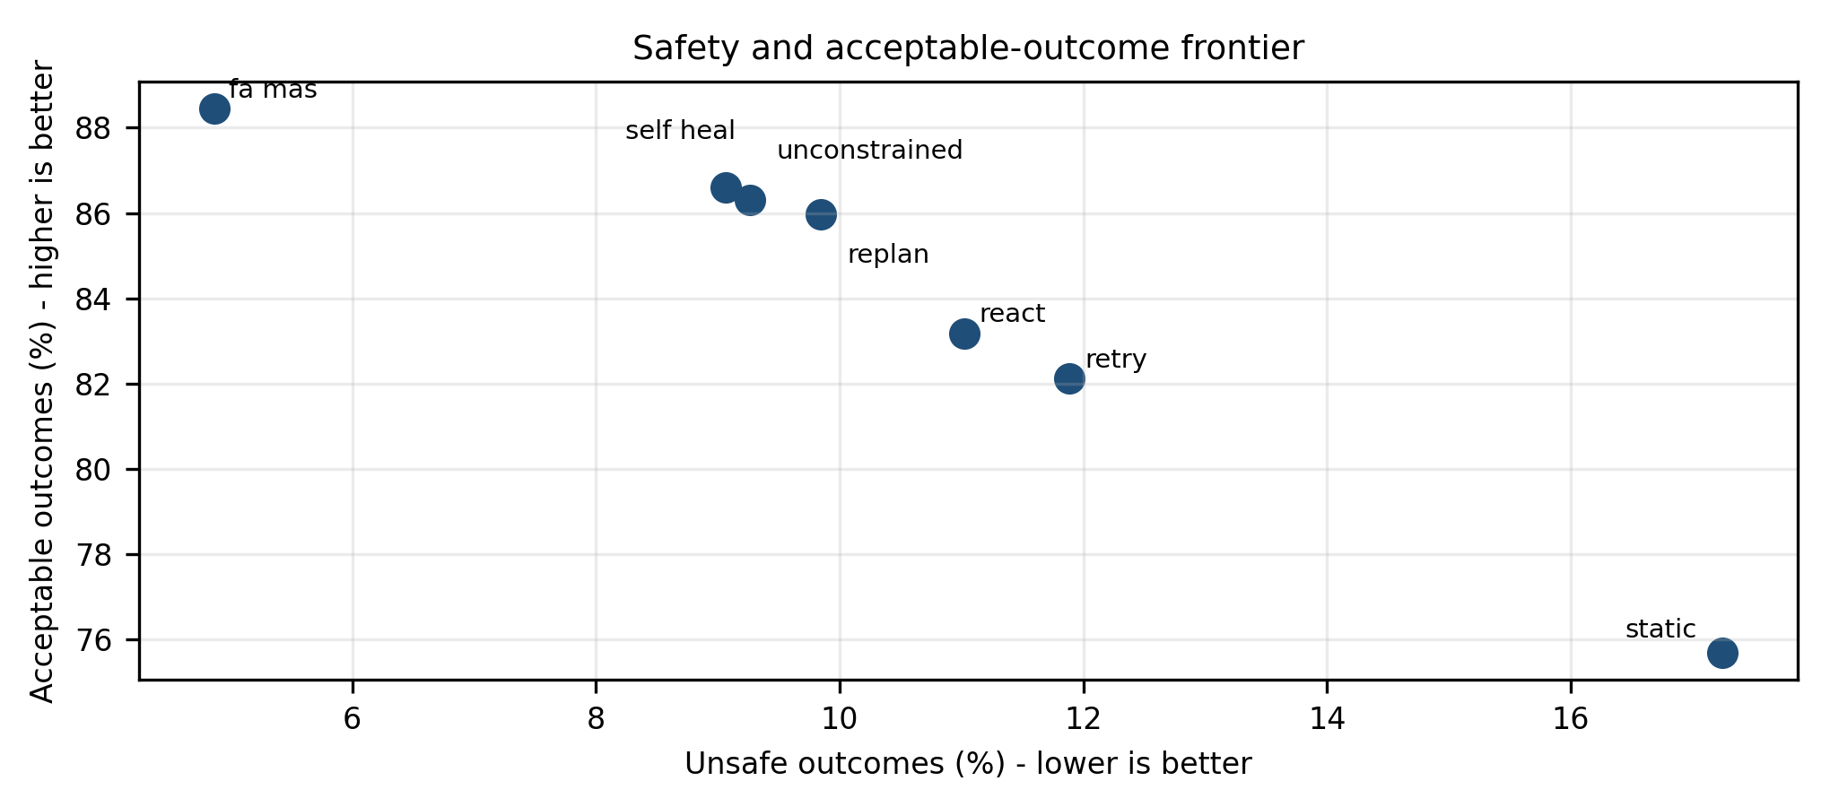
Fig. 3. Original simulator outcomes under unequal diagnosis parameters and the original terminal criterion.
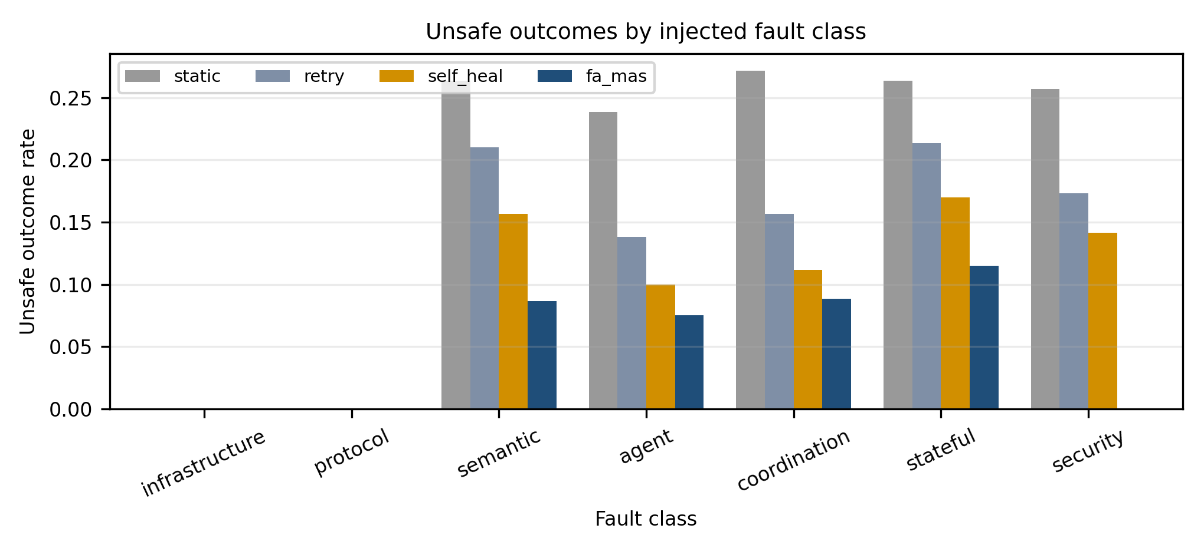
Fig. 4. Original simulator unsafe rates under its weaker terminal criterion.
RQ4 Diagnosis. Aggregate detection and localization are reported as implementation diagnostics, not claims about model-based root-cause analysis. Contract-sensitive faults receive deterministic evidence boosts in FA-MAS. Removing semantic-contract evidence increases unsafe outcomes from 5.21% to 6.57% within faulty FA-MAS cells, although completion rises from 83.95% to 84.67%. This is another conservative-safety tradeoff.
RQ5 Ablations. Fixed rules and no substitution both reduce completion to 81.57% and increase unsafe outcomes to 5.88%. Removing provenance leaves completion unchanged in this simulator but reduces localization, demonstrating that the current recovery policy underuses localization confidence. This null result is disclosed rather than interpreted as evidence that provenance is unnecessary.
The no-compensation ablation completes 87.95% versus 83.95% for full FA-MAS in faulty cells, with unsafe outcomes of 5.38% versus 5.21%. Even after adding compensate-reconcile-recompose-resume, compensation consumes budget and sometimes fails before alternate completion. Under the original judge this difference is small; the stricter matched study reverses the safety ranking. Compensation is not demonstrated to improve aggregate safety in this simulator. A production selector should estimate downstream resume value and use compensation only when unresolved state risk dominates.
Sensitivity. The two injected intensities control whether the selected fault becomes active. Because one target step is selected per run, intensity changes fault incidence rather than compound-failure depth. The manuscript therefore avoids claims about correlated cascading failures.
Negative findings matter. FA-MAS does not dominate every baseline on every metric. Its contribution is a controllable safety–completion frontier with auditable semantics. Applications can set risk weights and escalation policies according to domain cost rather than maximizing completion blindly.
Internal validity checks include paired seeds, deterministic replay tests, full retention of failures, and direct end-state validation. The complete run table permits independent recomputation.
Post-audit matched sensitivity. An additional exploratory study executes 18,000 rows with equal detection/localization probabilities (0.82/0.76), no contract detection bonus, and the same recovery operations except for the stated ablation. A stricter judge counts active writes left by unfinished workflows as unsafe. Full FA-MAS completes 85.00%, accepts 87.09% and records 9.96% unsafe outcomes. Removing gates completes 86.82%, accepts 86.82% and records 9.73% unsafe. First-feasible selection completes 85.49%, accepts 87.58% and records 8.93% unsafe; removing compensation completes 87.71%, accepts 89.80% and records 7.60% unsafe. These negative findings reject a demonstrated safety advantage in this matched simulator. The study is post-audit exploratory, not preregistered; the original 52,500 rows remain unchanged historical results under their weaker terminal criterion.
Corrected exploratory sensitivity. A further 18,000 rows use the same authored cells and matched diagnosis inputs with effect-aware compensation, aligned selection/budgets and corrected authorization judgment. Full FA-MAS completes 87.73%, accepts 89.82% and records 7.58% unsafe outcomes. No-gates completion is identical, acceptance is 87.73% and unsafe rate is 9.67%. First-feasible completion is 85.49%, acceptance 87.58% and unsafe rate 8.93%. No-compensation completes 87.71%, accepts 89.80% and records 7.60% unsafe outcomes. The full-minus-no-compensation unsafe difference is -0.022 percentage points (conditional bootstrap interval -0.156 to +0.111), leaving compensation's aggregate benefit unresolved. Full-minus-no-gates unsafe difference is -2.089 points (-2.511 to -1.689), driven by the specified authorization gate. This is post-audit defect correction, not preregistered confirmation or natural-model capability evidence; both earlier CSVs remain preserved.
Public service mechanism checks. We execute unmodified retail and airline cancellation tools from the pinned public tau2-bench repository [25], selecting all 18 retail and seven airline tasks with a reference cancellation action and no initial-state override. Clean, before-commit failure and lost-reply conditions yield 150 runs over two wrappers. Reference actions are supplied directly; no user conversation or model is evaluated. Both wrappers match a one-write reference state in all retail cases and in clean/before-commit airline cases. Following lost airline replies, retry-first changes refund history in all seven cases; status reconciliation preserves the reference history. A repeated airline cancellation adds inverse entries, so this is ledger divergence, not a claim of net financial loss. Retail rejects repeated cancellation, illustrating provider-side protection. Terminal subject snapshots and full-database hashes are retained. Fault wrappers are authored; these are deterministic component checks, not official benchmark scores, full policy compliance or production validation.
The acceptable-outcome advantage is partly attributable to security abstention. FA-MAS safely terminates 3.42% of all runs when the policy gate blocks automatic recovery. Baselines without the gate never record safe termination and instead either fail or attempt an unsafe action. This mechanism is desirable only when the blocked condition is a true policy violation; false-positive gates would reduce utility and must be measured in the live protocol.
The compensation ablation exposes a limitation rather than a simple win. Removing compensation increases faulty-cell completion from 83.95% to 87.95%, while unsafe outcomes increase from 5.21% to 5.38%. In the simulator, compensation consumes an additional recovery attempt and can fail before substitute execution. A better selector needs a calibrated estimate of downstream resume value and should compensate only when unresolved state risk exceeds the expected loss of budget.
The equal results for fixed-rules and no-substitution show that the current action space does not isolate all conceptual modules. Likewise, removing provenance lowers localization without changing completion, demonstrating that localization confidence is not sufficiently coupled to selection. These negative findings identify concrete implementation work and prevent the ablation section from overstating modular causality.
Single-step conformance. In 18 engineered cases per policy, FA-MAS completes 15 and safely stops three; stable-key retry completes six, verify-before-retry three, and static zero. No controller duplicates an effect because all use stable keys. The simple baselines lack some recovery operations, which explains much of the difference. Three-step conformance. Over 27 cases per policy, FA-MAS and feature-matched recovery both complete 18; FA-MAS safely stops six versus three for the control. In three authored incompatible-substitute cases, the control commits a semantically invalid alternate, whereas FA-MAS rolls back. In three cases where compensation fails, both remain unsafe with unresolved partial state. The stricter multi-step judge also counts prior committed writes left behind by simpler policies as unsafe. On the separate inventory implementation, FA-MAS completes four of seven authored faults, safely stops twice, and leaves one unsafe hold when release is unavailable. The feature-matched control completes four, safely stops none, and has three unsafe outcomes, including capture of a different SKU. All counts describe engineered mechanism behavior, not a real fault distribution; no p-values or live-model performance are inferred.
TABLE V
Historical paired differences: unequal diagnosis
Baseline | Δ complete | 95% CI | Δ acceptable | Δ unsafe
static | +9.33 | [+8.47, +10.18] | +12.76 | -12.38
retry | +2.91 | [+2.04, +3.76] | +6.33 | -7.02
react | +1.84 | [+1.02, +2.64] | +5.27 | -6.16
replan | -0.96 | [-1.87, -0.07] | +2.47 | -4.98
self heal | -1.58 | [-2.49, -0.62] | +1.84 | -4.20
unconstrained | -1.29 | [-2.22, -0.38] | +2.13 | -4.40

TABLE VI
FA-MAS ablations in faulty cells percent
Variant | Complete | Accept. | Unsafe | Localized
fixed rules | 81.57 | 85.24 | 5.88 | 19.76
full | 83.95 | 87.62 | 5.21 | 19.76
no compensation | 87.95 | 91.62 | 5.38 | 19.76
no provenance | 83.95 | 87.62 | 5.21 | 15.79
no semantic contracts | 84.67 | 88.33 | 6.57 | 17.79
no substitution | 81.57 | 85.24 | 5.88 | 19.76

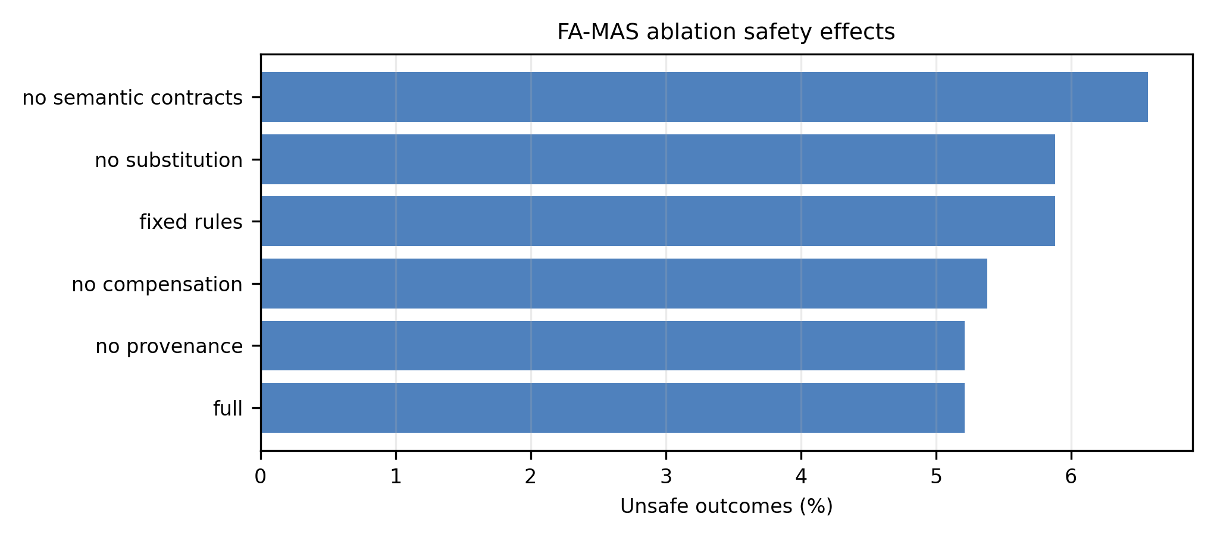
Fig. 5. Historical ablations under the original terminal criterion; matched sensitivity is reported in text.

X LIVE MODEL CONFIRMATORY PROTOCOL
The earlier unexecuted single-decision Tier-2 plan is retained as a historical artifact. The new bounded end-to-end protocol uses real loopback HTTP/SQLite services and lets a tool-calling model choose every operation. It specifies 32 held-out task instances, two model classes and two policies, yielding 128 trajectories with at most 12 turns each (1,536 calls). Both controllers receive the same prompt, contracts, tools, stable intent keys and budgets; FA-MAS adds prerequisite, substitute-equivalence, replacement and capture gates. No live model calls have been made.
The held-out instances change workflow length, SKU and capacity; they are authored variants of known fault families, not unseen production tasks. Four development tasks are disjoint. Forty-four unit tests pass and eight scripted development trajectories complete, all marked non-live. The lock covers code, task bank, model endpoints and rates, and runtime versions. Provider failures remain in the data; incomplete matrices cannot enter the live comparison. Local hashing is not independent preregistration.
Analysis pairs task/model cells and clusters uncertainty by the 16 service/fault families. These small authored clusters do not provide demonstrated power for small effects or population estimates. The study tests one tool-using model at a time and does not validate multi-agent coordination or the full recovery frontier. Model IDs, endpoints, credentials and an approved billing ceiling remain execution gates.
Planning sensitivity uses 16 clusters of four paired cells, hypothetical discordance 0.10–0.50 and intracluster correlation 0–1. A noncentral-t reference approximation gives low power for a two-percentage-point difference. These inputs are assumptions, not live estimates; the reference test differs from the planned bootstrap/sign analysis. The bank remains unsuitable for claiming adequately powered detection of modest effects. Expansion must occur before freezing, with the added service families and budget disclosed.

XI DISCUSSION
The results illustrate why agent reliability is a services-computing problem. Completion-only evaluation rewards a system that takes an unauthorized or state-unsafe action if the final text looks correct. By separating completion, safe termination, and unsafe outcome, FA-MAS makes policy choices visible.
Contracts are useful when they constrain behavior, not merely document APIs. Idempotency and reconciliation determine whether retry is legal; scope and tenant determine whether substitution is feasible; compensation determines whether a partially completed workflow can return to a safe checkpoint; latency and cost determine whether any recovery remains within the end-to-end SLO.
The recomposition frontier offers a practical division of labor. Deterministic mechanisms enforce schemas, permissions, and known invariants. Statistical models estimate uncertain success, latency, and semantic risk. LLMs may propose candidates or explanations but cannot bypass hard gates.
Tradeoffs. Conservative policies increase safe termination and may reduce raw completion. Compensation itself can consume latency, cost, and failure probability. Contract completeness adds engineering burden, and incorrect contracts can create false confidence. Providers without reconciliation or compensation require manual escalation.
Threats to validity. Internal threats include authored simulator probabilities, simplified service distributions, and baseline abstractions. Construct threats include the chosen acceptable-outcome definition and cost units. The three HTTP domain labels use the same service state machine; the workflow faults and policy rules were authored together. External threats include single-fault runs, absence of live model behavior, and simplified authorization. Statistical intervals quantify simulator sampling uncertainty, not model misspecification; deterministic conformance counts have no inferential p-values.
Mitigations are explicit paired designs, end-state ground truth, negative-result reporting, open artifacts, and the Tier 2 protocol. Claims remain limited to the implemented environment until that protocol is executed.
Ethics and security. The workflows use synthetic identities and local state. No real refunds, bookings, or infrastructure changes occur. Logs should minimize sensitive payloads. Human escalation must expose evidence and recommended actions without revealing private reasoning traces.
The practical implication is that reliability targets should be multi-dimensional. A service owner can specify a completion target, maximum unsafe-outcome rate, safe-termination policy, and cost or latency envelope. The frontier then exposes whether a requested reliability level is attainable under the current contracts. If not, the appropriate engineering action may be to add reconciliation, idempotency, or compensation to a provider rather than to increase agent autonomy.
Contract quality becomes a new operational dependency. Schema extraction from OpenAPI can populate only part of the manifest; preconditions, effects, tenant boundaries, approval rules, equivalence, and compensation often require domain knowledge. Incorrect declarations can be more dangerous than missing declarations because they create false feasibility. Deployment therefore requires contract versioning, conformance tests, ownership, and change review.
Generalization is deliberately unresolved. The three labels represent monetary, reservation, and operational intents in the simulator and the original local HTTP suite shares one state machine. A second inventory service has genuinely different storage and business invariants, but its seven authored scenarios still cannot establish population-level generalization. Neither suite represents healthcare, identity administration, legal decisions, or long-running human workflows. Single-fault runs cannot measure correlated outages, malicious services, prompt injection through tool output, or recovery loops spanning hours.

XII REPRODUCIBILITY AND ARTIFACT AUDIT
Artifact contents. The package includes Python source, YAML protocols, unit tests, 52,500 run rows, grouped summaries, paired comparisons, ablations, figures, and a machine-readable manifest. The prior 10,500-row pilot is retained separately; version 2 changes are documented rather than silently replacing the pilot.
Audit checklist. Verify that every stochastic cell has the declared repetitions; seeds match across architectures; no primary row is missing; metrics are binary where required; all confidence intervals are reproducible; Holm adjustment is monotone within each metric family; no run is excluded; and figure values match CSV summaries.
Citation audit. The closest research and venue references were checked against primary publisher or arXiv records. Bibliographic details and citation relevance must be verified again against their final versions before submission; preprints should not be described as peer-reviewed publications unless verified.
Submission integrity. The simulator qualification is retained consistently in the abstract, methods, results, and limitations. The artifact should be anonymized only if required by the review process. Final portal submission must select the named special issue and include accurate originality, funding, authorship, and conflict-of-interest disclosures.
Artifact limitations. The present package is executable in the supplied environment but does not containerize operating-system dependencies or guarantee bitwise-identical floating-point rendering. The scoped wheel-hash lock and checksum manifest are supplied; a built container image, rights-cleared artifact license and archival DOI remain absent.
Data availability statement. The artifact includes simulator data and scripts; the local HTTP study includes 72 single-step, 135 three-step, and 35 inventory run rows, event traces, summaries, source, and protocol digests. The Tier 2 runner and held-out task bank are supplied, but no live-model outcome is reported. No proprietary or personal dataset is used. Future live-model traces will be filtered for provider terms and sensitive content before release.
Author contribution and funding statements must be confirmed by D. Dutia before submission, including any collaborator's actual contributions and any external funding.
Clean-install verification. A fresh virtual environment installs all 29 required distributions from binary wheels using SHA-256 enforcement, without inheriting site packages. Forty-four tests pass; 52,500 historical rows, the initial 18,000 matched rows and 18,000 corrected rows replay byte for byte. All 150 public-tool traces also reproduce byte for byte. This is isolated installation on the same host and interpreter build, not independent third-party replication. The lock is platform-specific and does not lock manuscript rendering dependencies. The upstream source commit, loaded files, data and MIT notice are preserved.
The release provides SHA-256 identifiers to the paper configuration, source tree, raw run table, and analysis outputs. The manuscript currently reports the protocol version and seed; the archive includes checksums, a complete scoped dependency pin file, a digest-pinned unbuilt container recipe, a read-only replay auditor and a transitive wheel-hash lock for CPython 3.12 Linux x86_64. A fresh virtual environment reproduces all observations on this host. Independent replication, a container build, archival DOI, rights-cleared license and author-confirmed citation metadata remain incomplete.
Artifact claims must match contents. The current package supports the reduced simulator, finite-action Pareto selection, two local services, and an unexecuted bounded live-study runner. It does not implement the complete production architecture. The data statement should name synthetic data and authored probabilities. If the artifact is reviewed anonymously, repository metadata, package authors, paths, and document properties must be scrubbed without changing executable content; otherwise the public release should preserve authorship and version history.
Submission compliance is separate from scientific validity. The final file must use the current IEEE journal template, remain within the special issue's 14-page ceiling, select the named special issue in the Author Portal, and include accurate originality, prior-publication, funding, conflict, authorship, and artifact disclosures. These declarations require author confirmation and cannot be inferred from code or manuscript text.

XIII CONCLUSION
FA-MAS reframes reliable agent execution as constrained recovery of a stateful service composition. The design combines contracts, failure-belief estimation, a proposed recomposition frontier and compensation-aware state recovery. Only reduced gates, finite-action selection and local service state are currently executable. The original simulator favors FA-MAS on recorded safety under unequal authored diagnosis parameters. The initial matched study is negative. After disclosed defect corrections, the exploratory simulator favors gated selection over two controls but shows no resolved benefit from compensation; orphan-state failures persist. No live-model advantage has been measured.
That negative boundary is the principal empirical lesson: service safety and task completion are distinct objectives. A runtime can finish more tasks by taking actions that violate authorization or leave inconsistent state. FA-MAS makes that tradeoff explicit and auditable.
The paper's defensible contribution is a reference specification and transparent mechanism evaluation; the matched and corrected sensitivity studies prevent an unconditional claim of safety superiority. It is a services-computing control architecture, formal objective, executable recovery protocol, and reproducible fault-injection methodology. Completion of the prespecified live-model protocol would strengthen external validity without changing the contract and state semantics evaluated here.

ACKNOWLEDGMENT
OpenAI ChatGPT and Codex assisted with drafting and revising Sections I–XIII, generating evaluation source code and figures, and preparing analysis scripts. The author is responsible for checking the scientific content, citations, code, and results before submission. Funding and author contribution disclosures require the author's confirmation.

APPENDIX A CONTRACT MANIFEST EXCERPT
service: refund; input: case_id, account_id, amount, currency, idempotency_key; preconditions: verified account and eligible policy; postconditions: one ledger entry linked to case; state: idempotent_write; reconcile: GET /refunds/by-key/{key}; compensate: POST /refunds/{id}/reverse; scopes: refund:write; approval: amount above configured threshold; alternatives: refund_backup; timeout and cost profiles: deployment specific.

APPENDIX B CLAIM CHECK
Supported with limitations: the reference simulator implements the reduced contract fields and recovery actions described in Section VII; it generated the reported observations; historical paired comparisons reproduce the recorded effects under unequal authored parameters and a weaker terminal judge. The initial matched exploratory study is negative; the corrected study remains conditional and does not establish production or live-model superiority. The artifact also implements the Tier 2 adapters, task split, protocol lock, transactional judge, trace hashing, and analysis gate. Not supported: full implementation of every architectural field, production readiness, exactly-once execution for arbitrary providers, universal model superiority, or live-LLM generality before Tier 2 execution.

REFERENCES
[1] IEEE Computer Society, “Special Issue on Large Language Models in Service-Oriented Ecosystems Design: Advances and Applications,” Call for Papers, 2026.
[2] S. Yao et al., “ReAct: Synergizing Reasoning and Acting in Language Models,” in Proc. ICLR, 2023, arXiv:2210.03629.
[3] T. Schick et al., “Toolformer: Language Models Can Teach Themselves to Use Tools,” in Proc. NeurIPS, 2023, arXiv:2302.04761.
[4] Q. Wu et al., “AutoGen: Enabling Next-Gen LLM Applications via Multi-Agent Conversation,” arXiv:2308.08155, 2023.
[5] S. Kim et al., “An LLM Compiler for Parallel Function Calling,” in Proc. ICML, 2024, arXiv:2312.04511.
[6] M. Cemri et al., “Why Do Multi-Agent LLM Systems Fail?” arXiv:2503.13657, 2025.
[7] A. Gupta, “ReliabilityBench: Evaluating LLM Agent Reliability Under Production-Like Stress Conditions,” arXiv:2601.06112, 2026.
[8] R. S. Babu and A. Agrawal, “Self-Healing Agentic Orchestrators for Reliable Tool-Augmented Large Language Model Systems,” arXiv:2606.01416, 2026.
[9] C. Jeong and Y. Shin, “A Self-Healing Framework for Reliable LLM-Based Autonomous Agents,” arXiv:2605.06737, 2026.
[10] X. Li et al., “Early Diagnosis of Wasted Computation in Multi-Agent LLM Systems via Failure-Aware Observability,” arXiv:2606.01365, 2026.
[11] Y. Xia et al., “Who Broke the System? Failure Localization in LLM-Based Multi-Agent Systems,” arXiv:2607.07989, 2026.
[12] H. Garcia-Molina and K. Salem, “Sagas,” in Proc. ACM SIGMOD, 1987, pp. 249–259.
[13] OpenAPI Initiative, “OpenAPI Specification Version 3.1.1,” 2024.
[14] Cloud Native Computing Foundation, “OpenTelemetry Specification,” accessed Sept. 2026.
[15] IEEE Author Center, “IEEE Article Templates,” accessed Sept. 2026.
[16] IEEE Author Center, “The IEEE Article Submission Process,” accessed Sept. 2026.
[17] IEEE Computer Society, “Author Resources and Submission Guidelines,” accessed Sept. 2026.
[18] M. Aiello, “A Paradigm Shift in Service Research: The Case of Service Composition,” IEEE Trans. Services Computing, vol. 18, no. 3, pp. 1213–1215, 2025, doi: 10.1109/TSC.2025.3552345.
[19] I. Georgievski and M. Aiello, “Initial Steps in Integrating Large Reasoning and Action Models for Service Composition,” arXiv:2507.18775, 2025.
[20] R. D. Pesl, “Adopting Large Language Models to Automated System Integration,” in Intelligent Information Systems, LNBIP 557, pp. 313–320, 2025, doi: 10.1007/978-3-031-94590-8_37.
[21] E. Y. Chang and L. Geng, “SagaLLM: Context Management, Validation, and Transaction Guarantees for Multi-Agent LLM Planning,” arXiv:2503.11951v3, 2025.
[22] B. Mohammadi et al., “Atomix: Timely, Transactional Tool Use for Reliable Agentic Workflows,” arXiv:2602.14849v2, 2026.
[23] K. Wang et al., “BRA-Audit: Budgeted Runtime Auditing for LLM Multi-Agent Systems via Cumulative-Exposure Audit-Point Placement,” arXiv:2608.14668v1, 2026.
[24] V. Srinivasan, “A Methodology for Selecting and Composing Runtime Architecture Patterns for Production LLM Agents,” arXiv:2605.20173v2, 2026.
[25] Sierra Research, tau2-bench, public source repository, revision 4ce7c0397c1eb65c9bbe59aeacfe1ca44a1cd699, retrieved Oct. 9, 2026. https://github.com/sierra-research/tau2-bench. Direct business-tool component evaluation only.

This paragraph of the first footnote will contain the date on which you submitted your paper for review, which is populated by IEEE. It is IEEE style to display support information, including sponsor and financial support acknowledgment, here and not in an acknowledgment section at the end of the article. For example, “This work was supported in part by the U.S. Department of Commerce under Grant 123456.” The name of the corresponding author appears after the financial information, e.g. (Corresponding author: Second B. Author). Here you may also indicate if authors contributed equally or if there are co-first authors. The next few paragraphs should contain the authors’ current affiliations, including current address and e-mail. For example, First A. Author is with the National Institute of Standards and Technology, Boulder, CO 80305 USA (e-mail: author@ boulder.nist.gov). Second B. Author Jr. was with Rice University, Houston, TX 77005 USA. He is now with the Department of Physics, Colorado State University, Fort Collins, CO 80523 USA (e-mail: author@lamar.colostate.edu). Third C. Author is with the Electrical Engineering Department, University of Colorado, Boulder, CO 80309 USA, on leave from the National Research Institute for Metals, Tsukuba 305-0047, Japan (e-mail: author@nrim.go.jp). Mentions of supplemental materials and animal/human rights statements can be included here. Color versions of one or more of the figures in this article are available online at http://ieeexplore.ieee.org
It is recommended that footnotes be avoided (except for the unnumbered footnote with the receipt date on the first page). Instead, try to integrate the footnote information into the text.

