Is Air Travel Safer Than Road Travel?

Introduction

Air travel has become an essential part of many people’s lives across the world. The number of commercial accidents worldwide has been on the decline since 1980, even as the total amount of air traffic has increased. With the Malaysian airline's accidents and the Boing max 737 crisis, there has been a lot of concern in the media about the safety of the airlines. In this blog post, we will address the concerns of the media by diving into the statistics and compare air travel with road travel to see which one is safer.

This study is based on crash and airline statistics from The Aviation safety network, Federal aviation administration, National highway safety traffic administration, and the World Bank. As a part of this study, data analysis is done on fatality counts, passenger counts, and miles data.

Fatality Rates

In the following graphic (Fig.1), the road fatalities are represented by blue bubbles and air fatalities by gray bubbles. As the number of fatalities for each year is compared, the data indicates that car fatalities are eighty to a hundred times more common than air fatalities for any year. This can be seen from the size of the bubbles in the graph. Air fatalities have been declining year by year.

**Car travel is 75 times more deadly than an airplane travel**

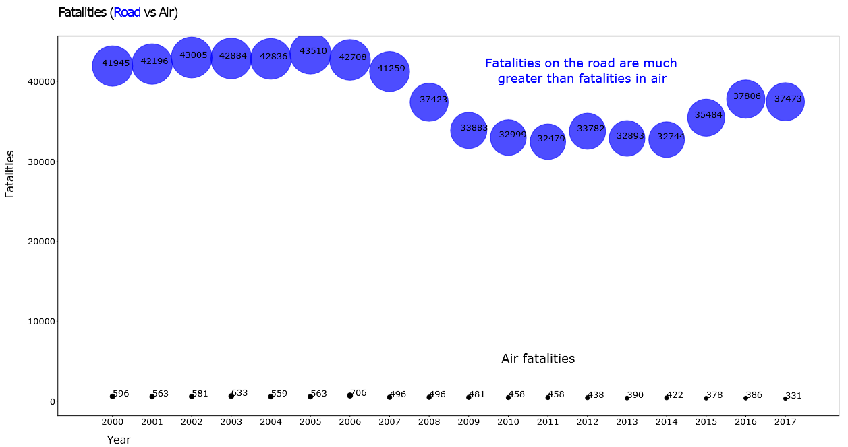

Fig.1

Let’s take a look at the data with a different approach. The following graphic on air and road fatalities (Fig.2) shows total air fatalities and road fatalities for 17 years using a bar chart. The blue bar indicates the road fatalities and gray bar indicates air fatalities. Do you see the number of road fatalities? There has been a staggering loss of life with 680 thousand deaths in road accidents. This is huge compared to the 9000 deaths in air. The air fatalities count includes all commercial and passenger fatalities and still, the number is very low. This statistic clearly shows that air travel is relatively safe compared to road travel.

**Around 680000 deaths were caused by road accidents between the years 2000 and 2017**

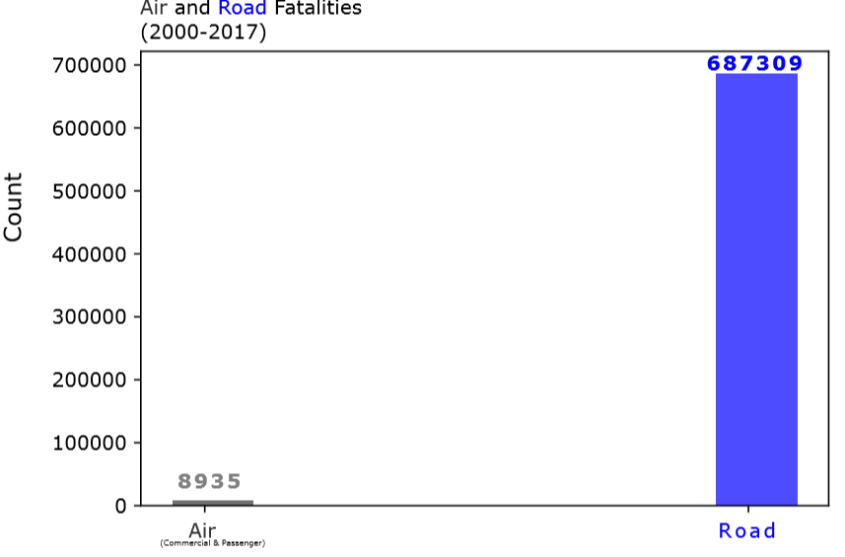

Fig.2

Airline Safety

Although air fatalities are very few, we cannot ignore the tragedies that were caused by deaths. Let’s research and find out more details by taking data from 2000 to 2014. The data in the scatter plot below (Fig.3) shows that not all airlines are unsafe. Only Malaysian, American, and Air France airlines have more than 10% of fatalities. The majority of airlines have a fatality rate between 2 to 5% as shown by the cluster on the graph. This statistic indicates that majority of the airlines are operating safely. Although Malaysian occupied the top position, the fatality rate is still small compared to the death rate in road accidents.

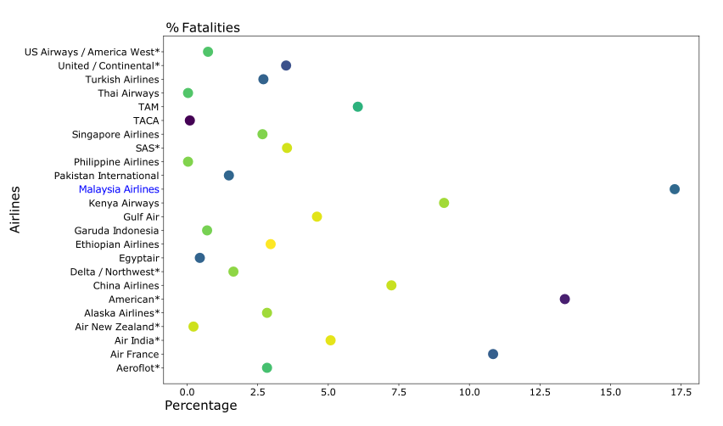

Fig.3

The next bar chart (Fig.4) shows the fatality count for the top ten airlines with Malaysian at 537 and United at 109. This bar chart is plotted with the data between the years 2000-2014. The total fatality count is still around 2500, which clearly shows that all airlines are making serious efforts to fly cautiously in order to provide safe travel to passengers and minimize fatalities.

**Around 2506 deaths were caused by airline accidents and Malaysian airlines tops with 537**

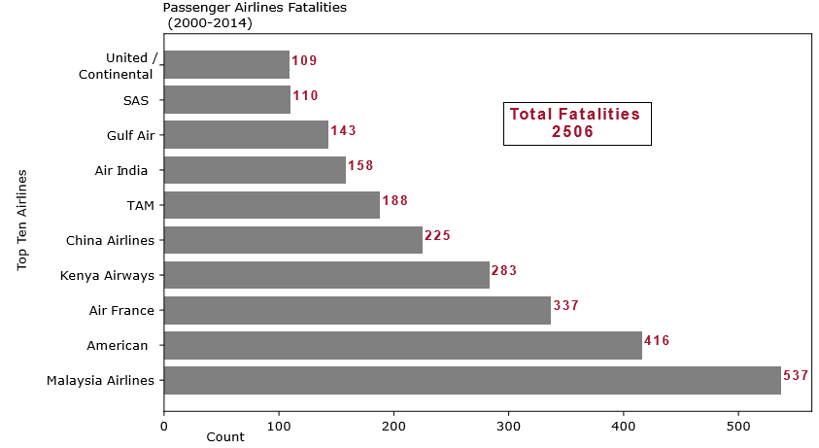

Fig.4

Does Miles Make any Difference?

While we are in a position to say that air travel is the safest, someone can argue that there are more travelers on the road than on air and so the number of deaths is always going to be higher on the road compared to the deaths in air. Let’s look at some more statistics related to the number of miles traveled on both the road and in air and understand the truth. The next graphic (Fig.5) compares the death rate based on the miles traveled, which clearly shows that for every 10 billion miles traveled, passengers die more on the road than in air. The road fatalities are 40 times as high as air.

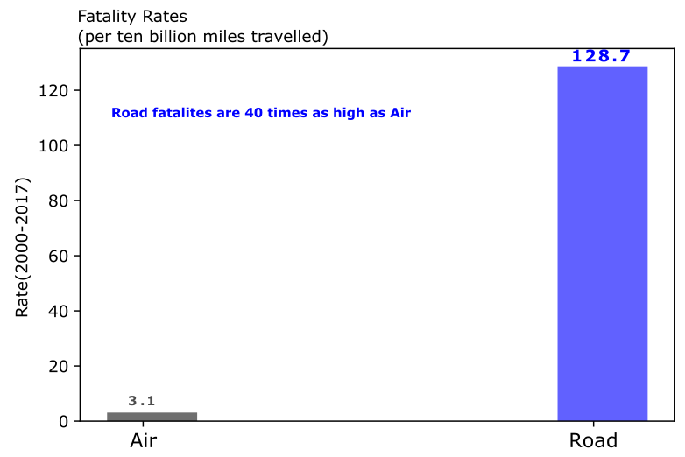

Fig.5

**For every ten billion miles traveled, 129 deaths happened on road but only 3 in air**

Passenger Data

With all of that said, it is proven that air travel has fewer fatalities and is much safer than using the road. Now that we know air travel is safer, we can investigate the data from a passenger perspective and their preference for choosing air travel. As shown in the line plot below (Fig.6) the passengers traveling in the air have been increasing both in the world and in the domestic sector. 2.29 billion passengers travelled worldwide in 2009 and since then the rate of increase has been accelerating as indicated by a steep rise in the gray curve. The same trend can be seen for domestic travel since 2014.

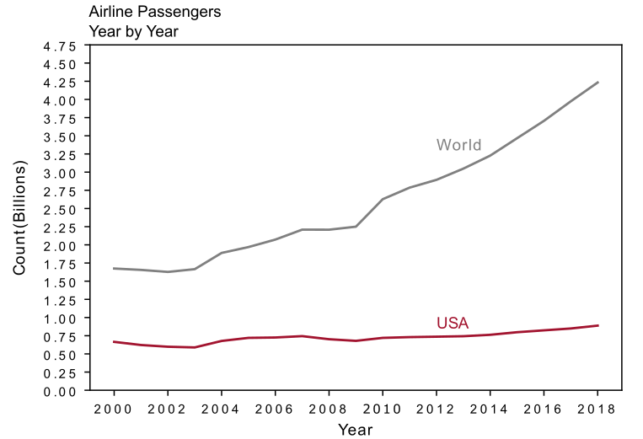

Fig.6

In the next line plot, the actual passenger miles traveled are plotted against the year of travel where we can see the same trend with an increase in the number of miles. (Fig.7). Passenger airline miles have been rapidly increasing since 2009, which means the air travelers are on the rise every year.

**Airline passengers have been on the rise every year**

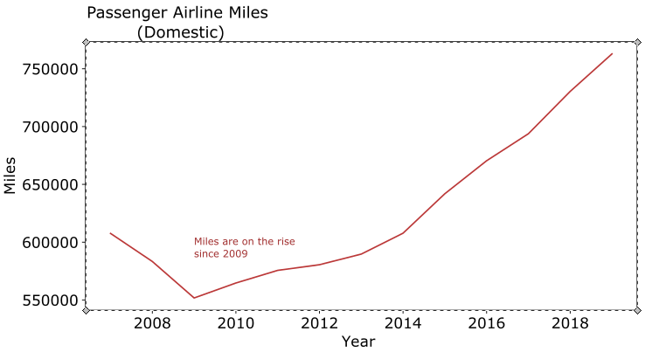

Fig.7

Conclusion

After going through several statistics we can conclude that air travel being dangerous is just a myth. In reality, air travel is much safer compared to road travel as evident from the low number of fatalities in air travel and an increasing number of air travelers. Passengers are going to choose more and more air travel in the coming years as airlines continue to make efforts to provide safe and secure travel across the globe.

Sources

Crash Statistics from National Highway Traffic Safety Administration, https://one.nhtsa.gov/data

Airlines Safety Data from Aviation Safety Network, https://github.com/fivethirtyeight/data/tree/master/airline-safety

World Airline passenger’s data from https://data.worldbank.org/indicator/is.air.psgr

Flight Statistics from Federal Aviation Administration