Homework 5 by Manuel Perez

Exercise 1:
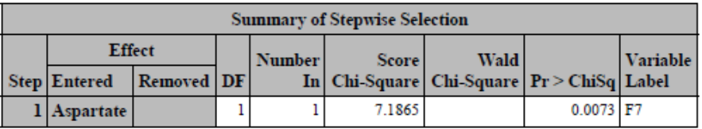
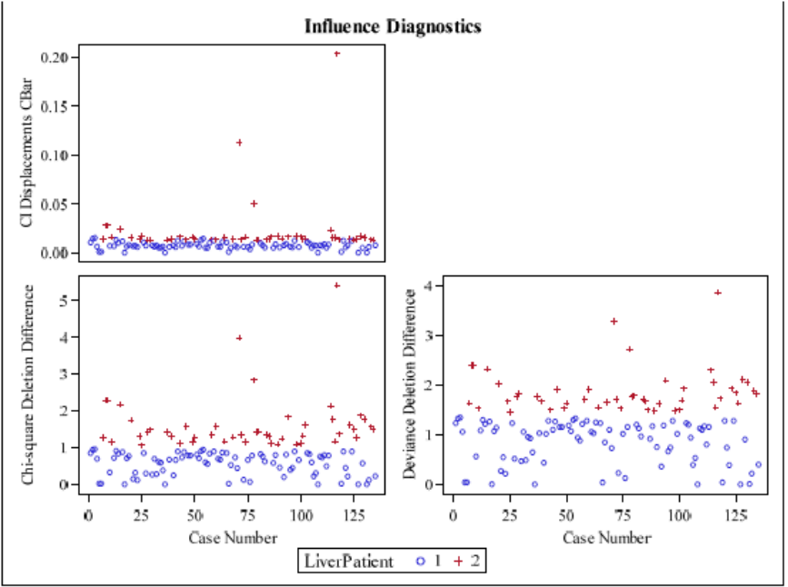
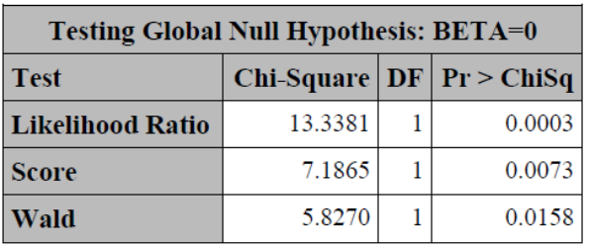
- After running a stepwise selection, on variables for Female patients, with a 0.05 significance requirement to enter and remain in the model, the only parameter that was significant in the model was Aspartate, p-value was 0.0073. The Likelihood ratio’s p-value was less 0.05 which indicated that the model was useful. With the cutoff line being 0.5 for cbar there were no further influential points in the model after doing a logistic regression, thus no observations were removed, and no refitting was done on the model.

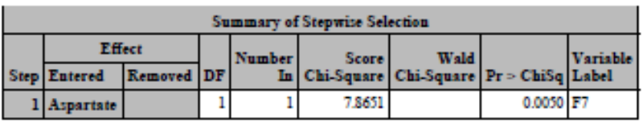
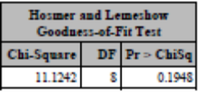
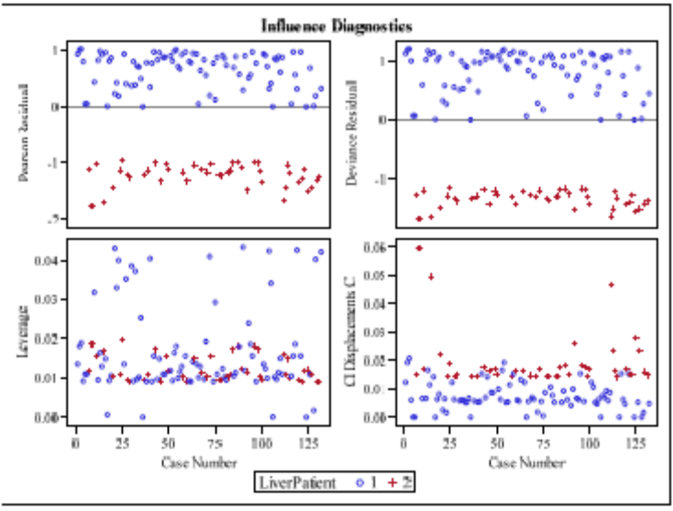
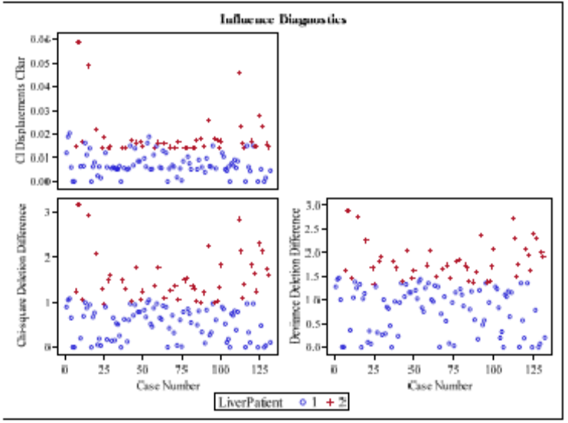
- There were some influential points that were above 0.5 in the cbar plot, thus a new cutoff line was introduced as 0.05. This new cutoff line took out two influential points in the model, but no new predictors were found to be significant. Aspartate was still the only significant parameter in the model. In addition, based on the Hosmer-Lemeshow Test the model is shown to be adequate and a good fit, p-value was 0.1948. There were still points that could be seen that were influential in the model, however using a new cutoff line there continued to add more influential points after each subsequent logistic regression, so only one cutoff line was used for logistic regression. Most of the points were in the (-2,2) band for the Residual plot which showed that the equal variance was held to be true. No further diagnostic issues were found.

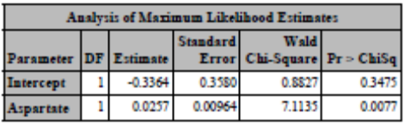
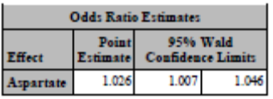
Estimate logistics regression equation:
$Log(\frac{p(LP=1)}{p(LP=2)}$|Female) = -0.3364 + 0.0257×Aspartate
- The odds of being a liver patient for an adult female patient changes by a factor of 1.026 with a one unit increase in Aspartate. The confidence limits don’t include 1 so the Aspartate predictor is shown to be significant. An interpretation of this model is that women with high levels of aspartate are more likely to be patients with active liver disease.

Exercise 2:
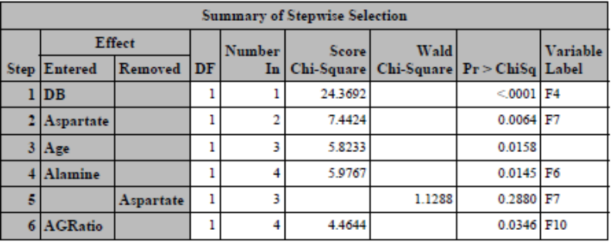
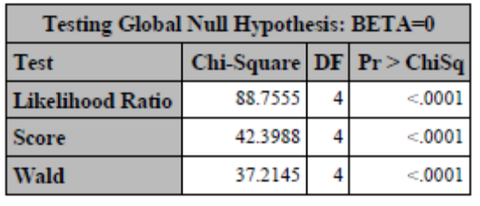
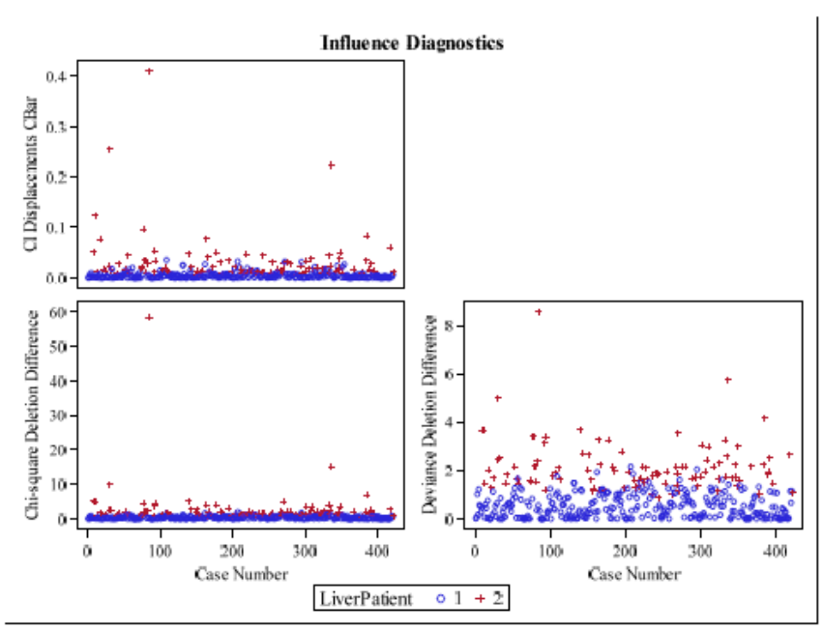
- After running a stepwise selection, on variables for Male patients, with a 0.05 significance requirement to enter and remain in the model, the only parameters that were significant were DB, Aspartatate, Age, Alamine, and AGRatio. The Likelihood ratio’s p-value was less than 0.0001, which indicated that the model was useful. With the cutoff line being 0.5 for cbar there was one influential point in the model after doing a logistic regression, thus refitting was done for the final model. No further parameters were found to be significant after the refitting.

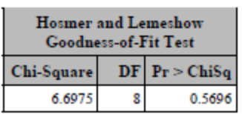
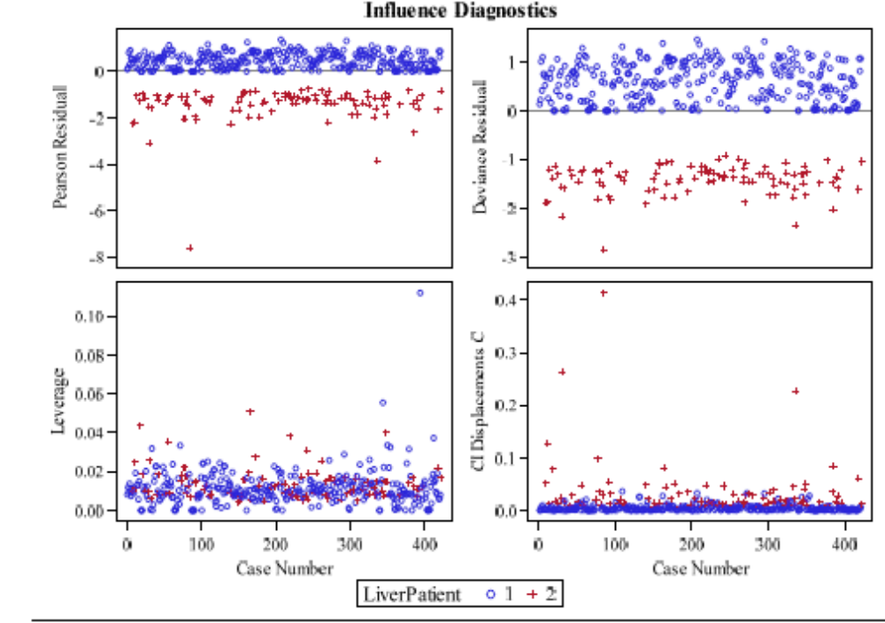

- After refitting the model there were no more influential points that were above 0.5 cbar cutoff line, so no further refitting needed to be done and no further parameters were found to be significant. Based on the Hosmer-Lemeshow Test the model was shown to be adequate and a good fit, p-value was 0.5696. The significant parameters were DB, Aspartatate, Age, Alamine, and AGRatio. Most of the points were within (-2,2) band so equal variance can be assumed. However, there were some points that were well outside of the band so that should be noted.

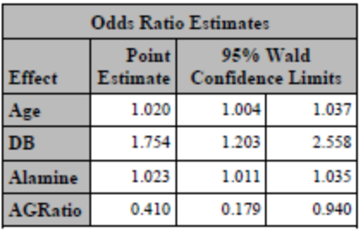
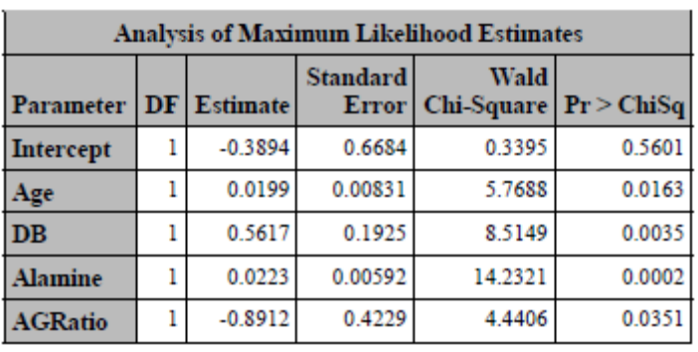
Estimator Logistic Regression Equation:
$Log(\frac{p(LP=1)}{p(LP=2)}$|Male) = -0.3894 + 0.0199×Age + 0.5617×DB +0.0223×Alamine +
-0.8912×AGRatio
- The odds of being a liver patient change by a factor of 1.020 with a one unit increase in Age. The confidence limit for the age predictor does not include 1 so the predictor is shown to be significant. The odds of being a liver patient change by a factor of 1.754 with a one unit increase in DB. The confidence limit for the DB predictor does not include 1 so the predictor is shown to be significant. The odds of being a liver patient change by a factor of 1.023 with a one unit increase in Alamine. The confidence limit for the Alamine predictor does not include 1 so the predictor is shown to be significant. The odds of being a liver patient change by a factor of -0.410 with a one unit increase in AGRatio. The confidence limit for the AGRation predictor does not include 1 so the predictor is shown to be significant. An interpretation for the model of Male patients is that men with lower levels of AGRatio and higher levels of DB, Alamine, and Age have a higher chance of having active liver disease. The two models are different in the model for Female patients only contains one parameter (Aspartate), whereas the model for Males contains four predictors (Age, DB, Alamine, and AGRatio). The model for Males has a high p-value for the Hosmer-Lemeshow Test so it has a better fit than the model for Females. Though, models were shown to be useful.

Exercise 3:
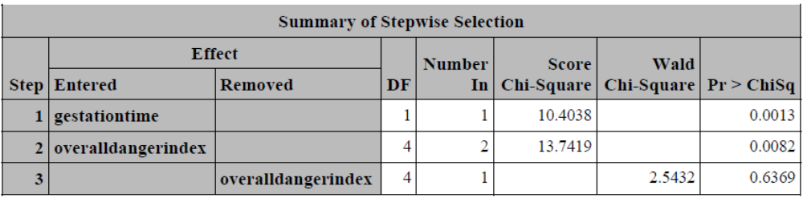
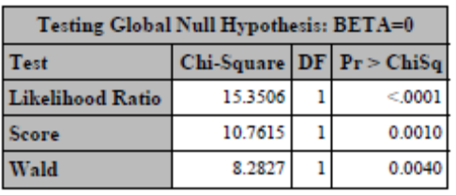
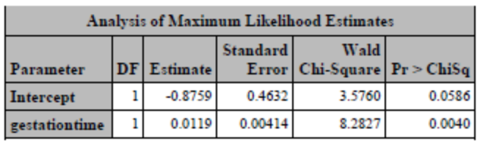
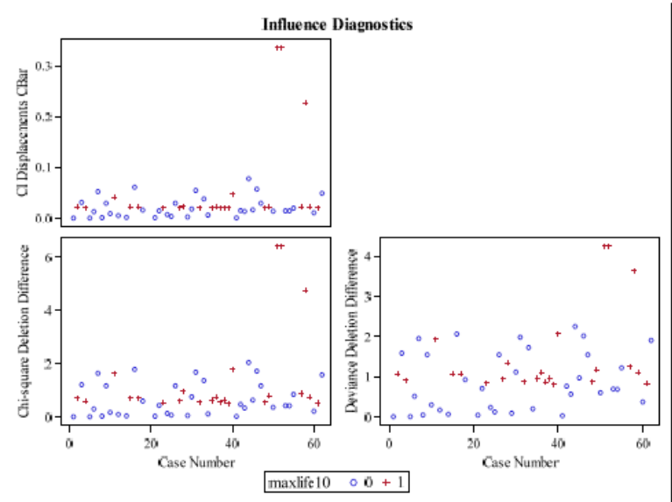
- After running a stepwise selection, on variables for Maxlife10, with a 0.05 significance requirement to enter and remain in the model the only parameter that was significant was gestationtime. There was a warning of quasicomplete separation of data points, so a full-fitted model with only gestationtime as a variable was run to obtain a Likelihood Estimate. Gestationtime was found to be significant, p-value was 0.0040. The Likelihood Ratio was found to be less than 0.0001, which means that the model is useful. There were no points above the 1.5 cbar cutoff line that created undue influence. Thus, no refitting was done for the model.

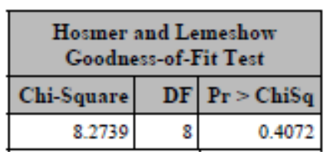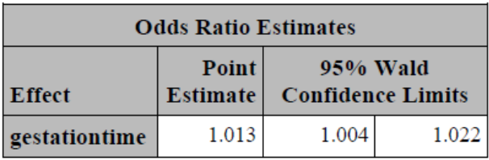
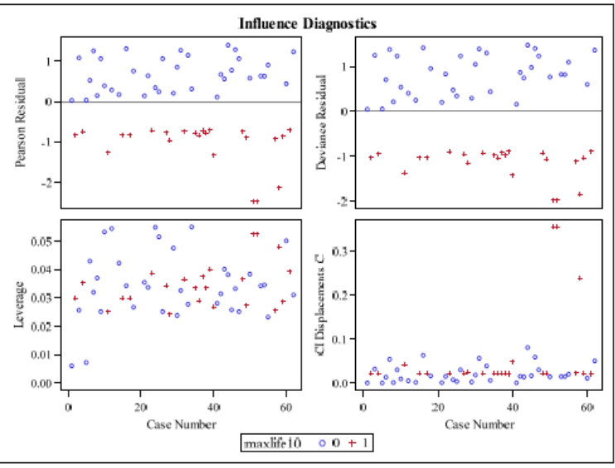
- Gestationtime was found to be significant, p-value was 0.0040, based on the Analysis of Maximum Likelihood Estimates. In addition, the confidence limits does not contain 1 so Gestationtime predictor is shown to be significant. The Hosmer-Lemeshow Test shows that the model is adequate, p-value is 0.4072. Most of the points were within the (-2,2) band so equal variance can be assumed. Thus, no further issues were found with the diagnostics

Estimated Logistics Regression Equation:
$Log(\frac{p(Maxlife10=0)}{p(Maxlife10=1)}$) = -0.8759 + 0.0119×Gestationtime
- Based on the model the odds of having a life span of at least ten years changes by a factor of 1.013 with a one unit increase in gestationtime. The confidence limits don’t contain 1 so the Gestationtime estimator is significant. An interpretation of this model is that the longer an animal gestates the more likely they are to live at least ten years.

Exercise 4:
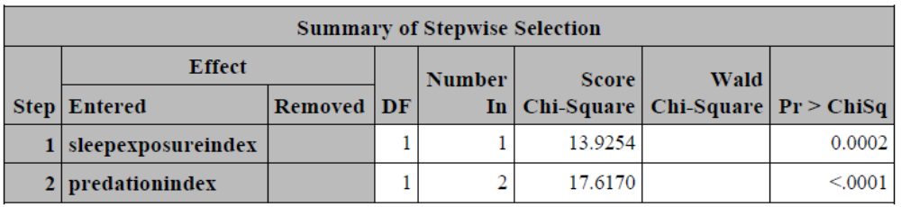
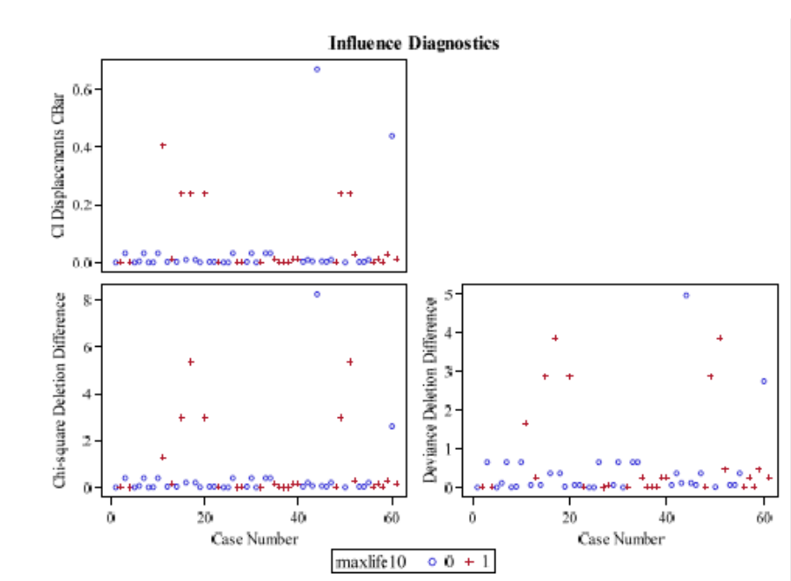
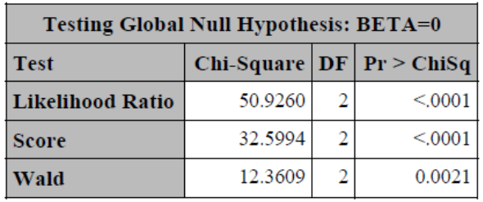
- After running a stepwise selection, on variables for Maxlife10, with a 0.05 significance requirement to enter and remain in the model the only parameters that were significant were predation index and sleep exposure index. There was only one point that was unduly influential with the cutoff line being 1.5 cbar, thus the model was refitted for this point. No further points were found to be above the cutoff line of 1.5cbar, so no further refitting was done on the model. The Likelihood Ratio’s p-value was found to be less than 0.0001 so the model was deemed useful.
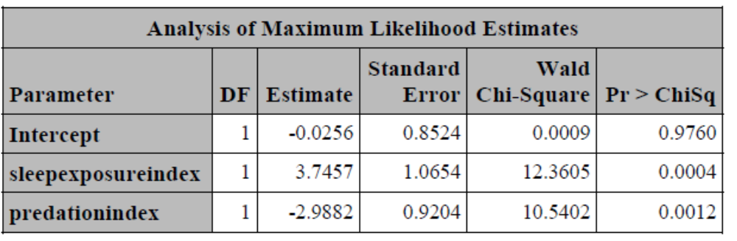
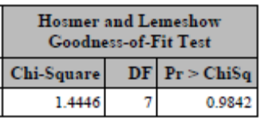
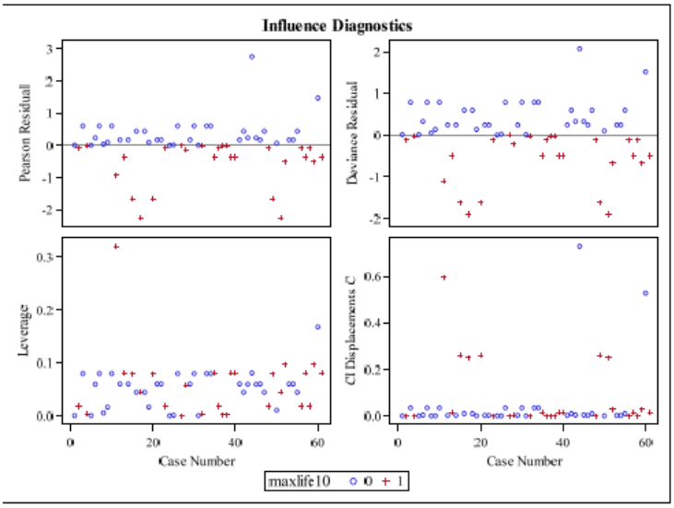
- Again, the significant parameters were predation index and sleep exposure index, both p-values were below 0.05. The Hosmer-Lemeshow Test showed that the model was adequate, however, the p-value is rather high at 0.9842 which may indicate overfitting so that should be noted when interpreting the model. There are no further problems with cbar, so no refitting was done. Most of the points were within (-2,2) band which means that equal variance can be assumed. No further issues were found with the diagnostics.
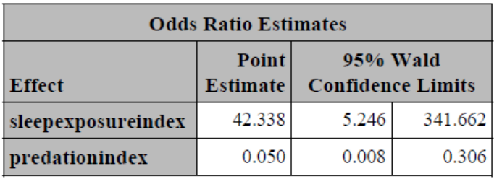
Estimated Logistics Regression Equation:
$Log(\frac{p(Maxlife10=0)}{p(Maxlife10=1)}$) = -0.0256 + 3.7457×Sleepexposureindex + -2.9882×Predationindex

- The odds of having a life span of at least ten changes by a factor of -0.050 with a one unit increase in predation index. The confidence limits don’t contain 1 so the Predation Index predictor is significant. The odds of having a life span of at least ten changes by a factor of 42.338 with a one unit increase in sleep exposure index. The confidence limits don’t contain 1.00 so the sleep exposure index predictor is significant. An interpretation of this model is that as animal is more likely to be preyed upon the less likely they are to live to 10 years and the more sleep exposure they have the more likely they are to live to 10 years.

