1. **Dickey-Fuller test:**

H0: Has unit root

t-stats < 5% t-stats ------- Cannot reject null

1. **Optimal Lag**
2. **Stationary**
3. **Series stationary at Level I (0):**

No need for checking co-integration since all the variables are stationary at levels. Thus, we perform only simple regression.

Use OLS model

1. **Series stationary at Level I (1):**

Since, all the variables are stationary at level I(1) we need to check the co-integration using following test.

**Johansen Co-integration test:**

H0: No co-integrating equation

1. Rejection at 5% level
2. Reject null hypothesis if value of TRACE and Max statistics >5% critical value

The * indicates the answer trace > critical value

If the series is Co-integrated it implies there is a long-run relationship and it can be combined in linear fashion.

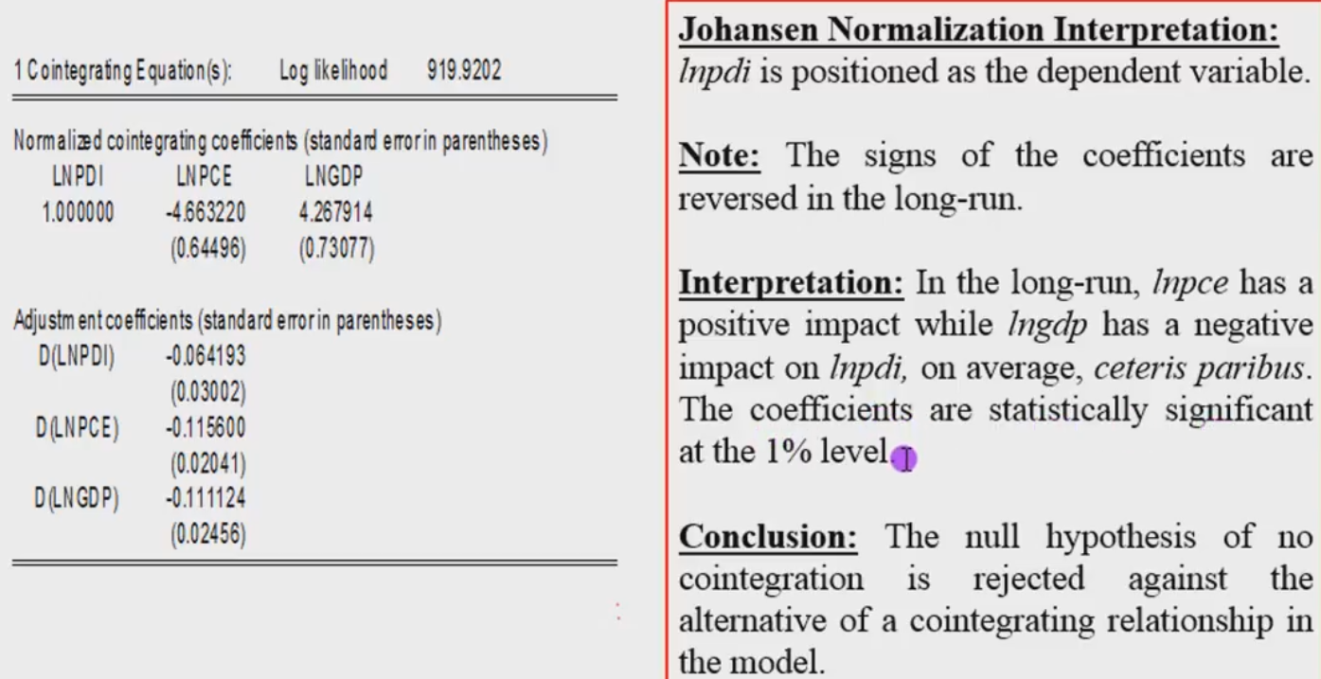

**Series stationary at different Level I(0) and I(1):**

Since, all the variables are stationary at at different Level I(0) and I(1) we need to check the co-integration using following test.

**Bounds Test:**

H0: No co-integrating equation

1. Rejection at 5% level
2. Reject null hypothesis if value of F-statistic > 5% critical value for upper bound I(1) --------- There is co-integration & estimate ECM.
3. Do not Reject null if value of F-statistic < 5% critical value for upper bound I(0) ---------

There is no co-integration & estimate ARDL.

**Estimate equation using ARDL**

**Model Selection:**

|  |  |  |  |
| --- | --- | --- | --- |
| Dependent variables | F-stats | Co-integration | Models |
| 1 |  | No | ARDL |
| 2 |  | Yes | ECM |
| 3 |  | no | ARDL |

**When there is co-integration for all dependent variables we use VECM model.**

**ARDL Model**

1. Do as group

Endogenous variable: dependent

Exogenous variable: independent

1. Check lag structure as group keeping every variable as dependent variable.
2. Estimate equation
   1. d(dependent variable) c d(dependent variable ( - 1)) d(independent (– 1))
3. Check residual diagnostics: Serial correlation LM

Check F- prob >0.05

* 1. If greater not affected by serial correlation. Cannot reject null hypothesis.

1. Stability by recursive estimate – cumsum test
2. Make residual series (proc) and name it as ECM
3. Estimate equation

d(dependent variable) c d(dependent variable ( - 1)) d(independent (– 1)) ecm(-1)

Ecm prob < 0.05

Repeat step 4 and 5

1. Causality check
   1. Wald’s test:

H0: co-efficient = 0

Reject null if F-stat< 0.05

* 1. Granger Causality:

H0: No granger causality

Reject null if F-stat< 0.05

**VECM**

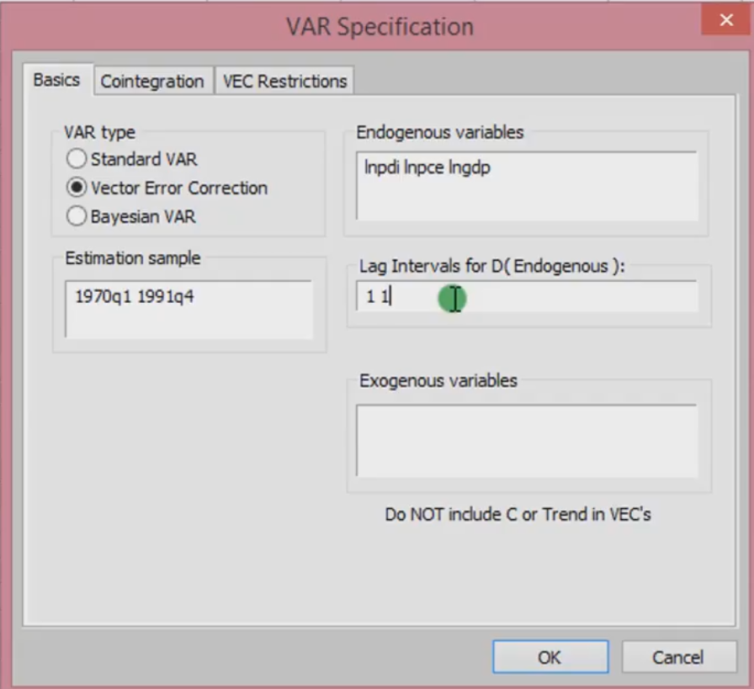

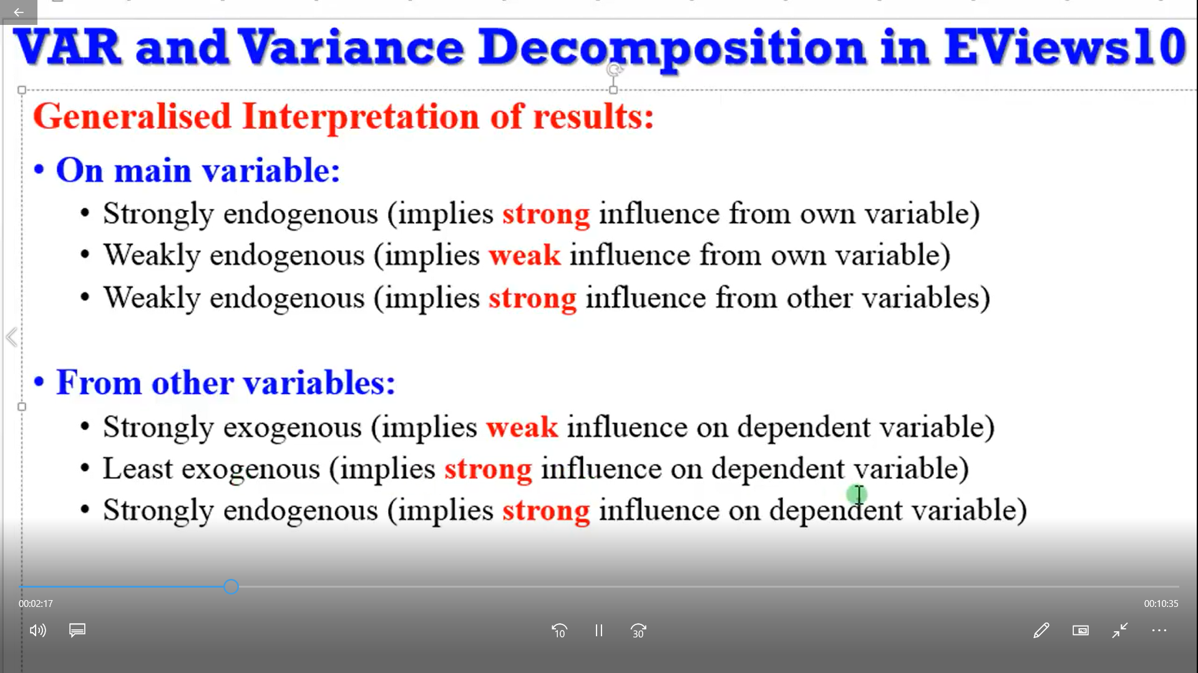

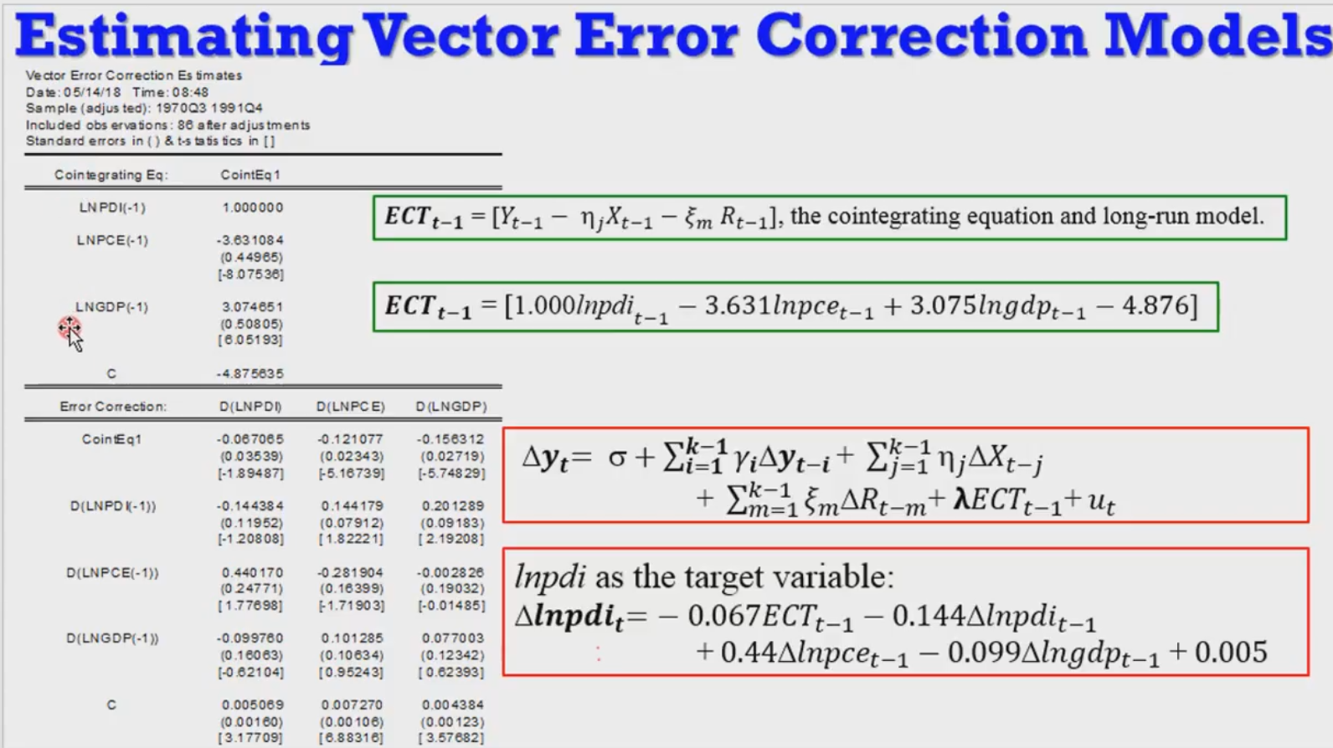

1. View – Residual test – Autocorrelation LM test
2. View – Residual test – residual test – cholessky covariance

Check for jarque- bara (Normality Test)

Each no. is each variable, the prob near to 0.2 is normally distributed

1. Causality test
   1. Pairwise Granger Causality:

H0: No granger causality

Reject null if F-stat< 0.05

1. Forcasting:

View – Variance decomposition

Percentage of forecast error variance for variable 1,2,3……

VAR and Impulse response function interpretation

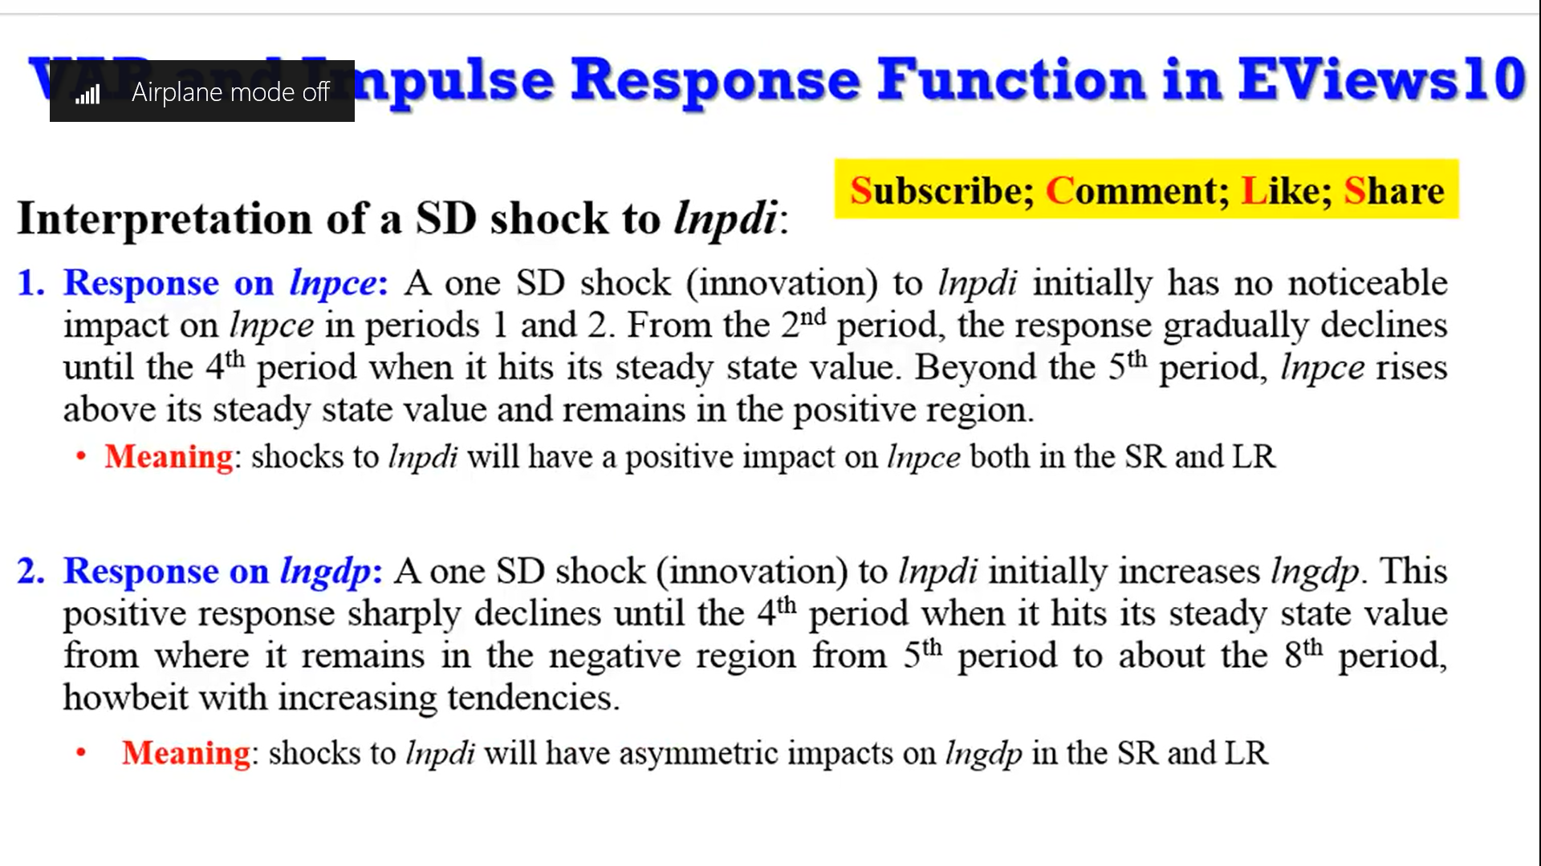

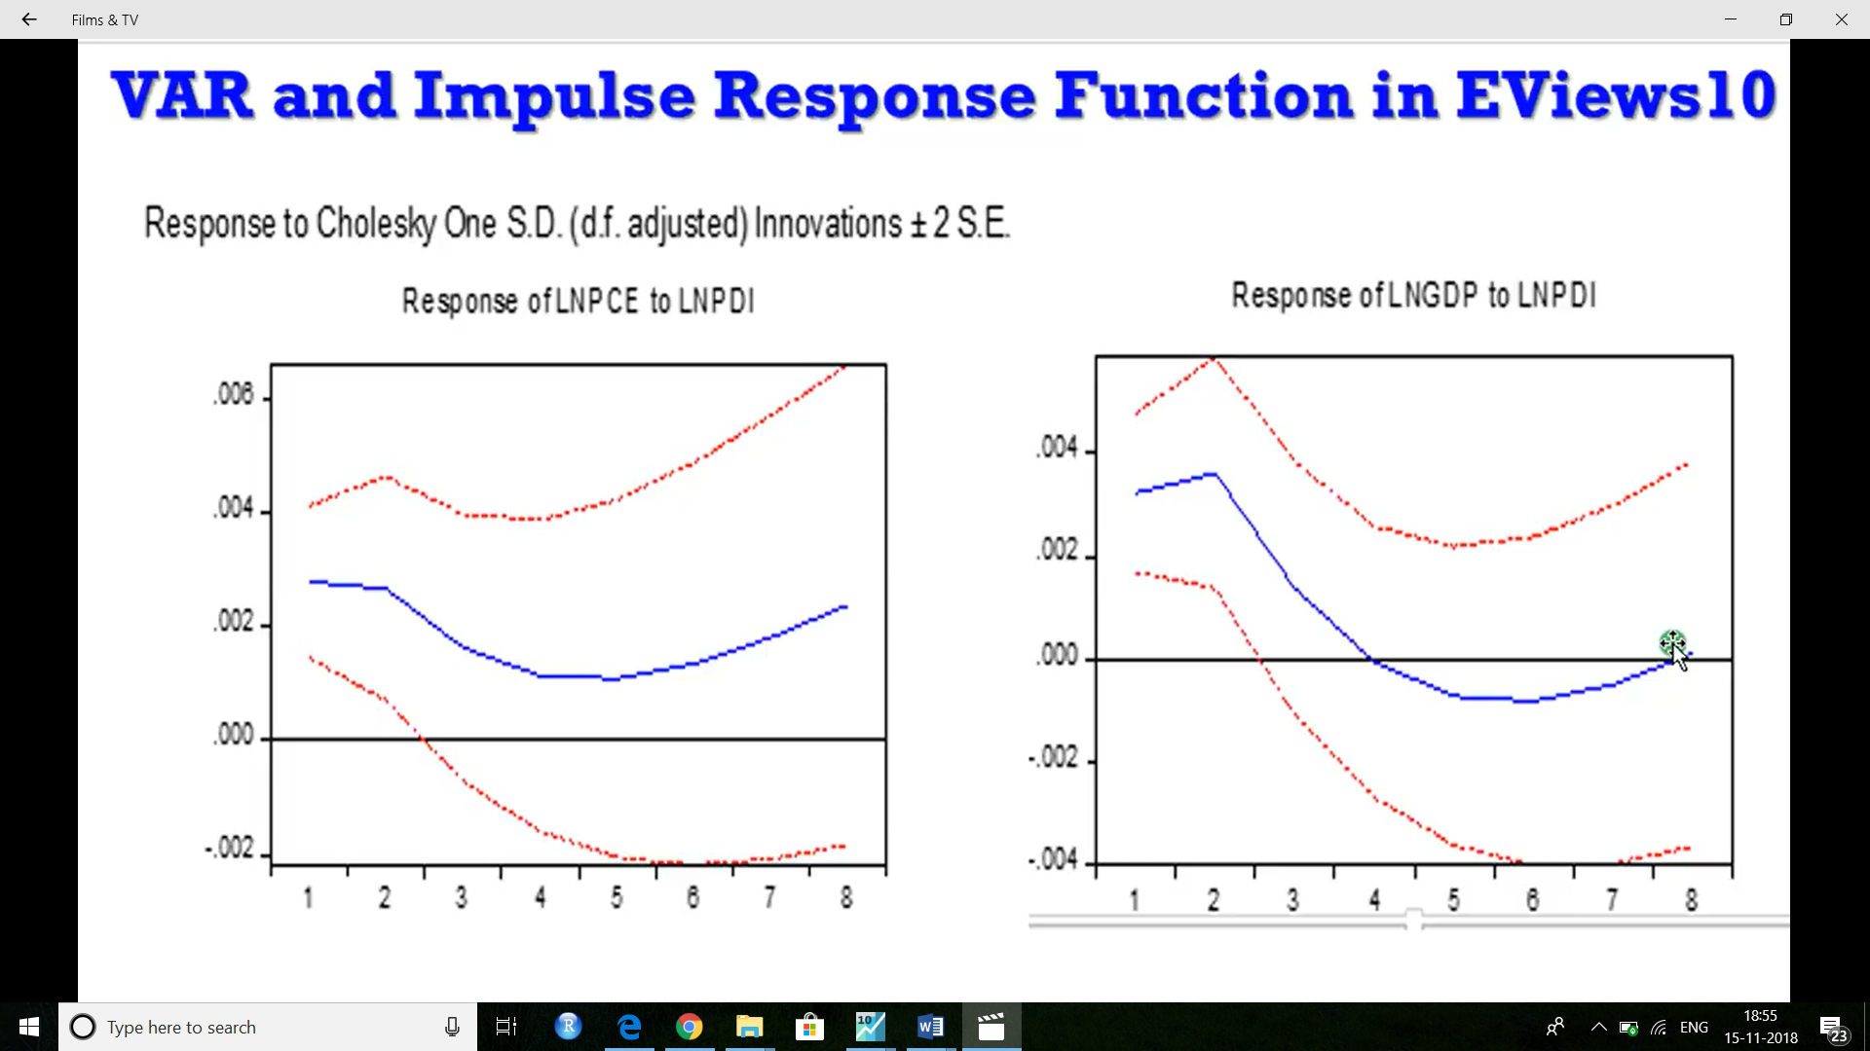

Theory –

Why is GARCH a better and therefore a far more widely used model than ARCH? The answer is that the former is more parsimonious, and avoids overﬁtting. Consequently, the model is less likely to breach non-negativity constraints.