**Univariate Time Series(Dataset - Sensex.xlsx):**

Univariate Time Series Variable: returns_sensex(returns has been calculated on the daily closed prices of sensex from Jan 1,2015 to Sept 21,2018 (daily data).

Checking for stationarity of returns_sensex:

|  |  |  |  |  |
| --- | --- | --- | --- | --- |
| Null Hypothesis: RETURNS_SENSEX has a unit root | | | | |
| Exogenous: Constant | | |  |  |
| Lag Length: 0 (Automatic - based on SIC, maxlag=20) | | | | |
|  |  |  |  |  |
|  |  |  |  |  |
|  |  |  | t-Statistic | Prob.* |
|  |  |  |  |  |
|  |  |  |  |  |
| Augmented Dickey-Fuller test statistic | | | -28.42251 | 0.0000 |
| Test critical values: | 1% level |  | -3.437228 |  |
|  | 5% level |  | -2.864466 |  |
|  | 10% level |  | -2.568381 |  |
|  |  |  |  |  |
|  |  |  |  |  |
| *MacKinnon (1996) one-sided p-values. | | | |  |
|  |  |  |  |  |

As Probability(p-value) of is less than 0.05(which is 0.000) , it means that null hypothesis of “No Stationarity” has been rejected. Therefore; “returns_sensex” variable is stationary.



Descriptive Statistics Of “returns_sensex” variable:

a)Histogram and Stats:



b)Stats Table:

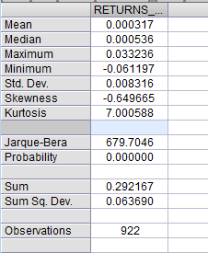

c)One Way Tabulation of distribution of values of “returns_sensex” variable:

|  |  |  |  |  |
| --- | --- | --- | --- | --- |
| Tabulation of RETURNS_SENSEX | | |  |  |
| Date: 11/16/18 Time: 14:42 | | |  |  |
| Sample (adjusted): 1/02/2015 9/21/2018 | | | |  |
| Included observations: 922 after adjustments | | | | |
| Number of categories: 5 | | |  |  |
|  |  |  |  |  |
|  |  |  |  |  |
|  |  |  | Cumulative | Cumulative |
| Value | Count | Percent | Count | Percent |
| [-0.08, -0.06) | 1 | 0.11 | 1 | 0.11 |
| [-0.04, -0.02) | 16 | 1.74 | 17 | 1.84 |
| [-0.02, 0) | 417 | 45.23 | 434 | 47.07 |
| [0, 0.02) | 483 | 52.39 | 917 | 99.46 |
| [0.02, 0.04) | 5 | 0.54 | 922 | 100.00 |
| Total | 922 | 100.00 | 922 | 100.00 |
|  |  |  |  |  |
|  |  |  |  |  |

Applying Arch Model :

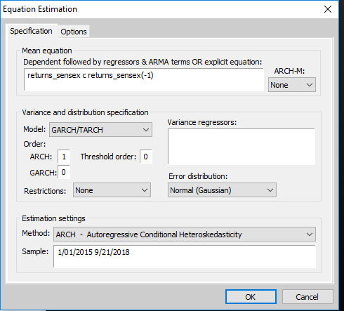

Performing Heteroskedasticity Test for ARCH Model:

|  |  |  |  |  |
| --- | --- | --- | --- | --- |
| Heteroskedasticity Test: ARCH | | |  |  |
|  |  |  |  |  |
|  |  |  |  |  |
| F-statistic | 2.95E-05 | Prob. F(1,918) | | 0.9957 |
| Obs*R-squared | 2.96E-05 | Prob. Chi-Square(1) | | 0.9957 |
|  |  |  |  |  |
|  |  |  |  |  |
|  |  |  |  |  |

As Probability(p-value) of is more than 0.05 for both Test Statistics, it means that null hypothesis of “No Volatility” or “No Arch Effect” has been accepted at lag 1 itself. Therefore; ARCH model can be used further for Estimation, Diagnostics and Forecasting purpose of this particular univariate time series variable of “returns_sensex”.

Estimation of ARCH Model:

|  |  |  |  |  |
| --- | --- | --- | --- | --- |
| Dependent Variable: RETURNS_SENSEX | | | |  |
| Method: ML ARCH - Normal distribution (BFGS / Marquardt steps) | | | | |
| Date: 11/16/18 Time: 14:46 | | |  |  |
| Sample (adjusted): 1/05/2015 9/21/2018 | | | |  |
| Included observations: 921 after adjustments | | | |  |
| Convergence achieved after 16 iterations | | | |  |
| Coefficient covariance computed using outer product of gradients | | | | |
| Presample variance: backcast (parameter = 0.7) | | | | |
| GARCH = C(3) + C(4)*RESID(-1)^2 | | | |  |
|  |  |  |  |  |
|  |  |  |  |  |
| Variable | Coefficient | Std. Error | z-Statistic | Prob. |
|  |  |  |  |  |
|  |  |  |  |  |
| C | 0.000305 | 0.000282 | 1.082150 | 0.2792 |
| RETURNS_SENSEX(-1) | 0.068380 | 0.035680 | 1.916499 | 0.0553 |
|  |  |  |  |  |
|  |  |  |  |  |
|  | Variance Equation | |  |  |
|  |  |  |  |  |
|  |  |  |  |  |
| C | 6.68E-05 | 2.69E-06 | 24.77605 | 0.0000 |
| RESID(-1)^2 | 0.027345 | 0.031769 | 0.860742 | 0.3894 |
|  |  |  |  |  |
|  |  |  |  |  |
| R-squared | 0.004253 | Mean dependent var | | 0.000302 |
| Adjusted R-squared | 0.003170 | S.D. dependent var | | 0.008309 |
| S.E. of regression | 0.008295 | Akaike info criterion | | -6.741558 |
| Sum squared resid | 0.063240 | Schwarz criterion | | -6.720601 |
| Log likelihood | 3108.488 | Hannan-Quinn criter. | | -6.733561 |
| Durbin-Watson stat | 1.998948 |  |  |  |

The top panel summarizes the input for the regression. The top panel provides information about regression inputs.The middle panel summarizes information about regression coefficients. The middle panel provides information about the estimated coefficients .The bottom panel provides summary statistics about the entire regression.

Here; in the case of ARCH model for this case of univariate time series data ; ARCH model doesn’t possess ARCH effect or volatility and has AIC (Akaike info criterion) value of -6.741558 and    Schwarz criterion(SC) value of -6.720601.

|  |
| --- |
|  |
|  |
|  |

|  |  |
| --- | --- |
|  |  |

|  |  |  |  |  |
| --- | --- | --- | --- | --- |
|  |  |  |  |  |

Applying Garch Model :

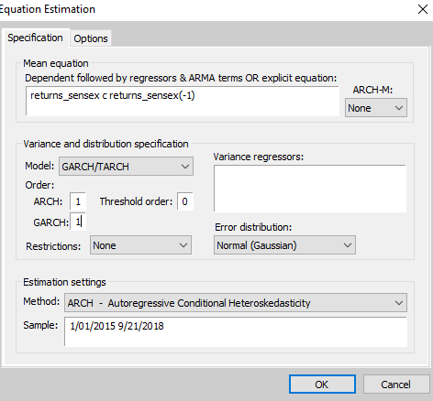

Performing Heteroskedasticity Test for GARCH Model:

|  |  |  |  |  |
| --- | --- | --- | --- | --- |
| Heteroskedasticity Test: ARCH | | |  |  |
|  |  |  |  |  |
|  |  |  |  |  |
| F-statistic | 0.585351 | Prob. F(1,918) | | 0.4444 |
| Obs*R-squared | 0.586253 | Prob. Chi-Square(1) | | 0.4439 |
|  |  |  |  |  |
|  |  |  |  |  |
|  |  |  |  |  |

As Probability(p-value) of is more than 0.05 for both Test Statistics, it means that null hypothesis of “No Volatility” or “No Arch Effect” has been accepted at lag 1 itself. Therefore; GARCH model can be used further for Estimation, Diagnostics and Forecasting purpose of this particular univariate time series variable of “returns_sensex”.

Estimation of GARCH Model:

|  |  |  |  |  |
| --- | --- | --- | --- | --- |
| Dependent Variable: RETURNS_SENSEX | | | |  |
| Method: ML ARCH - Normal distribution (BFGS / Marquardt steps) | | | | |
| Date: 11/16/18 Time: 14:55 | | |  |  |
| Sample (adjusted): 1/05/2015 9/21/2018 | | | |  |
| Included observations: 921 after adjustments | | | |  |
| Convergence achieved after 31 iterations | | | |  |
| Coefficient covariance computed using outer product of gradients | | | | |
| Presample variance: backcast (parameter = 0.7) | | | | |
| GARCH = C(3) + C(4)*RESID(-1)^2 + C(5)*GARCH(-1) | | | | |
|  |  |  |  |  |
|  |  |  |  |  |
| Variable | Coefficient | Std. Error | z-Statistic | Prob. |
|  |  |  |  |  |
|  |  |  |  |  |
| C | 0.000529 | 0.000253 | 2.093044 | 0.0363 |
| RETURNS_SENSEX(-1) | 0.068546 | 0.039043 | 1.755656 | 0.0791 |
|  |  |  |  |  |
|  |  |  |  |  |
|  | Variance Equation | |  |  |
|  |  |  |  |  |
|  |  |  |  |  |
| C | 1.04E-06 | 4.35E-07 | 2.382608 | 0.0172 |
| RESID(-1)^2 | 0.050842 | 0.011271 | 4.511068 | 0.0000 |
| GARCH(-1) | 0.933686 | 0.014916 | 62.59717 | 0.0000 |
|  |  |  |  |  |
|  |  |  |  |  |
| R-squared | 0.003363 | Mean dependent var | | 0.000302 |
| Adjusted R-squared | 0.002279 | S.D. dependent var | | 0.008309 |
| S.E. of regression | 0.008299 | Akaike info criterion | | -6.829386 |
| Sum squared resid | 0.063296 | Schwarz criterion | | -6.803189 |
| Log likelihood | 3149.932 | Hannan-Quinn criter. | | -6.819390 |
| Durbin-Watson stat | 1.997484 |  |  |  |

The top panel summarizes the input for the regression. The top panel provides information about regression inputs.The middle panel summarizes information about regression coefficients. The middle panel provides information about the estimated coefficients .The bottom panel provides summary statistics about the entire regression.

Here; in the case of GARCH model for this case of univariate time series data ; GARCH model doesn’t possess ARCH effect or volatility and has AIC (Akaike info criterion) value of -6.829386 and    Schwarz criterion(SC) value of -6.803189.

Applying Garch-M Model :

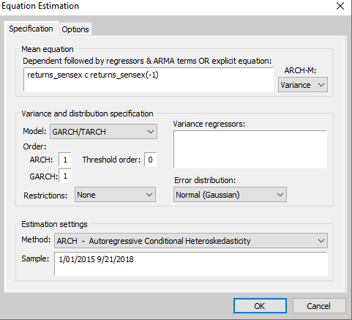

Performing Heteroskedasticity Test for GARCH-M Model:

|  |  |  |  |  |
| --- | --- | --- | --- | --- |
| Heteroskedasticity Test: ARCH | | |  |  |
|  |  |  |  |  |
|  |  |  |  |  |
| F-statistic | 0.634925 | Prob. F(1,918) | | 0.4258 |
| Obs*R-squared | 0.635868 | Prob. Chi-Square(1) | | 0.4252 |
|  |  |  |  |  |
|  |  |  |  |  |
|  |  |  |  |  |

As Probability(p-value) of is more than 0.05 for both Test Statistics, it means that null hypothesis of “No Volatility” or “No Arch Effect” has been accepted at lag 1 itself. Therefore; GARCH-M model can be used further for Estimation, Diagnostics and Forecasting purpose of this particular univariate time series variable of “returns_sensex”.

Estimation of GARCH-M Model:

|  |  |  |  |  |
| --- | --- | --- | --- | --- |
| Dependent Variable: RETURNS_SENSEX | | | |  |
| Method: ML ARCH - Normal distribution (BFGS / Marquardt steps) | | | | |
| Date: 11/16/18 Time: 15:01 | | |  |  |
| Sample (adjusted): 1/05/2015 9/21/2018 | | | |  |
| Included observations: 921 after adjustments | | | |  |
| Convergence achieved after 28 iterations | | | |  |
| Coefficient covariance computed using outer product of gradients | | | | |
| Presample variance: backcast (parameter = 0.7) | | | | |
| GARCH = C(4) + C(5)*RESID(-1)^2 + C(6)*GARCH(-1) | | | | |
|  |  |  |  |  |
|  |  |  |  |  |
| Variable | Coefficient | Std. Error | z-Statistic | Prob. |
|  |  |  |  |  |
|  |  |  |  |  |
| GARCH | 2.568173 | 9.211731 | 0.278794 | 0.7804 |
| C | 0.000385 | 0.000572 | 0.672283 | 0.5014 |
| RETURNS_SENSEX(-1) | 0.068922 | 0.039152 | 1.760365 | 0.0783 |
|  |  |  |  |  |
|  |  |  |  |  |
|  | Variance Equation | |  |  |
|  |  |  |  |  |
|  |  |  |  |  |
| C | 1.06E-06 | 4.52E-07 | 2.350732 | 0.0187 |
| RESID(-1)^2 | 0.051572 | 0.011418 | 4.516846 | 0.0000 |
| GARCH(-1) | 0.932603 | 0.015292 | 60.98611 | 0.0000 |
|  |  |  |  |  |
|  |  |  |  |  |
| R-squared | 0.003792 | Mean dependent var | | 0.000302 |
| Adjusted R-squared | 0.001622 | S.D. dependent var | | 0.008309 |
| S.E. of regression | 0.008302 | Akaike info criterion | | -6.827320 |
| Sum squared resid | 0.063269 | Schwarz criterion | | -6.795883 |
| Log likelihood | 3149.981 | Hannan-Quinn criter. | | -6.815324 |
| Durbin-Watson stat | 1.997291 |  |  |  |

The top panel summarizes the input for the regression. The top panel provides information about regression inputs.The middle panel summarizes information about regression coefficients. The middle panel provides information about the estimated coefficients .The bottom panel provides summary statistics about the entire regression.

Here; in the case of GARCH-M model for this case of univariate time series data ; GARCH-M model doesn’t possess ARCH effect or volatility and has AIC (Akaike info criterion) value of -6.827320 and    Schwarz criterion(SC) value of -6.795883.

Applying TGarch Model :

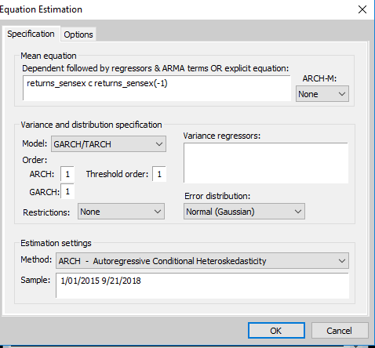

Performing Heteroskedasticity Test for TGARCH Model:

|  |  |  |  |  |
| --- | --- | --- | --- | --- |
| Heteroskedasticity Test: ARCH | | |  |  |
|  |  |  |  |  |
|  |  |  |  |  |
| F-statistic | 2.027377 | Prob. F(1,918) | | 0.1548 |
| Obs*R-squared | 2.027316 | Prob. Chi-Square(1) | | 0.1545 |

As Probability(p-value) of is more than 0.05 for both Test Statistics, it means that null hypothesis of “No Volatility” or “No Arch Effect” has been accepted at lag 1 itself. Therefore; TGARCH model can be used further for Estimation, Diagnostics and Forecasting purpose of this particular univariate time series variable of “returns_sensex”.

Estimation of TGARCH Model:

|  |  |  |  |  |
| --- | --- | --- | --- | --- |
| Dependent Variable: RETURNS_SENSEX | | | |  |
| Method: ML ARCH - Normal distribution (BFGS / Marquardt steps) | | | | |
| Date: 11/16/18 Time: 15:07 | | |  |  |
| Sample (adjusted): 1/05/2015 9/21/2018 | | | |  |
| Included observations: 921 after adjustments | | | |  |
| Convergence achieved after 27 iterations | | | |  |
| Coefficient covariance computed using outer product of gradients | | | | |
| Presample variance: backcast (parameter = 0.7) | | | | |
| GARCH = C(3) + C(4)*RESID(-1)^2 + C(5)*RESID(-1)^2*(RESID(-1)<0) + | | | | |
| C(6)*GARCH(-1) | | |  |  |
|  |  |  |  |  |
|  |  |  |  |  |
| Variable | Coefficient | Std. Error | z-Statistic | Prob. |
|  |  |  |  |  |
|  |  |  |  |  |
| C | 0.000253 | 0.000252 | 1.004895 | 0.3149 |
| RETURNS_SENSEX(-1) | 0.097387 | 0.037093 | 2.625485 | 0.0087 |
|  |  |  |  |  |
|  |  |  |  |  |
|  | Variance Equation | |  |  |
|  |  |  |  |  |
|  |  |  |  |  |
| C | 3.09E-06 | 5.69E-07 | 5.436301 | 0.0000 |
| RESID(-1)^2 | -0.047163 | 0.014484 | -3.256196 | 0.0011 |
| RESID(-1)^2*(RESID(-1)<0) | 0.192673 | 0.024182 | 7.967693 | 0.0000 |
| GARCH(-1) | 0.901343 | 0.017652 | 51.06314 | 0.0000 |
|  |  |  |  |  |
|  |  |  |  |  |
| R-squared | 0.003236 | Mean dependent var | | 0.000302 |
| Adjusted R-squared | 0.002152 | S.D. dependent var | | 0.008309 |
| S.E. of regression | 0.008300 | Akaike info criterion | | -6.863386 |
| Sum squared resid | 0.063304 | Schwarz criterion | | -6.831950 |
| Log likelihood | 3166.589 | Hannan-Quinn criter. | | -6.851391 |
| Durbin-Watson stat | 2.054617 |  |  |  |

The top panel summarizes the input for the regression. The top panel provides information about regression inputs.The middle panel summarizes information about regression coefficients. The middle panel provides information about the estimated coefficients .The bottom panel provides summary statistics about the entire regression.

Here; in the case of TGARCH model for this case of univariate time series data ; TGARCH model doesn’t possess ARCH effect or volatility and has AIC (Akaike info criterion) value of -6.863386 and    Schwarz criterion(SC) value of -6.831950.

**Conclusion:** Therefore; by applying various models of ARCH,GARCH,GARCH-M,TGARCH on univariate time series data of “return_sensex” which are returns calculated on the daily closed prices of sensex from Jan 1,2015 to Sept 21,2018 (daily data) and then further checking ARCH effect or Volatility effect of those models through Heteroskedasticity test and finally estimating those models ; we find that all 4 models mentioned above doesn’t possess ARCH or Volatility effect at lag 1 itself and therefore by comparing their AIC (Akaike info criterion) value and    Schwarz criterion(SC) value we came to conclusion that “T-GARCH” model doesn’t possess ARCH or Volatility effect at lag 1 itself but also has AIC (Akaike info criterion) value and    Schwarz criterion(SC) value minimum as compared to other 3 models of ARCH,GARCH and GARCH-M. Thus; TGRARCH model is suggested as best estimation model for this particular case of given univariate time series data of return_sensex” which are returns calculated on the daily closed prices of sensex from Jan 1,2015 to Sept 21,2018 (daily data) .