**ANN**

**Dataset**: bike_day

Data contains 731 entries with 16 columns

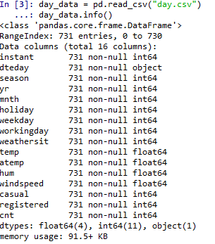

A plot of count with respect to date

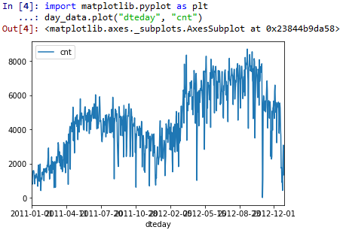

The fields that we have dropped are

**'season', 'weathersit', 'mnth', 'weekday'**

After pre-processing we got a total of 31 features

Then we fitted the model on rest of the features after splitting into train and test set.

We used **RMSprop** as an optimal optimizer

**Model Summary:**

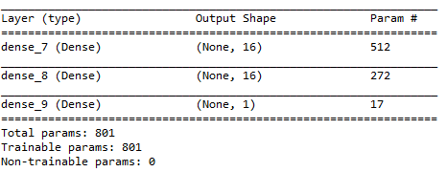

The model is being trained on 548 entries.

We ran 100 eochs

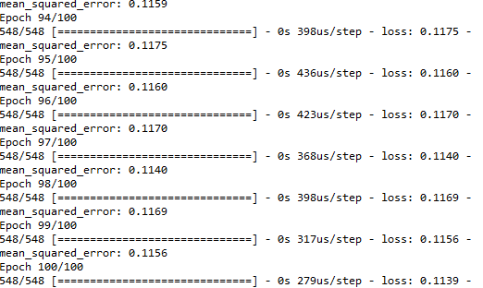

The model is evaluated on the test set with 183 entries, mse found out to be



Variance Score



**Dataset**: bike_hour

Data contains 17379 entries with 17 columns

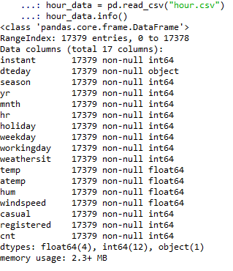

A plot of count with respect to date

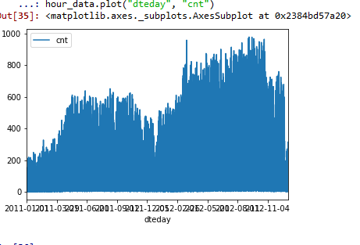

The fields that we have dropped are

**'season', 'weathersit', 'mnth', 'hr', 'weekday'**

After pre-processing we got a total of 56 features

Then we fitted the model on rest of the features after splitting into train and test set.

We used **RMSprop** as an optimal optimizer

**Model Summary:**

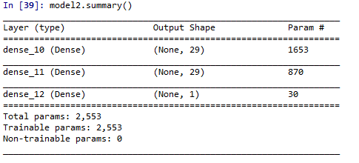

The model is being trained on 13034entries.

We ran 100 eochs

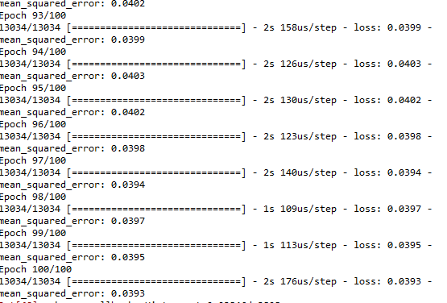

The model is evaluated on the test set with 4345 entries, mse found out to be

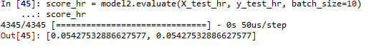

**Variance Score**

