**RNN_1**

**Dataset:** imdb (default keras dataset)

Data consisted of 25,000 train and test samples with 500 features.

We test on two optimizer namely **RMSprop** and **adam** with learning rate as 0.001 and found that the optimal optimizer in this case is **“adam”**

**Model Summary:**

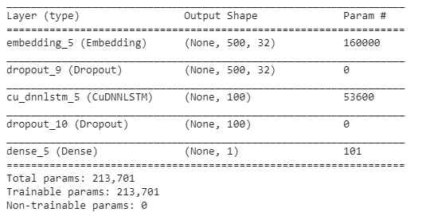

We have trained the data on 20,000 samples and validated on 5000 samples

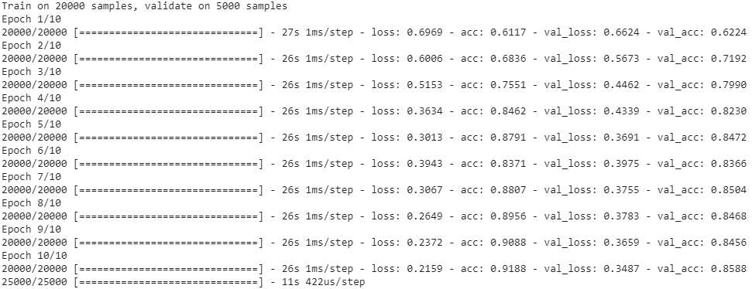

Later on final model is evaluated on 25,000 test samples

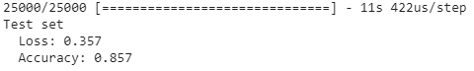

**RNN_2**

**Dataset:** External data reviews.txt and labels.txt

Data consisted of 17,500 train and 7500 test samples with 500 features.

**Text Pre-processing**: Each reviews is cleaned such as stopwords and punctuation marks are removed

We test on two optimizer namely **RMSprop** and **adam** with learning rate as 0.001 and found that the optimal optimizer in this case is **“adam”**

**Model Summary:**

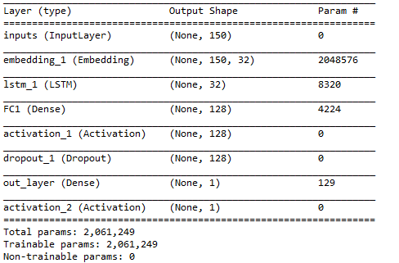

We have trained the data on 14,000 samples and validated on 3500 samples

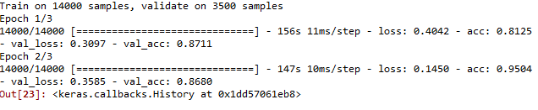

Later on final model is evaluated on 25,000 test samples

